Supplementary Data

Figures

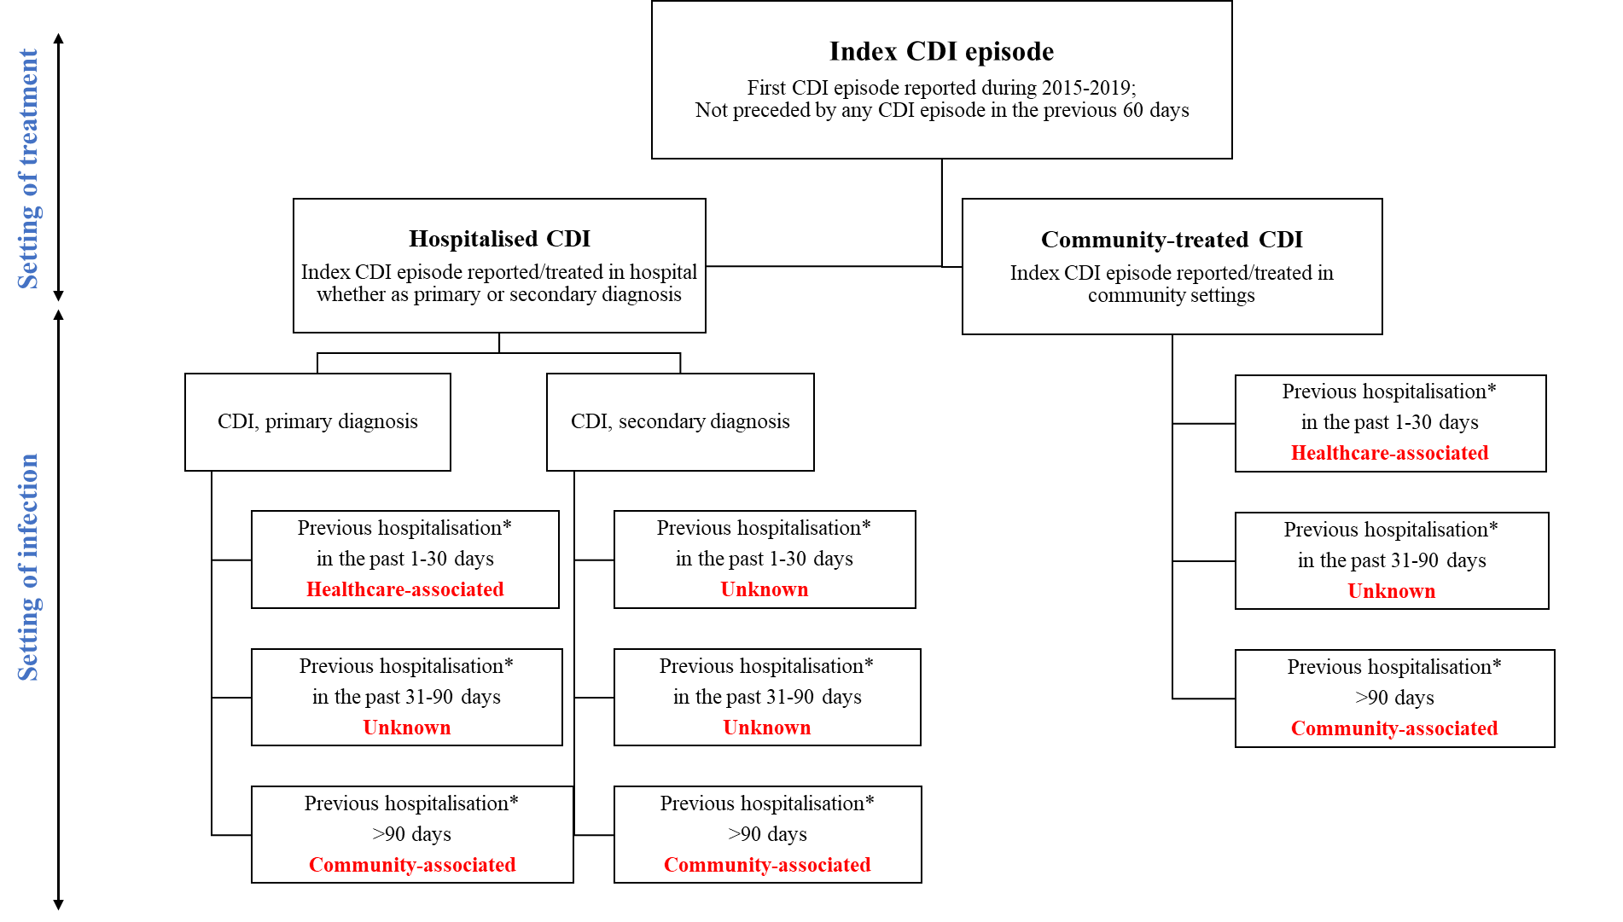
*Previous hospitalisation includes complete hospitalisation (>24 h or overnight stay, irrespective of cause) or transfer from a healthcare facility. CDI, Clostridioides difficile infection.
Fig. S1 Classification of index CDI episodes by setting of treatment and infection.

Tables

Table S1 Inclusion and exclusion criteria for patient selection

Inclusion criteria | Exclusion criteria
Adult patient (≥18 years of age) with:  - A medical diagnosis indicating a Clostridioides difficile enterocolitis (ICD-10 code: A04.7) recorded in a hospital or community setting between 2015 and 2019  - The patient is observable in the database at least 12 months before the date of diagnosis. | - Patients with index CDI episode reported in community setting for whom the date of CDI onset cannot be approximated:  - Patients presenting with ≥1 gastrointestinal condition listed below during the same or the previous quarter of the CDI were excluded:  - A09 - Other gastroenteritis and colitis of infectious and unspecified origin  - K52 - Other noninfective gastroenteritis and colitis  - A48 - Other bacterial diseases not elsewhere classified  - K50 - Crohn disease  - K57 - Diverticular disease of intestine  - Patients with no record of biological tests for identification of bacterial toxin A or B nor prescriptions of antibiotics indicated for CDI (non-topical metronidazole, or vancomycin or fidaxomicin) within the quarter of the diagnosis.  - Patients without information on key demographics (e.g., year of birth).  - Patients with a prior CDI episode within the previous 60 days (8 weeks) of the index CDI episode.  - Patients with a CDI diagnosis recorded in the 6-month period prior to the index CDI episode
CDI: Clostridioides difficile infection; ICD-10:International Classification of Diseases.

