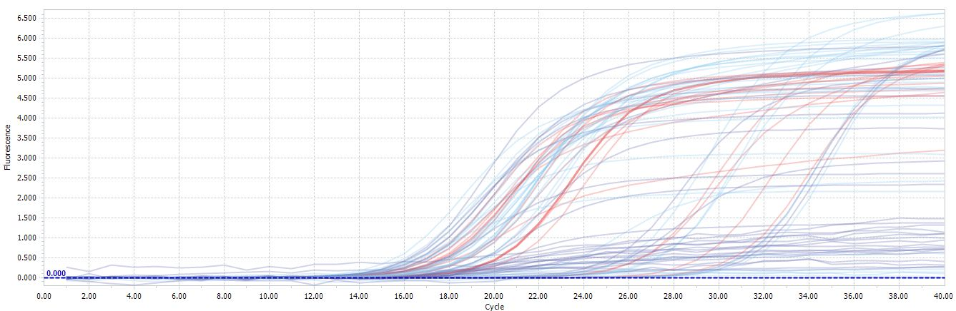
A
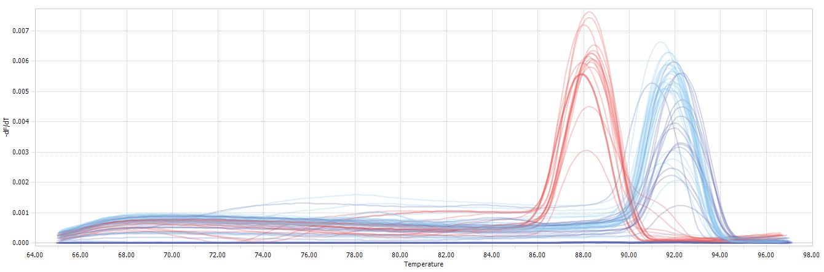
B

Figure S2. Amplification curves (A) and melting peaks (B) corresponding to for rpsL (reference gene, red), mexY (target gene, purple), and phoP (target gene, blue) genes.

