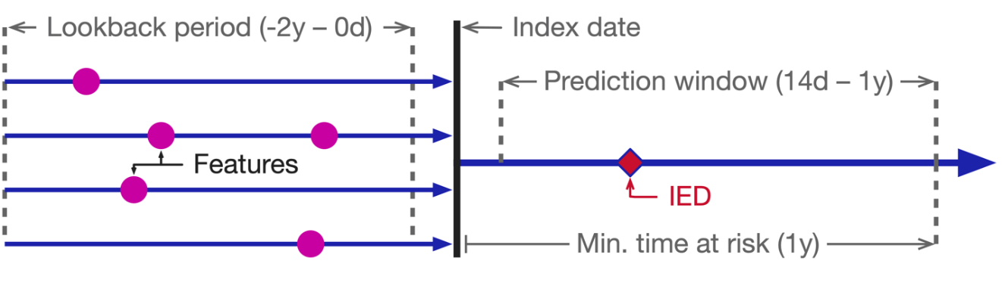

Fig. S1 Study design. The patient-level prediction design used in the study. Features from a patient’s medical record in the 2 years prior to an index date were used to predict whether the outcome (IED) would occur in the prediction window, defined as 14 days to 1 year following the index date.

IED, invasive Escherichia coli disease

a
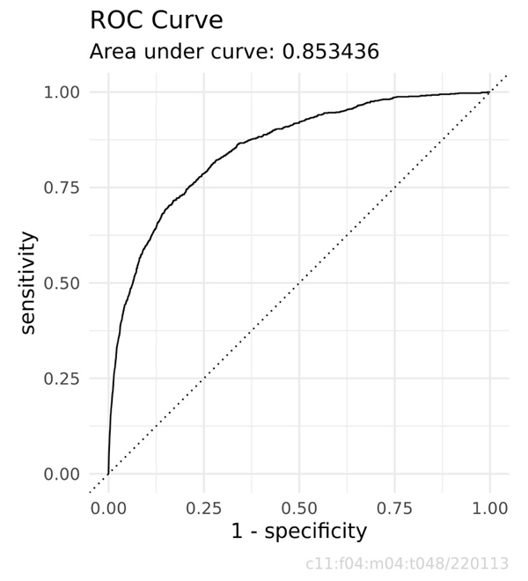
b
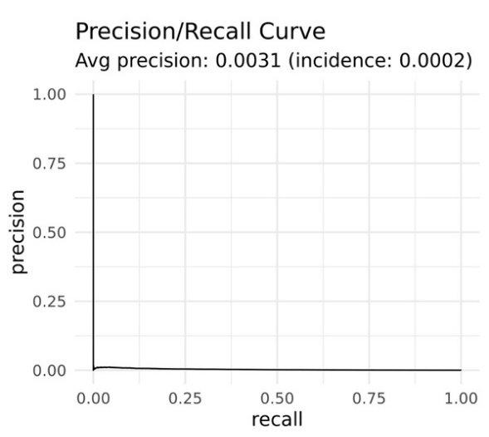
Fig. S2 Model performance as shown by a the receiver operating characteristic curve on the test set, along with area under the curve and b the precision-recall curve on the test set, along with average precision.
ROC, receiver operating characteristic

