Supplementary Figure 2 Multivariate association between post-culture hospital LOS and time to CAZ-AVI use in culture-positive ENT (A) and PsA (B)
(A) ENT (N=904)
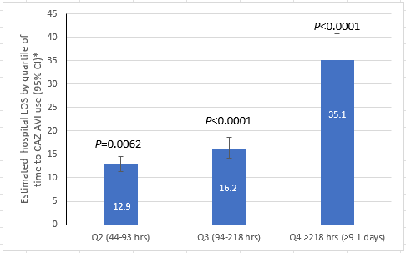
*Quartile 1 is the reference (<44 hours): Estimated LOS (95%CI) = 10.9 (9.4-12.6).
CAZ-AVI, ceftazidime-avibactam; CI, confidence interval; ENT, Enterobacterales; LOS, length of stay; Q, quartile.

(B) PsA (N=697)
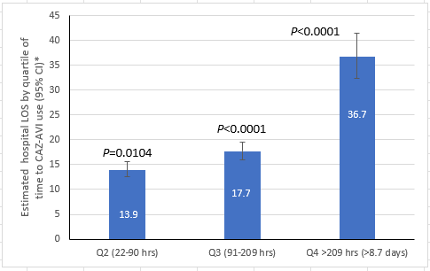
*Quartile 1 is the reference (<22 hours): Estimated LOS (95%CI) = 11.2 (9.7-12.8).
CAZ-AVI, ceftazidime-avibactam; CI, confidence interval; LOS, length of stay; PsA, Pseudomonas aeruginosa; Q, quartile.

