Modelling the long-term health impact of COVID-19 using Graphical Chain Models
Brief heading: Long COVID prediction by Graphical Chain Models
K. Gourgoura et al.

Supplementary Material

Graphical Chain Modelling

Graphical Chain Models (GCMs) can be seen as extension of Structural Equation Models, by allowing for (a) variables of any type and (b) situations where a complete ordering of individual variables cannot be postulated, but a complete ordering among blocks of variables is possible [25].
In a GCM, variables are typically represented by nodes and nodes are partitioned into blocks, with a natural ordering between blocks, as follows: block 1 - explanatory variables; block 2 – variables that are responses of the variables in block 1 and explanatory for the variables in the subsequent blocks, and so on.
Let A be in block 3 and B be in block 1. A←B implies that B is an explanatory variable of A. Then B is a parent of A. Let A and C be in the same block. A-C means that the two variables are associated after conditioning on all the variables in block 1 and 2. Let A be in block 3 and D be in block 1. Absence of an arrow between A and D implies that A is independent from D given all parents of A. Let A and E be in block 3. Absence of an undirected edge between A and E implies that A and E have no residual correlation given all parents of A and E.
To fit a CGM, after the formation of the blocks, the following steps were performed:
- Step 1. Take the variable from the block with the highest number and fit a univariate regression model with this variable as response and all variables in the preceding blocks as covariates. Test for quadratic effects and two-way interactions. Use backward selection to reduce the model with BIC as information criterion. This step allows us to determine the parents of each variable and to place the arrows in the CGM pointing from the significant covariates to the response variable.
- Step 2. Once univariate regression model for each variable against the covariates in the previous blocks has been selected, the procedure adds, to each univariate regression performed in Step 1, the variables in the same block, together with its parent nodes. This step allows us to determine the residual effect of concomitant variables and add an undirected edge for each significant coefficient in this second set of regressions. If there are no further variables, jump to the next block in the ordering and repeat Steps 1 and 2.

Supplementary Table 1. Full dataset list
N | Variable | Nature of the variable | Description
1 | Gender | Binary | Male or female
2 | DOB | Date | Date of birth
3 | Hospital | Date | Date of hospital admission
4 | NIV | Binary | Need for non-invasive ventilation (yes or not)
5 | ICU | Binary | Need for admission to intensive care unit (yes or not)
6 | Discharge | Date | Date of hospital discharge
7 | Follow-up | Date | Date of follow-up visit
8 | Fatigue | Binary | Fatigue patients report (yes or not)
9 | Height | Quantitative | Patient height in centimetres (cm)
10 | Weight | Quantitative | Patients weight in kilograms (Kg)
11 | SBP | Quantitative | Systolic blood pressure in millimeters of mercury (mmHg)
12 | DBP | Quantitative | Diastolic blood pressure in millimeters of mercury (mmHg)
13 | HR | Quantitative | Heart rate in beats/minute
14 | O2 | Quantitative | Peripheral oxygen saturation in percentage (%)
15 | Waist | Quantitative | Waist circumference in centimetres (cm)
16 | Hip | Quantitative | Hip circumference in centimetres (cm)
17 | Arm | Quantitative | Arm circumference in centimetres (cm)
18 | Neck | Quantitative | Neck circumference in centimetres (cm)
19 | Smoking | Nominal | Smoking habit (1:nonsmoker, 2:past smoker, 3:current smoker)
20 | Hypertension | Binary | Patient history of hypertension (yes or not)
21 | Dyslipidemia | Binary | Patient history of dyslipidemia (yes or not)
22 | Diabetes | Binary | Patient history of diabetes (yes or not)
23 | AF | Binary | Patient history of atrial fibrillation (yes or not)
24 | CAD | Binary | Patient history of coronary artery disease (yes or not)
25 | COPD | Binary | Patient history of chronic obstructive pulmonary disease (yes or not)
26 | Thyroid | Binary | Patient history of thyroid function disorders (yes or not)
27 | BB | Binary | Daily intake of beta-blockers (yes or not)
28 | ASA | Binary | Daily intake of acetylsalicylic acid (yes or not)
29 | Hypo | Binary | Daily intake of anti-hypertensive medications (yes or not)
30 | Insulin | Binary | Daily intake of insulin (yes or not)
31 | Statins | Binary | Daily intake of statins (yes or not)
32 | Hb | Quantitative | Hemoglobin in grams per deciliter (g/dl)
33 | Leukocytes | Quantitative | Leukocytes count in n x 10³/mmc
34 | Neutrophils | Quantitative | Neutrophil count in percentage (%)
35 | Lymphocytes | Quantitative | Lymphocyte count in percentage
36 | Platelet | Quantitative | Platelet count in n x 10⁶/mmc
37 | Glycemia | Quantitative | Plasma glucose concentration in milligrams per deciliter (mg/dL)
38 | BUN | Quantitative | Blood Urea Nitrogen in milligrams per deciliter (mg/dL)
39 | Creatinine | Quantitative | Serum creatinine level in milligrams per deciliter (mg/dL)
40 | Uric acid | Quantitative | Plasma uric acid level in milligrams per deciliter (mg/dL)
41 | Na | Quantitative | Serum sodium concentration in milliequivalent per liter (mEq/L)
42 | K | Quantitative | Serum potassium concentration in milliequivalent per liter (mEq/L)
43 | AST | Quantitative | Serum aspartate aminotransferase level in units per liter (U/L)
44 | ALT | Quantitative | Serum alanine aminotransferase level in units per liter (U/L)
45 | BIL.TOT | Quantitative | Serum total bilirubin level in milligrams per deciliter (mg/dL)
46 | ALP | Quantitative | Serum alkaline phosphatase level in units per liter (U/L)
47 | GGT | Quantitative | Serum gamma-glutamyl transferase in units per liter (U/L)
48 | TC | Quantitative | Serum total cholesterol level in milligrams per deciliter (mg/dL)
49 | HDL | Quantitative | Serum high-density lipoprotein cholesterol level in milligrams per deciliter (mg/dL)
50 | LDL | Quantitative | Serum low-density lipoprotein cholesterol level in milligrams per deciliter (mg/dL)
51 | TG | Quantitative | Serum triglyderides level in milligrams per deciliter (mg/dL)
52 | LDH | Quantitative | Serum lactate dehydrogenase level in units per liter (U/L)
53 | INR | Quantitative | International normalized ratio
54 | FIBR | Quantitative | Serum fibrinogen level in milligrams per deciliter (mg/dL)
55 | DDIMER | Quantitative | Serum D-dimer level in nanograms per milliliter (ng/ml)
56 | VITD | Quantitative | Serum vitamin D level in nanograms per milliliter (ng/ml)
57 | PCR | Quantitative | Serum C-reactive protein level in milligrams per deciliter (mg/dL)
58 | FERRITIN | Quantitative | Serum ferritin level in nanograms per milliliter (ng/ml)
59 | HRCT | Ordinal | High resolution computed tomography of the lung performed at follow-up (1:normal, 2:residual parenchymal disease, 3:signs of fibrotic evolution)
60 | RETICULAR | Quantitative | Presence of lung reticulations to follow-up HRCT as fibrosis-like lesions
61 | TRACTION | Quantitative | Presence of lung tractions to follow-up HRCT as fibrosis-like lesions
62 | HONEY | Quantitative | Presence of honeycombing to follow-up HRCT as fibrosis-like lesions
63 | GROUND | Quantitative | Presence of ground glass opacities to follow-up HRCT
64 | CONSOLIDATION | Quantitative | Presence of lung consolidations to follow-up HRCT
65 | PLEURAL | Quantitative | Presence of pleural effusion to follow-up HRCT
66 | FEV1 | Quantitative | Forced expiratory volume in 1 second at follow-up spirometry
67 | FEV1% | Quantitative | Forced expiratory volume in 1 second vs predicted values (in percentage)
68 | FEV1/FVC | Quantitative | Tiffenaeau index expressed as FEV1/FVC ratio
69 | FVC | Quantitative | Forced vital capacity at follow-up spirometry in litter
70 | FVC% | Quantitative | Forced vital capacity at follow-up spirometry vs predicted values (in percentage)
71 | EF | Quantitative | Left ventricular ejection fraction at follow-up echocardiography in percentage
72 | E/A | Quantitative | Early to late diastolic transmittal flow velocity in E-wave/A-wave ratio
73 | TAPSE | Quantitative | Tricuspid annular plane systolic excursion in millimetres
74 | PAPS | Quantitative | Estimated pulmonary artery systolic pressure in millimetre of mercury (mmHg)
75 | SIV.D | Quantitative | Interventricular end-diastolic septal thickness in millimetre
76 | DT.D | Quantitative | Left ventricular end-diastolic diameter in millimetre
77 | PW.D | Quantitative | Left ventricular end-diastolic posterior wall in millimetre
78 | AORTIC ROOT | Quantitative | Aortic root diameter expressed in millimetre
79 | VO2 | Quantitative | Peak respiratory oxygen uptake in mL/kg/min
80 | VE/VCO2 slope | Quantitative | Minute ventilation/carbon dioxide production slope
81 | LT | Quantitative | VO2 at lactate threshold
82 | R | Quantitative | Respiratory exchange ratio
83 | PETCO2 | Quantitative | Partial pressure of end-tidal carbon dioxide
84 | O2 pulse | Quantitative | Ratio of VO2 (mL/min) and heart rate (beats/min), expressed as mL/beat
85 | VO2 Watt | Quantitative | Slope of VO2 (mL/min) to workload (Watts)
86 | DASS Stress | Quantitative | Depression Anxiety and Stress Scale – Stress score
87 | DASS Anxious | Quantitative | Depression Anxiety and Stress Scale – Anxiety score
88 | DASS Depression | Quantitative | Depression Anxiety and Stress Scale – Depression score
89 | SF12 Phisical | Quantitative | The 12-item Short-Form Health Survey, summary score of physical health
90 | SF12 Mental | Quantitative | The 12-item Short-Form Health Survey, summary score of mental health
91 | IES R total | Quantitative | The Impact of Event Scale – Revised (IES-R) - total score
92 | IES R Avoidance | Quantitative | The Impact of Event Scale – Revised (IES-R) – avoidance subscale
93 | IES R Intrusiveness | Quantitative | The Impact of Event Scale – Revised (IES-R) – intrusiveness subscale
94 | IES R Hyperarousal | Quantitative | The Impact of Event Scale – Revised (IES-R) – hyperarousal subscale
95 | Age | Quantitative | Age expressed in years
97 | BMI | Quantitative | Body mass index (kg/m)
98 | Hosp stay | Quantitative | Length of hospital stay expressed in days
99 | FU time | Quantitative | Time from hospital discharge to follow-up visit expressed in days

Supplementary Table 2: summaries of final models for Background variables - Block 1
Final model summaries – Background Explanatory Variables – Block 1
 | AGE |  |  | BMI |  |  | GENDER |  |  | SMOKING
Predictors | Estimates | CI | p | Estimates | CI | p | Odds Ratios | CI | p | Odds Ratios | CI | p
(Intercept) | 58.20 | 56.28 – 60.11 | <0.001 | 33.31 | 31.08 – 35.53 | <0.001 | 40.59 | 3.72 – 574.46 | 0.003 | 0.81 | 0.54 – 1.21 | 0.308
GENDER [2] |  |  |  | -3.17 | -5.78 – -0.56 | 0.017
BMI |  |  |  |  |  |  | 0.92 | 0.85 – 0.99 | 0.027
Observations | 96 |  |  | 96 |  |  | 96 |  |  | 96

Supplementary Table 3: summaries of final models for Intermediate variables - Block 2
Final model summaries – Intermediate Variables – Block 2
 | TIME_UNTIL_FOLLOWUP |  |  | ICU
Predictors | Estimates | CI | p | Odds Ratios | CI | p
(Intercept) | 140.23 | 128.95 – 151.51 | <0.001 | 0.00 | 0.00 – 0.06 | <0.001
BMI |  |  |  | 1.12 | 1.03 – 1.23 | 0.014
SMOKING [2] |  |  |  | 3.33 | 1.07 – 11.73 | 0.045
Observations | 96 |  |  | 96

Supplementary Table 4: summaries of final models for Outcome variables - Block 3
Final model summaries – Response Variables – Block 3
 | VO2 |  |  | log_DDIMER |  |  | FEV1 |  |  | DEPRESSION |  |  | FATIGUE
Predictors | Est | CI | p | Est | CI | p | Est | CI | p | OR | CI | p | OR | CI | p
(Intercept) | 33.27 | 26.01 – 40.52 | <0.001 | 3.67 | 2.34  – 5.01 | <0.001 | 4.75 | 3.80  –  5.71 | <0.001 |  |  |  | 0.47 | 0.27  –  0.77 | 0.004
TIME_UNTIL_FOLLOUP | 0.02 | 0.00  –  0.03 | 0.019
AGE | -0.16 | -.024 –  -0.08 | <0.001 | 0.03 | 0.01  –  0.04 | <0.001 | -0.03 | -0.05  –  -0.02 | <0.001
BMI | -0.30 | -0.43  –  -0.17 | <0.001 | 0.02 | 0.00  –  0.04 | 0.045 | -0.00 | -0.02  0.01 | 0.622
GENDER [2] | 4.22 | 2.48  –  5.96 | <0.001 | 0.03 | -0.26 –  0.33 | 0.830 | 0.80 | 0.55  –  1.04 | <0.001 | 0.47 | 0.26  –  0.85 | 0.015
FEV1 |  |  |  | 0.05 | -0.15  –  0.25 | 0.603
FATIGUE [2] |  |  |  |  |  |  | -0.23 | -0.44  –  -0.01 | 0.036 | 2.62 | 1.51  –  4.61 | 0.001
1|2 |  |  |  |  |  |  |  |  |  | 2.12 | 1.11  –  4.04 | 0.024
2|3 |  |  |  |  |  |  |  |  |  | 3.49 | 1.78  –  6.84 | <0.001
SOMKING [2] |  |  |  |  |  |  |  |  |  | 1.89 | 1.09  –  3.33 | 0.028
DEPRESSION [2] |  |  |  |  |  |  |  |  |  |  |  |  | 2.14 | 0.60  –  7.63 | 0.230
DEPRESSION [3] |  |  |  |  |  |  |  |  |  |  |  |  | 10.71 | 3.13  –  49.97 | 0.001
Observations | 96 |  |  | 96 |  |  | 96 |  |  | 96 |  |  | 96

Supplementary Table 5: summary of final model for HRCT as response - Block 4
Final model summary – Block 4
 | TIME_UNTIL_FOLLOWUP
Predictors | Odds Ratios | CI | p
1|2 | 7.16 | 0.40 – 129.47 | 0.179
2|3 | 23.98 | 1.29 – 447.11 | 0.034
GENDER [2] | 2.30 | 1.04 – 5.18 | 0.046
ICU [2] | 2.40 | 1.14 – 5.13 | 0.025
AGE | 1.06 | 1.02 – 1.11 | 0.004
TIME_UNTIL_FOLLOWUP | 0.99 | 0.99 – 1.00 | 0.052
VO2 | 0.93 | 0.86 – 1.01 | 0.078
Observations | 68

Supplementary Table 6: Descriptive statistics of comorbidities and concomitant medications
 | Absent | Present | Na¹
Concomitant medications
BB | 72 ( 75 % ) | 24 ( 25 % ) | 12
ASA | 87 ( 90.62 % ) | 9 ( 9.38 % ) | 12
Hypo | 89 ( 92.71 % ) | 7 ( 7.29 % ) | 12
Insulin | 95 ( 98.96 % ) | 1 ( 1.04 % ) | 12
Statins | 83 ( 86.46 % ) | 13 ( 13.54 % ) | 12
Comorbidities
Hypertension | 46 ( 48.42 % ) | 49 ( 51.58 % ) | 13
Dyslipidemia | 49 ( 51.58 % ) | 46 ( 48.42 % ) | 13
Diabetes | 85 ( 89.47 % ) | 10 ( 10.53 % ) | 13
AF | 94 ( 97.92 % ) | 2 ( 2.08 % ) | 12
CAD | 95 ( 98.96 % ) | 1 ( 1.04 % ) | 12
COPD | 84 ( 89.36 % ) | 10 ( 10.64 % ) | 14
Thyroid | 85 ( 88.54 % ) | 11 ( 11.46 % ) | 12
¹The count of missing values for each variable; ²Each parenthesis denotes the percentage of observations within a level, excluding missing values

Supplementary Figure 1: Missing values of the selected variables
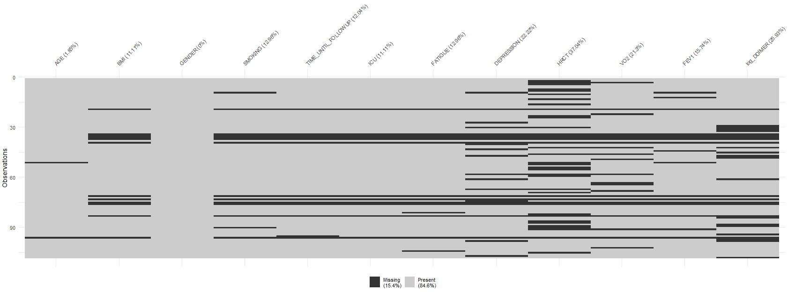

Supplementary Figure 2: Population pyramid of the sample according to age and gender.
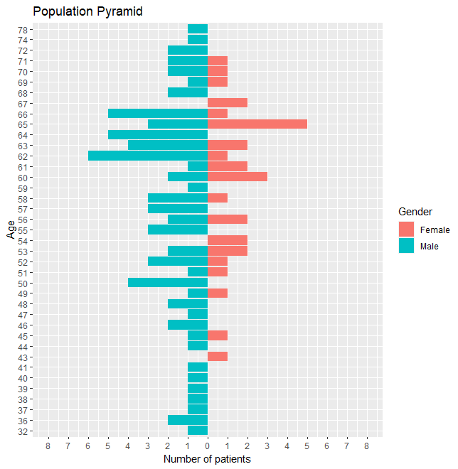

Supplementary Figure 3: Histograms and bar plots of key variables
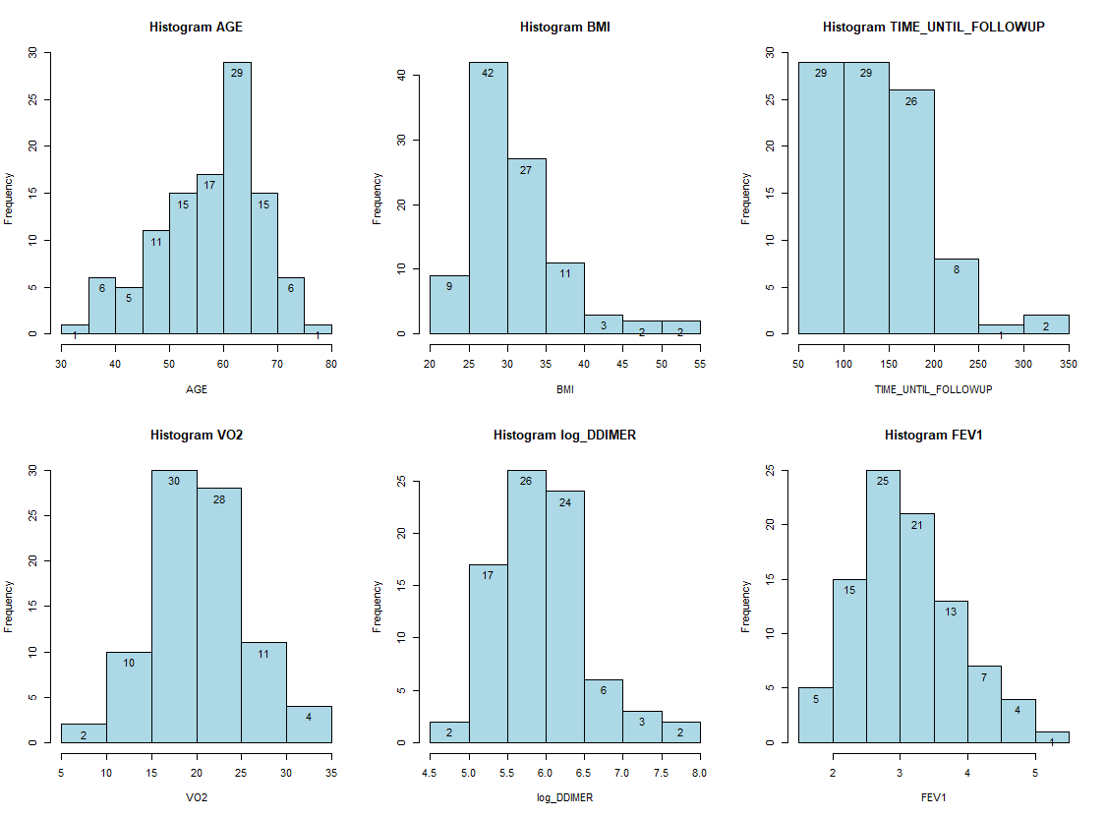
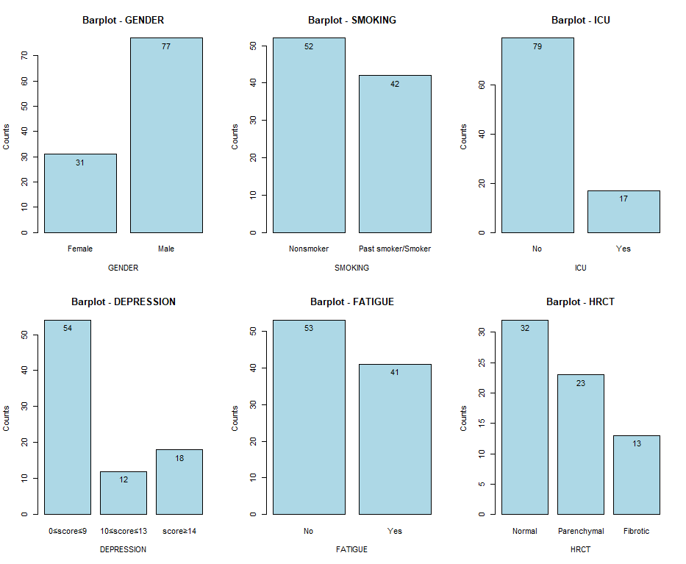

Supplementary Figure 4: Scatter plots of each continuous variables against the continuous variables in the same block and in the preceding blocks
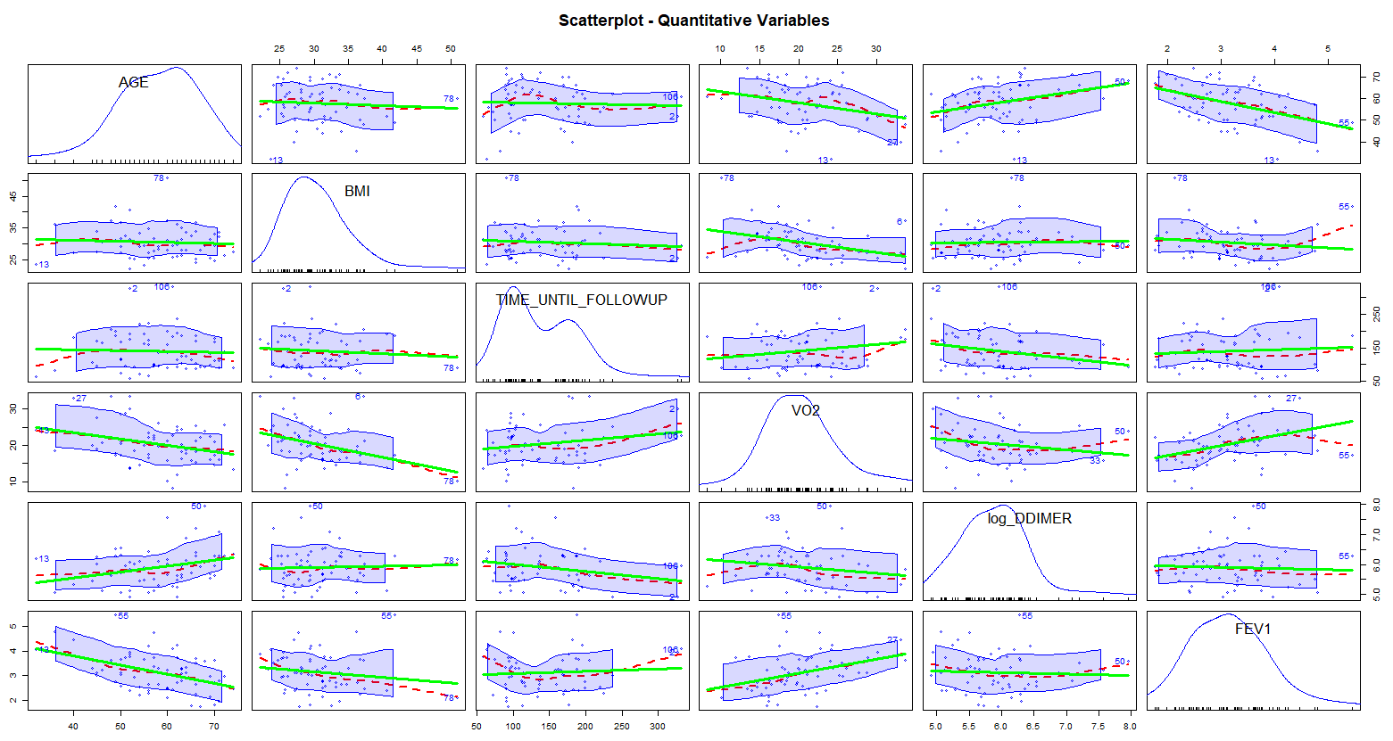

Supplementary Figure 5: Q-Q plots against normality of the continuous outcome variables, grouped according to the qualitative variables in the same block and in the preceding blocks
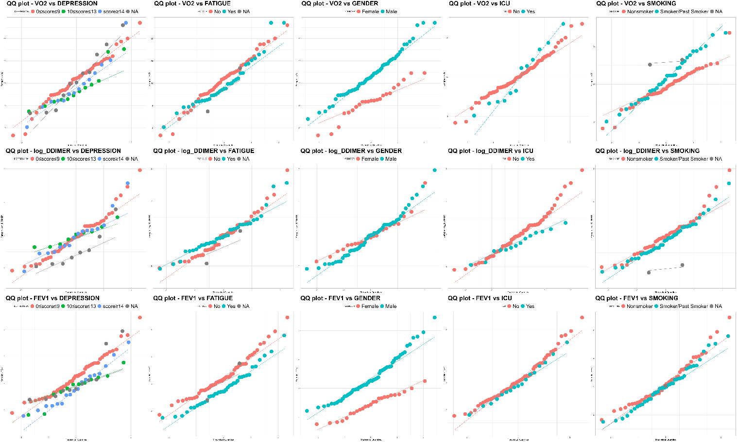

Supplementary Figure 6: Q-Q plots of the residuals of the univariate regressions of each quantitative outcome variables in block 3
