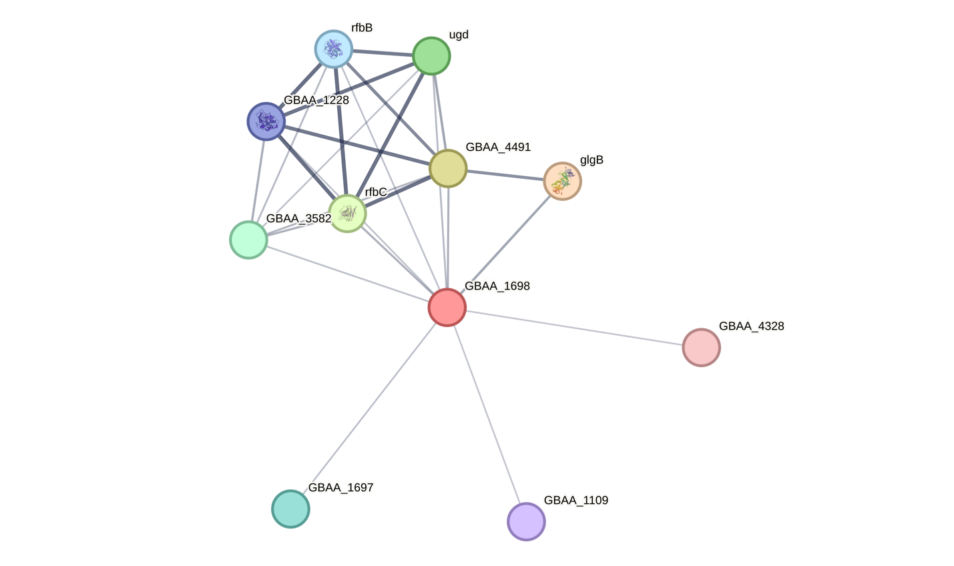

Additional file 11. Prediction of protein-protein interaction by STRING v.12.0.
GBAA_1698 (BA1698) is glycosyltransferases predicted to be physically or functionally working together with glgB, 1,4-alpha-glucan branching enzyme; rfbC, dTDP-4-dehydrorhamnose 3,5-epimerase; ugd, UDP-glucose 6-dehydrogenase; rfbB, dTDP-glucose 4,6-dehydratase; GBAA_1228, putative glucose-1-phosphate thymidylyltransferase; GBAA_4491, nucleotidyl transferase family protein; GBAA_3582, glycosyltransferase group 2 family protein; GBAA_1109, alpha/beta hydrolase; GBAA_1697 and GBAA_4328, hypothetical proteins. Line thickness indicates the strength of data support.

