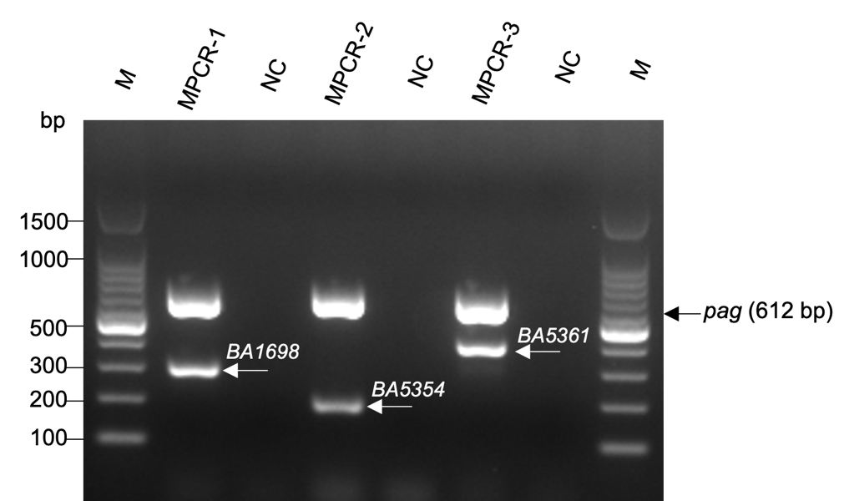

Additional file 6. Colony PCR performed directly using B. anthracis Sterne 34F2 for detecting chromosome-encoded target genes and the pag gene encoded on pXO1 plasmid. M is a 100 bp DNA ladder used as a marker. NC is no-template negative control. We used 1.5% agarose gel.

