Supplementary Tables and Figures

Supplementary Table 1. Probe and Primers for hpd Gene Detection and Serotyping of Haemophilus influenzae

Target gene | Primer or Probe Name | Real-time Primers and Probes Nucleotide Sequence (5' to 3') | Working Stock  Conc (µM) | Final Conc (nM) | Suggested Probe Modifications
hpd | hpdF822 | GGTTAAATATGCCGATGGTGTTG | 1.25 | 100
 | hpdR952 | TGCATCTTTACGCACGGTGTA | 3.75 | 300
 | Pb896i | TTGTGTACACTCCGT"T"GGTAAAAGAACTTGCAC | 1.25 | 100 | 5' FAM, BHQ1 on "T", 3' SpC6
Serotyping
Hia | F261 | GGT CTG CGG TGT CCT GTG T | 1.25 | 100
acsB | R427 | CCG GTC ATC TTT TAT GCT CCA A | 3.75 | 300
 | Pb375i | TAA TTT TCT TGC “T”CA ATA CCG CCT TCC CA | 1.25 | 100 | 5' FAM, BHQ1 on "T", 3' SpC6
Hib | F192 | TGA TGC ATT GAA AGA AGG TGT AAT TT | 3.75 | 300
bcsB | R359 | CCT GCG GTA ATA ACA TGA TCA TAA A | 7.5 | 600
 | Pb244i | TGT CGT GCA G”T”A GCA AAC CGT AAC CTT ACT C | 1.25 | 100 | 5' FAM, BHQ1 on "T", 3' SpC6
Hic | F7667 | CAT TGG TGA TGG TTC AGT TAT TGG | 7.5 | 600
ccsD | R7784 | TAC AGC ATT CAG CAA TAA TGG G | 3.75 | 300
 | Pb7726i | ATT GCA “T”CG CCG CAG GAG TTC CCG | 2.5 | 200 | 5' FAM, BHQ1 on "T", 3' SpC6
Hid | F2211 | CCT AAA ATA CGG ACC TAG TGC AC | 7.5 | 600
dcsE | R2255 | CCG ATG AGA CCA AGT ATG GTT A | 1.25 | 100
 | Pb2221i | AAC GAG C”T”A GAG CTG GTG CTG AA | 3.75 | 300 | 5' FAM, BHQ1 on "T", 3' SpC6
Hie | F1523 | ACT AAA ATA TGG CCC AAA CCC AC | 7.5 | 600
ecsH | R1589 | CCG ATG AGC CCA AGT ATG ATG A | 7.5 | 600
 | Pb1555i | AAC GAG CAA AAG CCG G”T”G CGG AT | 2.5 | 200 | 5' FAM, BHQ1 on "T", 3' SpC6
Hif | F7164 | CCC TGA AAA GCG TTG ACT TTG | 7.5 | 600
bexD | R7313 | CCA ACT TCA GGA CCA AGT CAT TC | 3.75 | 300
 | Pb7242i | TGC TGC TAA C”T”C AGA TGC ATC AGC TCC TT | 2.5 | 200 | 5' FAM, BHQ1 on "T", 3' SpC6

Note: Thermal cycler settings
1x: 50°C for 2min
1x: 95°C for 10min
40x:
95°C for 15sec
60°C for 1min

Supplementary Table 2. Genome assembly quality.

Genome ID | Contigs | Total length | Min | Max | Mean | StdDev | N50 | L50 | N90 | L90 | N95 | L95 | %GC
1 | 30 | 1870472 | 515 | 541325 | 62349 | 113699 | 244159 | 3 | 30955 | 11 | 18142 | 15 | 38.01
2 | 31 | 1818468 | 515 | 500704 | 58660 | 103574 | 171533 | 3 | 49229 | 12 | 41363 | 14 | 37.96
3 | 27 | 1779948 | 510 | 546028 | 65924 | 119951 | 250466 | 3 | 48962 | 10 | 27505 | 12 | 37.87
4 | 38 | 1774877 | 507 | 321093 | 46707 | 72812 | 137102 | 5 | 31098 | 14 | 24792 | 17 | 37.86
5 | 27 | 1814967 | 579 | 920796 | 67221 | 178031 | 920796 | 1 | 26952 | 9 | 19545 | 13 | 37.84
6 | 27 | 1899188 | 535 | 543858 | 70340 | 111590 | 155971 | 4 | 51520 | 12 | 27237 | 15 | 38.03
7 | 18 | 1830682 | 559 | 612940 | 101705 | 174556 | 433432 | 2 | 102498 | 6 | 41084 | 7 | 38.09
8 | 26 | 1853037 | 517 | 543145 | 71271 | 113361 | 134732 | 4 | 45758 | 12 | 32578 | 14 | 38.04
9 | 27 | 1776175 | 545 | 377834 | 65784 | 99765 | 240576 | 3 | 49295 | 11 | 27378 | 13 | 37.87
10 | 28 | 1856440 | 503 | 709995 | 66301 | 138874 | 234643 | 2 | 52155 | 10 | 26093 | 13 | 38.05

Supplementary Table 3. Species identification and contamination evaluation based on rMLST score.

Genome ID | rank | taxon | support | rST | species
1 | SPECIES | Haemophilus influenzae | 100% | 125160 | Haemophilus influenzae
2 | SPECIES | Haemophilus influenzae | 100% | 125160 | Haemophilus influenzae
3 | SPECIES | Haemophilus influenzae | 100% | 125169 | Haemophilus influenzae
4 | SPECIES | Haemophilus influenzae | 100% | 154450 | Haemophilus influenzae
5 | SPECIES | Haemophilus influenzae | 96% | 190900 | Haemophilus influenzae
6 | SPECIES | Haemophilus influenzae | 100% | 24211 | Haemophilus influenzae
7 | SPECIES | Haemophilus influenzae | 98% | 190910 | Haemophilus influenzae
8 | SPECIES | Haemophilus influenzae | 100% | 190917 | Haemophilus influenzae
9 | SPECIES | Haemophilus influenzae | 100% | 190918 | Haemophilus influenzae
10 | SPECIES | Haemophilus influenzae | 96% | 197931 | Haemophilus influenzae

Supplementary Figure 1. (a) Choosing high-quality, publicly available NTHi draft genomes from PubMLST to evaluate the diversity of the ten NTHi genomes in this study in the context of previously published genomes. Draft genomes were categorized as “high-quality” if they fulfilled the following criteria: 1) Total number of contigs < 250; 2) Total assembly length between 1,7 – 2,1 Mbps; 3) N50 > 25,000; 4) L50 < 25; and 5) No evidence of contamination as indicated from both total length and rMLST profile assignment (1). The complete dataset of these genomes is available in Supplementary File 1 (b) Minimum-spanning tree of the public NTHi genomes in and including ten genomes in the current study.

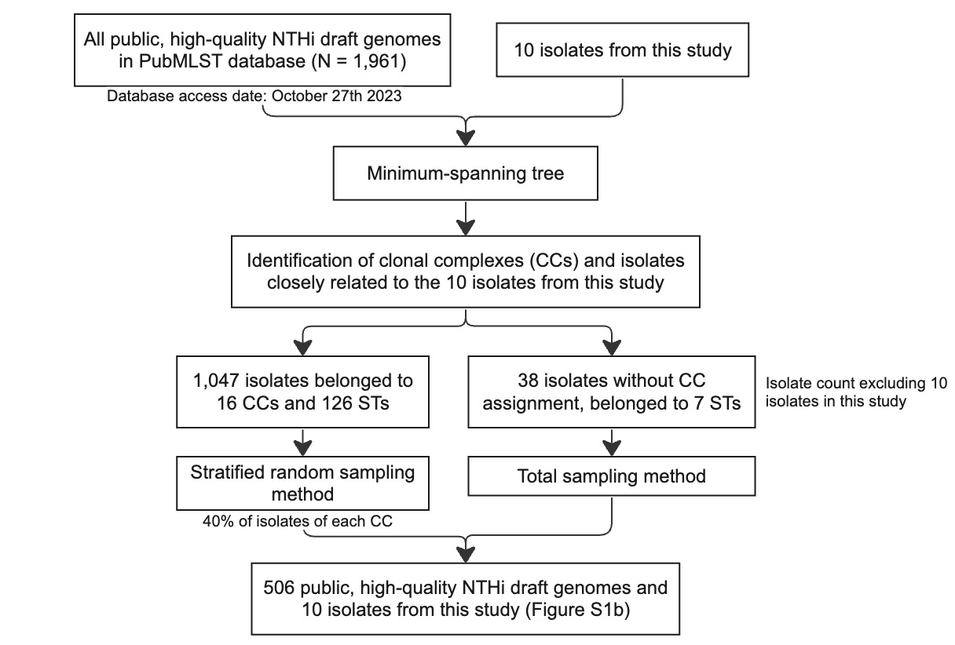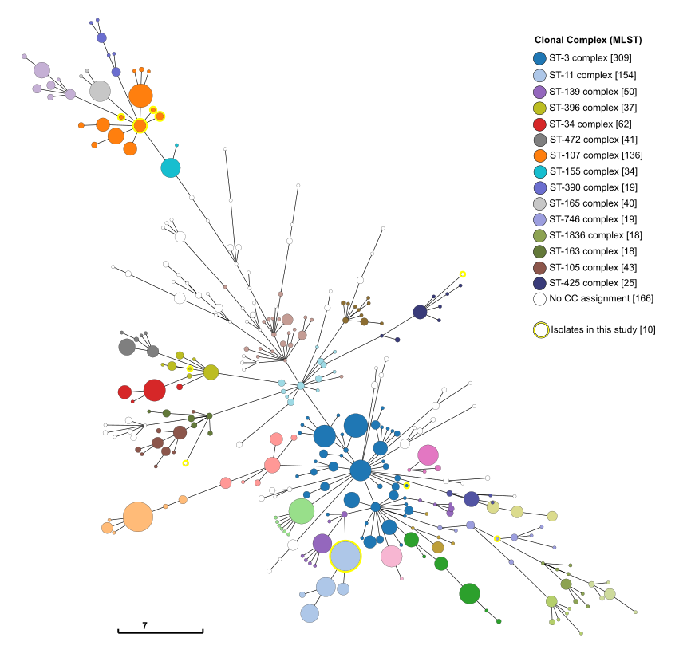
(a)
(b)

1. Tatusova T, Ciufo S, Fedorov B, O’Neill K, Tolstoy I. RefSeq microbial genomes database: new representation and annotation strategy. Nucleic Acids Res. 2014 Jan;42(Database issue):D553-559.

Supplementary Figure 2. Whole-genome alignment visualization between H. influenzae reference genome 477 and Genome ID 1.

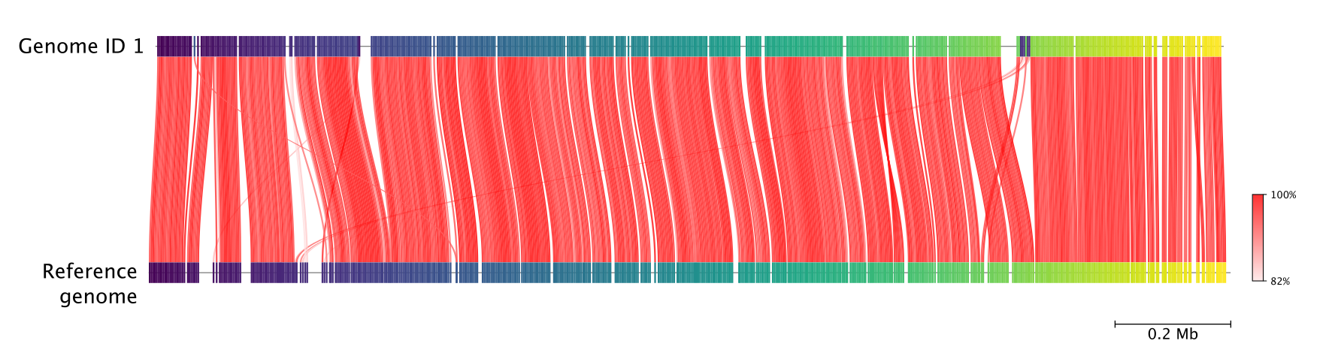

Supplementary Figure 3. H. influenzae reference genome 477 visualization as a circular genome, annotated with 1) CDS position and functional group; 2) GC skewness; 3) Specific position of 7 MLST loci and 53 rMLST loci.

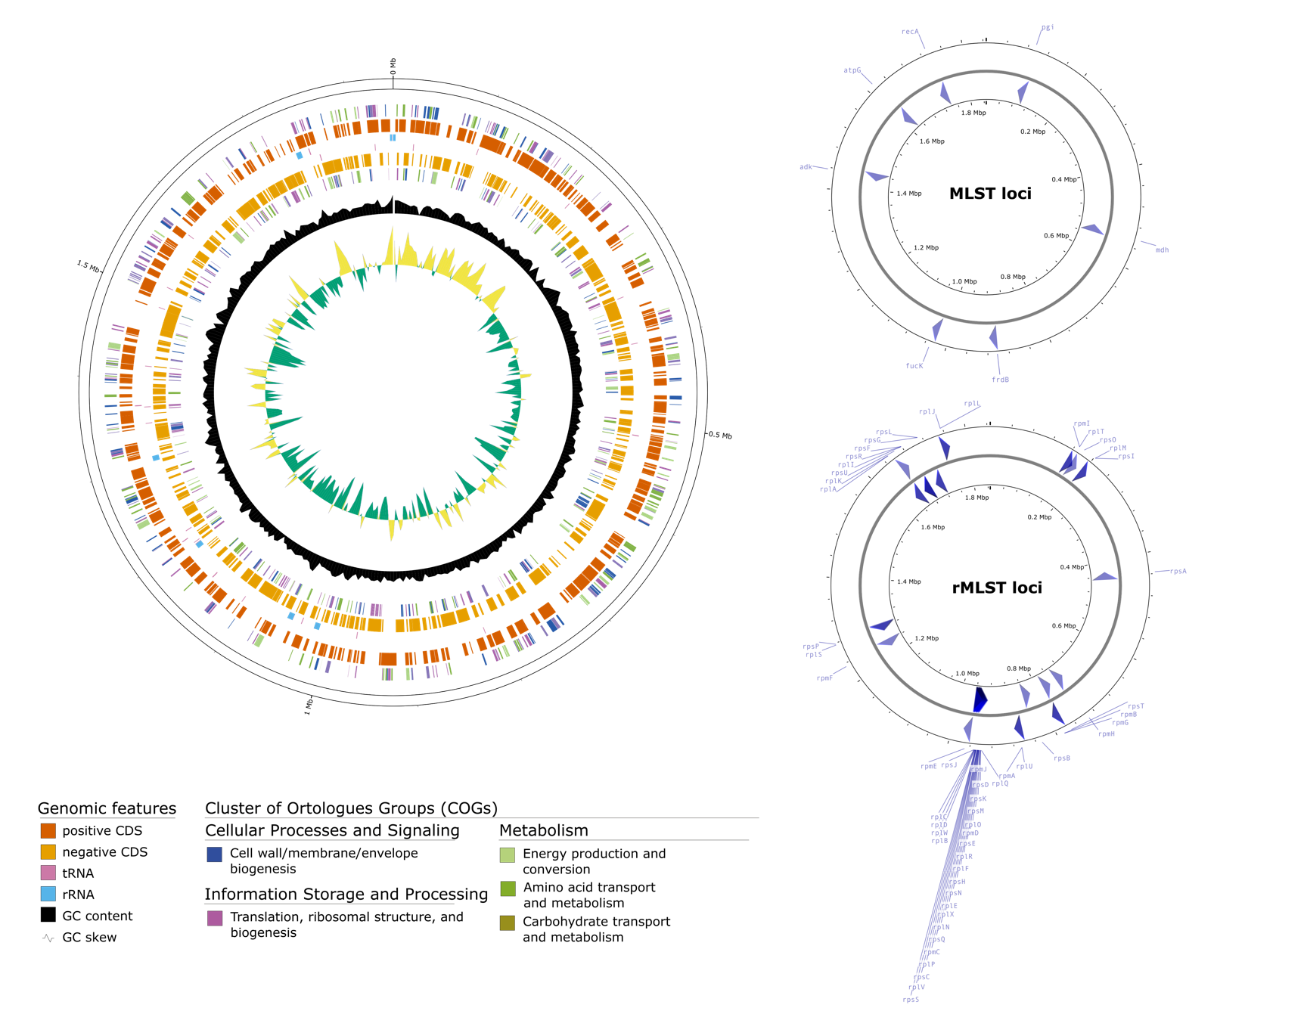

Supplementary Figure 4. Phylogeny of ten H. influenzae genomes from invasive disease isolates, annotated with virulence factors-related genes differentially present among the genomes.

