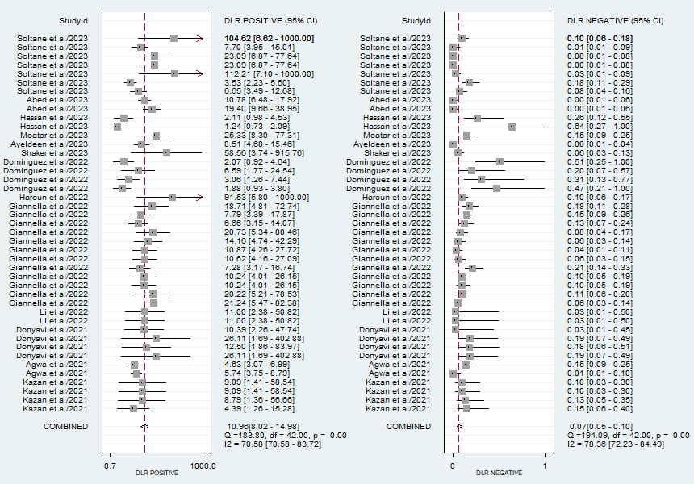
Fig A: Forest plot illustrating pooled positive likelihood ratio (PLR) and negative likelihood ration (NLR) of miRNAs in the diagnosis of COVID-19.

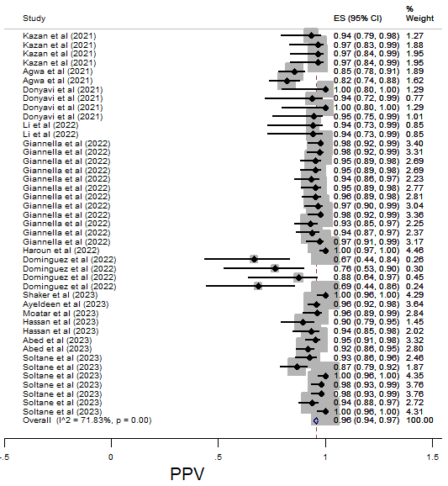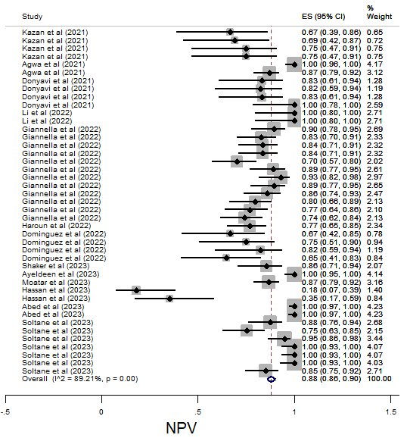
Fig B: Forest plot showing pooled positive predictive value (PPV) and negative predictive value (NPV) of miRNAs in the diagnosis of COVID-19.

