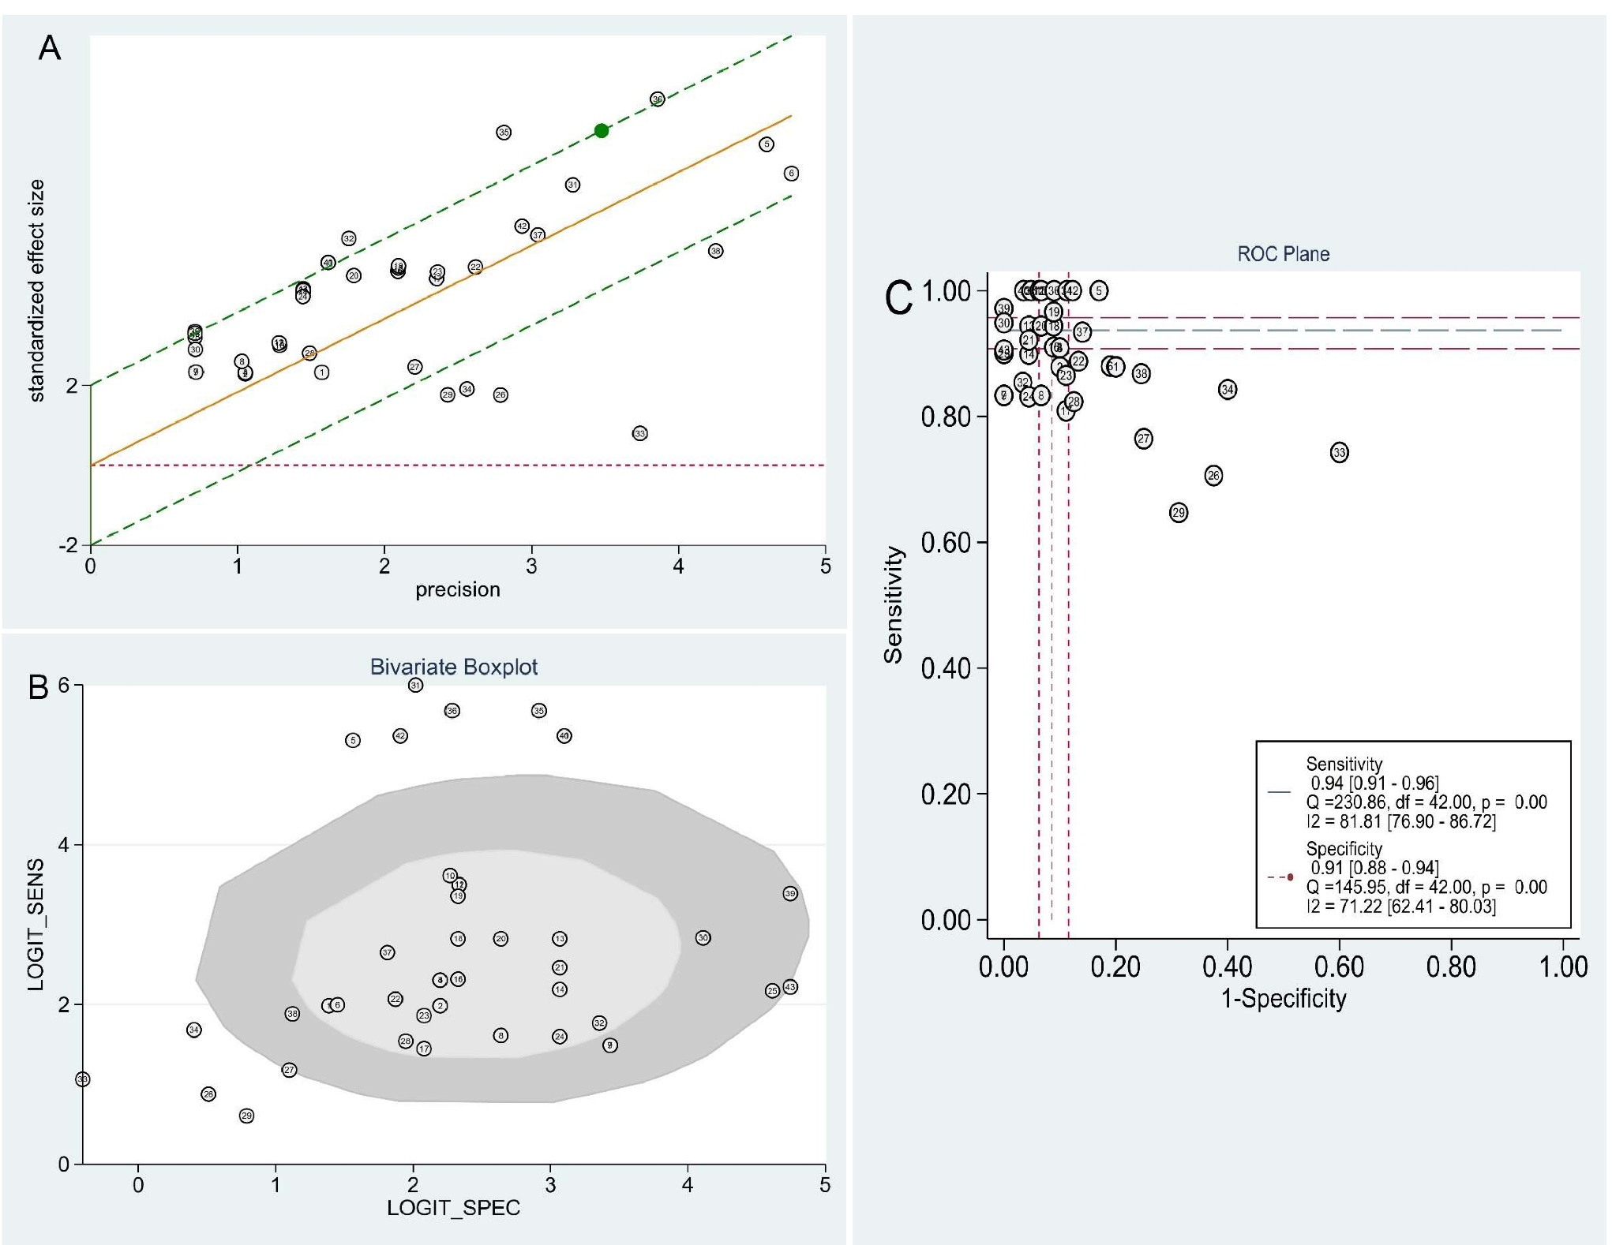
Fig: Heterogeneity assessment of included studies, illustrating (A) Galbraith star charts, (B) Bivariate boxplots, and (C) ROC plane for the assessment of threshold effect.

