1.case report
After examination, the patient developed chronic inflammatory lesions in the lower lobes of both lungs, a little effusion in the pericardium and a little effusion in the pleural cavity of both lungs. White blood cell count 13.72×109 /L↑, neutrophil count 6.56×109 /L↑, C-reactive protein 88.8 mg/L↑, Potassium 3.2 mg/L↓, sodium 131 mmol/L↓, albumin 34.4 g/L↓, aspartic aminotransferase 53 U/L, lactate dehydrogenase 365 U/L↑,Lipase 303 U/L↑, interleukin-6 169.10 ng/L↑.The patient's mental state is poor, appetite is average, sleep is average. After admission, the patients were given anti-inflammatory and anti-infective treatment, and the patients still had recurrent fever during the treatment. In order to determine the cause of fever, the whole blood was extracted for Next Generation sequencing, after obtaining the informed consent of the patient. After admission, due to the increase of white blood cells and neutrophils, blood samples were drawn for Metagenomic Next Generation sequencing after a period of antibiotic treatment.

2. Among the detected sequences, there is a sequence (TTAGGGAATACCGATCCGGTAGCCGTTTCTTCACTATCGGAATGAAGAGAAAAGCCGCTAAAATTCAAGAAGCACT) of C. burnetii, the size of which is 76pb. This sequence was subsequently aligned in GenBank using the BLAST search engine (https://blast.ncbi.nlm.nih.gov/Blast.cgi) (Figure 1).
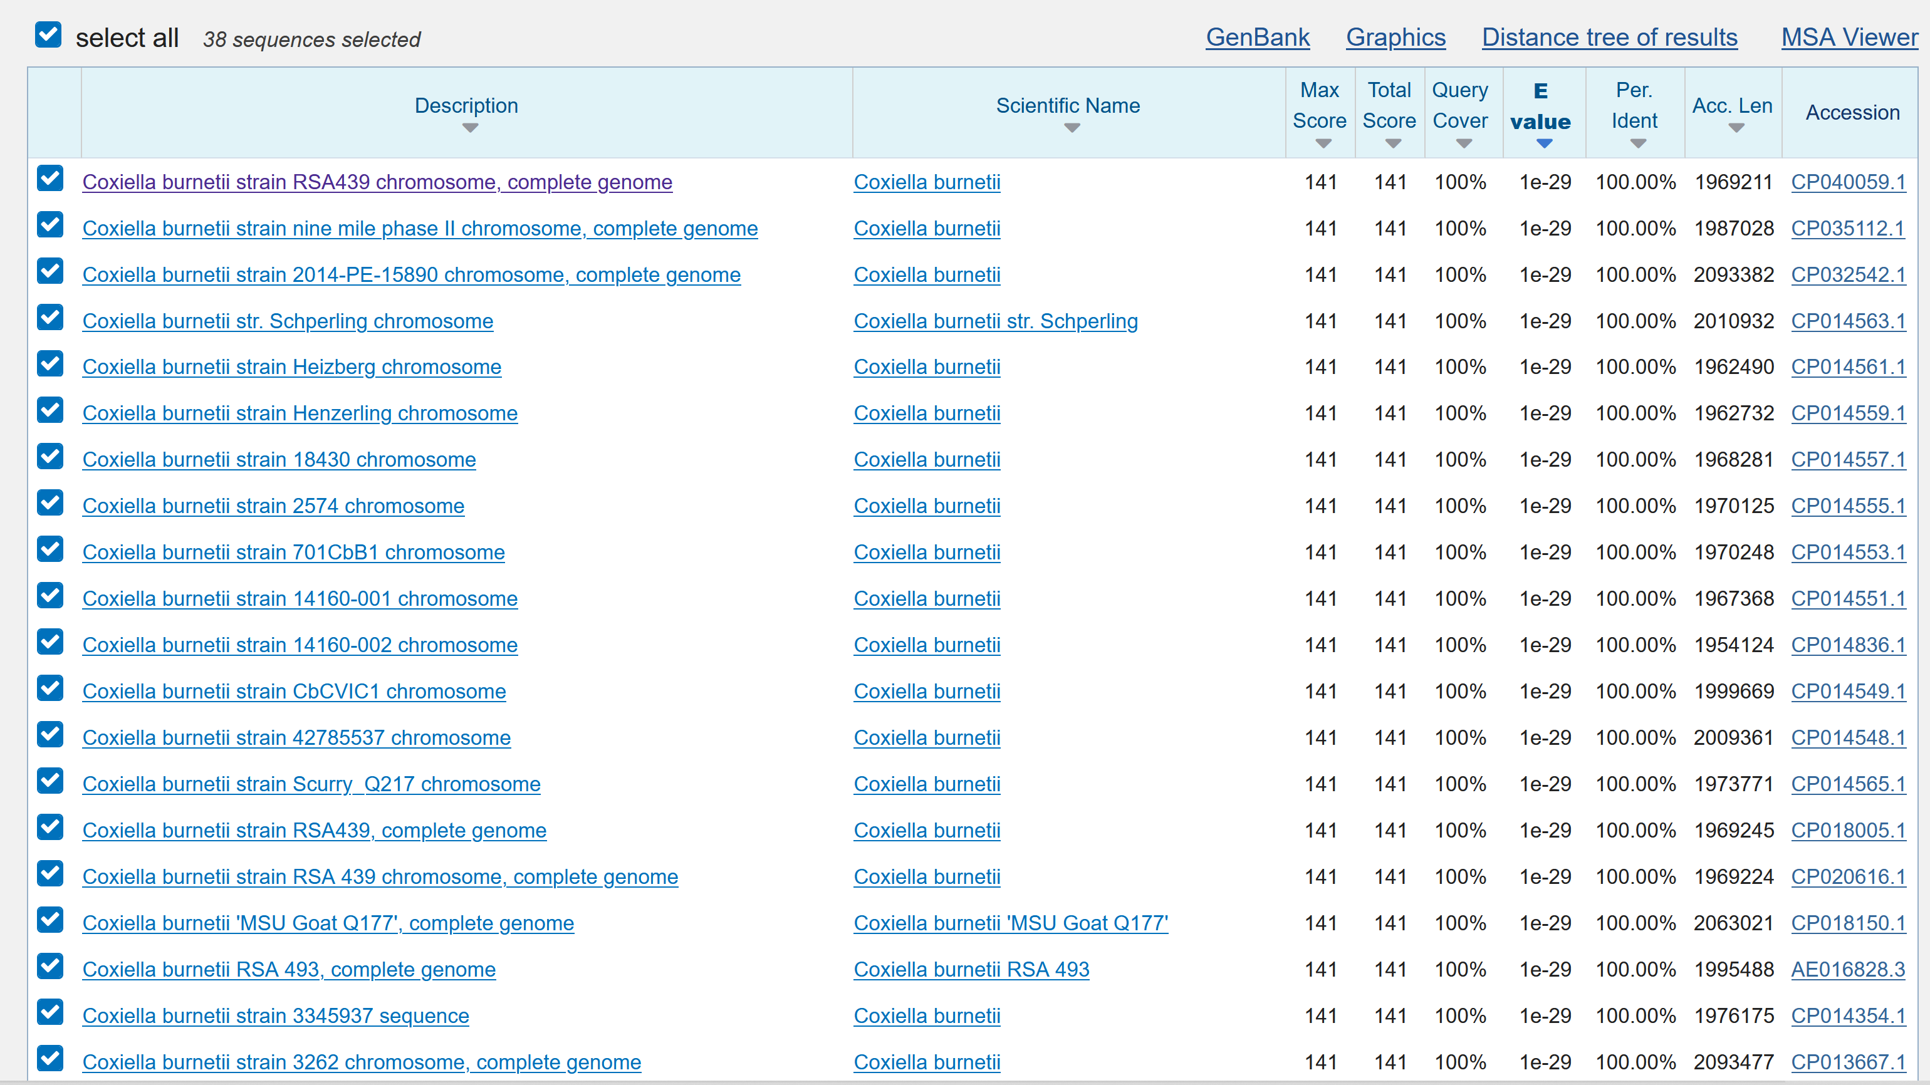
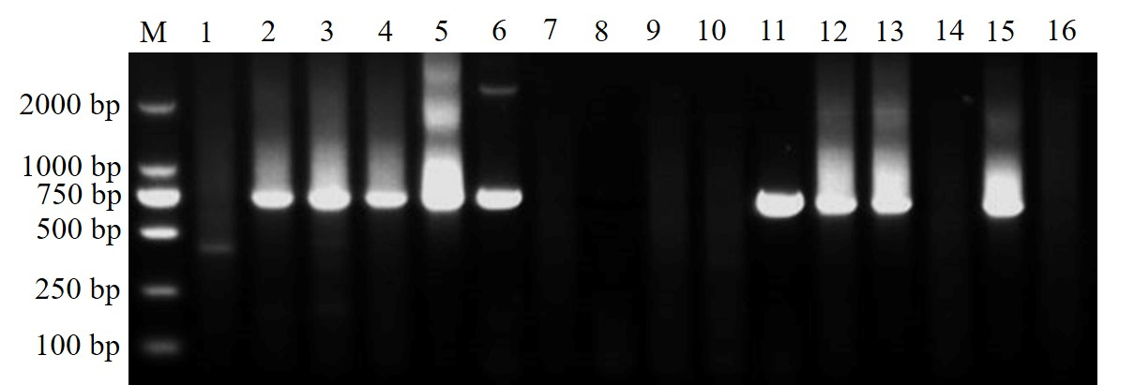
Figure S1 The sequence was subsequently aligned in GenBank using the BLAST search engine
Figure S2 Amplification results of Cox16S gene in some hedgehog ticks and hedgehog samples. M represents DL 2000 marker, lanes 1-10 are partial hedgehog tick samples, Lanes 11-16 are samples of hedgehog spleen. The target sequence is about 700 bp.

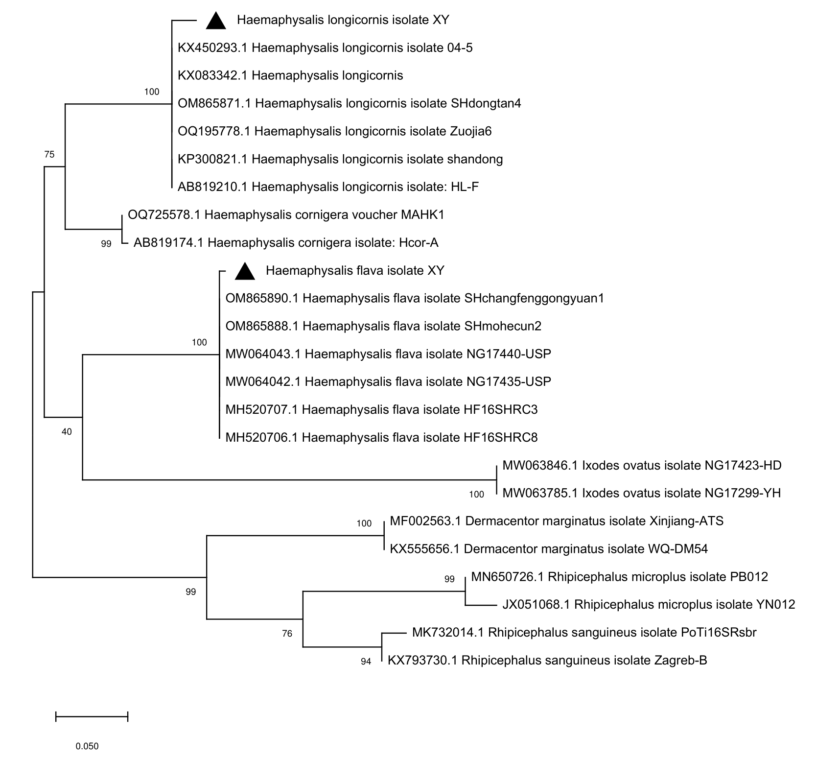
Figure S3 A phylogenetic tree based on 16S rRNA sequencing of all analyzed tick samples. Bootstrap values were calculated with 1000 replicates. Bootstrap values ≥60% were shown at branch nodes. The novel genotypes detected in this study were marked with black triangles.
Gene |  | Primers (5'-3') |  | Tm | Fragment size
Tick
 | 16S rRNA | TickHF: | GGTATTTTGACTATA CAA AGGTAT TG | 55℃ | 300bp
 |  | TickHR: | TTATTACGCTGTTATCCCTAGAGTATT
Coxiella
 | 16S rRNA | Cox16SF1 - | CGTAGGAATCTACCTTRTAGWGG | 52-56°C | 1st PCR run: Cox16SF1/Cox16SR2: 1321-1429bp
 |  | Cox16SF2 - | TGAGAACTAGCTGTTGGRRAGT |  | 2nd PCR run : Cox16SF2/Cox16SR2: 624-627bp
 |  | Cox16SR1 - | ACTYYCCAACAGCTAGTTCTCA |  | Alternative 2nd PCR run: Cox16SF1/Cox16SR1:900bp
 |  | Cox16SR2 - | GCCTACCCGCTTCTGGTACAATT
 | 23S rRNA | Cox23SF1 - | GCCTGCGAWAAGCTTCGGGGAG | 56°C | 1st PCR run: Cox23SF1/Cox23SR2: 694-1188bp
 |  | Cox23SF2 - | GATCCGGAGATWTCYGAATGGGG |  | 2nd PCR run: Cox23SF2/Cox23SR1: 583-867bp
 |  | Cox23SR1 - | TCGYTCGGTTTCGGGTCKACTC |  | Alternative 2nd PCR run: Cox23SF1/Cox23SR2: 601-884bp
 |  | Cox23SR2 - | CTCCTAKCCACASCTCATCCCC
 | GroEL | CoxGrF1 - | TTTGAAAAYATGGGCGCKCAAATGGT | 56°C | 1st PCR run: CoxGrF1/CoxGrR2: 655bp
 |  | CoxGrR2 - | CGRTCRCCAAARCCAGGTGC |  | 2nd PCR run: CoxGrF2/CoxGrR1: 619bp
 |  | CoxGrF2 - | GAAGTGGCTTCGCRTACWTCAGACG
 |  | CoxGrR1 - | CCAAARCCAGGTGCTTTYAC
 | rpoB | CoxrpoBF2 - | GGGCGNCAYGGWAAYAAAGGSGT | 56°C | 1st PCR run: CoxrpoBF2/CoxrpoBR1: 607-610bp
 |  | CoxrpoBR1 - | CACCRAAHCGTTGACCRCCAAATTG |  | 2nd PCR run: CoxrpoBF3/CoxrpoBR3: 539-542bp
 |  | CoxrpoBF3 - | TCGAAGAYATGCCYTATTTAGAAG
 |  | CoxrpoBR3 - | AGCTTTMCCACCSARGGGTTGCTG
 | dnaK | CoxdnaKF1 - | CGTCARGCRACGAARGATGCA | 54°C | 1st PCR run: CoxdnaKF1/CoxdnaKR: 777bp
 |  | CoxdnaKF2 - | GAAGTGGATGGCGARCAYCAATT |  | Alternative 1st PCR run: CoxdnaKF3/CoxdnaKR: 636bp
 |  | CoxdnaKF3 - | GGTACKTTYGATATTTCCATC |  | 2nd PCR run: CoxdnaKF2/CoxdnaKR: 603bp
 |  | CoxdnaKR - | CGTCATGAYKCCGCCYAAGG |  | Alternative 2nd PCR run: CoxdnaKF2/CoxdnaKR3: 512bp
 |  | CoxdnaKR3- | CTTGAATAGCYGCACCAATAGC
 | ompB | Omp1 | AGTAGAAGCATCCCAAGCATTG | 55℃ | 1st PCR run：Omp1/Omp2 :438bp
 |  | Omp2 | TGCCTGCTAGCTGTAACGATTG |  | 2nd PCR run :Omp3/Omp4
 |  | Omp3 | GAAGCGCAACAAGAAGAACA
 |  | Omp4 | TGGAAGTTATCACGCAGTTG
 | COX2 | COX2F | CAACCCTGAATACCCAAGGA | 55℃ | 397bp
 |  | COX2R | GAAGCTTCTGATAGGCGGGA
 | COX5 | COX5F | CAGGAGCAAGCTTGAATGCG | 55℃ | 395bp
 |  | COX5R | TGGTATGACAACCCGTCATG
 | COX18 | COX18F | CGCAGACGAATTAGCCAATC | 55℃ | 557bp
 |  | COX18R | TTCGATGATCCGATGGCCTT
 | COX20 | COX20F | GATATTTATCAGCGTCAAAGCAA | 55℃ | 631bp
 |  | COX20R | TCTATTATTGCAATGCAAGTGG
 | COX22 | COX22F | GGGAATAAGAGAGTTAGCTCA | 55℃ | 383bp
 |  | COX22R | CGCAAATTTCGGCACAGACC
 | COX37 | COX37F | GGCTTGTCTGGTGTAACTGT | 55℃ | 463bp
 |  | COX37R | ATTCCGGGACCTTCGTTAAC
 | COX51 | COX51F | TAACGCCCGAGAGCTCAGAA | 55℃ | 674bp
 |  | COX51R | GCGAGAACCGAATTGCTATC
 | COX56 | COX56F | CCAAGCTCTCTGTGCCCAAT | 55℃ | 479bp
 |  | COX56R | ATGCGCCAGAAACGCATAGG
 | COX57 | COX57F | TGGAAATGGAAGGCGGATTC | 55℃ | 617bp
 |  | COX57R | GGTGGAAGGCGTAAGCCTTT
 | COX61 | COX61F | GAAGATAGAGCGGCAAGGAT | 55℃ | 611bp
 |  | COX61R | GGGATTTCAACTTCCGATAGA
Table S1 Primers for the amplification of sequences

Table S2 IgM test results of serum samples from febrile patients
 | 1 | 2 | 3 | 4 | 5 | 6 | 7 | 8 | 9 | 10 | 11 | 12
A | 0.041 | 0.001 | 0.774 | 0.729 | 1.472 | 0.046 | 0.514 | 0.161 | 0.255 | 0.179 | 0.151 | 0.277
B | 0.142 | 0.305 | 0.198 | 0.113 | 0.13 | 0.279 | 0.874 | 0.143 | 0.093 | 0.09 | 0.146 | 0.171
C | 0.197 | 0.194 | 0.126 | 0.183 | 0.091 | 0.132 | 1.123 | 0.153 | 0.141 | 0.204 | 0.094 | 0.278
D | 0.217 | 0.157 | 0.094 | 0.995 | 0.105 | 0.365 | 2.835 | 0.219 | 0.182 | 0.292 | 0.407 | 0.179
E | 0.604 | 0.205 | 0.226 | 0.117 | 0.103 | 0.184 | 0.284 | 0.155 | 0.142 | 0.076 | 0.128 | 0.117
F | 0.075 | 0.152 | 0.65 | 0.154 | 0.234 | 0.174 | 0.218 | 0.122 | 0.183 | 0.149 | 0.265 | 0.336
G | 0.303 | 0.21 | 0.182 | 0.068 | 0.207 | 0.123 | 0.26 | 0.338 | 0.192 | 0.333 | 0.118 | 0.479
H | 0.163 | 0.21 | 0.232 | 0.235 | 0.432 | 0.34 | 0.231 | 0.468 | 0.075 | 0.192 | 0.146
A1 is Negative control, A2 is substrate blank, A3 and A4 are Cut-off control, A5 is Positive control, yellow are positive.

