Supplemental material
R code for sample size estimates
p = 0.87 ### lowest expected success ratio of worst performing hcvst samplesize = 200
nn = 100000 #### a large population from which we draw our sample
dta = as.data.frame(matrix(NA, nrow = nn, ncol=1)) # data frame to fill
dta[,1] = c(1:n) #### row id
names(dta) = "id"
dta$hcvst <- rbinom(nrow(dta), 1, p) # for each individual, success of hcvst given p
s = 2000 #### number of simulations
B = as.data.frame(matrix(NA, nrow = s, ncol = 5))
for (i in 1:s){
print(i)
sample = sample(1:nn, samplesize, replace=F)
newdata = dta[sample,]
B[i,1] = mean(newdata$hcvst)
x = prop.test(round(sum(newdata$hcvst), 0), nrow(newdata), conf.level = 0.9)
xx = binom.test(round(sum(newdata$hcvst), 0), nrow(newdata), 0.8, conf.level = 0.95,alternative = "greater")
B[i,2] = x$conf.int[1]
B[i,3] = x$conf.int[2]
B[i,4] = ifelse(x$conf.int[1]> 0.8, 1, 0)
B[i,5] = ifelse(xx$p.value < 0.05, 1, 0)}
summary(B)

Figure 1 Pictorial instructions for use (IFU) that were purposively developed for this study. They are complemented by short sentences in Urdu, the national language. In blue is the English translation.
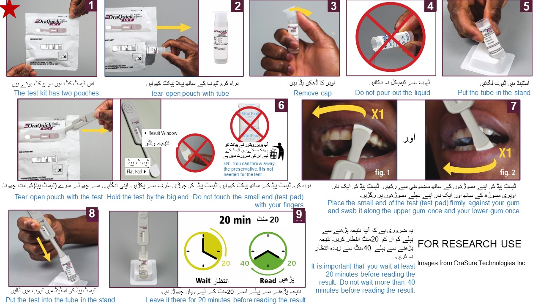

Figure 2 Pictorial instructions for result interpretation. They are complemented by short sentences in Urdu, the national language. In blue is the English translation.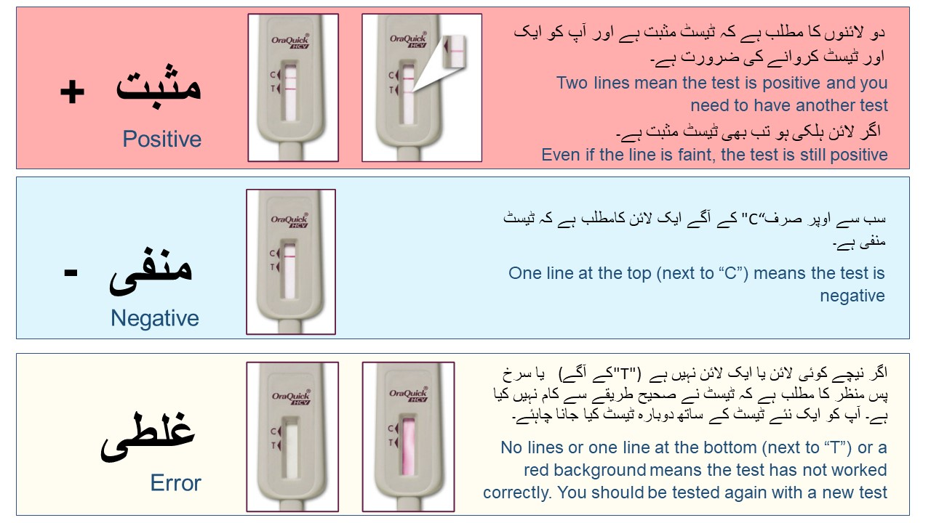

Annex 1 Self-test questionnaire
- Individual ID:
- Have you been tested for HCV before?
$□$ Yes; $□$ No; $□$ Don’t Know
- If yes, what was the year of your last test?
- Sex:
$□$ Male; $□$ Female
- Age in years:
- What level of schooling did you reach?
$□$ No schooling; $□$ Madrassa; $□$ Some primary school; $□$ Completed primary school; $□$ Middle school; $□$ Some secondary school; $□$ Completed secondary school; $□$ Post secondary course (university, diploma etc); $□$ Prefer not to say
- Are you able to read this line of Urdu out loud to me: “Today we are testing for a disease of the liver that can affect people of any age.”?
$□$ Read aloud with no errors; $□$ Read aloud with errors on one or two words; $□$ Only a few words correctly read aloud; $□$ Cannot read any words aloud; $□$ Reports unwilling to read aloud.
Saliva-based test
- Checklist (record when observed):
$□$ Sanitised hands without intervention; $□$ Opened box; $□$ Read instructions; $□$ Removed test from pouch; $□$ Removed cap from vial; $□$ Placed vial in stand; $□$ Completely swabbed around upper part of gum; $□$ Completely swabbed around lower part of gum; $□$ Inserted device into the buffer solution; $□$ Checked time at start of test; $□$ Test fluid ran across strip; $□$ Discarded test in waste bag; $□$ Put cap on vial and discarded in waste bag
- Faults (record when observed):
$□$ Touched swab with fingers; $□$ Swabbed too deep in mouth (behind teeth); $□$ Limited swabbing upper mouth; $□$ Limited swabbing upper mouth; $□$ Used equipment not put in waste bags; $□$ Dropped test kit on floor; $□$ Dropped vial on floor; $□$ Difficulty adding vial to stand; $□$ Spilled buffer in work site; $□$ No mistakes observed; $□$ Other (specify)
- What single thing would you say the participant found most difficult (select one):
$□$ Opening test kit; $□$ Opening vial; $□$ Adding vial to test stand; $□$ Collecting saliva sample; $□$ Adding test to buffer; $□$ They didn’t seem to face any difficulties; $□$ Other (specify)
- Did you have to provide additional verbal assistance in any of the following steps (select all that apply):
$□$ Familiarising with instructions; $□$ Identifying test kit; $□$ Identifying vial; $□$ Identifying rack; $□$ Opening test kit; $□$ Opening vial; $□$ Collecting saliva sample; $□$ Adding test kit to buffer; $□$ Managing waste; $□$ Other (specify)
- Did you have to provide direct assistance in any of the following steps (select all that apply):
$□$ Collecting saliva sample; $□$ Adding sample to buffer; $□$ Other (specify)
To the participant:
- How confident do you feel that you performed the test correctly (select one)?
$□$ I feel very confident that I did everything right;$□$ I think I did most things right;$□$ I think I got several things wrong;$□$ I think I got most things wrong
- Do you think the written instructions are easy or difficult to understand (select one)?
$□$ Very easy; $□$ Easy; $□$ Difficult; $□$ Very difficult; $□$ Didn’t read them
- Do you have any specific recommendations on how we can improve the written instructions?
- Do you think the pictures are easy or difficult to follow (select one)?
$□$ Very easy; $□$ Easy; $□$ Difficult; $□$ Very difficult; $□$ Didn’t read them
- Do you have any specific recommendations on how we can improve the picture-based instructions?
- How difficult or easy did you find each of the following steps:
- Opening test kit (select one):
$□$ Very difficult; $□$ Difficult; $□$ Slightly difficult; $□$ Slightly easy; $□$ Easy; $□$ Very easy
- Opening the vial (select one):
$□$ Very difficult; $□$ Difficult; $□$ Slightly difficult; $□$ Slightly easy; $□$ Easy; $□$ Very easy
- Adding vial to stand (select one):
$□$ Very difficult; $□$ Difficult; $□$ Slightly difficult; $□$ Slightly easy; $□$ Easy; $□$ Very easy
- Collecting saliva sample (select one):
$□$ Very difficult; $□$ Difficult; $□$ Slightly difficult; $□$ Slightly easy; $□$ Easy; $□$ Very easy
- Adding test kit to vial (select one):
$□$ Very difficult; $□$ Difficult; $□$ Slightly difficult; $□$ Slightly easy; $□$ Easy; $□$ Very easy
Questions to participant after saliva HCVST test performed
- Overall, would you describe this test as difficult or easy to perform (select one)?
$□$ Very difficult; $□$ Difficult; $□$ Slightly difficult; $□$ Slightly easy; $□$ Easy; $□$ Very easy
- Do you think you could perform this test by yourself at home without anyone there to support you?
$□$ Yes $□$ No $□$ Don’t know
- Do you think you could read the results alone?
$□$ Yes; $□$ No; $□$ Don’t know
- If the test was free of charge and could be collected from the clinic or delivered to your home, do you think you would use self-testing in the future? $□$ Yes; $□$ No; $□$ Don’t know
- Would you recommend self-testing to a friend or family member?
$□$ Yes; $□$ No; $□$ Don’t know (If no or don’t know, why?)
- What do you think are the advantages of self-testing for hepatitis C?
$□$ Privacy; $□$ No need to come to a clinic; $□$ I can test myself anytime; $□$ Not sure; $□$ Other (specify)
- Which are the disadvantages of self-testing for hepatitis C?
$□$ Difficult to perform; $□$ Low confidence in results; $□$ No counselling; $□$ Don’t know; $□$ Other (specify)
- If you could do a test at home that was similar to the one you performed today but used a saliva sample from your mouth [blood sample from a small prick to your finger] rather than blood [saliva], would that be preferable?
$□$ Yes; $□$ No; $□$ Don’t know
- If you were tested for HCV in the future, which of the following would be your preference for where and how the test is done:
$□$ At home by myself; $□$ At home by a family member or friend; $□$ At home by a visiting health care worker; $□$ By myself in a private place outside my home; $□$ At the MSF clinic or another clinic close to my home; $□$ Other (specify)
Reading results
- What result does the participant report?
$□$ Positive; $□$ Negative; $□$ Invalid
- What is the correct result?
$□$ Positive; $□$ Negative; $□$ Invalid
What is the result of the clinic test (performed by MSF staff)?
$□$ Positive; $□$ Negative; $□$ Invalid

