RSM01, a Novel Respiratory Syncytial Virus Monoclonal Antibody: Preclinical Characterization and Results of a First-in-Human, Randomised Clinical Trial
Aurelio Bonavia^{1*}, Micha Levi^{1*†}, Harald Rouha², Adriana Badarau², Jonne Terstappen³, Shayne Watson¹, Aparna B. Anderson¹, Joleen T. White¹, Jintanat Ananworanich¹, Dale Taylor⁴, Andrijana Radivojevic ⁵, Michael Shaffer¹, Luisa M. Stamm¹, Michael W. Dunne¹
¹Bill & Melinda Gates Medical Research Institute, Cambridge, MA, United States
²Arsanis Biosciences, Vienna, Austria
³Center for Translational Immunology, University Medical Centre Utrecht, Utrecht, The Netherlands
⁴PPD Inc, Orlando, FL, United States
⁵intiGROWTH LLC, Miami, FL, United States
*These authors contributed equally to this work
†Correspondence:
Micha Levi
Clinical Pharmacology Leader
Bill & Melinda Gates Medical Research Institute, Cambridge, MA, United States
Email: micha.levi@gatesmri.org
Phone: +1-201-953-5699

Supplementary Information

Methods
RSM01 epitope mapping
Peptides were immobilised on streptavidin sensors (FortèBio, Pall Life Sciences). Association and dissociation of the monoclonal antibodies (100 nM or 5000 nM) to the immobilised peptide in the assay buffer (PBS plus 0. 1% BSA) were monitored for 5 min each. Response units (RU) and equilibrium dissociation constants (Kd) were determined using the Data Analysis 7 software (FortéBio, Pall Life Sciences) by simultaneously fitting the association and dissociation curves to a 1:1 binding model. RU was > 0.05 for peptide binding.
In vitro microneutralisation assay
Virus neutralisation assays were performed in 96-well plates using Hep-2 cells (ATCC-CCL23) for all strains except RSV-B1 (Vero C1008, ECACC #85020206) and the RSV-B Wash/18537 strain obtained from Sigmovir (M104 cells, ECACC #85102918). Cells were cultured in MEM (Gibco) supplemented with antibiotic-antimycotic (Gibco) and fetal bovine serum (FBS, Sigma; 5% in culture/seeding medium, 2.5% during assay incubation and 0% during the virus adsorption step).
All comparator and test antibodies were expressed in CHO cells [based on publicly available sequence data for comparators] and purified by protein A affinity chromatography. Antibodies were serially diluted in non-supplemented MEM and preincubated with virus diluted in MEM on ice. The optimal infection inoculum based on virus infectivity/titer was pre-determined for each viral strain and stock used. A CHO expressed negative control antibody directed against a non-viral, unrelated antigen was included in all experiments.
Cells were harvested by trypsinization, pelleted and resuspended through a 21G needle and diluted in MEM supplemented with 5% FBS to a final concentration of 3 x 10E5/mL (Hep-2, MA104) or 2 x 10E5/mL (Vero). 100 μL of the cell suspension was then added to each well, resulting in a total assay volume of 200 μL/well and a FBS concentration of 2.5%.
Each assay plate included an untreated control (no virus or monoclonal antibody) and “virus only” control – to allow monitoring of cell monolayer integrity and virus induced cytopathic effect (CPE). Plates were incubated at 33°C or 37°C and 5% CO2 for 4 to 6 days, depending on the isolate. Following incubation, medium was aspirated, and cells were washed twice with PBS and fixed with 80% acetone/PBS.
Air-dried cells were washed with PBS supplemented with 0.1% Tween-20 (PBS-T) and blocked with 1% non-fat dry milk in PBS (blocking buffer) for 1 hour at RT. Cells were then stained with goat-derived, polyclonal-anti-RSV antibody (BioRad #7950-004, 1:100 in blocking buffer) for 1 hour at 37°C. Following 3 washing steps with PBS-T to remove unbound antibody, cells were incubated with HRP conjugated secondary antibody (HRP conjugated donkey-anti goat IgG, Southern Biotech #6420-05, 1:2500 in blocking buffer) for 30 min at 37°C. Cells were then washed again 3x with PBS-T, followed by addition of 50 μL/well TMB substrate (ThermoFisher Scientific, #34209). The enzymatic reaction was stopped after 10 minutes by addition of 50 μL/well 1M HCl. Absorbance at 450 nm was measured using a Synergy™ HT Multi-Mode Microplate Reader (BioTek). EC50 values were calculated by non-linear regression analysis using GraphPad Prism 6.0 software (GraphPad Software, La Jolla, CA, USA).
Epitope conservation
Only proteins between 510 and 590 amino acid sequences in length were downloaded to limit the search to near full length protein sequences. Prior to alignment, any sequences with unknown (X) amino acids at any position were removed. From the RSV-A lineage 6,166 proteins (retrieved on Apr 4, 2024) were aligned and from the RSV-B lineage 5,871 proteins were aligned (retrieved on May 7, 2024). The lineages were aligned separately using Clustal Omega (version 1.2.4) with default parameters. After alignment, columns with gaps in greater than 5,000 sequences were removed from analysis and AA positions were manually inspected to ensure positions matched to canonical positions. Amino acids which did not match the consensus at each position were reported as variants.
Generation of MARMs
HEp-2 cells (ATCC® CCL-23) were cultured in MEM (Gibco) supplemented with antibiotic-antimycotic (Gibco) and fetal bovine serum (5% for seeding medium, 2.5% during assay incubation and 0% for the virus adsorption step) at 37°C, 5% CO₂. For the initial infection, cells were seeded at 5x10⁵ cells/well in 6-well plates in 3 mL medium. Following overnight incubation, virus and antibody were pre-mixed in serum free medium and pre-incubated for 30 min at 37°C, in 1.5 mL microcentrifuge tubes. Growth medium was aspirated, and the cell monolayer was washed in serum free medium. One mL of the antibody/virus suspension was then transferred to each well for the initial infection. After 2.5 hours, the infection inoculum was removed and replaced with 3 mL assay medium supplemented with antibody. A “no-antibody control” and a mock control was included in all experiments. The presence of cytopathic effect (CPE) was assessed daily using light microcopy. 3 days after infection (when CPE became visible in the control sample), the content from each well was lysed by two freeze/thaw cycles in 600 µL 25% sucrose solution in PBS. Cellular debris was removed by centrifugation in 1.5 mL tubes (800 x g, 4°C, 10 min). The cleared lysate was aliquoted and stored at -80°C and/or immediately used for the next infection round. The selection process was repeated 7 more times (8 rounds in total). Samples with visible CPE were subjected to RNA extraction using the Aurum total RNA Mini kit (Bio-Rad) following the manufacturer’s instructions. Eluted RNA was reverse transcribed into cDNA using an iScript cDNA Synthesis Kit (Bio-Rad). The F-protein sequence was then amplified using a Phusion High-Fidelity PCR Mastermix (Thermo Scientific), purified by gel extraction (QIAquick Gel Extraction Kit, Qiagen) and subjected to sequencing. Sequences were analyzed using CLC workbench 6.
Cotton rat animal model – plaque assay
Lung and nasal homogenates from cotton rats were clarified by centrifugation and diluted in Eagle’s Minimum Essential Medium (EMEM). Confluent HEp-2 monolayers were infected in duplicate with diluted homogenates in 24 well plates. After one hour of incubation at 37°C in a 5% CO₂ incubator, wells were overlaid with 0.75% methylcellulose medium. After 4 days of incubation (6 days for RSV B), the overlay was removed, and the cells fixed with 0.1% crystal violet stain for one hour and then rinsed and air dried. Plaques were counted and virus titer expressed as PFUs per gram of tissue. Viral titers were calculated as geometric mean plus standard error for all animals in a group at a given time.
Human FcγR binding assay
Binding of test antibodies to human FcγRs (FcγRI, FcγRIIA [both 167R and 167H polymorphisms], FcγRIIB, FcγRIIIA [both 176F and 176V polymorphisms] and FcγRIIIB) was assessed by single cycle analysis using a Biacore™ T200 Surface Plasmon Resonance (SPR) instrument running at a flow rate of 30 μl/min. Data were analysed using Biacore T200 Evaluation Software (Cytiva, Uppsala, Sweden)
Simulation of RSM01 PK in infant populations
PK profiles in serum were simulated for three different input doses (50 mg, 25 mg, and 10 mg) administered via the intramuscular (IM) route. Two distinct synthetic population scenarios were examined: North American and African infants. The proportion of virtual participants surpassing the presumed serum threshold concentration of 6.8 μg/mL [1, 2] was calculated across all scenarios and input dose amounts [3]. Additionally, the total time to cross the concentration threshold for 50% of participants within each age group was simulated to estimate the persistence of RSM01 concentration.
Extrapolation of PK for North American Infants
Data from the National Health and Nutrition Immunization Survey (NHANES) were used to generate age-specific synthetic cohorts of 100 participants [4]. Individual weight values were utilised in the allometric scaling method described by Mahmood to determine appropriate clearance (CL) rate values for RSM01 in serum [5].
Extrapolation of PK for African Infants
Distributions for African infants was simulated using age-specific population weight statistics of Nigerian children (males and females) [6, 7]. For each age group, samples of 50 males and 50 females were sampled from a normal distribution with mean and standard deviation values corresponding to the specific age group. These virtual participants were considered representative of the African infant population.
Assembly of the analysis dataset was performed using Statistical Analysis System (SAS®). Population pharmacokinetic modeling was performed using nonlinear mixed-effects modeling (NONMEM®) Version 7.4.3 (ICON, Hanover, MD, US), a software package for nonlinear mixed-effects analysis. R Version 4.2.0 or higher was used for graphical analyses, model diagnostics, statistical summaries, and simulations.

References
1. Zhu Q, McLellan JS, Kallewaard NL, Ulbrandt ND, Palaszynski S, Zhang J, Moldt B, Khan A, Svabek C, McAuliffe JM: A highly potent extended half-life antibody as a potential RSV vaccine surrogate for all infants. Science translational medicine 2017, 9(388):eaaj1928.
2. Jorgensen SC: Nirsevimab: review of pharmacology, antiviral activity and emerging clinical experience for respiratory syncytial virus infection in infants. Journal of Antimicrobial Chemotherapy 2023, 78(5):1143-1149.
3. V P, MP G, K S: Population pharmacokinetic modeling of MEDI8897, an extended half-life monoclonal antibody, and dose prediction in preterm and full-term infants to prevent lower respiratory tract infection due to respiratory syncytial virus. In: Conference on Pharmacometrics 2018; San Diego; 2018.
4. Centers for Disease Control and Prevention (CDC), National Center for Health Statistics (NCHS), National Health and Nutrition Examination Survey Data. Hyattsville, MD, US Department of Health and Human Services, Centers for Disease Control and Prevention,1999-2004. [https://www.cdc.gov/growthcharts/cdc-growth-charts.htm]
5. Mahmood I: Dosing in children: a critical review of the pharmacokinetic allometric scaling and modelling approaches in paediatric drug development and clinical settings. Clinical pharmacokinetics 2014, 53:327-346.
6. Normal weight for African (Nigerian) boys. Weight for African (Nigerian) Boys [https://stats.areppim.com/stats/stats_weightboysng.htm]
7. Normal weight for African (Nigerian) boys. Weight for African (Nigerian) Girls [https://stats.areppim.com/stats/stats_weightgirlsng.htm]

Supplement Tables

Supplement Table 1. Sample collection timepoints for PK, ADA, and RSV-neutralising antibodies assessment
Nominal sampling time | Analyte
Nominal sampling time | RSM01 | ADA | RSV Neutralising
D1 Prior to first dose | All cohorts | All cohorts | All cohorts
D1 (5 min) | Cohorts 1, 3, 4
D1 (8 hr) | Cohorts 1-4
D2 (24 hr) | Cohorts 1-4
D3 (2 day) | Cohorts 1-4
D6 (5 day) | Cohorts 1-4
D8 (1 wk) | All cohorts
D15 (2 wk) | Cohorts 1-4 | Cohorts 1-4
D29 (4 wk) | All cohorts | All cohorts
D61 (2 mo) | Cohorts 1-4 | Cohorts 1-4
D91 (3 mo) | All cohorts | All cohorts | All cohorts
D121 (4 mo) | Cohorts 1-4 | Cohorts 1-4
D151 (5 mo) | All cohorts | All cohorts | All cohorts
Dose escalation phase included cohorts 1-4. Dose escalation cohort 5 is included in all cohorts. ADA anti-drug antibody, RSV respiratory syncytial virus

Supplement Table 2. Sequence variation in the RSV-F protein in tested RSV-A and RSV-B viruses
Please see excel file Supplement Table 2.xlsx

Supplement Table 3. EC50 of RSV mABs against a panel of RSV-A and -B viruses
Please see excel file Supplement Table 3.xlsx

Supplement Table 4. Relative potency increases of RSM01 versus nirsevimab and palivizumab against a RSV-A and -B viruses
Virus Strains | Potency increases of RSM01 relative to nirsevimab | Potency increases of RSM01 relative to palivizumab
RSV-A
A2 | 2 | 98
Long | 2 | 108
02-000110 | 2 | 94
05-000417 | 2 | 65
09-000457 | 3 | 61
10-002012 | 3 | 196
11-005406 | 2 | 96
12-048900 | 3 | 82
13-005275 | 2 | 85
15-007040 | 2 | 51
15-052644 | 2 | 85
RSV-B
B1 | 1 | 3
9320 | 3 | 33
Wash/18537 (Military) | NE* | 8
Wash/18537 (ATCC) | 10 | 40
03-000005 | 2 | 27
07-000431 | 2 | 45
09-017069 | 4 | 6
02-000467 | 1 | 13
05-004042 | 1 | 11
10-000871 | 1 | 28
11-014548 | 2 | 20
11-051327 | 1 | 18
13-013576 | 1 | 45
17-000478 | 1 | 90
*The fold change was not estimable because Wash/18537 (Military) strain was resistant to nirsevimab. NE, not estimable.

Supplement Table 5. Genetic variations in circulating RSV strains.
RSV Variants | % of total
RSV-A
K68M | 0.06
N70H | 0.06
T72P | 0.06
L203F + E218A | 0.06
L203V | 0.06
I206V | 0.31
S213R | 1.84
S215L | 0.06
RSV-B
K68R | 0.15
G71E | 0.15
N201S | 0.75
N201K | 0.15
N201D | 0.15
Q202R | 0.30
Q202X | 0.15
L203I | 0.15
I206M | 0.15
Q209K | 7.49
Q209R | 0.30
Q209E | 0.45
S211N | 0.30
S211I | 0.15
R213H | 0.15
S215F | 0.60
S215T | 0.45
N216T | 0.15
Table shows the amino acid variation frequency present in GenBank up to 2018 in the primary interface of RSM01 relative to the consensus sequence represented by isolate 13-005275 for RSV-A and 07-000431 for RSV-B

Supplement Table 6. Sequence variation analysis using the whole epitope site Ø sequences from GenBank up to 2024.
Please see excel file Supplement Table 6.xlsx
Table shows updated sequence variation analysis conducted using sequences from GenBank up to 2024 for the whole site Ø epitope. The consensus sequence in this panel depicts the most prominent amino acid representative in the database. Highlighted in grey is the RSM01 primary interface. Sites noted with an * are those where the consensus amino acid differs from that at the same position in supplement Table 5
Supplement Table 7. Mutations in RSV MARMs
RSV | MEDI8897/NVS | PVZ
A2 | None | K272M (P2) N262Y (P2)
13-005275 (consensus RSV-A) | None | None
B9320 | K65E (P2)  N208D (P7) | K272M (P2)
B-Wash-ATCC | K68E (P5) | K272N(P4)
07-000431 (consensus RSV-B) | L203I (P2) | None
MARM monoclonal antibody resistant mutant, NVS nirsevimab, P Passage number, PVZ Palivizumab, RSV Respiratory syncytial virus,

Supplement Table 8. Prophylactic efficacy in nasal tissues from RSV-infected cotton rats.

Viral load, mean (SD) | Control | RSM01, mg/Kg |  | NVS, mg/Kg |  | PVZ, mg/Kg,
Viral load, mean (SD) | Control | 0.3 | 1.0 | 0.3 | 1.0 | 0.3 | 1.0 | 3.0
RSV-A
Exp 1 | 6.33 (0.02) | 5.62 (0.10) | 3.62 (0.07) | 5.58 (0.13) | 3.17 (0.14) | 6.59 (0.04) | 6.32 (0.05) | 5.99 (0.16)
Exp 2 | 6.19 (0.08) | 4.66 (0.34) | 2.96 (0.38) | 5.21 (0.11) | 2.75 (0.18) | 6.24 (0.07) | 6.23 (0.16) | 5.94 (0.69)
RSV-B Wash
Exp 1 | 5.85 (0.14) | 5.06 (0.28) | 3.14 (0.16) | 5.75 (0.11) | 5.48 (0.16) | 5.81 (0.06) | 5.76 (0.04) | 5.07 (0.18)
Exp 2 | 5.74 (0.06) | 4.93 (0.13) | 3.6 (0.22) | 5.38 (0.12) | 5.62 (0.10) | 5.59 (0.18) | 5.18 (0.03) | 5.12 (0.03)
Cotton rats were dosed prophylactically with 1mg/kg of RSM01, nirsevimab or palivizumab one day pre-challenge. Nasal tissues were harvested 4 days post-challenge, and the viral load was determined by plaque assay. Data shown are mean (SD) for RSV-A and RSV-B
Exp experiment, NVS nirsevimab, PVZ Palivizumab, RSV, respiratory syncytial virus, SD standard deviation

Supplement Table 9. Human FcγR binding using Surface Plasmon Resonance

Antibody/K_{D}(M) | hCD64  hFcγRI | hCD32a (167 Arg)  hFcγRIIA_{167R} | hCD32a (167 His)  hFcγRIIA_{167H} | hCD32b  hFcγRIIB | hCD16a (176 Phe)  hFcγRIIIA_{176F} | hCD16a (176Phe)  hFcγRIIIA_{176V} | hCD16b  hFcγRIIIB
Trastuzumab | 1.88E-09 | 4.70E-06 | 1.07E-06 | 8.27E-06 | 7.01E-07 | 1.98E-07 | 2.07E-06
IgG4 S242P/L248E | NB | 2.72E-06 | NB | 2.35E-06 | NB | NB | NB
RSM01 | 4.89E-09 | 7.37E-06 | 3.80E-06 | 5.91E-06 | 3.71E-06 | 1.76E-06 | 9.48E-06
h human; FcγR Fc gamma receptor; NB no binding

Supplement Table 10 Population PK Model Parameter Estimates for RSM01 Serum PK
Parameters | Estimates | %RSE | 95% CI
CL (L/hr) | 0.00199 | 8 | 0.00169, 0.00229
V1 (L) | 3.21 | 5 | 2.89, 3.54
V2 (L) | 2.18 | 9 | 1.80, 2.56
Q (L/hr) | 0.029 | 23 | 0.016, 0.042
D1 (hr) | 92.7 | 7 | 79.94, 105.46
1-F | 0.18 | 6 | 0.09-0.26
WT-CL | 0.6 | -- | --
WT-V | 0.9 | -- | --
Random effects | Estimates (%CV) | %RSE | 95 % CI | Shrinkage (%)
IIV on CL | 0.25 | 26.5% |  | 4
IIV on V1 | 0.051 | 29.9% |  | 21.7
IIV on V2 | 0.12 | 29.4% |  | 32.6
Residual error | Estimates | %RSE
EP | 0.16 | 6.5 | 0.14, 0.18 | --
EPS | 1 FIX | -- | -- | 13
Source: RSM01_base_model_diagnostics_0011_v2.html
Abbreviations: %CV=percentage of the coefficient of variation; %RSE=percentage of the relative standard error; CI=confidence interval; CL=clearance; D1=duration; EP=proportional residual error; EPS=ε (random error); F=bioavailability; IIV=interindividual variability; PK=pharmacokinetic; Q=intercompartmental clearance; WT-CL=body weight effect on CL; WT-V=body weight effect on V; V=volume of distribution; V1=central V; V2=peripheral V

Supplement Figures

Supplement Figure 1. Trial design. The study schema with an outline of RSM01 dosing schedule is presented
SRT Safety review team, IM intramuscular, IV intravenous
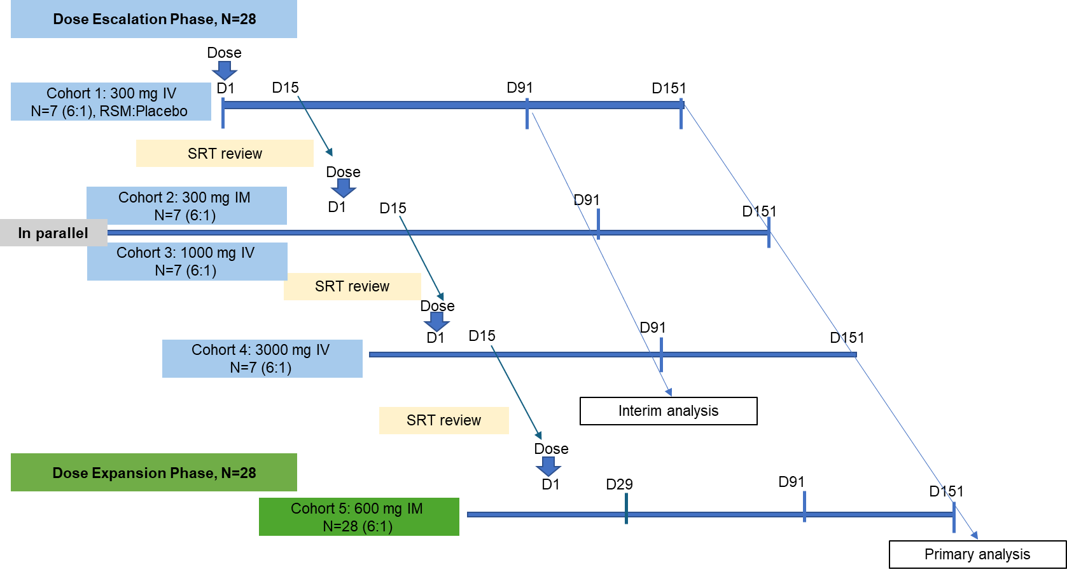
Supplement Figure 2. RSM01 dose-normalised concentration over time after intravenous or intramuscular dose. Mean (+ SD) dose-normalised RSM01 serum concentration-time profiles are presented for each dose cohort
IM intramuscular, IV intravenous, SD standard deviation.
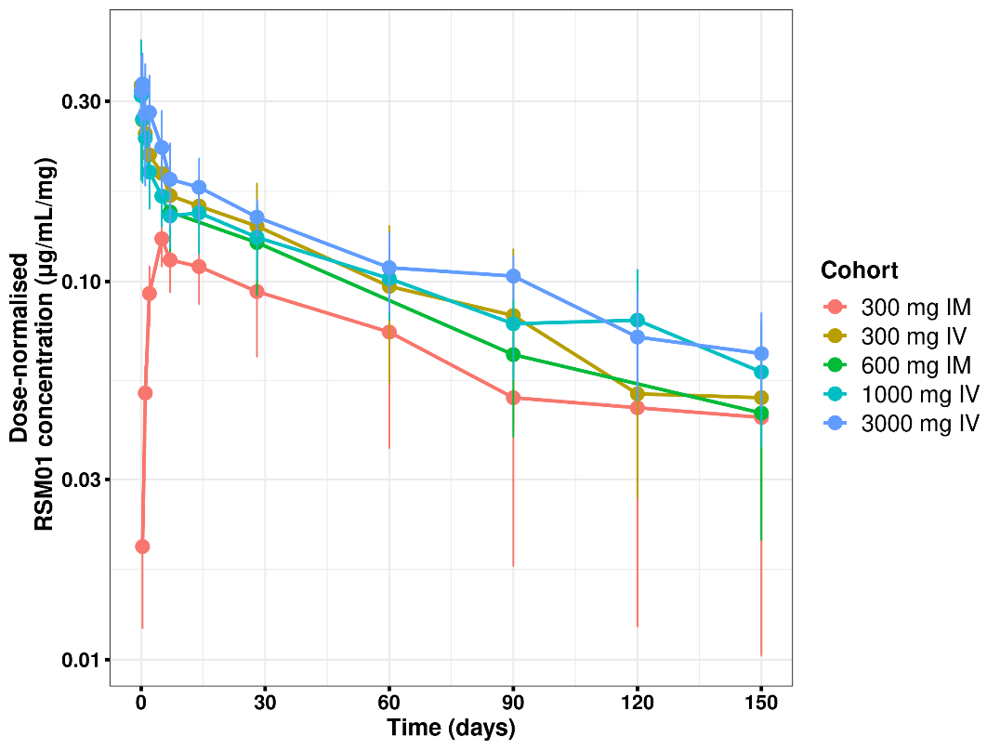
Supplement Figure 3: RSM01 concentration over time by cohort, stratified by administration route Figure shows individual measurable serum RSM01 concentrations versus time (semi-logarithmic), stratified by dose and the route of administration. The left column shows individual profiles following RSM01 intramuscular administration and the right column shows individual profiles following intravenous administration
IM intramuscular, IV intravenous
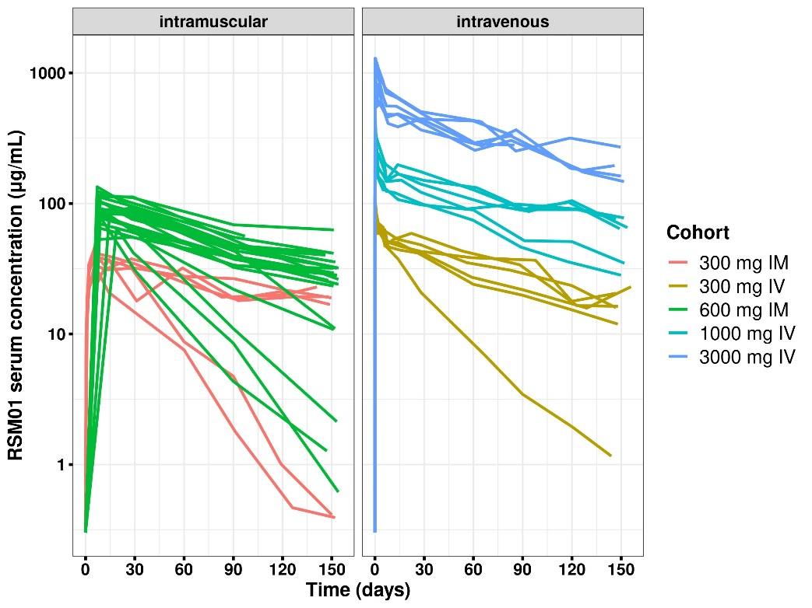
Supplement Figure 4: Individual RSM01 concentration-time profiles by ADA status, stratified by cohort. Figure shows individual measurable serum RSM01 concentrations versus time (semi-logarithmic) according to ADA status stratified by dose cohort. The left column shows individual profiles following 600 mg IM administration and the right column shows individual profiles following 1000 mg IV administration. Cohorts in which all participants were ADA negative are not shown in the figure
ADA antidrug antibodies, IM intramuscular, IV intravenous
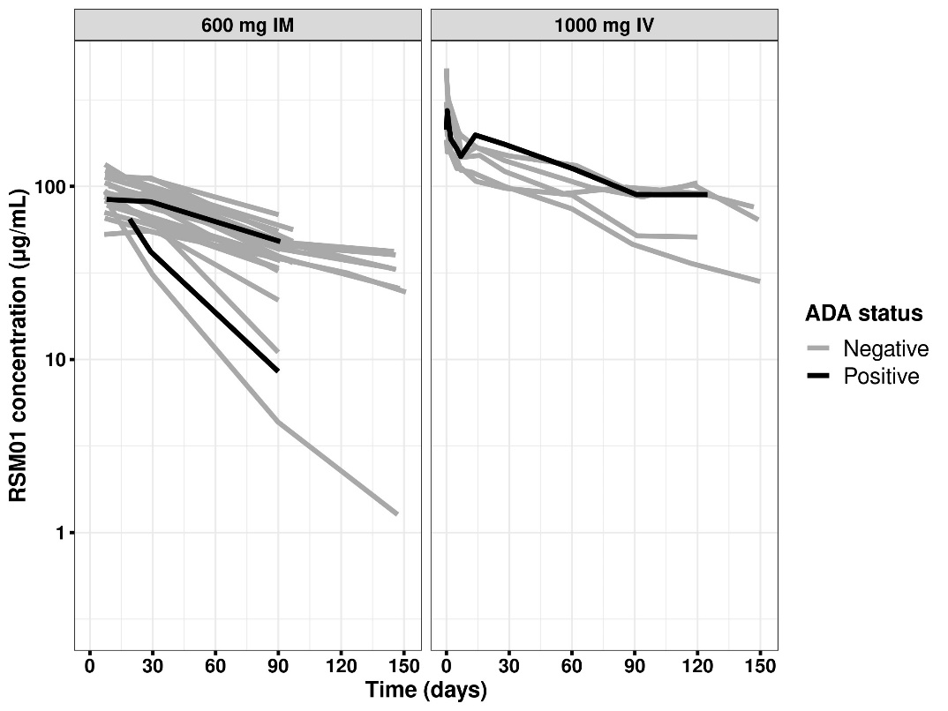

Supplement Figure 5: Goodness of Plots for the Final Model for the Serum. Dots represent individual data points and solid lines represent smoothed LOESS lines. Dashed lines are lines of identity. LOESS Locally weighted scatterplot smoothing
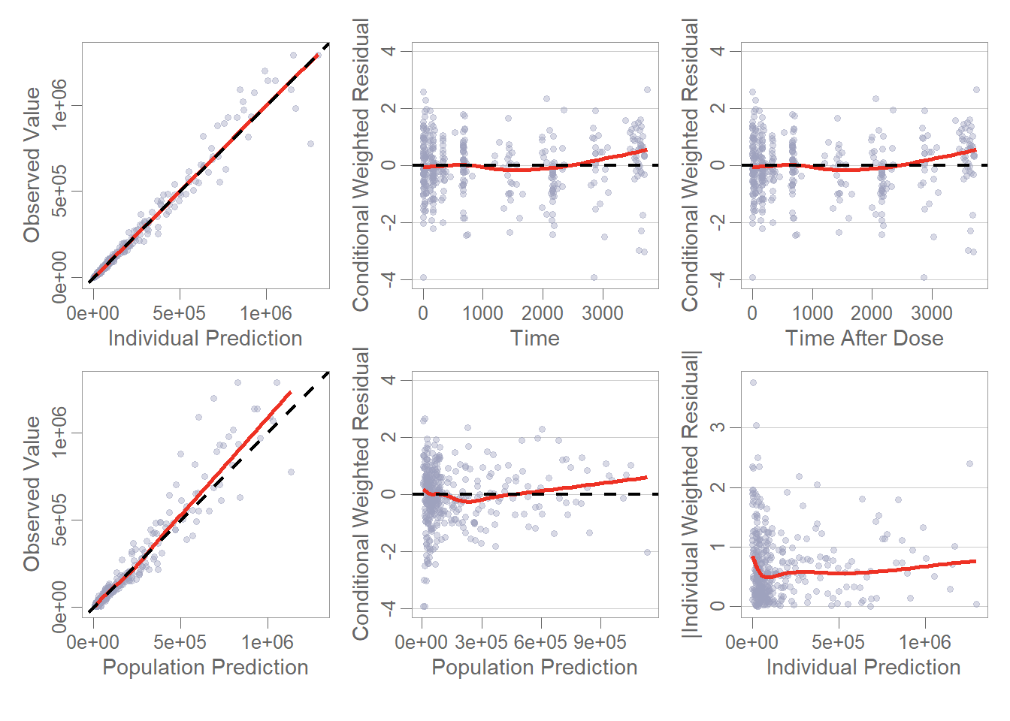

Supplement Figure 6: Semilog pcVPC for the Serum by Dose and Administration Route. Dots represent observed data points. CI confidence interval; p5 5th percentile; p95 95th percentile; PI prediction interval; pcVPC prediction-corrected visual predictive check; semilog semilogarithmic
