Supplementary Table S1: Sequences of primers used in this study.
Gene | Primer sequence | Annealing temp (°C) | Product size (bp)
16S rRNA | F-TCAACCTGGGAACTGCATCC  R-AGGCACCAATCCATCTCTGG | 55 | 410
Class A β-lactamases
blaKPC | F-TGTTGCTGAAGGAGTTGGGC  R-ACGACGGCATAGTCATTTGC | 56 | 340
blaGES | F-GAAACCAAACGGGAGACGC  R-CTTGACCGACAGAGGCAACT | 60 | 207
blaSME | F-TATGGAACGATTTCTTGGCG  R-CTCCCAGTTTTGTCACCTAC | 56 | 300
Class B β-lactamases
blaIMP | F-GGAATAGAGTGGCTTAAYTCTC  R- GGTTTAAYAAAACAACCACC | 50 | 232
blaVIM | F- CCGTGATGGTGATGAGTTGC  R- CTACTGGACCGAAGCGCAC | 55 | 290
blaNDM | F- TTGCGACTTATGCCAATGCG  R- CAGCCACCAAAAGCGATGTC | 56 | 214
Class D β-lactamases
blaOXA-48 | F-GCTTGATCGCCCTCGATT  R-GATTTGCTCCGTGGCCGAAA | 60 | 281
Integrons
intI1 Class 1 Integrase | F-GGTCAAGGATCTGGATTTCG  R-ACATGCGTGTAAATCATCGTC | 50 | 483
intI2 Class 2 Integrase | F-CACGGATATGCGACAAAAAGG T  R-GTAGCAAACGAGTGACGAAATG | 59 | 789
intI3 Class 3 Integrase | F-AGTGGGTGGCGAATGAGTG  R-TGTTCTTGTATCGGCAGGTG | 62 | 600
Class 1 Integron variable region | 5′-CS: GGCATCCAAGCAGCAAG  3′-CS: AAGCAGACTTGACCT`GA | 55 | Variable
IS1999 | F-ATCGGATGGTTTAGGGCTGC  R-CTACGGGGTGTATTCGAGCC | 56 | 487

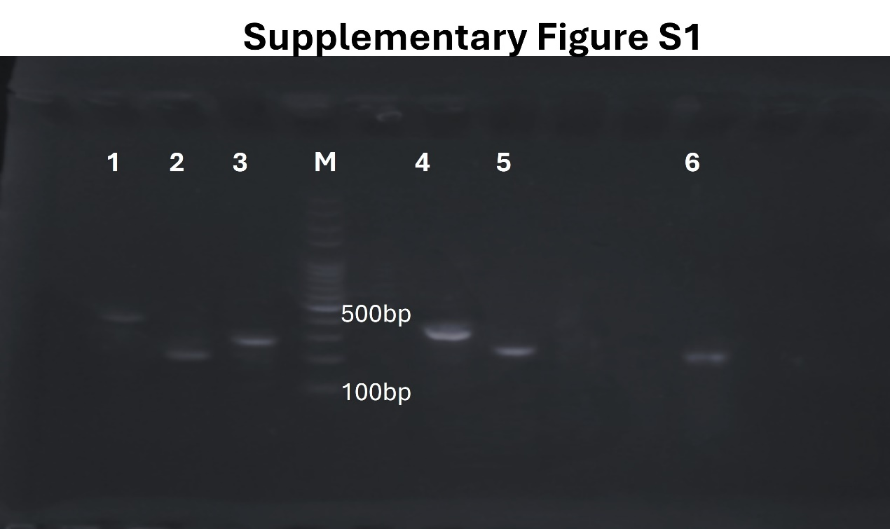
Supplementary Figure S1: Gel electrophoresis of the PCR amplified products for the tested genes. Lane M is a molecular size marker L(100-1000bp). Lane 1: 16S rRNA(410 bp), Lane 2: blaGES (207 bp); Lane 3: blaVIM (290 bp); Lane 4: blaKPC (340 bp); Lane 5: blaIMP (232 bp); Lane 6: blaNDM (214 bp).

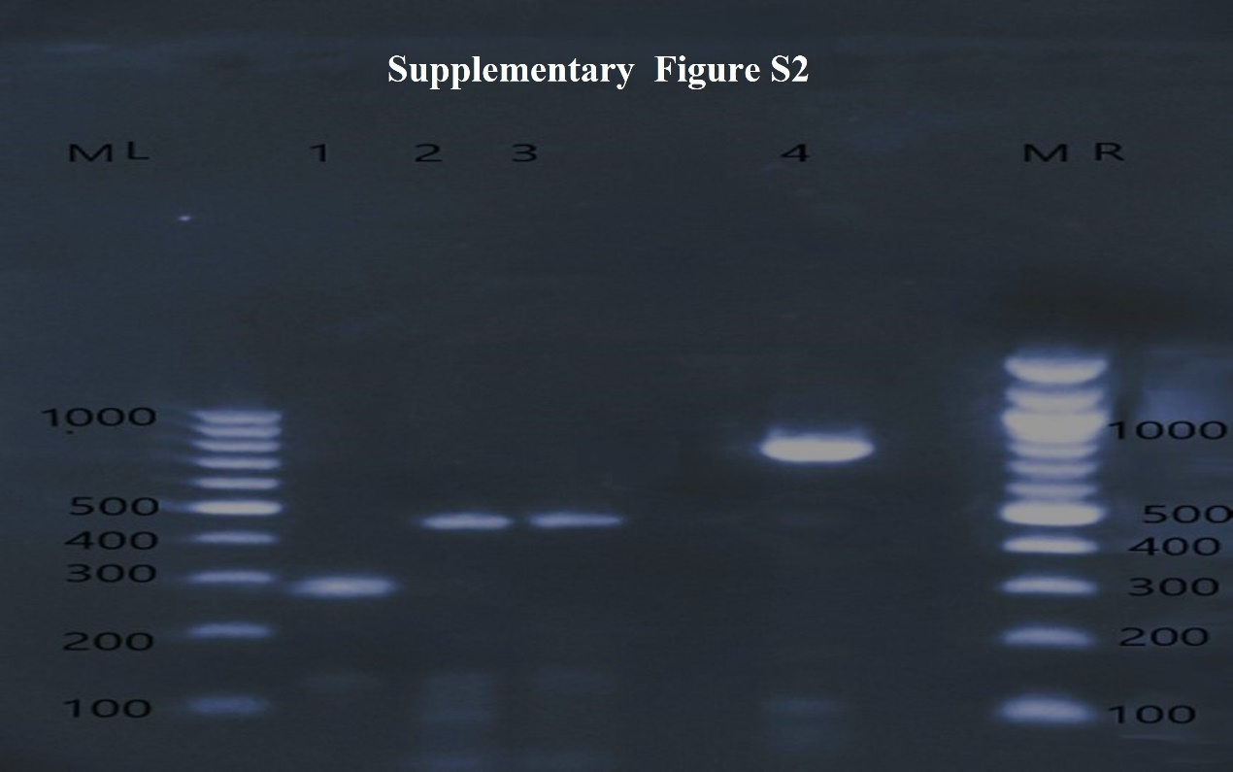
Supplementary Figure S2: Gel electrophoresis of the PCR amplified products for the tested genes. Lane M is a molecular size marker L(100-1000bp) and R(100-2000). Lane 1: PCR product of bla OXA-48 gene (281 bp), Lane 2 and 3, PCR product of intI1gene (483 bp); Lane 4, PCR product of intI2 gene (789 bp).

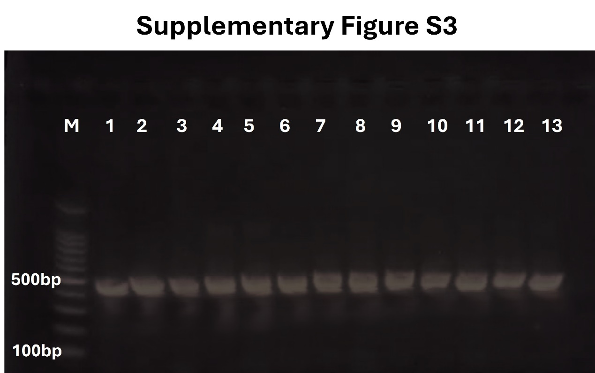
Supplementary Figure S3: Gel electrophoresis of the PCR amplified products for the tested genes. Lane M is a molecular size marker L(100-1000bp); Lane 1-13: PCR product of Tn1999 gene (487 bp).

