Supplementary material
Figures and Tables

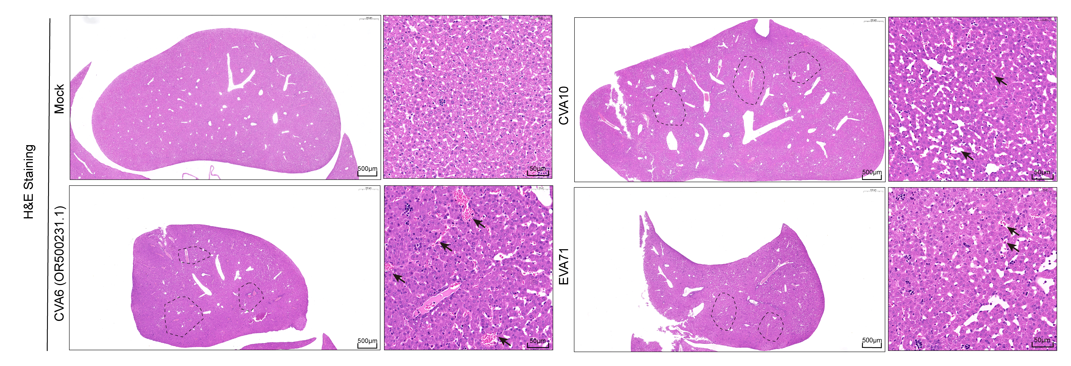
Fig. S1. Liver pathology of mice infected with different enteroviruses Wild-type (WT, C57BL/6J) mice were i.p. inoculated with a lethal dose of the various enterovirus (CVA6, CVA10, EV-A71) or saline (Mock), and sacrificed at the indicated time. H&E staining was conducted to assess liver pathology.

Fig. S2. The activation of NLRP3 inflammasome in HepG2 cell caused by CVA6 infection Immunofluorescence images (A) of CVA6 infected with an MOI of 1 for 48 hours or Mock-infected HepG2 cells. Nuclei (blue), CVA6 VP1 (green) and NLRP3 (red) are labeled or stained with specific antibodies, respectively. Scale bar=20 µm. Western blot analysis (B) was carried out using antibodies against NLRP3, Caspase-3, Cleaved-Casp3, pro-Caspase-1, Cleaved Casp1 (p20), IL-1β and IL-18 from CVA6-infected HepG2 cells (n=3) at 0hpi, 12hpi, 24hpi and 48hpi.

Fig. S3. Survival rates, clinical scores and body weights of mice were measured until 15 dpi Ten-day-old WT and NLRP3 KO mice (n=10∼12 per group) were i.p. inoculated with a lethal dose of the CVA6 strain (10⁵ TCID₅₀ /mouse, GenBank Accession number: OM179765) or saline (Mock).

Table S1 Basic characteristics and laboratory indicators of patients with HFMD
Variable | Mild (n=155) | Severe (n=155) | Z /U/χ² | P
Sex（Male）n,% | 105 (67.74%) | 112 (72.26%) | 0.753 | 0.386
Age（month） | 19(15,30) | 18(13,24) | -2.048 | ＜0.05
WBC (10⁹/L) | 10.61±3.97 | 10.64(7.64,14.74) | 1.082 | 0.28
RBC (10⁹/L) | 4.41±0.33 | 4.49±0.39 | 2.038 | ＜0.05
HGB (g/L) | 116.83±10.88 | 116.30±11.82 | -0.397 | 0.691
HCT (%) | 33.4(31.6,35.2) | 34.19±3.16 | 1.723 | 0.086
PLT (10⁹/L) | 289(239,355) | 328.73±79.65 | 3.108 | ＜0.01
MCV (fL) | 75.8(72.95,78.4) | 76.5(72.95,79.55) | 1.069 | 0.285
MCH (pg) | 26.7(25.6,28.05) | 25.95±2.26 | -2.170 | ＜0.05
MCHC (g/L) | 350.90±15.57 | 345.5(326.75,359) | -4.354 | ＜0.001
MPV (fL) | 9.7(9.1,10.3) | 9.7(9.3,10.3) | 0.851 | 0.395
PCT | 0.28(0.23,0.34) | 0.32±0.07 | 3.578 | ＜0.001
NEUT (%) | 53.2(31.9,67.15) | 41.4(23.05,66.45) | -2.746 | ＜0.01
LY (%) | 38(26.35,59.55) | 50.25(26.38,66,7) | 2.871 | ＜0.01
MONO (%) | 6(4.9,7.45) | 5.85(4.58,7.1) | -1.355 | 0.176
EO (%) | 0.7(0.1,2.35) | 1.25(0.1,3.2) | 1.760 | 0.078
BASO (%) | 0.2(0.1,0.3) | 0.2(0.1,0.3) | -0.845 | 0.398
NEUT (10⁹/L) | 5.22(2.61,8.31) | 3.86(1.76,8.79) | -1.418 | 0.156
LYMPH (10⁹/L) | 3.59(2.49,4.79) | 4.34(3.21,5.98) | 3.521 | ＜0.01
MONO (10⁹/L) | 0.56(0.4,0.85) | 0.52(0.38,0.82) | -0.503 | 0.615
EO (10⁹/L) | 0.07(0.01,0.2) | 012(0.02,0.26) | 1.925 | 0.054
BASO (10⁹/L) | 0.02(0.01,0.03) | 0.02(0.01,0.03) | -0.345 | 0.730
ALT (U/L) | 20.7(11,27.6) | 28.97±13.02 | 6.327 | ＜0.001
AST (U/L) | 38.54±8.05 | 40(34,46) | 2.741 | ＜0.01
ALP (U/L) | 199.09±48.61 | 194(163,237) | 1.739 | 0.083
GGT (U/L) | 10(9,11) | 10(9,11.7) | 1.474 | 0.140
TP (g/L) | 68.71±5.44 | 69(66,72) | 0.929 | 0.354
ALB (g/L) | 42(40,44) | 42(40,44) | 1.097 | 0.273
GLO (g/L) | 27(25,29) | 27(25,29) | 0.336 | 0.737
LDH (U/L) | 249.69±36.05 | 262.90±46.80 | 2.785 | ＜0.01
CK (U/L) | 73(54,102) | 79(59,120) | 1.579 | 0.114
CK-MB (U/L) | 19.41±9.33 | 20(13,31) | 2.819 | ＜0.01
BUN (mmol/L) | 3.1(2.58,3.8) | 3(2.4,3.9) | 0.338 | 0.736
CREA (umol/L) | 27(25,30) | 27(24.25,31) | -0.687 | 0.492
UA (umol/L) | 245(189.8,291.8) | 259.5(205.3,312.3) | 1.576 | 0.115
K (mmol/L) | 3.91±0.42 | 4(3.8,4.2) | 1.922 | 0.056
NA (mmol/L) | 136(133,138) | 137(135,140) | 3.463 | ＜0.01
CL (mmol/L) | 100(98,102) | 101(98,103) | 2.165 | ＜0.01
CA (mmol/L) | 2.42±0.09 | 2.49(2.41,2.55) | 5.805 | ＜0.001
Note: WBC: white blood cells; RBC: red blood cells; HGB: hemoglobin; HCT: hematocrit; PLT: platelet count; MCV: mean red blood cell volume; MCH: mean content of hemoglobin; MCHC: mean hemoglobin concentration; MPV: average platelet volume; PCT: Platelet hematocrit; NEUT: neutrophil ratio; LY: lymphocyte; MONO: monocyte; EO: eosinophil ratio; BASO: basophil ratio; LYMPH: lymphocyte count; ALT: alanine aminotransferase; AST: aspartate aminotransferase; ALP: alkaline phosphatase; GGT: glutaminyltransferase; TP: total protein; ALB: albumin; GLO: globulin; LDH: lactate dehydrogenase; CK: creatine kinase; CK-MB: creatine kinase isoenzymes; BUN: blood urea nitrogen; CREA: creatinine; UA: uric acid

