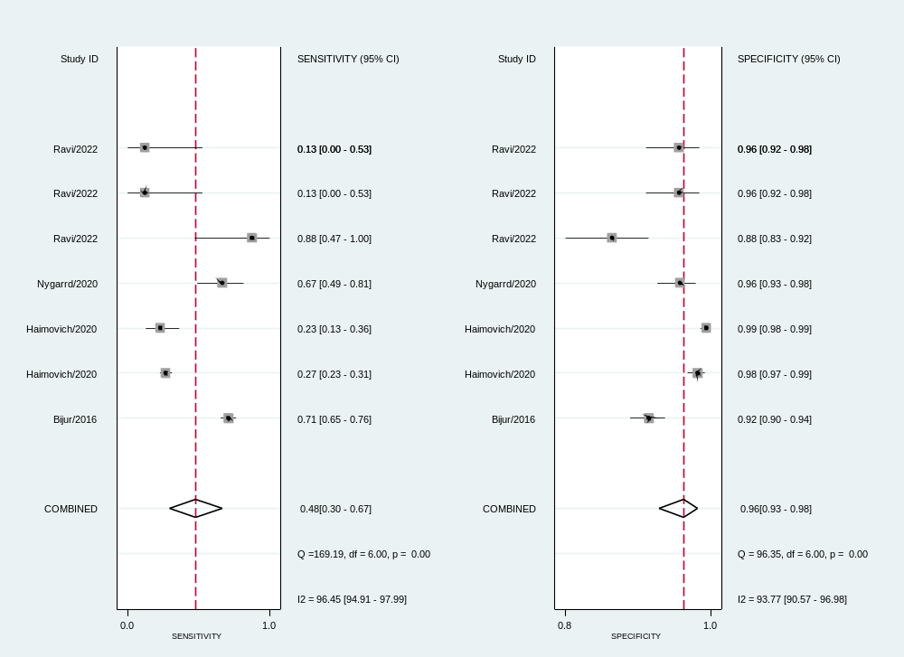
(A) Pooled sensitivity and specificity of TATs in adult subgroups

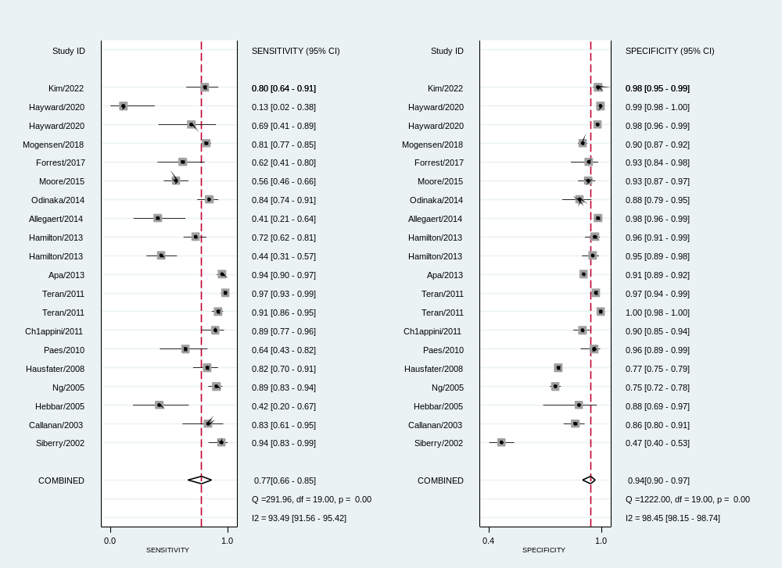
(B) Pooled sensitivity and specificity of TATs in child subgroups

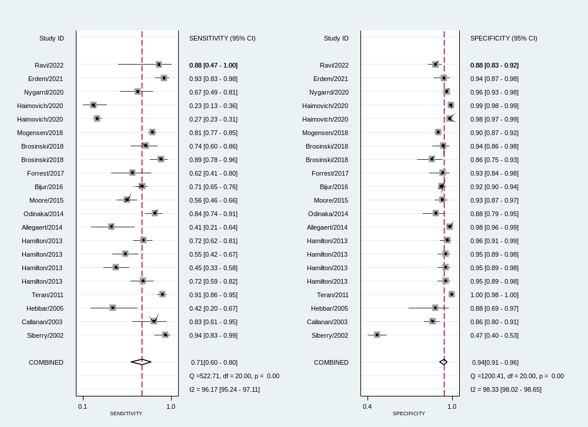
(C) Pooled sensitivity and specificity of TATs in fever threshold >38 °C subgroups

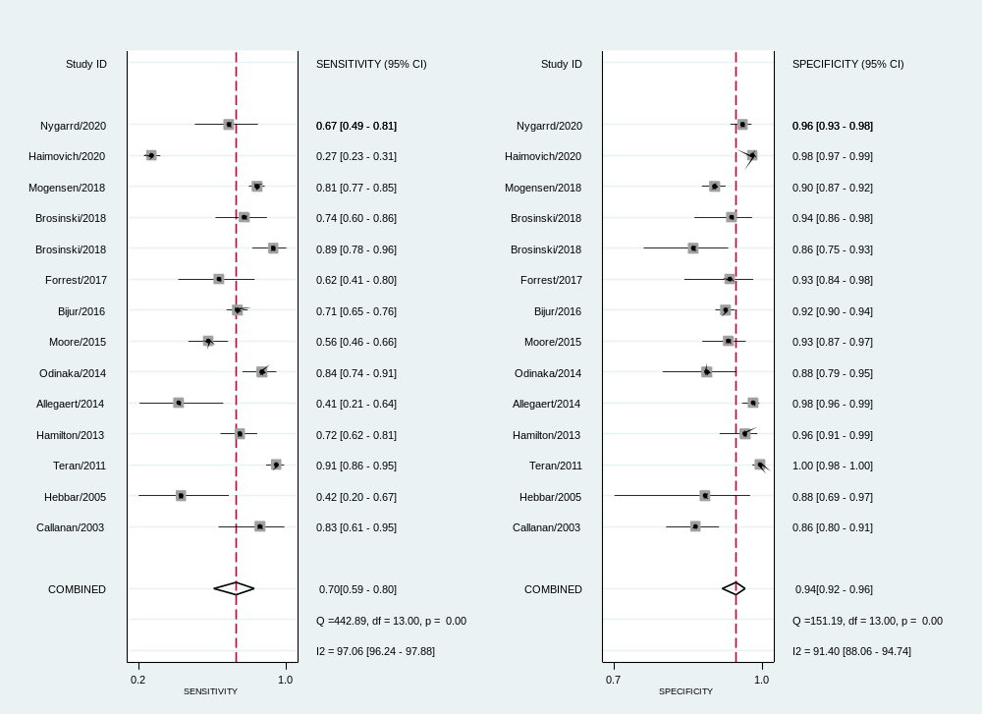
(D) Pooled sensitivity and specificity of TATs with rectal temperature as the reference standard
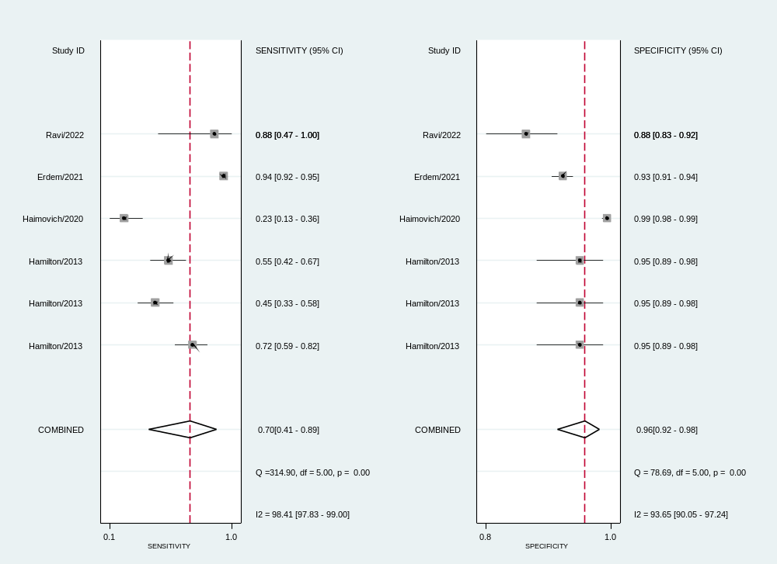
(E) Pooled sensitivity and specificity of TATs with oral, tympanic membrane, and axillary temperature as the reference standards

Supplementary Fig. 1 Forest plot showing pooled sensitivity and specificity for temporal artery thermometers (TATs) subgroups

