Parametric Network Search Supplement:
KNN, optimal search for K-value values: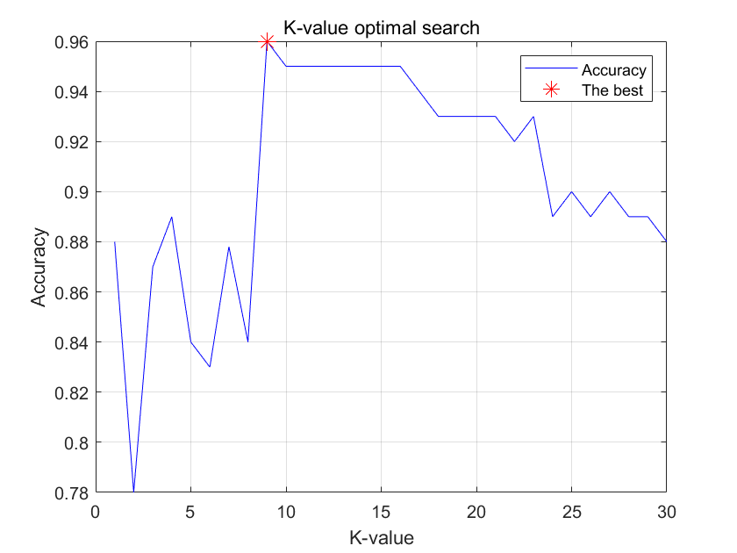

K-value | 1 | 2 | 3 | 4 | 5 | 6 | 7 | 8 | 9 | 10 | 11 | 12 | 13 | 14 | 15
Accuracy | 0.88 | 0.78 | 0.87 | 0.89 | 0.84 | 0.83 | 0.878 | 0.84 | 0.96 | 0.95 | 0.95 | 0.95 | 0.95 | 0.95 | 0.95
K-value | 16 | 17 | 18 | 19 | 20 | 21 | 22 | 23 | 24 | 25 | 26 | 27 | 28 | 29 | 30
Accuracy | 0.95 | 0.94 | 0.93 | 0.93 | 0.93 | 0.93 | 0.92 | 0.93 | 0.89 | 0.90 | 0.89 | 0.90 | 0.89 | 0.89 | 0.88

Decision tree depth, Tree depth value Optimal search: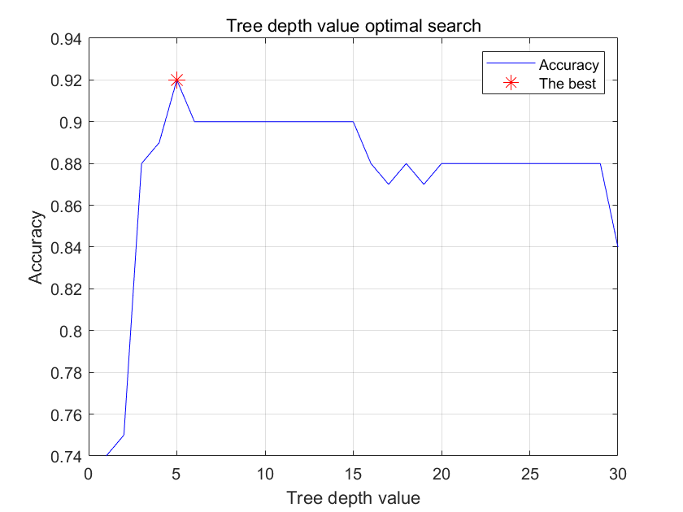
Tree depth value | 1 | 2 | 3 | 4 | 5 | 6 | 7 | 8 | 9 | 10 | 11 | 12 | 13 | 14 | 15
Accuracy | 0.74 | 0.75 | 0.88 | 0.89 | 0.92 | 0.90 | 0.90 | 0.90 | 0.90 | 0.90 | 0.90 | 0.90 | 0.90 | 0.90 | 0.90
Tree depth value | 16 | 17 | 18 | 19 | 20 | 21 | 22 | 23 | 24 | 25 | 26 | 27 | 28 | 29 | 30
Accuracy | 0.88 | 0.87 | 0.88 | 0.87 | 0.88 | 0.88 | 0.88 | 0.88 | 0.88 | 0.88 | 0.88 | 0.88 | 0.88 | 0.88 | 0.84

