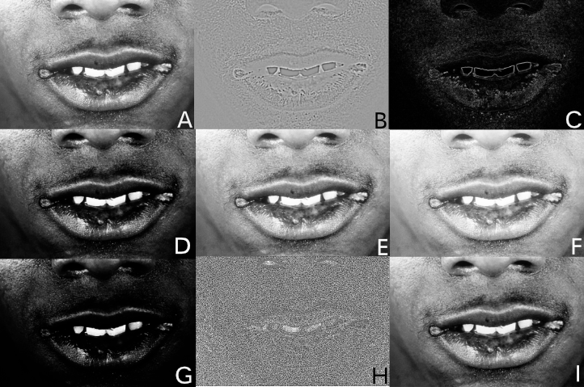
Supplement Figure 1: Nine different filters. (A) Original grey filter. (B) Laplacian of Gaussian filter, edge enhancement filter. (C) Gradient filter. (D) Square filter. (E) Square Root Filter. (F) Logarithm filter. (G) Exponential filter. (H) Local Binary Pattern 2D filter. (I) LL Wavelet filter.
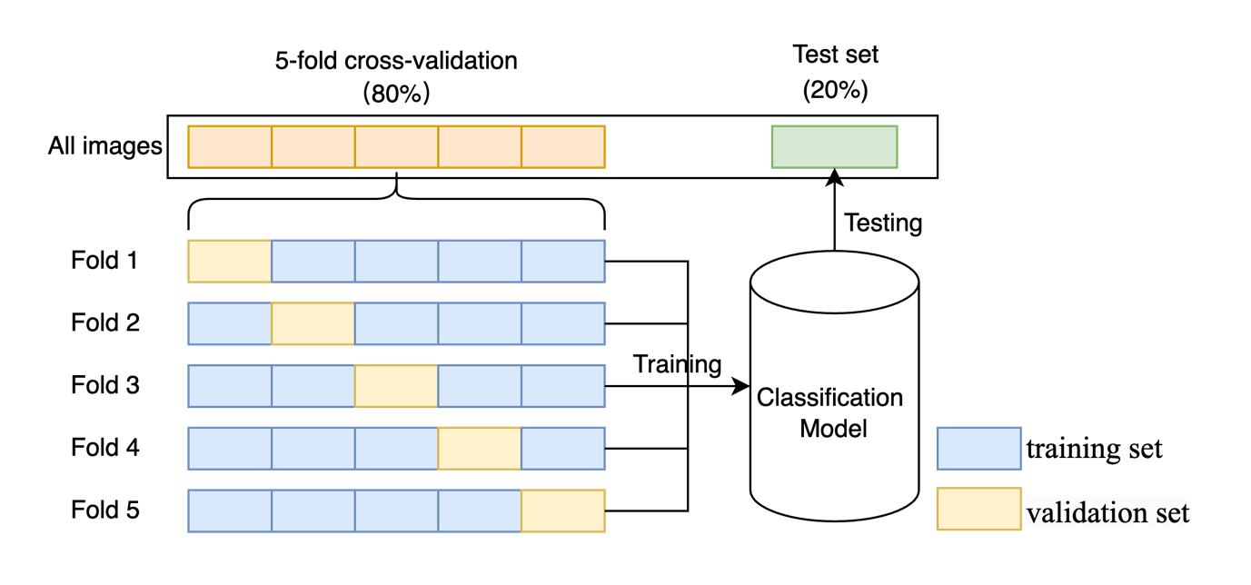

Supplement Figure 2: Methods of dividing images for training and testing the classification models

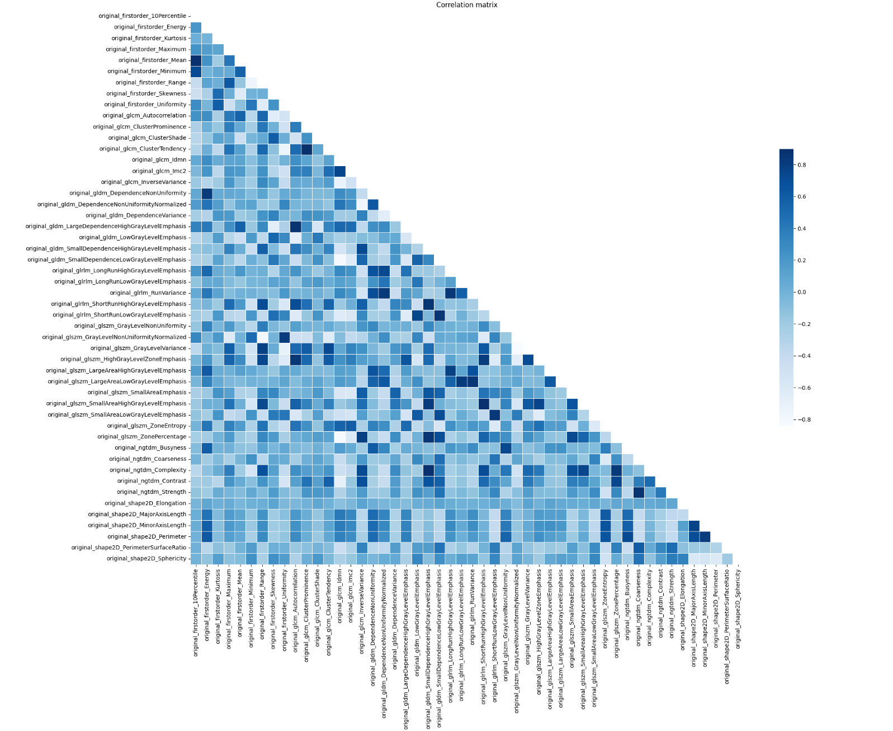
Supplement Figure 3: Correlation coefficient matrix of the remaining 50 features. The darker the colour, the stronger the correlation.

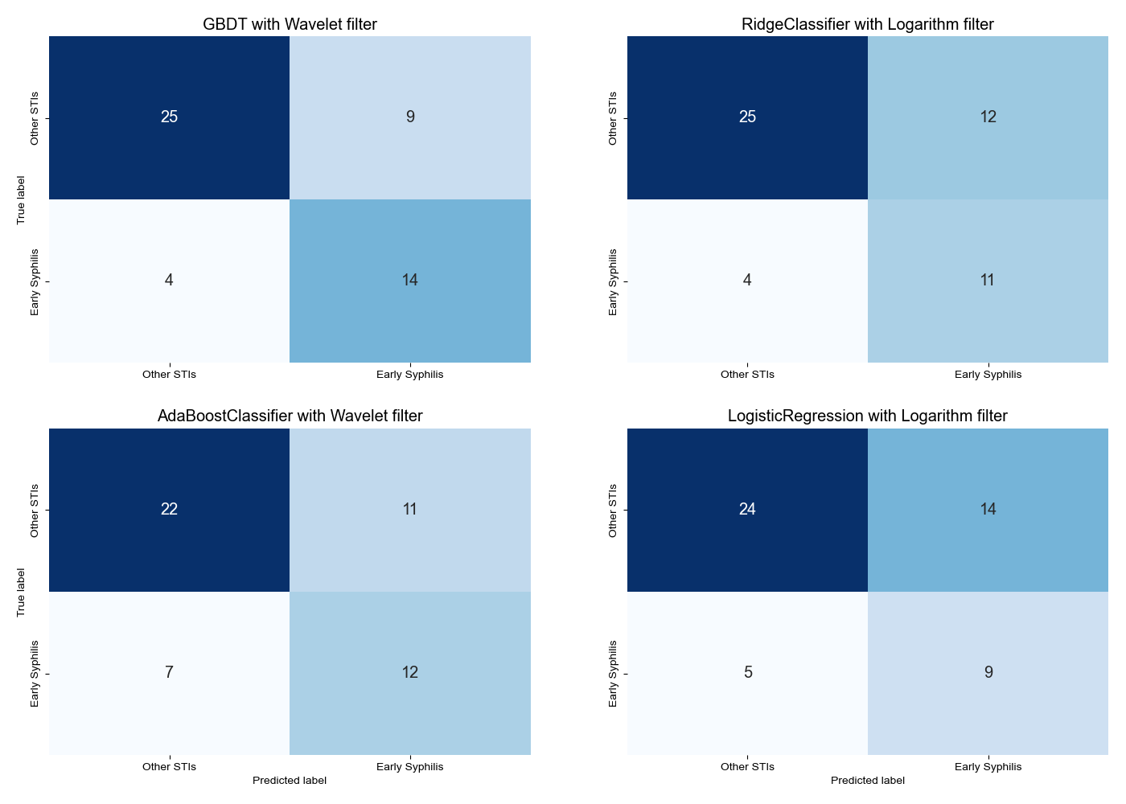
Supplement Figure 4: Confusion matrix for Top-4 prediction models. The number illustrates the correct and incorrect diagnoses made by the proposed AI-based diagnostic model.

Supplement Table 1: Training and test results for ten models with nine filters sorted by AUC of the test set.
Model name | Filter | Training (cross validation) |  |  |  |  | Test
Model name | Filter | Accuracy  (mean± std) | AUC  (mean± std) | 95%CI of AUC |  |  |  | Accuracy | AUC | Precision | Sensitivity | F1_score
LogisticRegression | Original | 0.697±0.061 | 0.770±0.064 | 0.680-0.859 |  |  |  | 0.654 | 0.772 | 0.647 | 0.478 | 0.55
LogisticRegression | LoG | 0.673±0.058 | 0.743±0.073 | 0.642-0.845 |  |  |  | 0.692 | 0.772 | 0.733 | 0.478 | 0.579
LogisticRegression | Gradient | 0.735±0.039 | 0.784±0.024 | 0.752-0.817 |  |  |  | 0.731 | 0.787 | 0.714 | 0.652 | 0.682
LogisticRegression | Square | 0.682±0.055 | 0.759±0.064 | 0.670-0.849 |  |  |  | 0.75 | 0.795 | 0.812 | 0.565 | 0.667
LogisticRegression | SquareRoot | 0.707±0.055 | 0.770±0.039 | 0.716-0.823 |  |  |  | 0.692 | 0.769 | 0.769 | 0.435 | 0.556
LogisticRegression | Logarithm | 0.740±0.077 | 0.812±0.066 | 0.721-0.903 |  |  |  | 0.635 | 0.775 | 0.643 | 0.391 | 0.486
LogisticRegression | Exponential | 0.707±0.025 | 0.772±0.058 | 0.692-0.853 |  |  |  | 0.673 | 0.795 | 0.714 | 0.435 | 0.541
LogisticRegression | LBP2D | 0.692±0.043 | 0.734±0.052 | 0.662-0.806 |  |  |  | 0.635 | 0.685 | 0.6 | 0.522 | 0.558
LogisticRegression | Wavelet | 0.707±0.047 | 0.794±0.055 | 0.719-0.870 |  |  |  | 0.673 | 0.739 | 0.714 | 0.435 | 0.541
GBDT | Original | 0.697±0.073 | 0.754±0.076 | 0.648-0.861 |  |  |  | 0.635 | 0.771 | 0.625 | 0.435 | 0.513
GBDT | LoG | 0.673±0.042 | 0.743±0.057 | 0.664-0.822 |  |  |  | 0.635 | 0.742 | 0.611 | 0.478 | 0.537
GBDT | Gradient | 0.712±0.065 | 0.753±0.047 | 0.688-0.818 |  |  |  | 0.673 | 0.742 | 0.636 | 0.609 | 0.622
GBDT | Square | 0.721±0.047 | 0.790±0.022 | 0.759-0.821 |  |  |  | 0.731 | 0.793 | 0.737 | 0.609 | 0.667
GBDT | SquareRoot | 0.668±0.050 | 0.755±0.049 | 0.686-0.823 |  |  |  | 0.596 | 0.759 | 0.583 | 0.304 | 0.4
GBDT | Logarithm | 0.726±0.063 | 0.761±0.067 | 0.668-0.854 |  |  |  | 0.692 | 0.769 | 0.733 | 0.478 | 0.579
GBDT | Exponential | 0.702±0.033 | 0.752±0.023 | 0.720-0.784 |  |  |  | 0.769 | 0.774 | 0.824 | 0.609 | 0.7
GBDT | LBP2D | 0.615±0.063 | 0.693±0.062 | 0.606-0.779 |  |  |  | 0.596 | 0.651 | 0.562 | 0.391 | 0.462
GBDT | Wavelet | 0.735±0.043 | 0.832±0.042 | 0.773-0.891 |  |  |  | 0.75 | 0.792 | 0.778 | 0.609 | 0.683
RidgeClassifier | Original | 0.716±0.049 | 0.782±0.062 | 0.696-0.868 |  |  |  | 0.654 | 0.769 | 0.647 | 0.478 | 0.55
RidgeClassifier | LoG | 0.672±0.067 | 0.741±0.057 | 0.661-0.820 |  |  |  | 0.75 | 0.783 | 0.778 | 0.609 | 0.683
RidgeClassifier | Gradient | 0.731±0.034 | 0.806±0.032 | 0.761-0.851 |  |  |  | 0.692 | 0.783 | 0.667 | 0.609 | 0.636
RidgeClassifier | Square | 0.720±0.070 | 0.773±0.062 | 0.687-0.860 |  |  |  | 0.712 | 0.787 | 0.786 | 0.478 | 0.595
RidgeClassifier | SquareRoot | 0.716±0.051 | 0.794±0.033 | 0.748-0.841 |  |  |  | 0.712 | 0.771 | 0.722 | 0.565 | 0.634
RidgeClassifier | Logarithm | 0.735±0.052 | 0.819±0.058 | 0.738-0.899 |  |  |  | 0.692 | 0.75 | 0.733 | 0.478 | 0.579
RidgeClassifier | Exponential | 0.692±0.021 | 0.776±0.063 | 0.689-0.863 |  |  |  | 0.654 | 0.802 | 0.667 | 0.435 | 0.526
RidgeClassifier | LBP2D | 0.687±0.057 | 0.745±0.049 | 0.676-0.813 |  |  |  | 0.615 | 0.685 | 0.588 | 0.435 | 0.5
RidgeClassifier | Wavelet | 0.726±0.033 | 0.789±0.036 | 0.740-0.839 |  |  |  | 0.692 | 0.736 | 0.706 | 0.522 | 0.6
SVM | Original | 0.701±0.066 | 0.743±0.061 | 0.658-0.829 |  |  |  | 0.635 | 0.766 | 0.625 | 0.435 | 0.513
SVM | LoG | 0.653±0.049 | 0.709±0.020 | 0.680-0.737 |  |  |  | 0.654 | 0.748 | 0.632 | 0.522 | 0.571
SVM | Gradient | 0.745±0.037 | 0.807±0.021 | 0.778-0.836 |  |  |  | 0.692 | 0.81 | 0.64 | 0.696 | 0.667
SVM | Square | 0.644±0.031 | 0.729±0.043 | 0.669-0.790 |  |  |  | 0.654 | 0.781 | 0.619 | 0.565 | 0.591
SVM | SquareRoot | 0.693±0.056 | 0.765±0.064 | 0.676-0.853 |  |  |  | 0.654 | 0.775 | 0.667 | 0.435 | 0.526
SVM | Logarithm | 0.702±0.025 | 0.770±0.043 | 0.710-0.830 |  |  |  | 0.692 | 0.712 | 0.769 | 0.435 | 0.556
SVM | Exponential | 0.659±0.045 | 0.730±0.039 | 0.675-0.785 |  |  |  | 0.654 | 0.783 | 0.647 | 0.478 | 0.55
SVM | LBP2D | 0.630±0.047 | 0.709±0.049 | 0.641-0.777 |  |  |  | 0.654 | 0.726 | 0.619 | 0.565 | 0.591
SVM | Wavelet | 0.706±0.062 | 0.805±0.055 | 0.728-0.882 |  |  |  | 0.673 | 0.807 | 0.688 | 0.478 | 0.564
KNN | Original | 0.625±0.023 | 0.651±0.035 | 0.603-0.699 |  |  |  | 0.615 | 0.661 | 0.6 | 0.391 | 0.474
KNN | LoG | 0.568±0.037 | 0.604±0.057 | 0.524-0.683 |  |  |  | 0.615 | 0.617 | 0.588 | 0.435 | 0.5
KNN | Gradient | 0.654±0.077 | 0.684±0.077 | 0.577-0.790 |  |  |  | 0.827 | 0.828 | 0.792 | 0.826 | 0.809
KNN | Square | 0.615±0.072 | 0.653±0.059 | 0.570-0.736 |  |  |  | 0.577 | 0.618 | 0.529 | 0.391 | 0.45
KNN | SquareRoot | 0.692±0.030 | 0.734±0.035 | 0.685-0.782 |  |  |  | 0.615 | 0.611 | 0.615 | 0.348 | 0.444
KNN | Logarithm | 0.635±0.054 | 0.659±0.047 | 0.593-0.725 |  |  |  | 0.538 | 0.606 | 0.429 | 0.13 | 0.2
KNN | Exponential | 0.635±0.055 | 0.667±0.048 | 0.600-0.733 |  |  |  | 0.615 | 0.64 | 0.579 | 0.478 | 0.524
KNN | LBP2D | 0.615±0.057 | 0.659±0.067 | 0.566-0.752 |  |  |  | 0.635 | 0.694 | 0.6 | 0.522 | 0.558
KNN | Wavelet | 0.683±0.058 | 0.717±0.052 | 0.645-0.790 |  |  |  | 0.596 | 0.669 | 0.571 | 0.348 | 0.432
GaussianProcessClassifier | Original | 0.682±0.060 | 0.756±0.074 | 0.653-0.858 |  |  |  | 0.673 | 0.79 | 0.688 | 0.478 | 0.564
GaussianProcessClassifier | LoG | 0.658±0.055 | 0.739±0.045 | 0.676-0.801 |  |  |  | 0.654 | 0.784 | 0.727 | 0.348 | 0.471
GaussianProcessClassifier | Gradient | 0.740±0.048 | 0.809±0.018 | 0.783-0.834 |  |  |  | 0.712 | 0.82 | 0.667 | 0.696 | 0.681
GaussianProcessClassifier | Square | 0.649±0.021 | 0.746±0.048 | 0.679-0.812 |  |  |  | 0.654 | 0.805 | 0.632 | 0.522 | 0.571
GaussianProcessClassifier | SquareRoot | 0.726±0.057 | 0.807±0.046 | 0.742-0.871 |  |  |  | 0.712 | 0.772 | 0.833 | 0.435 | 0.571
GaussianProcessClassifier | Logarithm | 0.688±0.062 | 0.778±0.030 | 0.736-0.819 |  |  |  | 0.673 | 0.768 | 0.75 | 0.391 | 0.514
GaussianProcessClassifier | Exponential | 0.692±0.023 | 0.737±0.053 | 0.663-0.810 |  |  |  | 0.692 | 0.786 | 0.706 | 0.522 | 0.6
GaussianProcessClassifier | LBP2D | 0.668±0.048 | 0.725±0.056 | 0.648-0.802 |  |  |  | 0.635 | 0.72 | 0.611 | 0.478 | 0.537
GaussianProcessClassifier | Wavelet | 0.726±0.035 | 0.811±0.040 | 0.755-0.867 |  |  |  | 0.731 | 0.816 | 0.737 | 0.609 | 0.667
DecisionTreeClassifier | Original | 0.634±0.046 | 0.633±0.074 | 0.530-0.737 |  |  |  | 0.635 | 0.699 | 0.643 | 0.391 | 0.486
DecisionTreeClassifier | LoG | 0.634±0.062 | 0.625±0.084 | 0.508-0.742 |  |  |  | 0.615 | 0.561 | 0.615 | 0.348 | 0.444
DecisionTreeClassifier | Gradient | 0.702±0.030 | 0.718±0.078 | 0.610-0.826 |  |  |  | 0.654 | 0.589 | 0.609 | 0.609 | 0.609
DecisionTreeClassifier | Square | 0.619±0.118 | 0.625±0.114 | 0.467-0.783 |  |  |  | 0.75 | 0.735 | 0.778 | 0.609 | 0.683
DecisionTreeClassifier | SquareRoot | 0.620±0.058 | 0.619±0.051 | 0.548-0.690 |  |  |  | 0.577 | 0.493 | 0.538 | 0.304 | 0.389
DecisionTreeClassifier | Logarithm | 0.615±0.073 | 0.603±0.063 | 0.515-0.691 |  |  |  | 0.615 | 0.65 | 0.615 | 0.348 | 0.444
DecisionTreeClassifier | Exponential | 0.639±0.068 | 0.627±0.043 | 0.568-0.687 |  |  |  | 0.654 | 0.675 | 0.667 | 0.435 | 0.526
DecisionTreeClassifier | LBP2D | 0.616±0.066 | 0.626±0.041 | 0.569-0.683 |  |  |  | 0.615 | 0.682 | 0.588 | 0.435 | 0.5
DecisionTreeClassifier | Wavelet | 0.717±0.057 | 0.695±0.079 | 0.585-0.805 |  |  |  | 0.615 | 0.522 | 0.579 | 0.478 | 0.524
RandomForestClassifier | Original | 0.616±0.063 | 0.691±0.050 | 0.622-0.760 |  |  |  | 0.615 | 0.666 | 0.636 | 0.304 | 0.412
RandomForestClassifier | LoG | 0.630±0.037 | 0.664±0.052 | 0.593-0.736 |  |  |  | 0.596 | 0.705 | 0.571 | 0.348 | 0.432
RandomForestClassifier | Gradient | 0.673±0.032 | 0.745±0.050 | 0.675-0.815 |  |  |  | 0.712 | 0.75 | 0.682 | 0.652 | 0.667
RandomForestClassifier | Square | 0.630±0.029 | 0.672±0.030 | 0.631-0.713 |  |  |  | 0.615 | 0.676 | 0.588 | 0.435 | 0.5
RandomForestClassifier | SquareRoot | 0.630±0.080 | 0.690±0.052 | 0.617-0.762 |  |  |  | 0.731 | 0.804 | 0.846 | 0.478 | 0.611
RandomForestClassifier | Logarithm | 0.654±0.037 | 0.712±0.066 | 0.620-0.803 |  |  |  | 0.635 | 0.684 | 0.643 | 0.391 | 0.486
RandomForestClassifier | Exponential | 0.610±0.032 | 0.693±0.065 | 0.603-0.783 |  |  |  | 0.673 | 0.682 | 0.688 | 0.478 | 0.564
RandomForestClassifier | LBP2D | 0.620±0.063 | 0.682±0.060 | 0.599-0.766 |  |  |  | 0.692 | 0.758 | 0.684 | 0.565 | 0.619
RandomForestClassifier | Wavelet | 0.663±0.085 | 0.732±0.098 | 0.596-0.868 |  |  |  | 0.577 | 0.726 | 0.538 | 0.304 | 0.389
MLPClassifier | Original | 0.558±0.009 | 0.649±0.073 | 0.548-0.751 |  |  |  | 0.558 | 0.592 | 0 | 0 | 0
MLPClassifier | LoG | 0.558±0.009 | 0.671±0.054 | 0.596-0.747 |  |  |  | 0.558 | 0.591 | 0 | 0 | 0
MLPClassifier | Gradient | 0.558±0.009 | 0.693±0.085 | 0.575-0.811 |  |  |  | 0.558 | 0.421 | 0 | 0 | 0
MLPClassifier | Square | 0.553±0.007 | 0.669±0.029 | 0.628-0.709 |  |  |  | 0.558 | 0.709 | 0 | 0 | 0
MLPClassifier | SquareRoot | 0.553±0.007 | 0.667±0.056 | 0.590-0.744 |  |  |  | 0.558 | 0.699 | 0 | 0 | 0
MLPClassifier | Logarithm | 0.558±0.009 | 0.701±0.042 | 0.642-0.760 |  |  |  | 0.558 | 0.693 | 0 | 0 | 0
MLPClassifier | Exponential | 0.558±0.015 | 0.676±0.025 | 0.641-0.710 |  |  |  | 0.558 | 0.606 | 0 | 0 | 0
MLPClassifier | LBP2D | 0.558±0.009 | 0.678±0.051 | 0.608-0.749 |  |  |  | 0.558 | 0.789 | 0 | 0 | 0
MLPClassifier | Wavelet | 0.567±0.013 | 0.775±0.051 | 0.705-0.845 |  |  |  | 0.558 | 0.745 | 0 | 0 | 0
MLPClassifier | Original | 0.558±0.009 | 0.649±0.073 | 0.548-0.751 |  |  |  | 0.558 | 0.592 | 0 | 0 | 0
MLPClassifier | LoG | 0.558±0.009 | 0.671±0.054 | 0.596-0.747 |  |  |  | 0.558 | 0.591 | 0 | 0 | 0
MLPClassifier | Gradient | 0.558±0.009 | 0.693±0.085 | 0.575-0.811 |  |  |  | 0.558 | 0.421 | 0 | 0 | 0
MLPClassifier | Square | 0.553±0.007 | 0.669±0.029 | 0.628-0.709 |  |  |  | 0.558 | 0.709 | 0 | 0 | 0
MLPClassifier | SquareRoot | 0.553±0.007 | 0.667±0.056 | 0.590-0.744 |  |  |  | 0.558 | 0.699 | 0 | 0 | 0
MLPClassifier | Logarithm | 0.558±0.009 | 0.701±0.042 | 0.642-0.760 |  |  |  | 0.558 | 0.693 | 0 | 0 | 0
MLPClassifier | Exponential | 0.558±0.015 | 0.676±0.025 | 0.641-0.710 |  |  |  | 0.558 | 0.606 | 0 | 0 | 0
MLPClassifier | LBP2D | 0.558±0.009 | 0.678±0.051 | 0.608-0.749 |  |  |  | 0.558 | 0.789 | 0 | 0 | 0
MLPClassifier | Wavelet | 0.567±0.013 | 0.775±0.051 | 0.705-0.845 |  |  |  | 0.558 | 0.745 | 0 | 0 | 0
GaussianNB | Original | 0.619±0.073 | 0.704±0.061 | 0.620-0.789 |  |  |  | 0.654 | 0.777 | 0.667 | 0.435 | 0.526
GaussianNB | LoG | 0.649±0.039 | 0.670±0.064 | 0.582-0.759 |  |  |  | 0.654 | 0.758 | 0.692 | 0.391 | 0.5
GaussianNB | Gradient | 0.557±0.083 | 0.703±0.045 | 0.640-0.765 |  |  |  | 0.596 | 0.766 | 0.526 | 0.87 | 0.656
GaussianNB | Square | 0.625±0.043 | 0.670±0.018 | 0.646-0.695 |  |  |  | 0.673 | 0.753 | 0.65 | 0.565 | 0.605
GaussianNB | SquareRoot | 0.663±0.035 | 0.758±0.049 | 0.691-0.825 |  |  |  | 0.712 | 0.766 | 0.654 | 0.739 | 0.694
GaussianNB | Logarithm | 0.630±0.034 | 0.748±0.027 | 0.710-0.785 |  |  |  | 0.635 | 0.715 | 0.562 | 0.783 | 0.655
GaussianNB | Exponential | 0.610±0.073 | 0.680±0.032 | 0.635-0.725 |  |  |  | 0.673 | 0.76 | 0.583 | 0.913 | 0.712
GaussianNB | LBP2D | 0.481±0.039 | 0.637±0.062 | 0.552-0.723 |  |  |  | 0.442 | 0.723 | 0.442 | 1 | 0.613
GaussianNB | Wavelet | 0.677±0.061 | 0.734±0.085 | 0.615-0.852 |  |  |  | 0.75 | 0.795 | 0.692 | 0.783 | 0.735

