Antimicrobial Resistance in Bacterial Pathogens Isolated from Cancer Patients: A Systematic Review and Meta-Analysis
Onyansaniba K. Ntim¹, Aaron Awere-Duodu¹, Abdul-Halim Osman¹, Eric S. Donkor^{1*}
¹Department of Medical Microbiology, University of Ghana Medical School, Accra, P.O. Box KB 4236, Ghana.
*Correspondence: Eric S. Donkor; esampane-donkor@ug.edu.gh
SUPPLEMENTARY MATERIALS

Supplementary material 1: Publication Bias
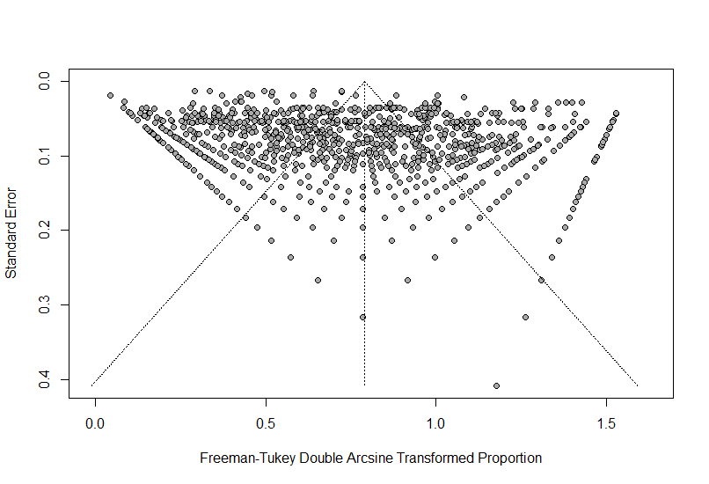
Figure S1. Funnel plot of included studies.

Supplementary Material 2: Pooled Prevalence of Antimicrobial Resistance in Bacterial Pathogens
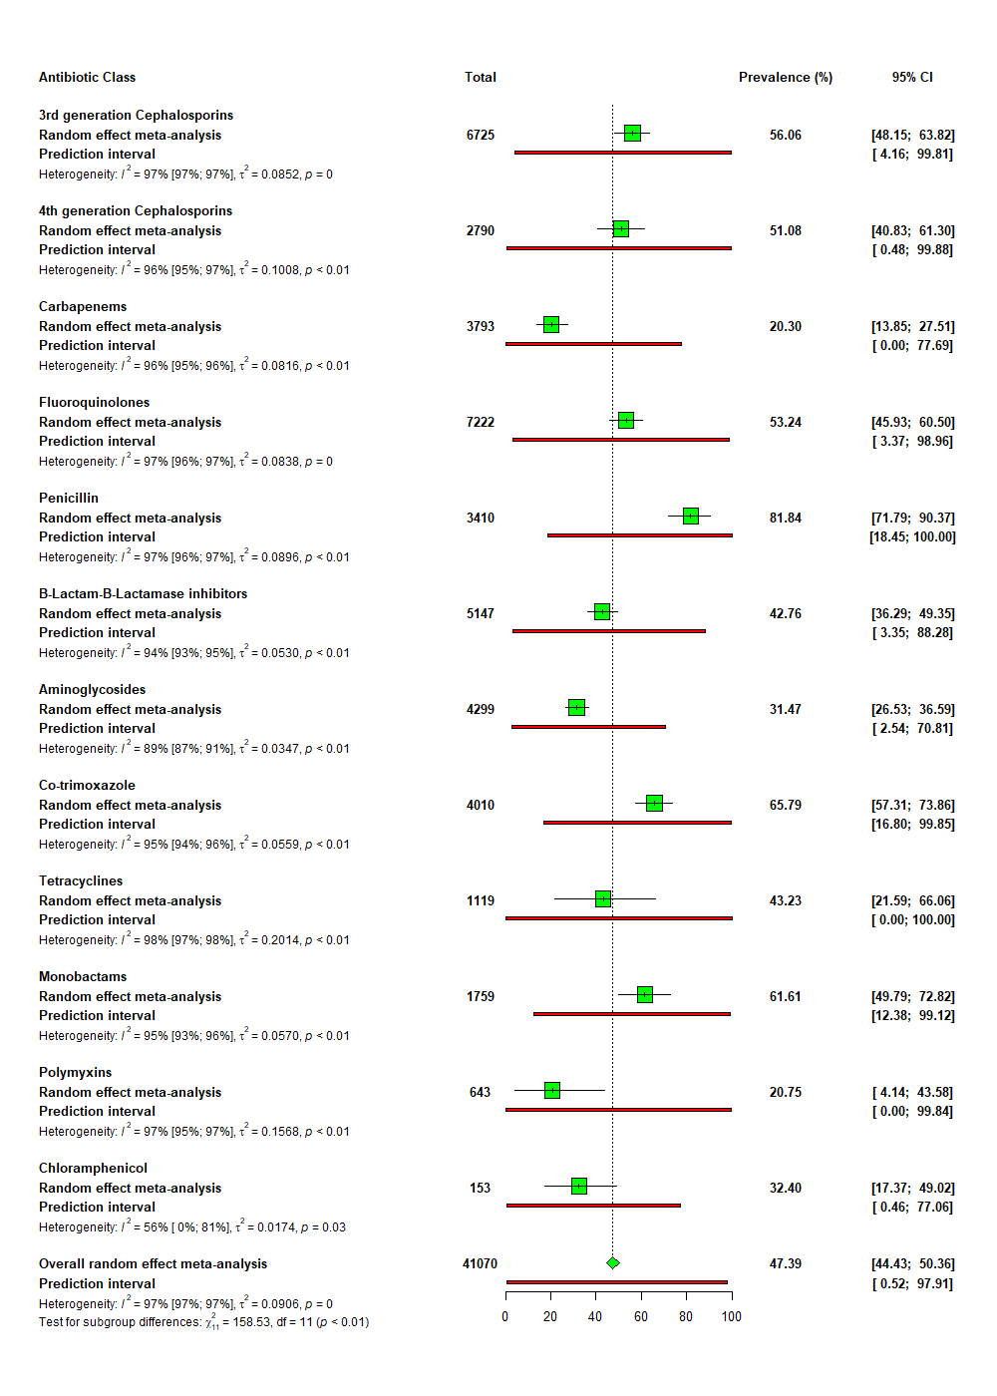

Figure S2. Forest plot of pooled prevalence of AMR in Escherichia coli infection.
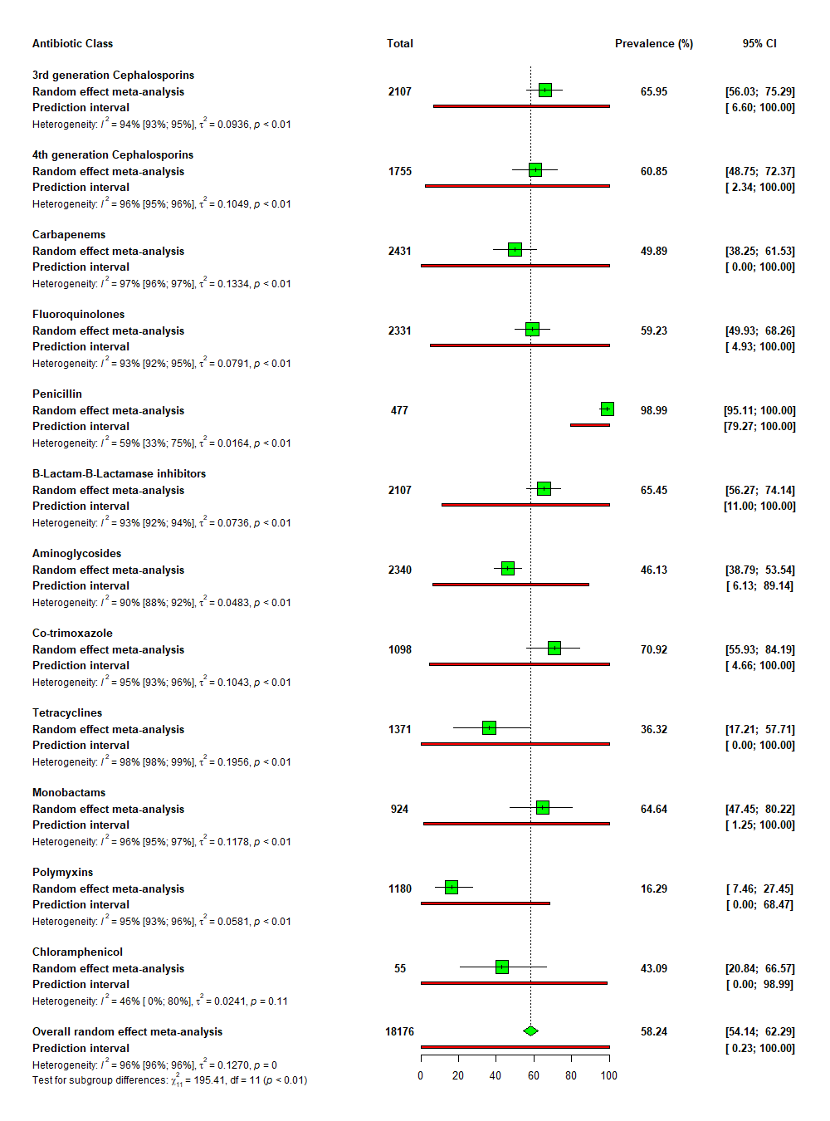

Figure S3. Forest plot of pooled prevalence of AMR in Klebsiella pneumoniae infection.
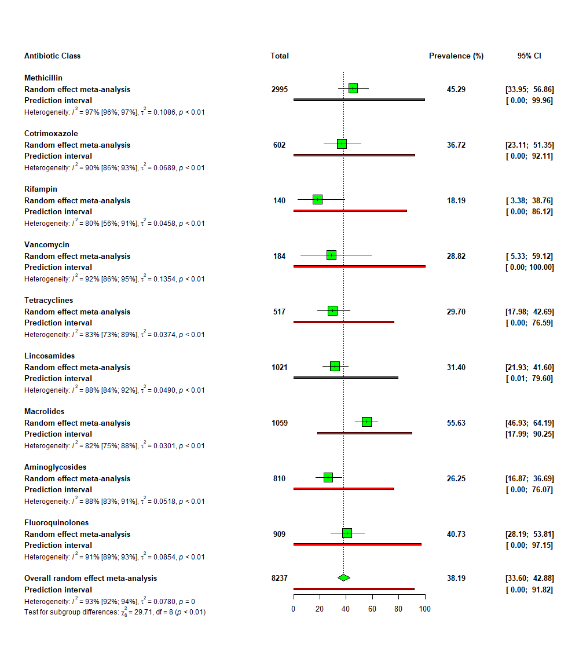

Figure S4. Forest plot of pooled prevalence of AMR in Staphylococcus aureus infection.
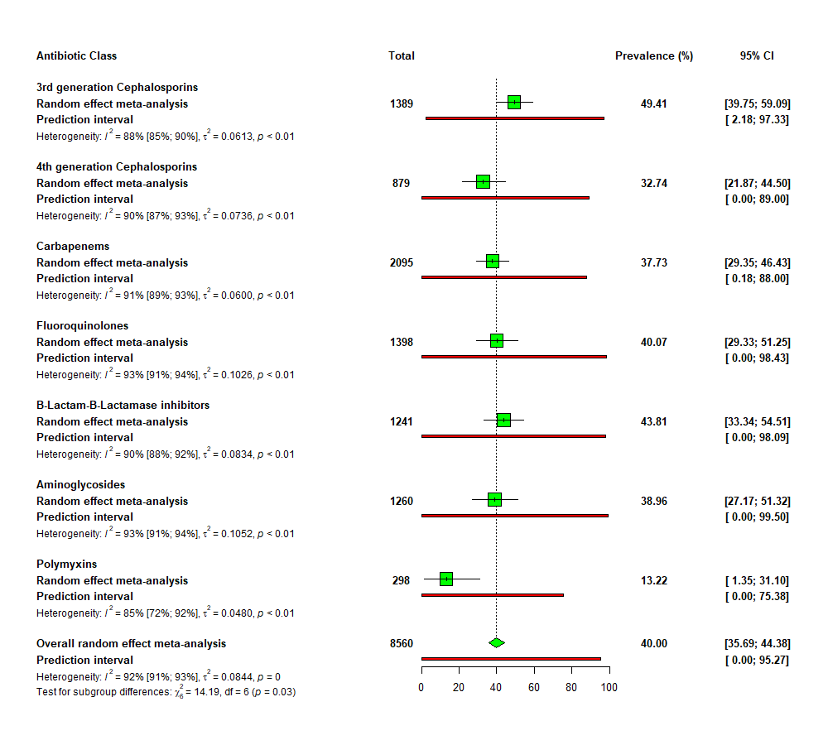

Figure S5. Forest plot of pooled prevalence of AMR in Pseudomonas aeruginosa infection.
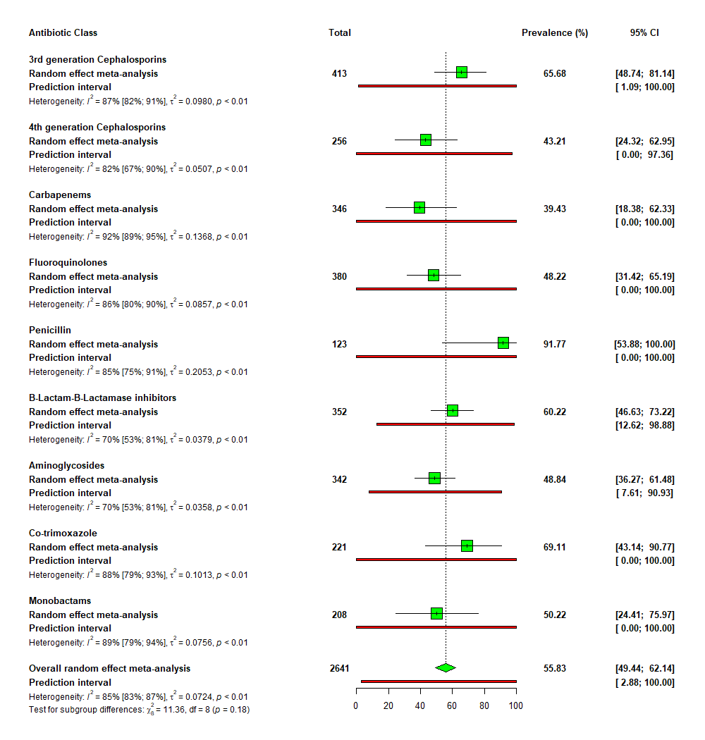

Figure S6. Forest plot of pooled prevalence of AMR in Enterobacter spp. infection.
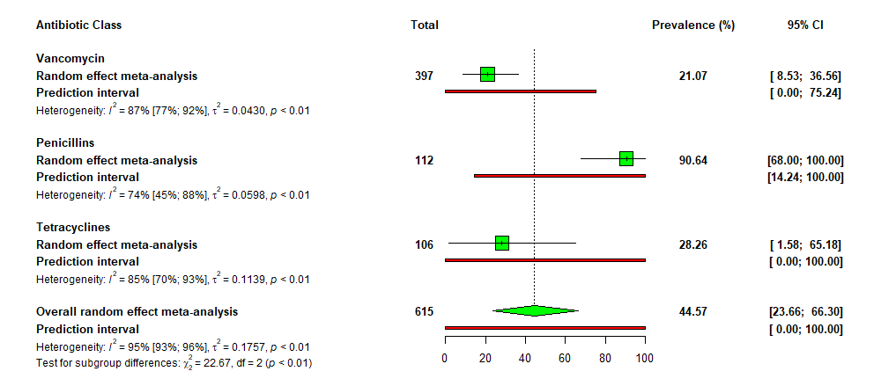Figure S7. Forest plot of pooled prevalence of AMR in Enterococcus faecium infection.
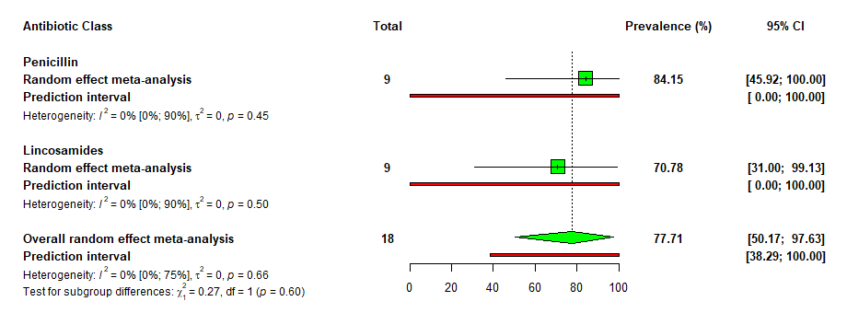
Figure S8. Forest plot of pooled prevalence of AMR in Streptococcus pneumoniae infection.
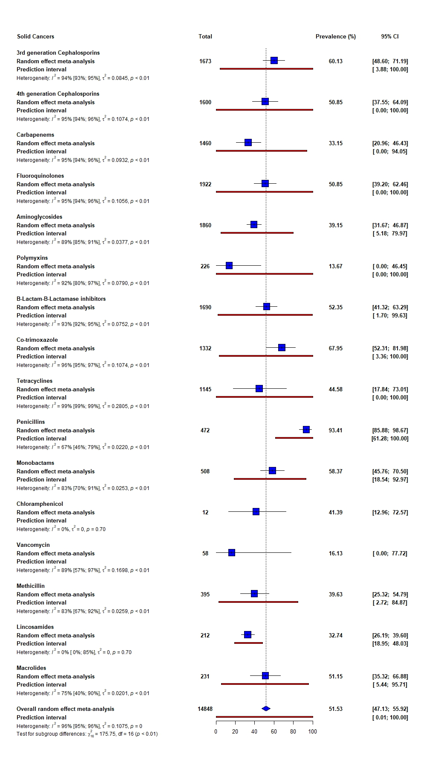
Figure S9. Forest plot of pooled prevalence of AMR among studies involving only solid cancer patients.
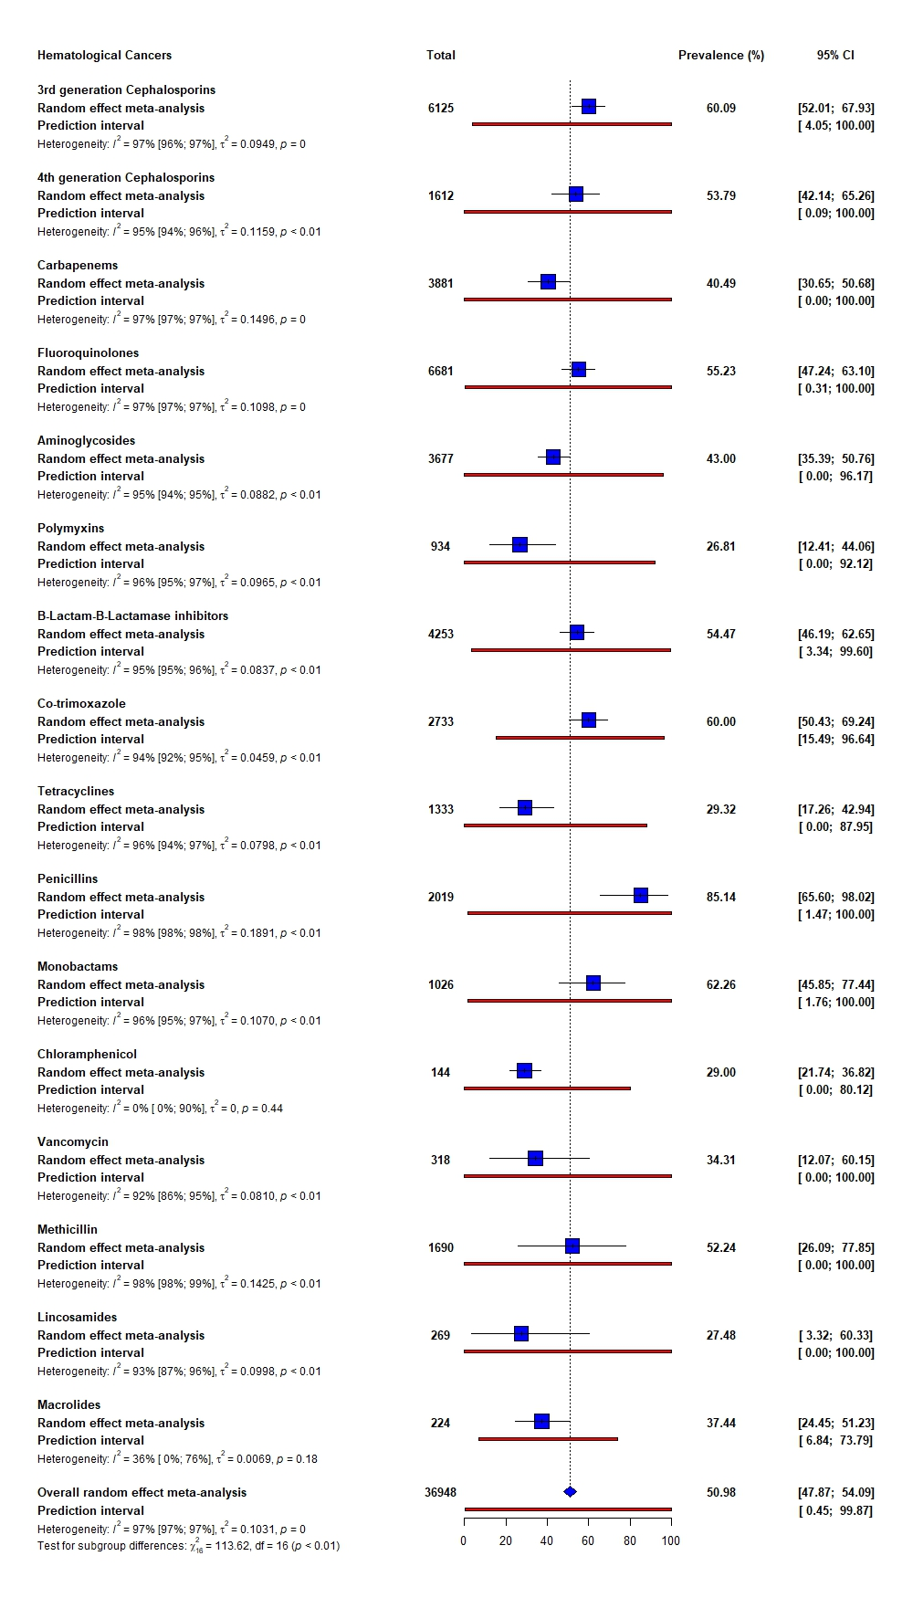
Figure S10. Forest plot of pooled prevalence of AMR among studies involving only haematological cancer patients.
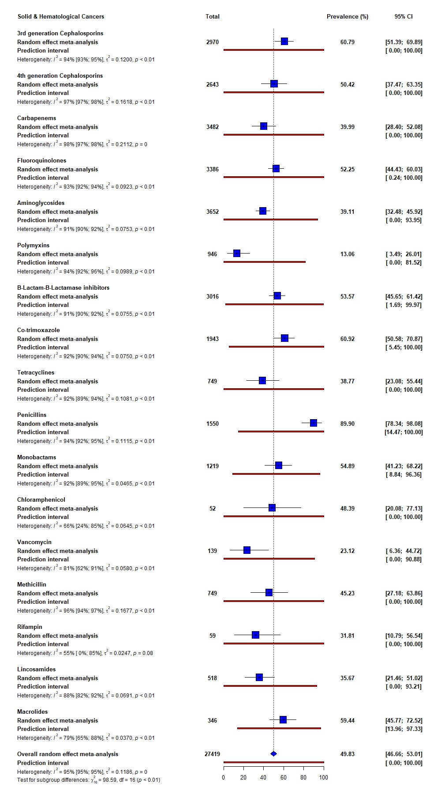
Figure S11. Forest plot of pooled prevalence of AMR among studies involving both cancer types.
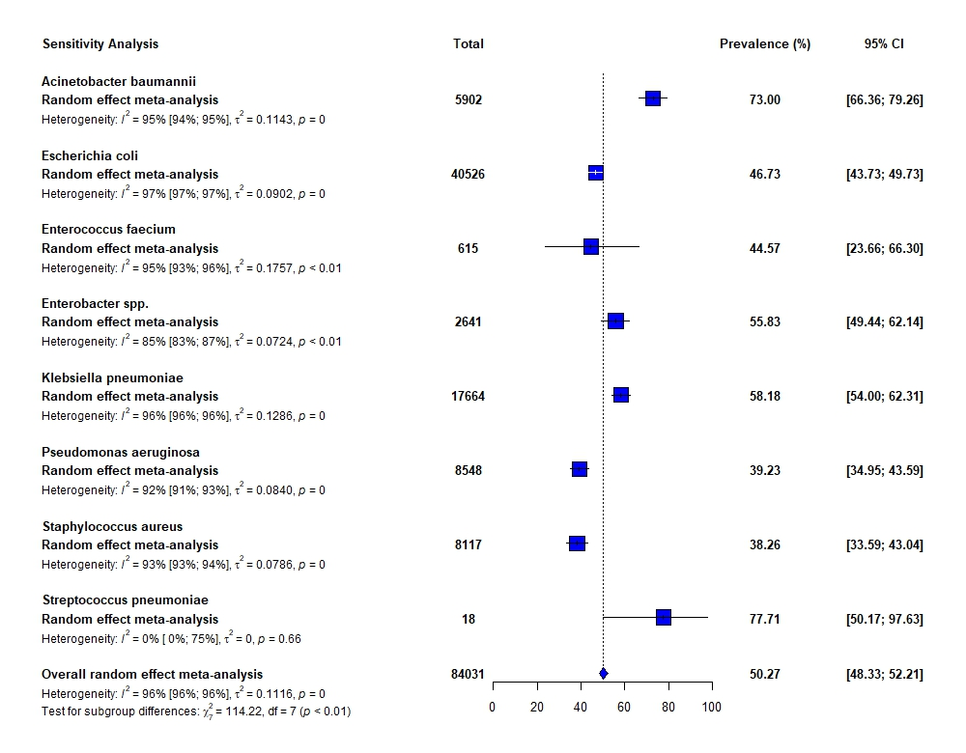
Figure S12. Forest plot of the sensitivity analysis excluding low-quality studies

