Supplement

eMethod 1: COVID-19 Stringency Index.
eMethod 2: Estimation of the instantaneous reproduction number.
eMethod 3: SVIRS model.
eFigure 1: Schematic illustration of the mechanistic model.
eFigure 2: COVID-19 Stringency Index in Beijing, China, from 2020-2022.
eTable: Description of model parameters and variables.

eMethod 1. COVID-19 Stringency Index
The Oxford Covid-19 Government Response Tracker (OxCGRT) is a project that collected information on policy measures to tackle COVID-19 over the years 2020, 2021, and 2022. The team is continuing research into the impacts and determinants of pandemic policy and working with partners to devise new approaches to data collection that can be deployed quickly in the face of future pandemics or global emergencies.
The OxCGRT dataset was collected by a team of over 1500 volunteers and published in real-time to understand variations in government responses and the effects of different policies on the pandemic and other outcomes of interest. By May 2023, most countries have lifted their COVID-19-related policies and the WHO declared an end to the public health emergency of international concern. The OxCGRT project, therefore, shifted its primary focus from collecting and reviewing data on government responses to the pandemic to carrying out cutting-edge research using the indicators we created in the past three years and providing decision-makers with evidence-based policy recommendations on the most effective responses in fighting future pandemics and epidemics.
The Oxford Coronavirus Government Response Tracker (OxCGRT) project calculate a Stringency Index, a composite measure of nine of the response metrics.
The nine metrics used to calculate the Stringency Index are: school closures; workplace closures; cancellation of public events; restrictions on public gatherings; closures of public transport; stay-at-home requirements; public information campaigns; restrictions on internal movements; and international travel controls.
The index on any given day is calculated as the mean score of the nine metrics, each taking a value between 0 and 100. A higher score indicates a stricter response (i.e. 100 = strictest response). If policies vary at the subnational level, the index is shown as the response level of the strictest sub-region.

eMethod 2. Estimation of the real-time effective reproduction number
Following Cori et al. [1], we assume that the distribution of infectiousness through time after infection is independent of calendar time. We model transmission with a Poisson process, so that the rate at which someone infected in time step t-s generates new infections in time step t, is equal to $R_{t}w_{s}$, where $R_{t}$is the instantaneous reproduction number at time and $w_{s}$ a probability distribution (hence summing to 1) describing the average infectiousness profile after infection. Therefore the incidence at time is Poisson distributed with mean${ R}_{t}\sum_{s=1}^{t}{I_{t-s}}w_{s}$, and the likelihood of the incidence${ I}_{t}$given the reproduction number${ R}_{t}$, conditional on the previous incidences ${ I}_{0},…,{ I}_{t-1}$, is:
$$P\left({ I}_{t} | { I}_{0}, …,{ I}_{t-1}, w, R_{t}\right)=\frac{{\left(R_{t}Λ_{t}\right)}^{{ I}_{t}}e^{-R_{t}Λ_{t}}}{{ I}_{t}!}$$
with $Λ_{t}$=$\sum_{s=1}^{t}{I_{t-s}}w_{s}$
Now, if transmissibility is assumed constant over a time period [t-$τ+1;t]$, measured by the reproduction number noted$R_{t,τ}$, the likelihood of the incidence during this time period, ${ I}_{t-τ+1},…,{ I}_{t}$ given the reproduction number$R_{t,τ}$, conditional on the previous incidences
${ I}_{0},…,{ I}_{t-τ}$ is:
$$P\left({ I}_{t-τ+1},…,I_{t} | { I}_{0}, …,{ I}_{t-τ}, w, R_{t,τ}\right)=\frac{{\left(R_{t,τ}Λ_{s}\right)}^{{ I}_{s}}e^{-R_{t,τ}Λ_{s}}}{{ I}_{s}!}.$$
Using a Bayesian framework with a Gamma distributed prior with parameters ($α,b$) for$R_{t,τ}$, the posterior joint distribution of $R_{t,τ}$ is
$$P\left({ I}_{t-τ+1},…,I_{t}, R_{t,τ} | { I}_{0}, …,{ I}_{t-τ}, w\right)= P\left({ I}_{t-τ+1},…,I_{t} | { I}_{0}, …,{ I}_{t-τ}, w, R_{t,τ}\right)P\left(R_{t,τ}\right)$$
$$=\left(\prod_{s=t-τ+1}^{t}{\frac{{\left(R_{t,τ}Λ_{s}\right)}^{{ I}_{s}}e^{-R_{t,τ}Λ_{s}}}{{ I}_{s}!})(}\frac{R_{t,τ}^{a-1}e^{-\frac{R_{t,τ}}{b}}}{Γ\left(a\right)b^{a}}\right)$$
$$=R_{t,τ}^{a+\sum_{s=t-τ+1}^{t}{I_{s}}-1}e^{{-R}_{t,τ}\left(\sum_{s=t-τ+1}^{t}{Λ_{s}+\frac{1}{b}}\right)}\prod_{s=t-τ+1}^{t}{\frac{Λ_{s}^{{ I}_{s}}}{I_{s}!}}\frac{1}{Γ\left(a\right)b^{a}}$$
Which is proportional to:
$R_{t,τ}^{a+\sum_{s=t-τ+1}^{t}{I_{s}}-1}e^{{-R}_{t,τ}\left(\sum_{s=t-τ+1}^{t}{Λ_{s}+\frac{1}{b}}\right)}\prod_{s=t-τ+1}^{t}{\frac{Λ_{s}^{{ I}_{s}}}{I_{s}!}}$.
Therefore, the posterior distribution of $R_{t,τ}$ is a Gamma distribution with parameters $(a+\sum_{s=t-τ+1}^{t}{I_{s}},\frac{1}{\frac{1}{b}+\sum_{s=t-τ+1}^{t}{Λ_{s}}}$). In particular, the posterior mean of${ R}_{t,τ}$ is$\frac{a+\sum_{s=t-τ+1}^{t}{I_{s}}}{\frac{1}{b}+\sum_{s=t-τ+1}^{t}{Λ_{s}}}$, and the posterior coefficient of variation (CV, standard deviation divided by mean) of ${ R}_{t,τ}$ is$\frac{1}{\sqrt{a+\sum_{s=t-τ+1}^{t}{I_{s}}}}$.
The results shown in the main text were obtained using a Gamma prior distribution with mean 3.2 and standard deviation 1.3 (therefore $a=3.2, b=1.3$) for each${ R}_{t,τ}$[2]. The all method described above can be implemented using the R package, EpiEstim, which can be downloaded at http://cran.r-project.org/web/ packages/EpiEstim/index.html.
eMethod 3. SVIRS model
We developed a susceptible-vaccinated-infectious-recovered-susceptible (SVIRS) model-based inferential framework to fit these influenza activity proxy data (e.g., ILI+ proxy) first and conducted forecasting afterwards
$\frac{dS}{dt}=-β_{e}\left(t\right)$SI$-τ\left(t\right)$S +$ρ_{R}$R+$ρ_{V}V$
$\frac{dV}{dt}={-\left(1-ω\right)β}_{e}\left(t\right)$VI$-ρ_{V}V$+ $τ\left(t\right)$S
$\frac{dI}{dt}={\left(1-ω\right)β}_{e}\left(t\right)$VI+$β_{e}\left(t\right)$SI- $γ$I
$\frac{dR}{dt}=γ$I-$ρ_{R}$R
Such SVIRS model would give the following time-varying reproduction number, $R_{e}\left(t\right)$= $\frac{β_{e}\left(t\right)}{γ}$, defined as the expected number of secondary cases transmitted by an index case in an entirely susceptible population at time t. For the ease of interpretation, we modelled R_{t} instead of $βt$. Since the influenza epidemics are seasonally forced, we introduced sinusoidal functions with a period of 52.14 weeks for the seasonal variation in R_{t} as follows:

$R_{e}\left(t\right)$= $R_{e,min}+$($R_{e,max}-R_{e,min}$)expit($α_{0}$+$α_{1}\sin\left(2π\frac{t}{52.14}\right)+α_{2}\cos\left(2π\frac{t}{52.14}\right)$)
The parameters $α_{0}$, $α_{1}$ and $α_{2}$ are the coefficients for the seasonality of $R_{e}\left(t\right)$, where expit (.) is the logistic sigmoid function (i.e., the inverse of logit function). $R_{e,min}$ and $R_{e,max}$provided the range of $R_{e}\left(t\right)$, which are the possible minimum and maximum time-varying reproduction number for influenza infection respective. $R_{e,max}$is fixed as 4 and $R_{e,min}$ is fixed as 1.

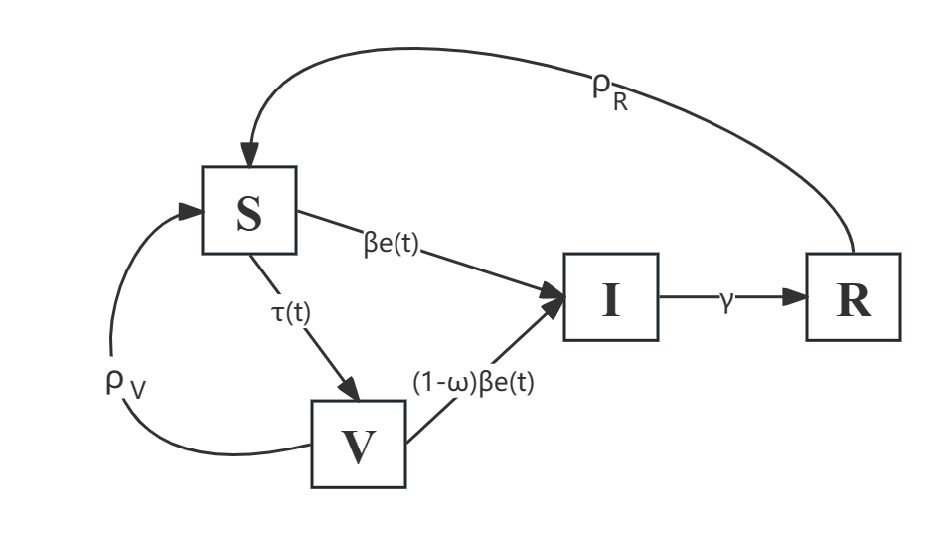
eFigure 1: Schematic illustration of the mechanistic model. The population is divided into 4 compartments, where S, V, I and R denote the susceptible, vaccinated, infectious and recovered individuals in the population, respectively, and $τ\left(t\right)$ denotes the vaccination rate. Notably, vaccine-acquired immunity wanes at a mean of 1/$ρ_{V}$ weeks. The process increment $H_{s}$ is the incidence number from compartments S to I with transmissibility $β_{e}(t)$, and the process increment $H_{V}$ is the incidence number from compartments V to I with transmissibility (1-$ω$) $β_{e}(t)$ under the leaky vaccine assumption of vaccine efficacy $ω$. The infectious population exhibits an infectious period of a mean of 1/$γ$ weeks and can transit to compartment R when recovered, while their infection-acquired immunity wanes 1/$ρ_{R}$ weeks later (mean), when they become susceptible again.

eFigure 2: The Stringency Index from 2020 to 2022 in Beijing, China. The stringency index is a composite measure based on nine response indicators, rescaled to a value from 0 to 100 (100 = strictest).

eTable: Description of model parameters and variables with their mode of estimation under the scheme of mechanistic model as illustrated in eFigure 1
Model variables and parameters | Description | Values and mode of estimation
S (t) | Susceptible individuals at time | Estimated by model
V (t) | Vaccinated individuals at time | Estimated by model
I (t) | Infectious individuals at time | Estimated by model
R (t) | Recovered individuals at time | Estimated by model
$$β_{e}(t)$$ | Transmission rate | Estimated by model
$$τ \left(t\right)$$ | Vaccination rate | Coverage: 9.4% [3]  Vaccination Period: October-December
$$ω$$ | Vaccine efficacy | 0.59 [4]
1/$γ$ | Mean infectious period | 4 days [5]
1/$ρ_{R}$ | Mean infection-acquired immunity waning delay | 1 year (Assumed)
1/$ρ_{V}$ | Mean vaccine-acquired immunity waning delay | 9 months [6]

References
1. Cori A, Ferguson NM, Fraser C, Cauchemez S. A new framework and software to estimate time-varying reproduction numbers during epidemics. Am J Epidemiol. 2013 Nov 1;178(9):1505-12.
2. Cowling BJ, Chan KH, Fang VJ, et al. Comparative epidemiology of pandemic and seasonal influenza A in households. New England Journal of Medicine 2010; 362: 2175-84.
3. Wang Q, Yue N, Zheng M, Wang D, Duan C, Yu X, Zhang X, Bao C, Jin H. Influenza vaccination coverage of population and the factors influencing influenza vaccination in mainland China: A meta-analysis. Vaccine. 2018 Nov 19;36(48):7262-7269. doi: 10.1016/j.vaccine.2018.10.045.
4. Osterholm MT, Kelley NS, Sommer A, Belongia EA. Efficacy and effectiveness of influenza vaccines: a systematic review and meta-analysis. Lancet Infect Dis. 2012 Jan;12(1):36-44. doi: 10.1016/S1473-3099(11)70295-X.
5. Centre for Disease Control and prevention (CDC), Hong Kong SAR, Key Facts About Influenza (Flu), (9 June 2022), https://www.cdc.gov/flu/about/keyfacts.htm. 2022.
6. Young B, Sadarangani S, Jiang L, Wilder-Smith A, Chen MI. Duration of Influenza Vaccine Effectiveness: A Systematic Review, Meta-analysis, and Meta-regression of Test-Negative Design Case-Control Studies. J Infect Dis. 2018 Feb 14;217(5):731-741. doi: 10.1093/infdis/jix632.

