Additional file 1. Description of commercial ELISA kits for IgM detection by study collection phase
 | Commercial ELISA kit
 | DENV IgM  Euroimmun® |  | ZIKV IgM  Vircell® |  | CHIKV IgM  Dia.pro® |  | CHIKV IgM  Vircell®
Phase collection | n | 1 and 2 | n | 1 and 2 | n | only 1 | n | only 2
Total samples tested (count, %) | 1,405 | 100 | 1,405 | 100 | 377 | 26.8 | 1,208 | 73.2
Antibody IgM (count, %)
Positive | 118 | 8.4 | 210 | 14.9 | 6 | 1.6 | 33 | 3.2
Negative | 1,210 | 86.1 | 1105 | 78.6 | 368 | 97.6 | 971 | 94.5
Borderline | 77 | 5.5 | 90 | 6.4 | 3 | 0.5 | 24 | 2.3

Additional file 2. Description of commercial ELISA kits for IgG detection by study collection phase
 | Commercial ELISA kit
 | DENV IgG  Euroimmun® |  | ZIKV IgG  Vircell® |  | ZIKV IgG Euroimmun® |  | CHIKV IgG  Mobius Life® |  | CHIKV IgG Euroimmun®
Phase collection | n | 1 and 2 | n | 1 and 2 | n | 1 and 2 | n | only 1 | n | only 2
Total samples tested | 1,405 | 100 | 1,405 | 100 | 403 | 28,6 | 377 | 26,8 | 1,208 | 73,2
Antibody IgG (count, %)
Positive | 891 | 63.4 | 608 | 43.3 | 60 | 14.9 | 14 | 3.7 | 29 | 2.8
Negative | 488 | 34.7 | 605 | 43.1 | 330 | 81.9 | 359 | 95.2 | 987 | 96.0
Borderline | 26 | 1.85 | 192 | 13.7 | 13 | 3.2 | 4 | 1.1 | 12 | 1.2

Additional file 3. Seroprevalence analysis of antibody classes and their confidence intervals with and without borderline results
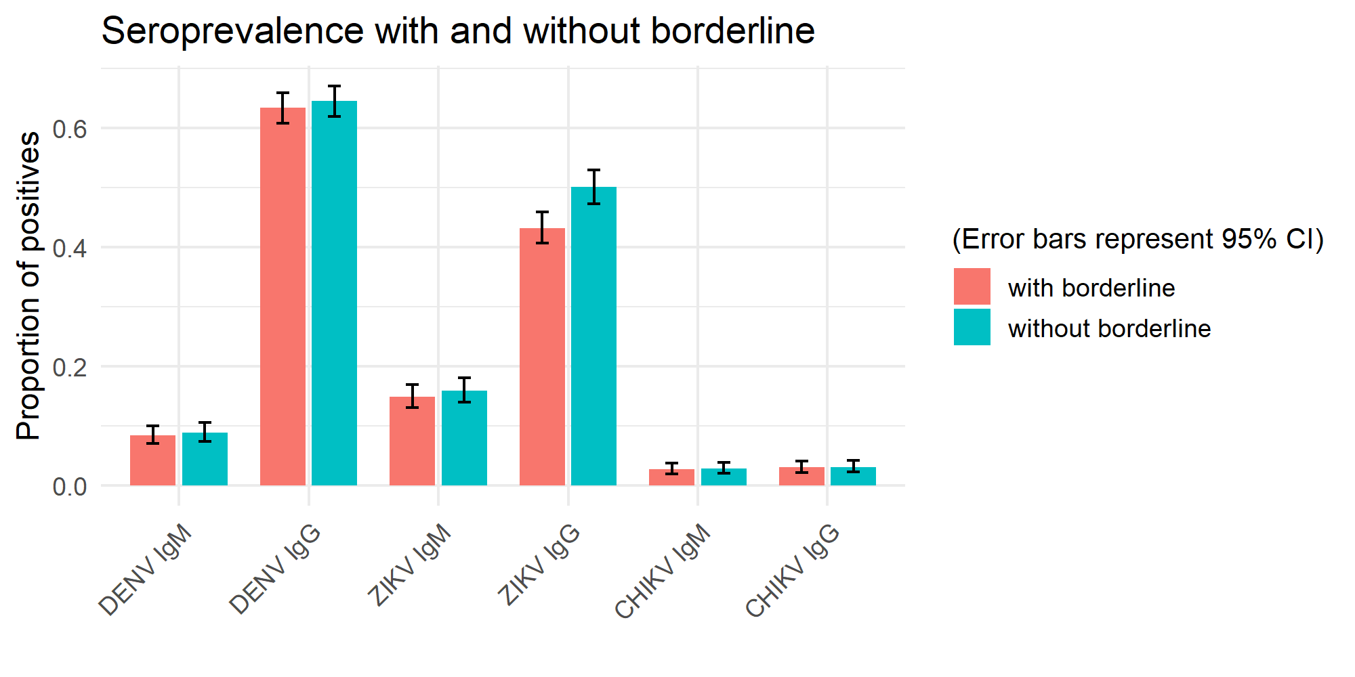

Additional file 4. Estimates of underreported cases. São Sebastião, Federal District, Brazil, 2020-2021
Arbovirus | Period | Seroprevalence | Estimated infections^{c} | Reported cases | Multiplication factor
Dengueª | 2006 to 2021 | 45.4 | 54.013 | 13,027 | 4.1
Zika^{b} | 2015 to 2021 | 0.24 | 286 | 16 | 17.8
Chikungunya | 2014 to 2021 | 3.1 | 3.688 | 44 | 83.8
ª and ^{b} only cases of monoinfection^{c} and population 118,972 inhabitants was considered to calculate the estimates

