Supplementary material. Questionnaire on demographic information and arbovirus exposure
Question | Response options
What is your date of birth? | (mm/dd/yyyy)
What is your gender? | (1) Female, (2) Male, (3) Other, (4) Prefer not to disclose
What is your level of education? | (1) Illiterate, (2) Elementary School, (3) High School, (4) University
Have you ever had dengue? | (1) Yes, (2) No, (3) Don't know
Have you ever had Zika? | (1) Yes, (2) No, (3) Don't know
Have you ever had chikungunya? | (1) Yes, (2) No, (3) Don't know

Supplementary material. Antibody index scatterplots
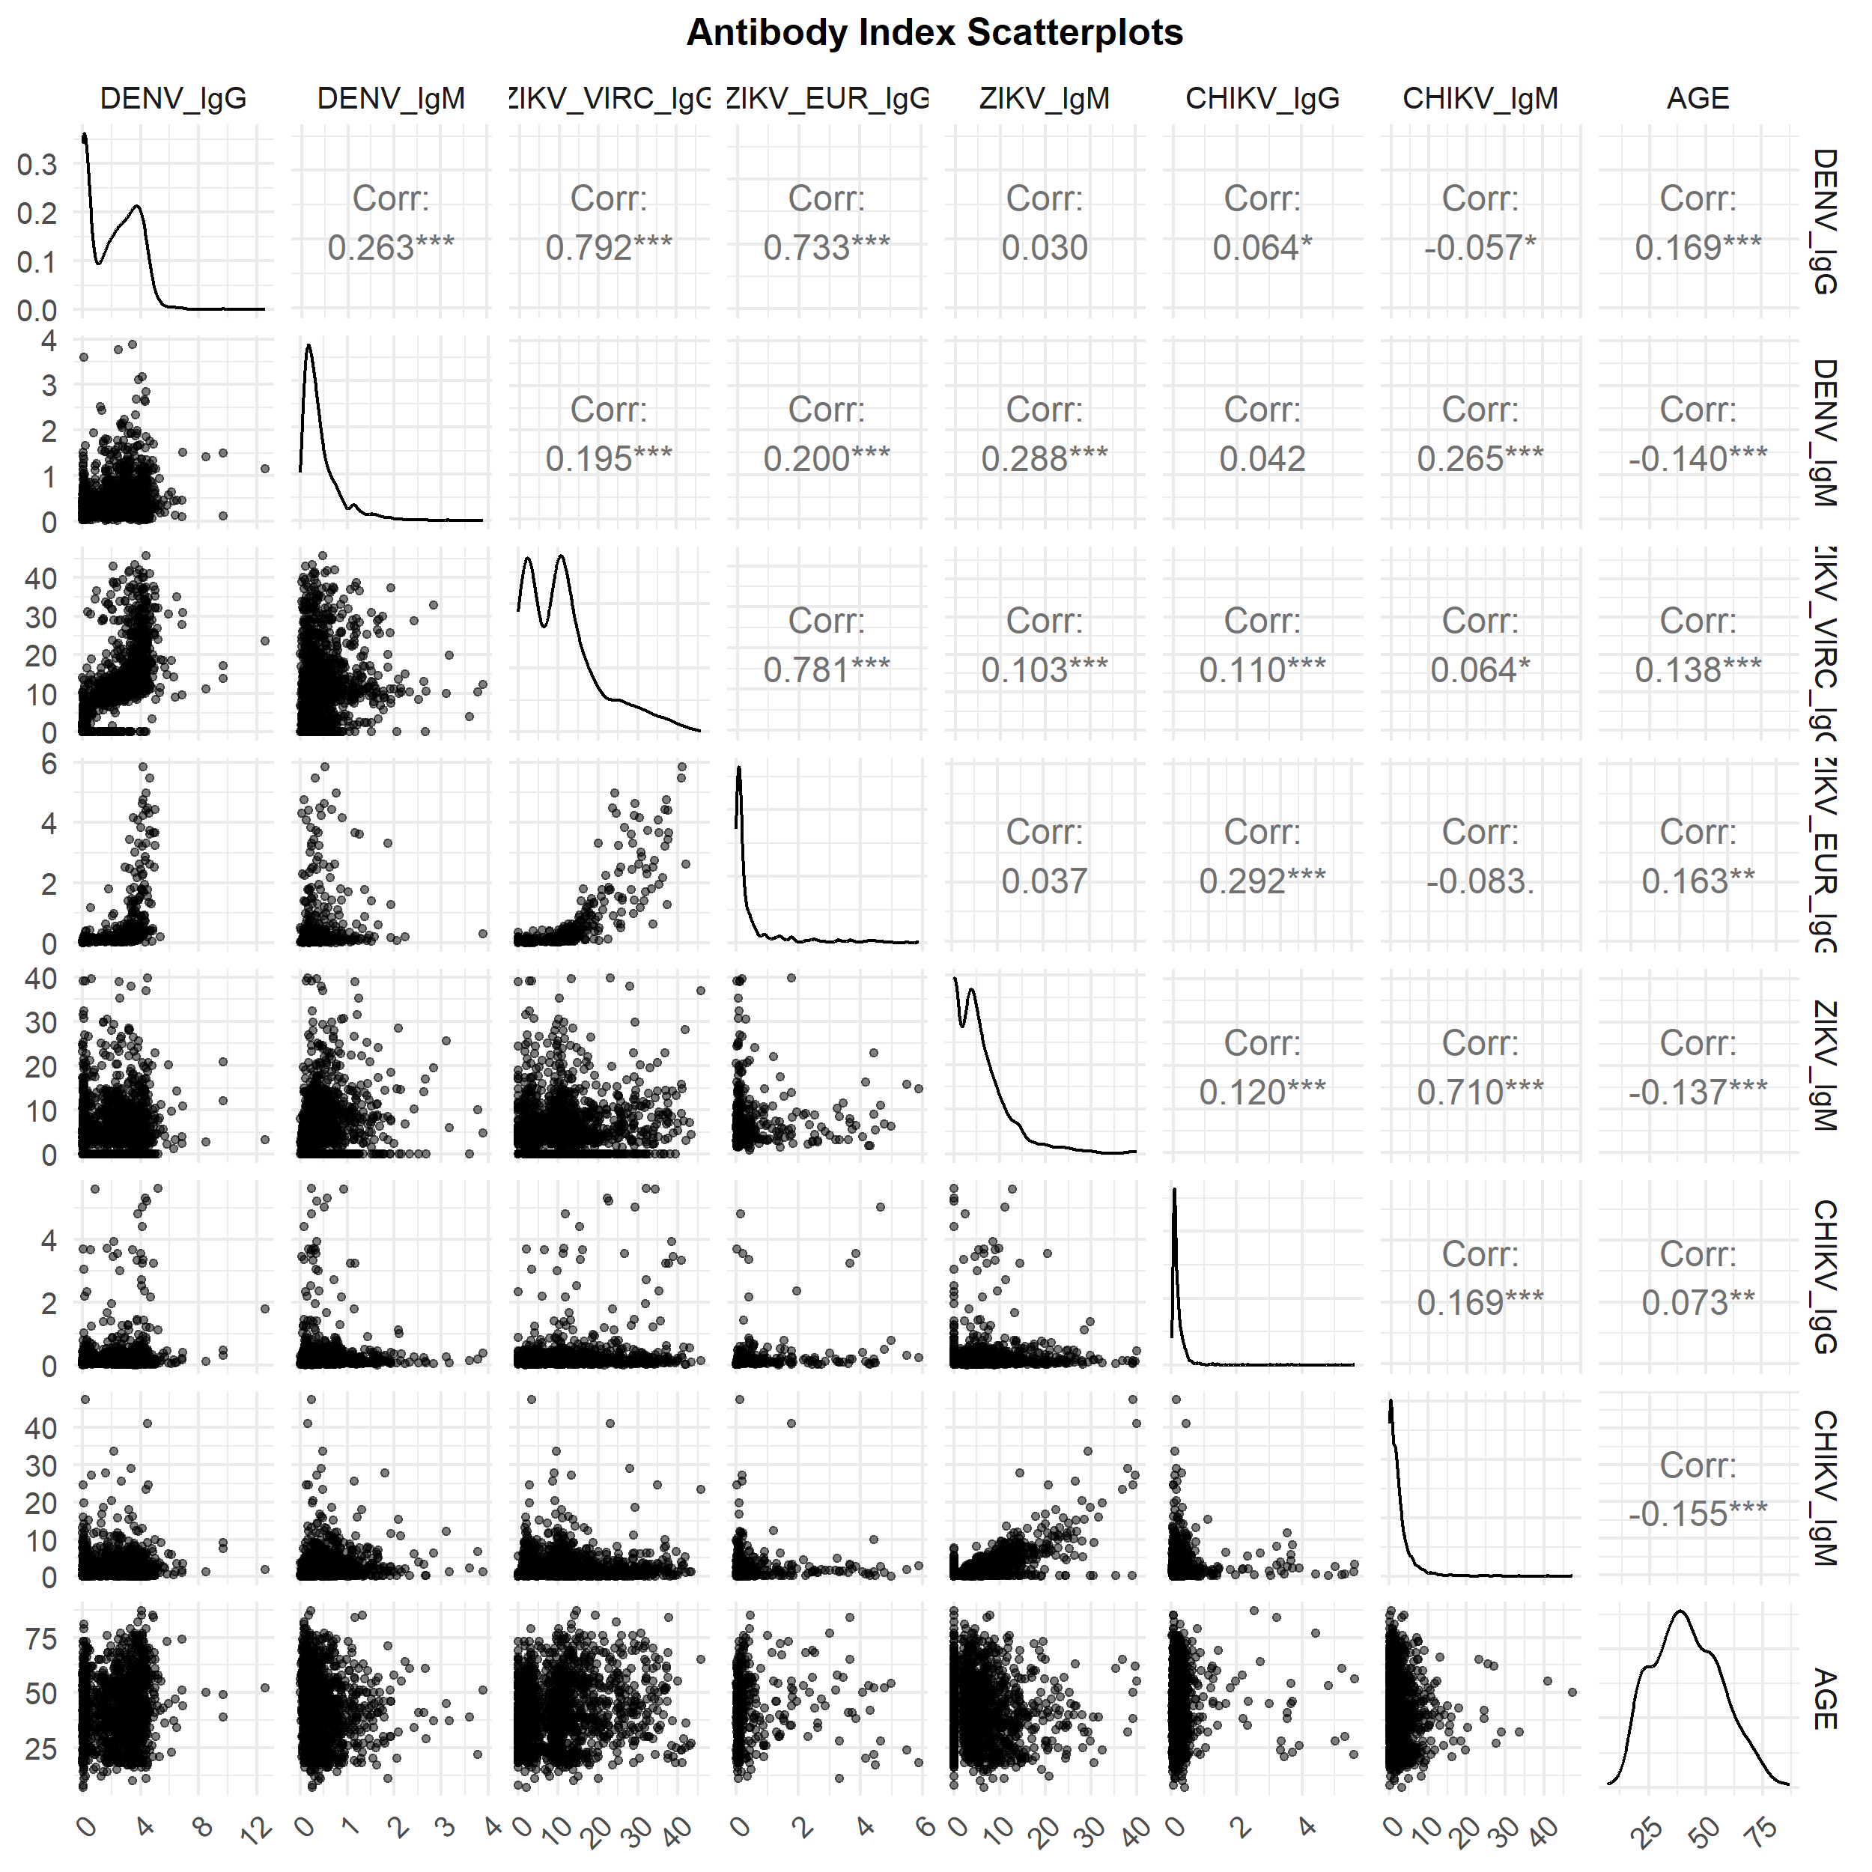

Supplementary material. Sensitivity Analysis
