Supplementary material

Supplementary Figure 1: Reasons for consulting at the outpatient department (n = 339, multiple reasons may apply)
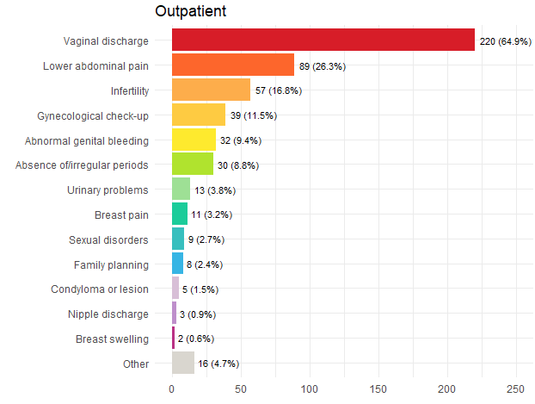

Supplementary Table 1: Comparison of STI/BV status for the six most common reasons for consulting at the outpatient department.
Reason for consulting | Women at the OPD* with STI† or BV  (N = 191) | Women at the OPD* with no STI† and no BV  (N = 141) | p-value‡
Vaginal discharge | 132 (69%) | 84 (60%) | 0.072
Lower abdominal pain | 44 (23%) | 44 (31%) | 0.10
Infertility | 33 (17%) | 24 (17%) | >0.9
Gynecological check-up | 13 (6.8%) | 24 (17%) | 0.003
Abnormal genital bleeding | 20 (10%) | 11 (7.8%) | 0.4
* OPD: Outpatient department. At the OPD, seven patients had missing values for BV and have been excluded, thus 332 patients were included in this analysis.
† STI includes infection with CT, NG, TV, or MG
‡ Statistical analyses were conducted using Chi-2 test

Supplementary Figure 2: Prevalence of CT, NG, TV, MG, CA, and BV by recruitment site and overall.
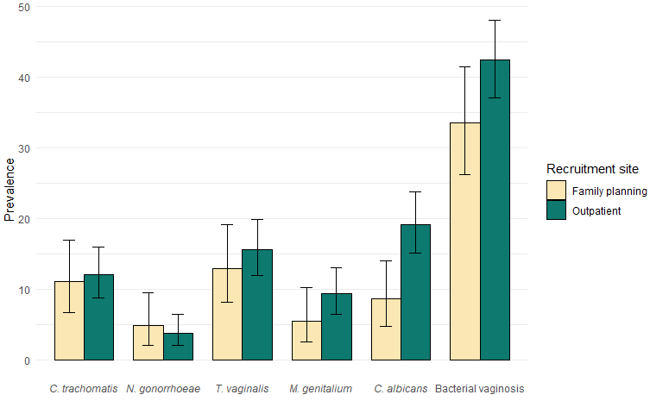
p = 0.004

Supplementary Table 2: Socio-demographic characteristic of women included in and excluded from the logistic regressions assessing factors associated with at least one STI.

Characteristics |  | Total  (N = 501) | Included in the analyses  (N = 463) |  | Excluded from the analyses  (N = 38) |  | p-value*
Age |  |  |  |  |  |  | 0.5
 | 18 – 24 | 185 | 172 | (37%) | 13 | (34%)
 | 25 – 34 | 224 | 204 | (44%) | 20 | (53%)
 | 35 – 45 | 92 | 87 | (19%) | 5 | (5%)
Education level |  |  |  |  |  |  | >0.9
 | No schooling or primary school | 62 | 56 | (12%) | 6 | (16%)
 | Middle school | 118 | 110 | (24%) | 8 | (21%)
 | High school | 132 | 122 | (26%) | 10 | (26%)
 | Higher education | 189 | 175 | (38%) | 14 | (37%)
Marital status |  |  |  |  |  |  | 0.4
 | Single / Divorced | 68 | 60 | (13%) | 8 | (21%)
 | In a relationship | 191 | 177 | (38%) | 14 | (37%)
 | Married | 242 | 226 | (49%) | 16 | (42%)
Activity |  |  |  |  |  |  | 0.2
 | Owner of their own business | 151 | 134 | (29%) | 17 | (45%)
 | Civil servant / Private sector | 160 | 149 | (32%) | 11 | (29%)
 | Jobless / Housewife / On leave | 118 | 112 | (24%) | 6 | (16%)
 | Student | 72 | 68 | (15%) | 4 | (11%)
STI |  |  |  |  |  |  | 0.1
 | No | 349 | 327 | (71%) | 22 | (58%)
 | Yes | 152 | 136 | (29%) | 16 | (42%)
* Statistical analyses were conducted using Chi-2 test

Supplementary Table 3: Factors associated with CT infections
Characteristic | Odds ratio | 95% CI | p- value
Age category |  |  | 0.001
18 – 24  25 – 34  35 – 45 | 5.92  3.04  - | 2.03, 25.2  1.01, 13.2  - | 0.004  0.079

Supplementary Table 4: Factors associated with NG infections
Characteristic | Odds ratio | 95% CI | p- value
Ever had sex in exchange for favors
No  Yes | -  8.51 | -  1.77, 31.6 | 0.011

Supplementary Table 5: Factors associated with TV infections
Characteristic | aOR | 95% CI | p- value
Ever had sex in exchange for favors
No  Yes | -  6.19 | -  1.78, 22.0 | 0.005
Vaginal microbiota |  |  | <0.001
Optimal  Intermediate  Bacterial vaginosis | -  5.77  4.88 | -  2.55, 14.0  2.35, 11.2 | <0.001  <0.001

We found no factors associated with MG infections.

