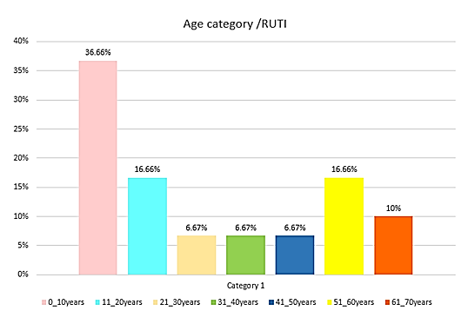
Supplementary file 2: Frequency distribution of urinary infection caused by uropathogenic Escherichia coli based on different age groups of patients with recurrent urinary infection.

