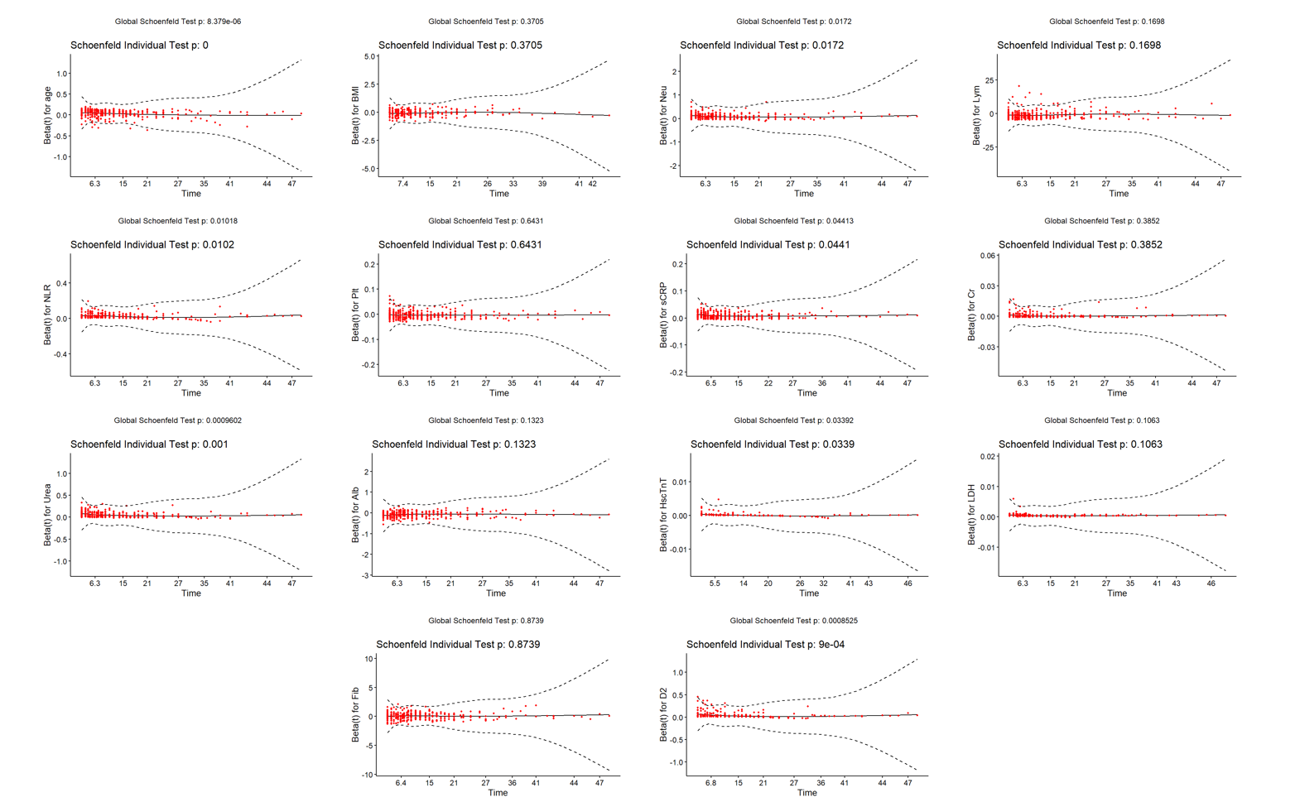
Supplementary Figure 1 Identification of continuous variables associated with in-hospital all-cause mortality in COVID-19 pneumonia patients with nonVTE using Schoenfeld residual method
BMI: body mass index; Neu: neutrophil; Lym: lymphocytes; NLR: neutrophil/lymphocyte ratio; Plt: platelets; Cr: creatinine; sCRP: hypersensitive C-reactive protein; Alb: albumin; Hs-cTnT: high-sensitivity cardiac troponin T; Fib: fibrinogen; D2: D-dimer; LDH: lactate dehydrogenase; COVID: coronavirus disease 2019; VTE: venous thromboembolism.

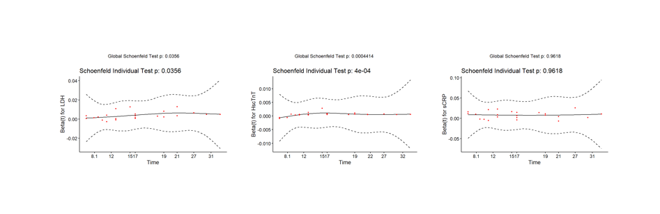
Supplementary Figure 2 Identification of continuous variables associated with in-hospital all-cause mortality in COVID-19 pneumonia patients with VTE using Schoenfeld residual method
sCRP: hypersensitive C-reactive protein; Hs-cTnT: high-sensitivity cardiac troponin T; LDH: lactate dehydrogenase; COVID: coronavirus disease 2019; VTE: venous thromboembolism.

Supplementary Table 1 Collinearity diagnosis of independent variables in multiple logistic regression analysis
model | Collinearity Statistics
model | Tolerance | VIF
(constant)
BMI | 0.962 | 1.039
Lym | 0.844 | 1.185
Plt | 0.875 | 1.143
Cr | 0.956 | 1.046
Alb | 0.912 | 1.097
LDH | 0.934 | 1.070
Fib | 0.872 | 1.147
BMI: body mass index; Lym: lymphocytes; Plt: platelets; Cr: creatinine; Alb: albumin; Fib: fibrinogen; LDH: lactate dehydrogenase.

