Supplemental Appendices
Figure S1. Flowchart for calibration process
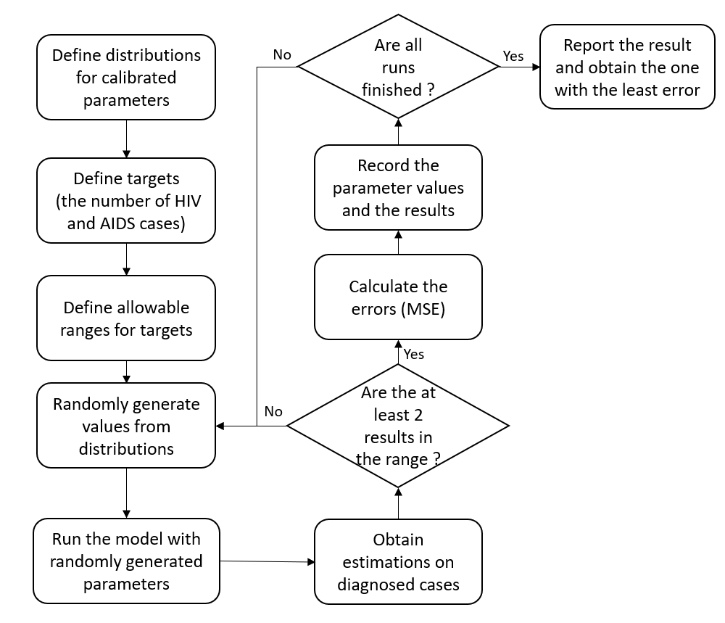

Table S1. Sources for calibration distributions and their values
Source | Diagnosed Rate | Treatment Rate
Gokengin D, Tabak F, Korten V, Lazarus J V, Unal S. The HIV Treatment Cascade in Turkey. HepHIV 2019 Bucharest Conference: Challenges of Timely and Integrated Testing and Care. 2019. p. P04/09. | 50% | 86%
Gokengin D, Cimen C, Cagatay A, Gencer S, Akalin H, Ceran N, et al. HIV cascade of care in Turkey:  Data from the HIV-TR cohort. HIV Med. 2019; 20: 112–113. | 41% and 48% | 88%
Yaylali, E., Erdogan, Z. M., Calisir, F., Gokengin, D., Korten, V., Tabak, F., ... & Sahin, T. (2023). Modeling the future of HIV in Turkey: cost-effectiveness analysis of improving testing and diagnosis. Plos one, 18(6), e0286254. | 47.80% | 70% and 87% based on CD4 level
Bilek, H. C., Deveci, A., & Aksakal-Tanyel, E. (2020). " 90-90-90" Hedefleri Bağlamında Tek Merkez HIV/AIDS Kohortu Değerlendirmesi. Klimik Journal/Klimik Dergisi, 33(1). | _ | 75.3%
Erdinc, F. S., Dokuzoguz, B., Unal, S. E. R. H. A. T., Komur, S. Ü. H. E. Y. L. A., Inkaya, A. C., İnan, D., ... & Multicentric Hiv Study Group. (2020). Temporal trends in the epidemiology of HIV in Turkey. Current HIV research, 18(4), 258-266. | _ | 79% (retained in care)

Table S2. Mixing Matrix for force of infection and intervals from the best 10 calibration sets
 | MSM | PWID | HET
MSM | 0.98  (0.90-0.99) | 0.97  (0.75-0.98) | 0.60  (0.52-0.81)
PWID | 0.88  (0.84-0.99) | 0.74  (0.59-0.87) | 0.47  (0.29-0.60)
HET | 0.79  (0.66-0.95) | 0.56  (0.47-0.83) | 0.33  (0.22-0.34)

Calculations on input parameters
We estimated the progression rates (p, q and r) by using the 1 - e^{1/year} formula while assuming these parameters are exponentially distributed which is common assumption in these types of models and performed following calculations:
p = q = 1 - e^{1/32} = 0.03
r = 1 - e^{1/71} = 0.0139
Here, 32 and 71 corresponds the expected years of life that a person with HIV diagnosed at age 20 not diagnosed and taking ART treatment, respectively based on CDC’s Vital Signs.

Table S3 shows Bernoulli model results depending on various treatment rates from the literature.
Table S3. Estimated HIV incidences according to MSM category and HIV prevalence rates for MSM depending on the treatment rates.
Treatment Rate | HIV  Prevalence | Category of MSM  population size |  | MSM Population |  |  | HIV Incidence of MSM | Total HIV Incidence |  | Percentage of MSM (%) |  |  | Diagnosis rate (%)
 | 0.03 | Low |  | 40.000 |  |  | 687 | 5.569 |  | 12,3% |  |  | 72,5%
 | 0.03 | Medium |  | 200.000 |  |  | 3.437 | 8.318 |  | 41,3% |  |  | 48,5%
86% | 0.03 | High |  | 1.500.000 |  |  | 25.777 | 30.658 |  | 84,1% |  |  | 13,2%
 | 0.127 | Low |  | 40.000 |  |  | 2.877 | 7.758 |  | 37,1% |  |  | 52,0%
 | 0.127 | Medium |  | 200.000 |  |  | 14.383 | 19.265 |  | 74,7% |  |  | 21,0%
 | 0.127 | High |  | 1.500.000 |  |  | 107.876 | 112.757 |  | 95,7% |  |  | 3,6%
 | 0.03 |  | Low |  | 40.000 | 1.018 |  | 8.287 |  |  | 12,3% |  |  | 48,7%
 | 0.03 |  | Medium |  | 200.000 | 5.088 |  | 12.357 |  |  | 41,2% |  |  | 32,7%
75.3% | 0.03 |  | High |  | 1.500.000 | 38.158 |  | 45.427 |  |  | 84,0% |  |  | 8,9%
 | 0.127 |  | Low |  | 40.000 | 4.218 |  | 11.488 |  |  | 36,7% |  |  | 35,1%
 | 0.127 |  | Medium |  | 200.000 | 21.092 |  | 28.362 |  |  | 74,4% |  |  | 14,2%
 | 0.127 |  | High |  | 1.500.000 | 158.193 |  | 165.462 |  |  | 95,6% |  |  | 2,4%
 | 0.03 | Low |  | 40.000 |  |  | 625 | 5.060 |  | 12,4% |  |  | 79,8%
 | 0.03 | Medium |  | 200.000 |  |  | 3.127 | 7.562 |  | 41,4% |  |  | 53,4%
88% | 0.03 | High |  | 1.500.000 |  |  | 23.452 | 27.887 |  | 84,1% |  |  | 14,5%
 | 0.127 | Low |  | 40.000 |  |  | 2.621 | 7.056 |  | 37,1% |  |  | 57,2%
 | 0.127 | Medium |  | 200.000 |  |  | 13.106 | 17.541 |  | 74,7% |  |  | 23,0%
 | 0.127 | High |  | 1.500.000 |  |  | 98.298 | 102.733 |  | 95,7% |  |  | 3,9%
 | 0.03 | Low |  | 40.000 |  | 501 |  | 4.043 | 12,4% |  |  | 99,8%
 | 0.03 | Medium |  | 200.000 |  | 2.506 |  | 6.048 | 41,4% |  |  | 66,7%
92% | 0.03 | High |  | 1.500.000 |  | 18.795 |  | 22.337 | 84,1% |  |  | 18,1%
 | 0.127 | Low |  | 40.000 |  | 2.106 |  | 5.648 | 37,3% |  |  | 71,5%
 | 0.127 | Medium |  | 200.000 |  | 10.531 |  | 14.073 | 74,8% |  |  | 28,7%
 | 0.127 | High |  | 1.500.000 |  | 78.980 |  | 82.522 | 95,7% |  |  | 4,9%

Figure S2 shows the results from one-way sensitivity analysis performed for each risk group in Bernoulli model. ‘The best’ stands for 20% more of the related parameter while ‘the worst’ stands for 20% less of the parameter. Greater the change in the incidence means greater the importance of that parameter.

Figure S2. One-way sensitivity analysis tornado diagrams

Table S4. Extreme Cases and expected results for internal validation
Extreme Scenarios | Anticipated Results
 | Diagnosed Cases | Incidence
Initial MSM population = 0 | 0 among MSM | 0 among MSM
Probability of transmission = 0 | Lower than previously | HIV incidence = 0
Testing rates = 0 | HIV cases = 0, AIDS cases are decreased | Incidences are increased
Treatment rates = 0 | Diagnoses are increased | Incidences are increased

Figure S3 shows the number of patients in each compartment based on the risk groups (HET, MSM, PWID) estimated by the dynamic compartmental model. In this study, HIV positive was assumed to include patients with CD4 level equal and higher than 200; AIDS includes patients with CD4 level lower than 200.
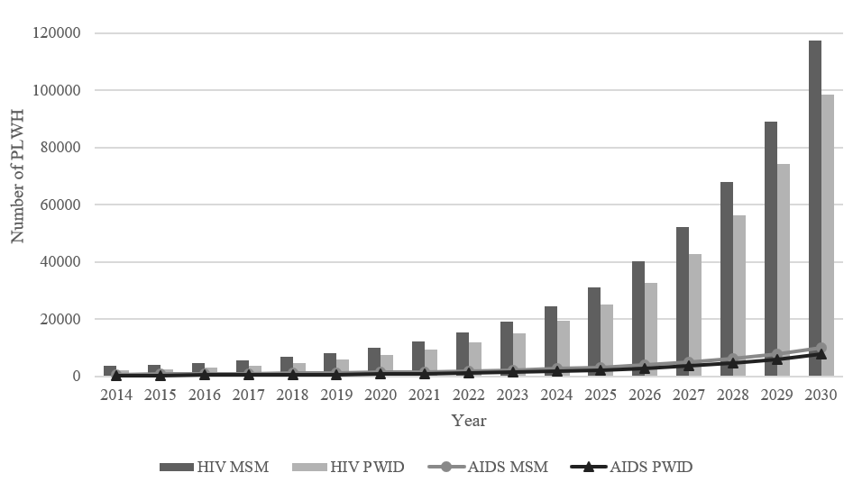
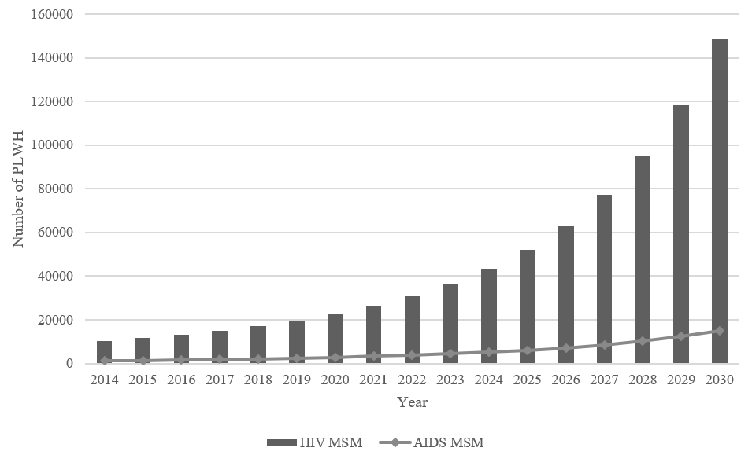
Figure S3. Distribution of HIV positive and AIDS patients among risk groups

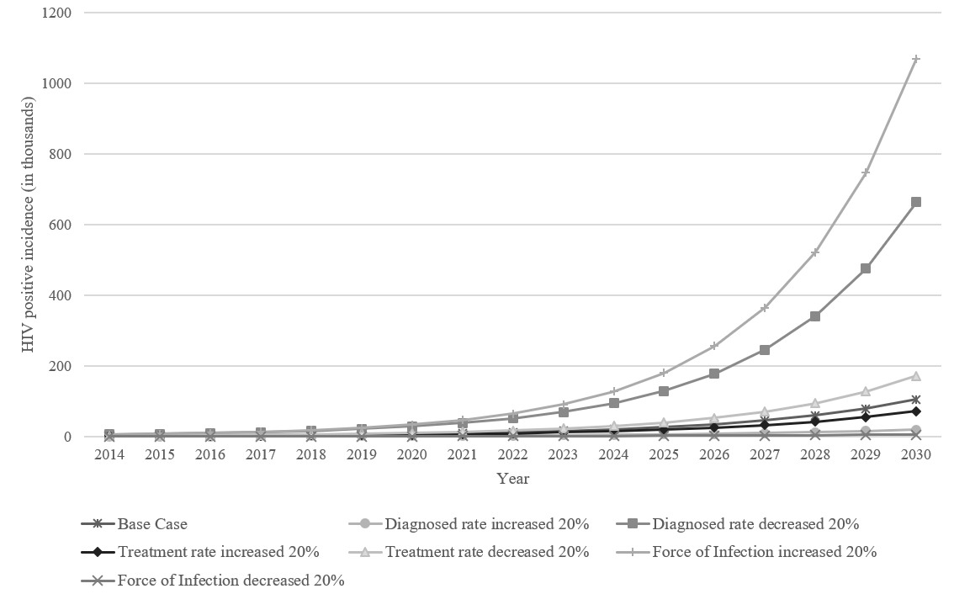
Figure S4. One-way sensitivity analyses for the compartmental model

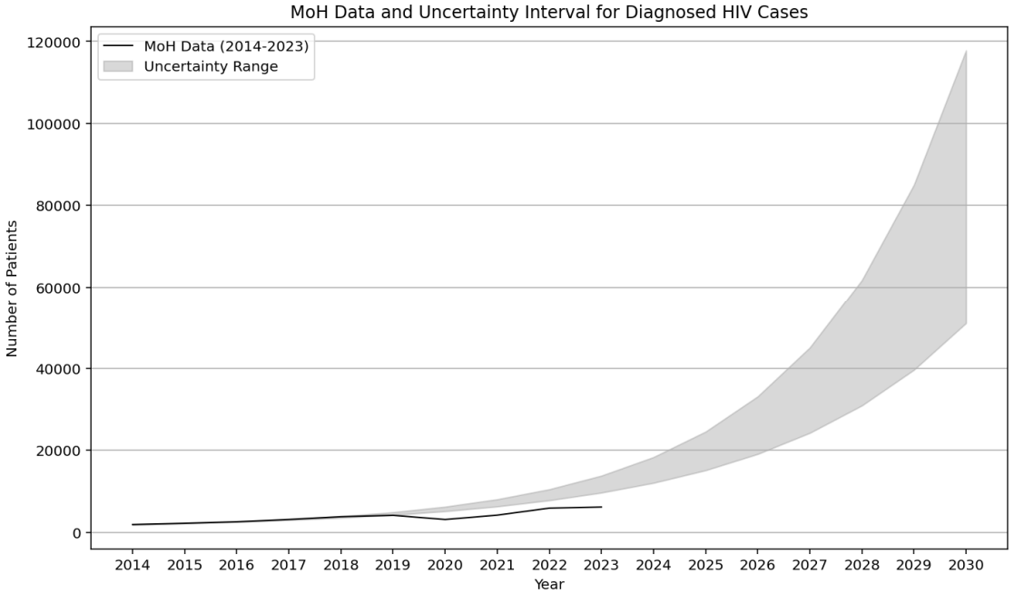
Figure S5. Uncertainty range from the best 10 parameter sets for HIV diagnoses

