Supplementary Table legends：
Table S1. Variable selection strategy.
Table S2. Threshold effect analysis of the association of the HALP score with 28-day mortality in sepsis patients.
Table S3. Comparison of AUC (DeLong-Test) for the HALP score and its individual components across different outcomes.
Table S4. Comparative effectiveness of Hemoglobin, Albumin, Lymphocyte, and Platelet levels as biomarkers for clinical outcomes.
Table S5. Comparison of key indicators, outcomes, and interaction effects between sepsis patients with Cancer and Non-cancer.
Table S6. Multivariable Cox regression analysis of the HALP score and 28-day mortality using multiple imputation (5 datasets) – results from the Adjust II model.
Table S7. Multivariable Cox regression analysis of the HALP score and 28-day mortality using pooled multiple imputation (5 datasets) – results from the Adjust II model.
Table S8. Multivariable Cox regression analysis of the HALP score and 28-day mortality using missForest imputation.

Supplementary Figure legends：
Figure S1. Receiver operating characteristic (ROC) curves for HALP score and its components (Hemoglobin, Albumin, Lymphocyte, and Platelet) in predicting different clinical outcomes.
Figure S2. Receiver operating characteristic (ROC) curves for SOFA and SOFA+HALP score in predicting 28-day mortality.

Table S1. Variable selection strategy
Variables | Value for the first 24 hours of ICU admission
Score system
SAPSII | the highest record
SOFA | the average record
CCI | the highest record
GCS | the lowest record
Vital Signs
Heart rate, b/min | the highest record
MAP, mmHg | the lowest record
RR, b/min | the highest record
Laboratory tests
RBC, 10⁹/L | the lowest record
HCT | the lowest record
Hb, g/dL | the first record
WBC, 10⁹/L | the highest record
Abs_Neutrophils, 10⁹/L | the highest record
Abs_Lymphocytes, 10⁹/L | the first record
Platelets, 10⁹/L | the first record
Albumin, g/dL | the first record
BUN, mg/dL | the highest record
Calcium, mg/dL | the lowest record
Chloride, mEq/L | the highest record
Creatinine, mg/dL | the highest record
Glucose, mg/dL | the highest record
Sodium, mEq/L | the highest record
Potassium, mEq/L | the highest record
INR | the highest record
PT, s | the highest record
APTT, s | the highest record
Lactate, mmol/L | the highest record
pH | the lowest record
PO₂, mmHg | the lowest record
PCO₂, mmHg | the highest record
SAPSII, Simplified Acute Physiology Score II; SOFA, Sequential Organ Failure Assessment; CCI, Charlson Comorbidity Index; GCS, Glasgow Coma Scale; MAP, mean arterial pressure; RR, respiration rate; RBC, red blood cell count; HCT, hematocrit; Hb, hemoglobin; WBC, white blood cell count; Abs_Neutrophils, absolute counts of neutrophil; Abs_Lymphocytes, absolute counts of lymphocyte; BUN, blood urea nitrogen; INR, international normalized ratio; PT, prothrombin time; APTT, activated partial thromboplastin time; pH, potential of hydrogen; PO2, partial pressure of oxygen; PCO2, partial pressure of carbon dioxide.

Table S2. Threshold effect analysis of the association of the HALP score with 28-day mortality in sepsis patients.
 | Non-adjusted  HR (95% CI) | P-value | Adjusted  HR (95% CI) | P-value
Model I
One line slope | 0.99 (0.99, 1.00) | 0.003* | 0.99 (0.99, 1.00) | 0.015*
Model II
Turning point (K) | 24.69
< K slope 1 | 0.97 (0.96, 0.99) | <0.001* | 0.98 (0.97, 0.99) | 0.004*
> K slope 2 | 1.00 (0.99, 1.01) | 0.682 | 1.00 (0.99, 1.01) | 0.944
LRT | <0.001* |  | 0.037*
Model I: linear analysis;
Model II: nonlinear analysis.
Adjusted variables: age, gender, race, BMI, RRT, vasopressor use, congestive heart failure, cerebrovascular disease, liver disease, renal disease, malignant cancer, SAPS II, SOFA, CCI, GCS, MAP, RR, RBC, WBC, Abs_Neutrophils, BUN, lactate, chloride, creatinine, glucose, potassium, INR, APTT, lactate clearance, fluid balance, pH, PO₂, and PCO₂.
HR, hazard ratio; CI, confidence interval; LRT, logarithmic likelihood ratio test.

Comparison of AUC  (DeLong-Test) | 28-day mortality |  | 90-day mortality |  | 360-day mortality |  | HOSP-mortality |  | ICU-mortality
Comparison of AUC  (DeLong-Test) | Z-value | P-value | Z-value | P-value | Z-value | P-value | Z-value | P-value | Z-value | P-value
HALP score vs. Hemoglobin | 0.167 | 0.867 | 0.173 | 0.863 | -0.341 | 0.733 | -0.128 | 0.898 | 2.069 | 0.039
HALP score vs. Albumin | -1.497 | 0.135 | -1.363 | 0.173 | -0.365 | 0.715 | -1.48 | 0.138 | -1.173 | 0.241
HALP score vs. Lymphocyte | -1.808 | 0.071 | -1.263 | 0.207 | -0.450 | 0.653 | -2.085 | 0.037 | -1.149 | 0.250
HALP score vs. Platelet | 0.656 | 0.512 | 1.534 | 0.125 | 2.584 | 0.010 | 0.150 | 0.881 | 0.481 | 0.631
Table S3. Comparison of AUC (DeLong-Test) for the HALP score and its individual components across different outcomes.
HOSP-mortality, In-hospital mortality; ICU-mortality, in-ICU mortality.

Table S4. Comparative effectiveness of Hemoglobin, Albumin, Lymphocyte, and Platelet levels as biomarkers for clinical outcomes.
Variables  Outcomes | Hemoglobin |  | Albumin |  | Lymphocyte |  | Platelet
Variables  Outcomes | HR (95%CI) | P | HR (95%CI) | P | HR (95%CI) | P | HR (95%CI) | P
28-day mortality | 0.97 (0.92, 1.03) | 0.356 | 0.80 (0.70, 0.90) | <0.001* | 0.90 (0.81, 1.00) | 0.043* | 1.00 (1.00, 1.00) | 0.671
90-day mortality | 0.98 (0.93, 1.03) | 0.361 | 0.76 (0.68, 0.85) | <0.001* | 0.90 (0.82, 0.98) | 0.022* | 1.00 (1.00, 1.00) | 0.778
360-day mortality | 0.96 (0.92, 1.00) | 0.052 | 0.76 (0.69, 0.85) | <0.001* | 0.88 (0.82, 0.96) | 0.004* | 1.00 (1.00, 1.00) | 0.897
HOSP-mortality | 0.95 (0.89, 1.02) | 0.184 | 0.79 (0.67, 0.93) | 0.005* | 0.86 (0.75, 0.98) | 0.029* | 1.00 (1.00, 1.00) | 0.409
ICU-mortality | 0.98 (0.91, 1.06) | 0.608 | 0.88 (0.73, 1.05) | 0.151 | 0.92 (0.80, 1.07) | 0.280 | 1.00 (1.00, 1.00) | 0.145
HOSP_LOS | 0.02 (-0.36, 0.40) | 0.929 | -2.15 (-3.05, -1.25) | <0.001* | -0.50 (-1.19, 0.18) | 0.150 | 0.00 (0.00, 0.01) | 0.400
ICU_LOS | 0.13 (-0.07, 0.32) | 0.210 | -0.63 (-1.10, -0.17) | 0.008* | -0.27 (-0.63, 0.08) | 0.135 | 0.00 (0.00, 0.01) | 0.004*

Adjust: age, gender, race, BMI, RRT, vasopressor use, congestive heart failure, cerebrovascular disease, liver disease, renal disease, malignant cancer, SAPS II, SOFA, CCI, GCS, MAP, RR, RBC, WBC, Abs_Neutrophils, BUN, lactate, chloride, creatinine, glucose, potassium, INR, APTT, lactate clearance, fluid balance, pH, PO₂, and PCO₂.
HR, hazard ratio; CI, confidence interval; HOSP-mortality, in-hospital mortality; ICU-mortality, in-ICU mortality; HOSP_LOS, hospital length of stay; ICU_LOS, ICU length of stay.

Table S5. Comparison of key indicators, outcomes, and interaction effects between sepsis patients with Cancer and Non-cancer.
Variable | Non-cancer patients  (n=2,545) | Cancer patients  (n=423) | P-value | P for Interaction
Hemoglobin, g/dL | 10.50 (9.00-12.20) | 9.50 (8.20-11.00) | <0.001*
Albumin, g/dL | 3.00 (2.50-3.40) | 2.60 (2.20-3.10) | <0.001*
Lymphocytes, 10⁹/L | 0.95 (0.55-1.46) | 0.67 (0.38-1.19) | <0.001*
Platelets, 10⁹/L | 187.00 (124.00-260.00) | 170.00 (98.00-280.00) | 0.894
HALP score | 15.92 (8.60-29.21) | 9.87 (5.13-22.23) | <0.001*
28-Day Mortality | 633 (24.87%) | 176 (41.61%) | <0.001* | 0.129
Data are presented as median (Q1–Q3) or N (%);
P for Interaction represents the significance of the interaction between cancer status and HALP score in predicting 28-day mortality (derived from multivariable Cox regression analysis).

Table S6. Multivariable Cox regression analysis of the HALP score and 28-day mortality using multiple imputation (5 datasets) – results from the Adjust II model.
Exposure | Multiple Imputation 1 |  | Multiple Imputation 2 |  | Multiple Imputation 3 |  | Multiple Imputation 4 |  | Multiple Imputation 5
 | Adjust II  HR (95% CI) | P-value | Adjust II  HR (95% CI) | P-value | Adjust II  HR (95% CI) | P-value | Adjust II  HR (95% CI) | P-value | Adjust II  HR (95% CI) | P-value
HALP score as continuous | 0.99 (0.99, 1.00) | 0.018* | 0.99 (0.99, 1.00) | 0.016* | 0.99 (0.99, 1.00) | 0.016* | 0.99 (0.99, 1.00) | 0.016* | 0.99 (0.99, 1.00) | 0.017*
HALP score dichotomous
Low (<13.5) | Ref |  | Ref |  | Ref |  | Ref |  | Ref
High (≥13.5) | 0.79 (0.68, 0.91) | 0.002* | 0.79 (0.68, 0.91) | <0.001* | 0.79 (0.68, 0.91) | 0.002 | 0.78 (0.68, 0.91) | 0.002* | 0.79 (0.67, 0.94) | 0.002*
HALP score quartile
Q1 (≤8.01) | Ref |  | Ref |  | Ref |  | Ref |  | Ref
Q2 (8.01-15.10) | 0.94 (0.78, 1.14) | 0.525 | 0.94 (0.77, 1.13) | 0.495 | 0.93 (0.77, 1.13) | 0.479 | 0.94 (0.77, 1.13) | 0.501 | 0.94 (0.78, 1.14) | 0.550
Q3 (15.10-28.20) | 0.75 (0.61, 0.92) | 0.006* | 0.75 (0.61, 0.92) | 0.007* | 0.75 (0.61, 0.92) | 0.006* | 0.74 (0.61, 0.92) | 0.005* | 0.75 (0.61, 0.92) | 0.007*
Q4 (≥28.20) | 0.78 (0.63, 0.96) | 0.022* | 0.77 (0.63, 0.96) | 0.019* | 0.78 (0.63, 0.96) | 0.021* | 0.81 (0.63, 1.04) | 0.020* | 0.78 (0.63, 0.97) | 0.024*
P for trend | 0.99 (0.99, 1.00) | 0.015 | 0.99 (0.99, 1.00) | 0.014 | 0.99 (0.99, 1.00) | 0.016* | 0.99 (0.99, 1.00) | 0.015* | 0.99 (0.99, 1.00) | 0.017*

Table S7. Multivariable Cox regression analysis of the HALP score and 28-day mortality using pooled multiple imputation (5 datasets) – results from the Adjust II model.
Exposure | Adjust II  HR (95% CI) | P-value
HALP score as continuous | 0.99 (0.99, 1.00) | <0.001*
HALP score dichotomous
Low (<13.5) | Ref
High (≥13.5) | 0.79 (0.68, 0.92) | 0.002*
HALP score quartile
Q1 | Ref
Q2 | 0.94 (0.77, 1.14) | 0.512
Q3 | 0.75 (0.61, 0.92) | 0.006
Q4 | 0.78 (0.63, 0.98) | 0.033
P-value for trend | 0.99 (0.99, 1.00) | 0.048*

Table S8. Multivariable Cox regression analysis of the HALP score and 28-day mortality using missForest imputation.
Exposure | Non-adjusted  HR (95% CI) | P-value | Adjust I  HR (95% CI) | P-value | Adjust II  HR (95% CI) | P-value
HALP score as continuous | 0.99 (0.99, 1.00) | 0.003* | 1.00 (0.99, 1.00) | 0.022* | 0.99 (0.99, 1.00) | 0.015*
HALP score dichotomous
Low (<13.5) | Ref |  | Ref |  | Ref
High (≥13.5) | 0.73 (0.64, 0.84) | <0.001* | 0.77 (0.67, 0.89) | 0.003* | 0.78 (0.68, 0.91) | 0.002*
HALP score quartile
Q1 | Ref |  | Ref |  | Ref
Q2 | 0.86 (0.71, 1.03) | 0.097 | 0.86 (0.71, 1.03) | 0.103 | 0.94 (0.78, 1.14) | 0.529
Q3 | 0.68 (0.56, 0.83) | <0.001* | 0.72 (0.59, 0.87) | <0.001* | 0.75 (0.61, 0.93) | 0.008*
Q4 | 0.73 (0.60, 0.89) | 0.002* | 0.79 (0.65, 0.96) | 0.016* | 0.78 (0.63, 0.96) | 0.019*
P-value for trend | 0.99 (0.99, 1.00) | 0.002 | 0.99 (0.99, 1.00) | 0.022 | 0.99 (0.99, 1.00) | 0.014*

Figure S1. Receiver operating characteristic (ROC) curves for HALP score and its components (Hemoglobin, Albumin, Lymphocyte, and Platelet) in predicting different clinical outcomes.
(A) ROC curves for 28-day mortality; (B) ROC curves for 90-day mortality; (C) ROC curves for 360-day mortality; (D) ROC curves for in-hospital mortality; (E) ROC curves for in-ICU mortality.
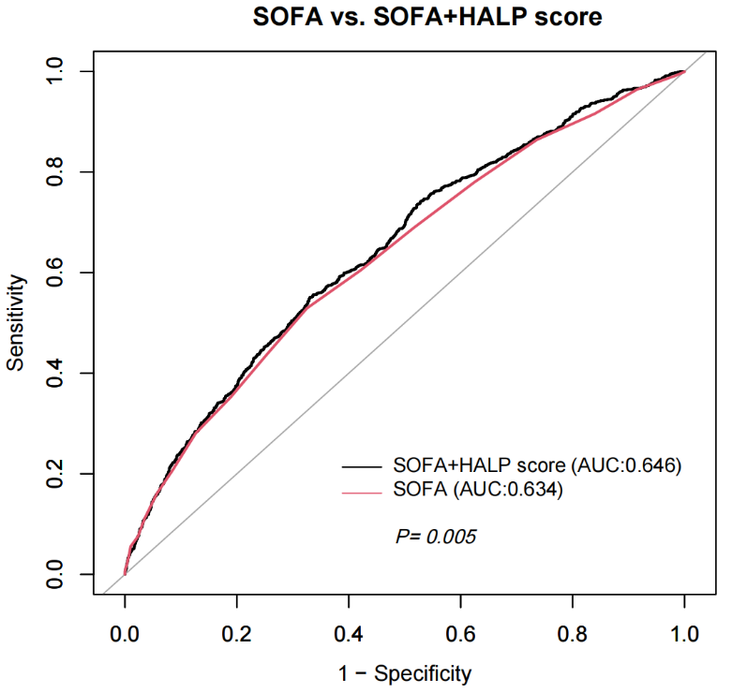
Figure S2. Receiver operating characteristic (ROC) curves for SOFA and SOFA+HALP score in predicting 28-day mortality.

