Supplementary Figure1 Forest plot for the effect of in-hospital mortality.
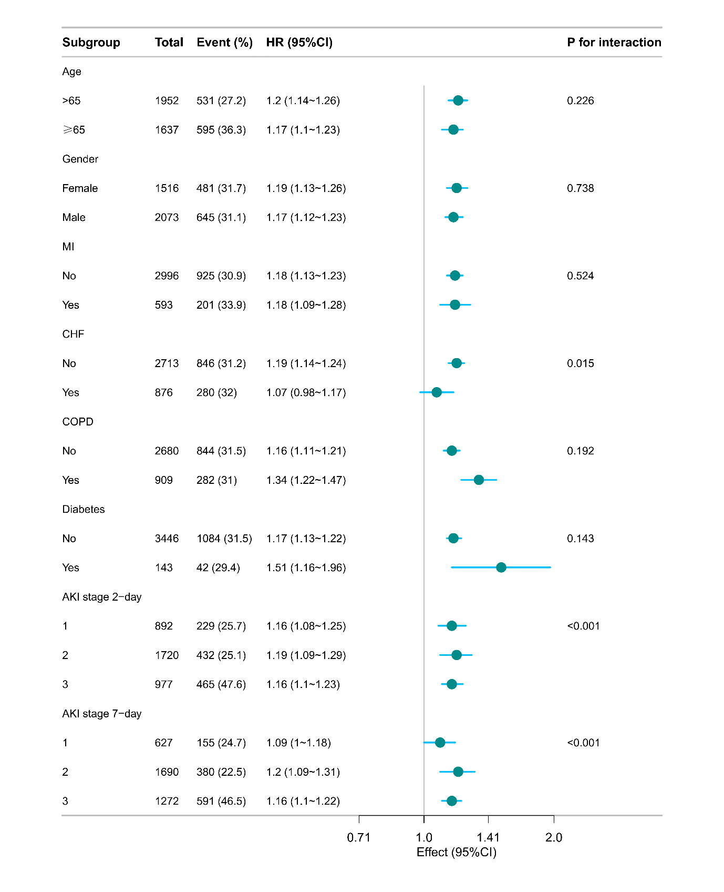
Supplementary Figure2 Forest plot for the effect of 30-day mortality.
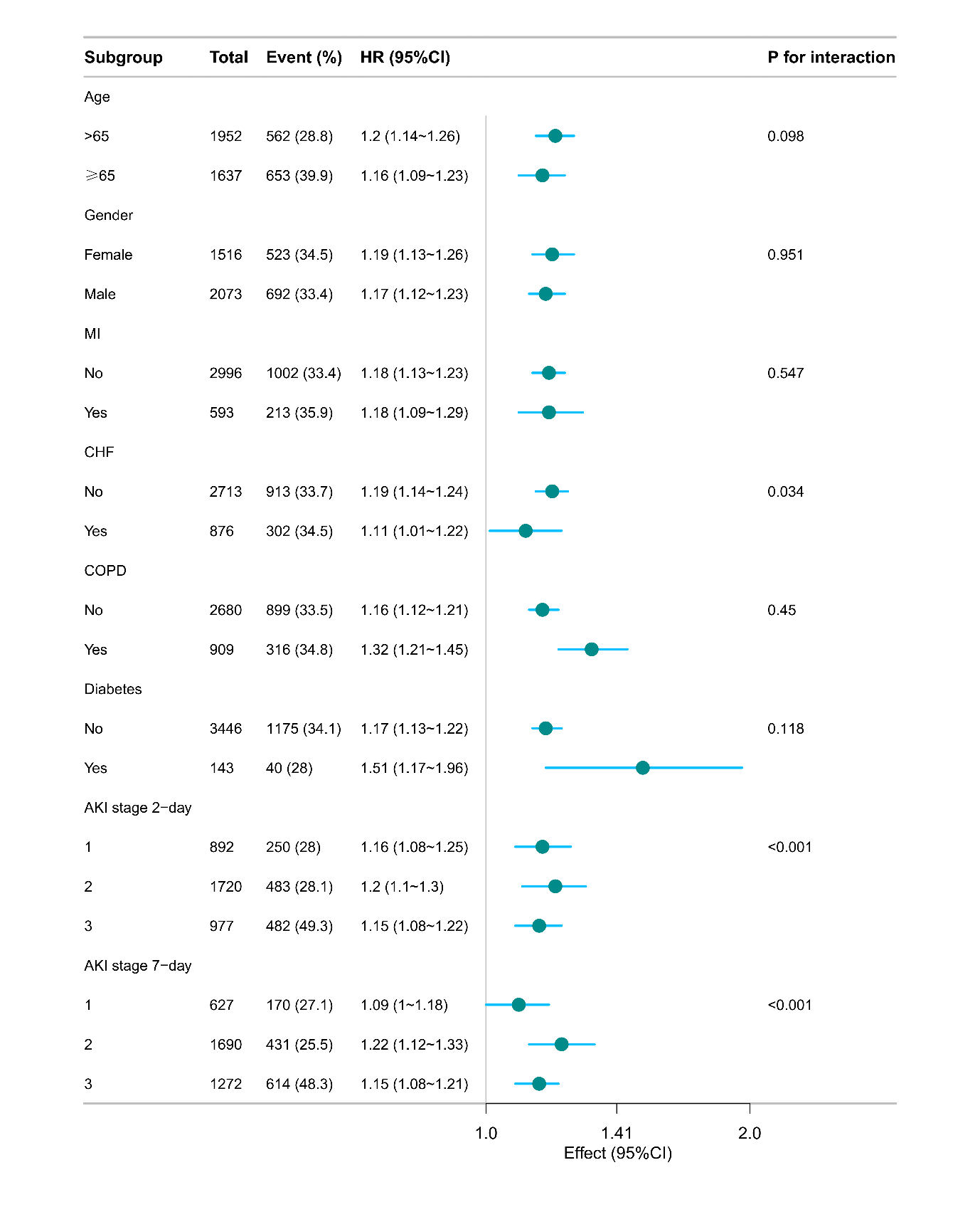
Supplementary Figure3 Forest plot for the effect of 90-day hospital mortality.
