Appendix

- Formula for Poisson and quasi-Poisson segmented regression models
Calculating the change in outcome at comprehensive strategy implementation, unadjusted for seasonality
log Y_{t} = 𝑏₀ + 𝑏₁(𝑡−𝑇) + 𝑏₂ 𝑥 + 𝑏₃ 𝑥(𝑡−𝑇)
Where Y_{t} is the outcome variable at time 𝑡, 𝑡 represents the elapsed time in months since the start of the study, 𝑥 is a dummy variable indicating the implementation of comprehensive strategy, and 𝑇 is the center time.
Calculating the change in outcome at comprehensive strategy implementation, adjusted for seasonality
log Y_{t} = 𝑏₀ + 𝑏₁(𝑡−𝑇) + 𝑏₂ 𝑥 + 𝑏₃ 𝑥(𝑡−𝑇) + 𝑏₄ sin($\frac{2πt}{12}$) + 𝑏₅ cos($\frac{2πt}{12}$) + 𝑏₆ sin($\frac{4πt}{12}$ ) + 𝑏₇ cos($\frac{4πt}{12}$)
Where sin($\frac{2πt}{12}$) , cos($\frac{2πt}{12}$) , sin($\frac{4πt}{12}$ ) and cos($\frac{4πt}{12}$) are two sine and cosine pairs of Fourier terms used to adjust the seasonality.
Counterfactual model, unadjusted for seasonality
log Y_{t} = 𝑏₀ + 𝑏₁(𝑡 − 𝑇)
Counterfactual model, adjusted for seasonality
log Y_{t} = 𝑏₀ + 𝑏₁(𝑡 − 𝑇) + 𝑏₄ sin($\frac{2πt}{12}$) + 𝑏₅ cos($\frac{2πt}{12}$) + 𝑏₆ sin($\frac{4πt}{12}$ ) + 𝑏₇ cos($\frac{4πt}{12}$)

2. Sample R code for Poisson and quasi-Poisson regression models, using proportions of 30-day ART initiation as an example

# Load packages
library(tsModel)
library(tidyverse)
library(sandwich)
library(dplyr)
library(qcc)

# Centre time
list2$time_c <- list2$n - 48 # Time centered at the first month of “action plan”
list2$time_e <- list2$n - 95 # Time centered at the end of 2021
# Overdispersion test
qcc.overdispersion.test(list2$x)

# Quasi-Poisson regression model of proportions of 30-day ART initiation without adjusting for seasonality
model_time <- glm(x ~ interruption + n + interruption:time_c, family = quasipoisson, list2)
summary(model_time)

# Calculated the impact of “action plan” at the end of 2021 without adjusting for seasonality
model_time_end <- glm(x - interruption + n + interruption:time_e, family = quasipoisson, list2)
summary(model_time_end)

# Look at residuals for autocorrelation
acf(residuals(model_time, type = "deviance"))
pacf(residuals(model_time, type = "deviance"))
acf(residuals(model_time_end, type = "deviance"))
pacf(residuals(model_time_end, type = "deviance"))

# Calculate Newey-West standard errors, with the lag taking the optimal value calculated
est <- exp(c(coef(model_time)["interruption:time_c"], coef(model_time)["interruption"], coef(model_time)["n"]))
se1 <- sqrt(diag(NeweyWest(model_time, prewhite = F)))["interruption:time_c"]
se2 <- sqrt(diag(NeweyWest(model_time, prewhite = F)))["interruption"]
se3 <- sqrt(diag(NeweyWest(model_time, prewhite = F)))["n"]
lb <- est * exp(-1.96 * c(se1, se2, se3))
ub <- est * exp(1.96 * c(se1, se2, se3))
table <- cbind(round(est, digits = 3), round(lb, digits = 3), round(ub, digits = 3))
table

# Calculate trend and confidence intervals after “action plan”
V <- NeweyWest(model_time, prewhite = F)
se <- sqrt(V["n", "n"] + V["interruption:time_c", "interruption:time_c"]+ 2 * V["n", "interruption:time_c"])
slope_post <- sum(coef(model_time)[c("n", "interruption:time_c")])
lower <- slope_post - 1.96 * se
upper <- slope_post + 1.96 * se
round(exp(cbind(slope_post, lower, upper)),3)

# Quasi-Poisson regression model of proportions of 30-day ART initiation adjusting for seasonality
model_time_sea <- glm(x ~ interruption + n + interruption:time_c +harmonic(month, 2, 12), family = quasipoisson, list2)
summary(model_time_sea)

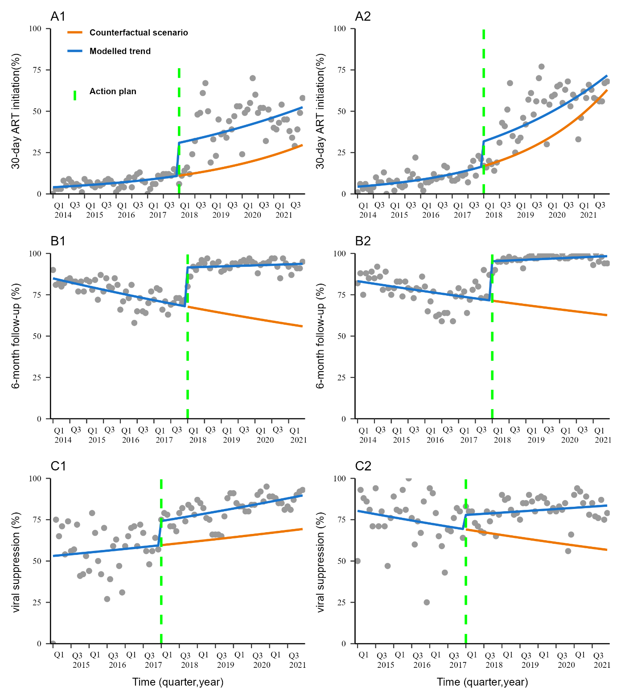
Figure S1. Poisson or quasi-Poisson segmented regression models for three outcomes among HIV/AIDS patients reported in Liangshan from 1 January 2014 to 31 December 2021, not accounting for seasonality. 30-day ART initiation = proportion of 30-day ART initiation per month (A1, A2), 6-month follow-up = proportion of 6-month follow-up per month (B1, B2), viral suppression = proportion of viral suppression per month (C1, C2). For C1 and C2, the start of the analysis of the effective viral load was January 2015. A1, B1 and C1 refer to key areas, while A2, B2 and C2 refer to non-key areas. ART: Antiretroviral therapy. Action plan: January 2018.

Table S1 Sensitivity analyses without seasonality in the analysis of the impact of the comprehensive strategy on three indicators of ART continuum in Liangshan among PLHIV and in different subgroups, from 2014 to 2021#
 | Level change at  action plan | Level change at the end of the analysis＊ | Trend before  action plan | Trend after  action plan
Proportion of 30-day ART initiation
IRR(95% CI) | 2.256(1.380-3.689) | 1.442(0.840-2.477) | 1.025(1.018-1.033) | 1.016(1.004-1.028)
Gender
Male | 2.277(1.374-3.775) | 1.289(0.713-2.329) | 1.028(1.019-1.036) | 1.016(1.004-1.028)
Female | 2.249(1.383-3.657) | 1.870(0.982-3.562) | 1.020(1.011-1.030) | 1.016(1.004-1.028)
Age
0-14 | 1.967(0.991-3.901) | 1.736(0.333-9.045) | 1.020(0.998-1.042) | 1.017(1.004-1.030)
15-34 | 2.204(1.335-3.640) | 1.267(0.691-2.320) | 1.028(1.020-1.037) | 1.016(1.004-1.028)
35-59 | 2.297(1.403-3.762) | 1.556(0.674-3.590) | 1.023(1.010-1.037) | 1.015(1.003-1.026)
≥60 | 2.333(1.183-4.601) | 2.100(0.537-8.211) | 1.016(0.998-1.035) | 1.014(1.002-1.026)
Region
Non-key areas | 1.907(1.225-2.968) | 1.138(0.626-2.069) | 1.028(1.019-1.038) | 1.017(1.008-1.028)
Key areas | 2.831(1.587-5.052) | 1.772(0.807-3.890) | 1.021(1.010-1.032) | 1.011(0.997-1.025)
Route of transmission
Heterosexual | 2.095(1.292-3.399) | 1.450(0.799-2.630) | 1.023(1.014-1.032) | 1.015(1.004-1.026)
Injection drug use | 2.589(1.662-4.032) | 1.770(0.705-4.443) | 1.024(1.011-1.037) | 1.016(1.004-1.027)
Others | 2.033(1.170-3.531) | 1.067(0.290-3.922) | 1.030(1.012-1.047) | 1.016(1.002-1.030)
Proportion of 6-month follow-up
IRR(95% CI) | 1.334(1.219-1.460) | 1.613(1.405-1.852) | 0.997(0.996-0.999) | 1.001(0.999-1.002)
Gender
Male | 1.279(1.190-1.375) | 1.470(1.320-1.638) | 0.997(0.996-0.999) | 1.001(0.999-1.002)
Female | 1.417(1.247-1.609) | 1.862(1.516-2.287) | 0.994(0.992-0.997) | 1.001(0.999-1.003)
Age
0-14 | 1.383(1.196-1.599) | 1.544(1.159-2.057) | 0.998(0.994-1.002) | 1.001(0.998-1.003)
15-34 | 1.355(1.246-1.474) | 1.615(1.438-1.813) | 0.996(0.994-0.997) | 1.000(0.998-1.002)
35-59 | 1.333(1.212-1.466) | 1.690(1.421-2.011) | 0.995(0.993-0.998) | 1.001(1.000-1.003)
≥60 | 1.128(1.041-1.221) | 1.190(1.006-1.407) | 0.999(0.997-1.001) | 1.000(0.999-1.001)
Region
Non-key areas | 1.329(1.174-1.506) | 1.565(1.233-1.987) | 0.997(0.994-1.000) | 1.001(1.000-1.002)
Key areas | 1.343(1.268-1.422) | 1.668(1.512-1.840) | 0.995(0.994-0.996) | 1.001(0.999-1.002)
Route of transmission
Heterosexual | 1.349(1.215-1.498) | 1.681(1.423-1.987) | 0.995(0.993-0.997) | 1.001(0.999-1.002)
Injection drug use | 1.329(1.230-1.435) | 1.568(1.381-1.779) | 0.997(0.995-0.999) | 1.001(0.999-1.003)
Others | 1.298(1.143-1.474) | 1.600(1.282-1.997) | 0.996(0.993-1.000) | 1.002(1.000-1.003)
Proportion of viral suppression
IRR(95% CI) | 1.231(1.086-1.395) | 1.622(1.194-2.204) | 0.995(0.989-1.001) | 1.003(1.002-1.004)
Gender
Male | 1.270(1.123-1.438) | 1.789(1.412-2.267) | 0.995(0.989-1.001) | 1.003(1.001-1.004)
Female | 1.187(1.068-1.319) | 1.352(0.725-2.519) | 0.996(0.992-1.000) | 1.004(1.001-1.007)
Age
0-14 | 1.273(0.894-1.814) | 1.617(0.517-5.051) | 1.000(0.982-1.018) | 1.005(1.001-1.009)
15-34 | 1.253(1.079-1.455) | 1.689(1.055-2.705) | 0.997(0.988-1.007) | 1.004(1.002-1.005)
35-59 | 1.175(1.015-1.360) | 1.324(0.830-2.113) | 0.999(0.990-1.008) | 1.001(1.000-1.003)
≥60 | 1.069(0.891-1.283) | 0.970(0.553-1.701) | 1.002(0.993-1.011) | 1.000(0.997-1.002)
Region
Non-key areas | 1.119(0.966-1.296) | 1.460(1.052-2.028) | 0.996(0.990-1.002) | 1.002(0.999-1.004)
Key areas | 1.244(1.070-1.447) | 1.288(0.759-2.185) | 1.003(0.995-1.012) | 1.004(1.002-1.006)
Route of transmission
Heterosexual | 1.158(1.009-1.328) | 1.324(0.874-2.007) | 0.999(0.990-1.009) | 1.002(1.001-1.004)
Injection drug use | 1.281(1.084-1.512) | 1.603(0.834-3.081) | 1.000(0.989-1.012) | 1.005(1.003-1.007)
Others | 1.333(1.031-1.723) | 1.595(0.800-3.179) | 0.998(0.985-1.010) | 1.002(1.000-1.004)
IRR, incidence rate ratio; CI, confidence interval; ART, antiretroviral therapy. Action plan: January 2018. #: Three indicators: proportion of patients who underwent 30 days of ART initiation, proportion of patients who underwent 6 months of follow-up, and proportion of patients who experienced viral suppression.＊: The three indicators were measured from January 2014 to December 2021, to June 2021, and from January 2015 to December 2021. Key areas: Butuo, Zhaojue, Yuexi, and Meigu. Non-key areas: all areas in Liangshan except for key areas.

Table S2 Characteristics of newly diagnosed PLHIV in key areas and non-key areas of Liangshan, 2014 to 2021
 | Key areas |  |  | Non-key areas
 | Total  (n=20,744) | Before action plan(n=9926) | After action plan(n=10,818) | Total  (n=17,144) | Before action plan(n=7829) | After action plan(n=9315)
Gender (%)
Male | 11,171(53.9) | 5655(57.0) | 5516(51.0) | 10,998(64.2) | 5169(66.0) | 5829(62.6)
Female | 9573(46.1) | 4271(43.0) | 5302(49.0) | 6146(35.8) | 2660(34.0) | 3486(37.4)
Age, years (%)
0-14 | 2043(9.8) | 543(5.5) | 1500(13.9) | 728(4.2) | 226(2.9) | 502(5.4)
15-34 | 11,916(57.4) | 6453(65.0) | 5463(50.5) | 7738(45.1) | 4145(52.9) | 3593(38.6)
35-59 | 6458(31.1) | 2809(28.3) | 3649(33.7) | 7017(40.9) | 2797(35.7) | 4220(45.3)
≥60 | 327(1.6) | 121(1.2) | 206(1.9) | 1661(9.7) | 661(8.4) | 1000(10.7)
Route of transmission (%)
Heterosexual | 12,200(58.8) | 4804(48.4) | 7396(68.4) | 12,551(73.2) | 5024(64.2) | 7527(80.8)
Injection drug use | 6298(30.4) | 4429(44.6) | 1869(17.3) | 3491(20.4) | 2339(29.9) | 1152(12.4)
Others | 2246(10.8) | 693(7.0) | 1553(14.4) | 1102(6.4) | 466(6.0) | 636(6.8)
Before action plan: January 2014-December 2017. After the action plan: January 2018-December 2021. Key areas: Butuo, Zhaojue, Yuexi, and Meigu. Non-key areas: all areas in Liangshan except for key areas. Others: mother-to-child, homosexual, and blood transfusion or unknown.

Table S3 Poisson or Quasi-Poisson segmented regression models of the impact of comprehensive strategy on three indicators of ART continuum among PLHIV in different areas of Liangshan, from 2014 to 2021#, accounting for seasonality
 | Key areas |  | Non-key areas
 | Level change at  action plan | Level change at the end of the analysis＊ | Level change at  action plan | Level change at the end of the analysis＊
Proportion of 30-day ART initiation
IRR (95% CI) | 3.128(1.944-5.035) | 1.961(1.060-3.626) | 2.126(1.504-3.006) | 1.274(0.812-1.998)
Gender
Male | 3.442(2.068-5.730) | 2.087(1.018-4.280) | 2.079(1.465-2.949) | 1.081(0.718-1.627)
Female | 2.833(1.771-4.530) | 1.959(0.959-4.002) | 2.300(1.578-3.352) | 2.063(1.037-4.103)
Age (years)
0-14 | 2.595(0.946-7.123) | 3.717(0.254-54.284) | 1.440(0.545-3.807) | 2.342(0.171-32.173)
15-34 | 2.942(1.718-5.039) | 1.460(0.649-3.286) | 1.978(1.371-2.855) | 1.245(0.664-2.334)
35-59 | 3.471(2.155-5.588) | 2.991(1.184-7.558) | 2.226(1.595-3.108) | 1.195(0.646-2.208)
≥60 | 1.761(0.793-3.913) | 2.103(0.702-6.298) | 2.596(1.386-4.862) | 2.207(0.577-8.441)
Route of transmission
Heterosexual | 2.852(1.851-4.393) | 2.228(1.210-4.103) | 2.068(1.474-2.901) | 1.199(0.736-1.954)
Injection drug use | 3.560(1.915-6.619) | 2.510(0.793-7.942) | 2.356(1.607-3.454) | 1.189(0.566-2.497)
Others | 2.635(1.276-5.442) | 1.151(0.165-8.035) | 1.549(0.904-2.652) | 1.263(0.365-4.364)
Proportion of 6-month follow-up
IRR (95% CI) | 1.349(1.285-1.417) | 1.684(1.531-1.852) | 1.336(1.189-1.502) | 1.582(1.261-1.985)
Gender
Male | 1.284(1.218-1.354) | 1.527(1.395-1.670) | 1.278(1.167-1.399) | 1.399(1.151-1.701)
Female | 1.415(1.318-1.520) | 1.849(1.566-2.184) | 1.442(1.244-1.671) | 1.910(1.426-2.558)
Age (years)
0-14 | 1.475(1.195-1.821) | 1.846(1.203-2.832) | 1.491(1.214-1.831) | 1.548(1.001-2.392)
15-34 | 1.347(1.265-1.435) | 1.627(1.464-1.808) | 1.375(1.249-1.514) | 1.606(1.298-1.987)
35-59 | 1.337(1.247-1.435) | 1.743(1.518-2.002) | 1.333(1.193-1.489) | 1.683(1.346-2.104)
≥60 | 1.395(1.221-1.595) | 2.040(1.576-2.640) | 1.114(1.025-1.210) | 1.136(0.959-1.346)
Route of transmission
Heterosexual | 1.391(1.283-1.508) | 1.787(1.554-2.056) | 1.319(1.183-1.470) | 1.602(1.310-1.960)
Injection drug use | 1.267(1.218-1.318) | 1.563(1.458-1.677) | 1.389(1.213-1.591) | 1.618(1.253-2.090)
Others | 1.367(1.179-1.585) | 1.704(1.249-2.323) | 1.281(1.131-1.452) | 1.412(1.067-1.868)
Proportion of viral suppression
IRR (95% CI) | 1.051(0.852-1.297) | 1.821(0.667-4.973) | 1.031(0.752-1.414) | 1.994(0.749-5.308)
Gender
Male | 1.102(0.805-1.510) | 1.251(0.375-4.167) | 1.034(0.717-1.490) | 2.112(0.699-6.379)
Female | 0.998(0.811-1.228) | 2.518(0.819-7.740) | 0.975(0.722-1.316) | 2.371(0.859-6.542)
Age (years)
0-14 | 0.648(0.367-1.144) | 4.459(0.863-23.043) | 0.687(0.285-1.653) | 0.374(0.007-19.966)
15-34 | 1.098(0.879-1.372) | 2.530(0.982-6.519) | 0.890(0.685-1.155) | 3.099(1.051-9.136)
35-59 | 1.029(0.684-1.549) | 1.415(0.387-5.181) | 1.169(0.873-1.566) | 2.122(0.900-5.003)
≥60 | 1.085(0.344-3.423) | 4.302(0.002-96.800) | 0.873(0.718-1.063) | 0.979(0.236-4.068)
Route of transmission
Heterosexual | 1.055(0.842-1.322) | 5.718(2.168-15.082) | 1.009(0.793-1.284) | 0.878(0.251-3.072)
Injection drug use | 1.206(0.879-1.656) | 1.096(0.303-3.960) | 0.899(0.529-1.528) | 4.231(0.565-31.657)
Others | 0.882(0.599-1.299) | 5.164(1.040-25.635) | 0.911(0.465-1.785) | 4.872(0.388-61.121)
IRR, incidence rate ratio; CI, confidence interval; ART, antiretroviral therapy. Action plan: January 2018. #: Three indicators: proportion of patients who underwent 30 days of ART initiation, proportion of patients who underwent 6 months of follow-up, and proportion of patients who experienced viral suppression.＊: The three indicators were measured from January 2014 to December 2021, to June 2021, and from January 2015 to December 2021, respectively. Key areas: Butuo, Zhaojue, Yuexi, and Meigu. Non-key areas: all areas in Liangshan except for key areas.

