Supplement: The Changing Landscape of Nontyphoidal Salmonellosis: Epidemiological Patterns, Imported Cases and Serovar Distribution in Germany from 2012 to 2023

Simon Brinkwirth^{1,2,3}, Achim Dörre⁴, Klaus Stark¹, Anika Meinen^{1*}

¹Robert Koch Institute, Department of Infectious Disease Epidemiology, Unit 35: Gastrointestinal Infections, Zoonoses and Tropical Infections, Seestr. 10, 13353 Berlin, Germany
²Postgraduate Training for Applied Epidemiology (PAE), Robert Koch-Institute, Berlin, Germany
³European Programme for Intervention Epidemiology Training (EPIET), European Centre for Disease Prevention and Control (ECDC), Stockholm, Sweden.
⁴Robert Koch Institute, Department of Infectious Disease Epidemiology, Unit 31: Focal Point for the Public Health Service, Crisis Management, Outbreak Investigations and Training Programmes, Seestr. 10, 13353 Berlin, Germany

*Corresponding author: Anika Meinen
Email: meinena@rki.de
Phone: (+49) 3018754-3663

Keywords:
Salmonellosis; Epidemiology; Serovar; Imported Cases; Germany; Incidence Trends

Supplemental Figures

An overall increasing trend for nontyphoidal salmonellosis is observed across all German regions, nevertheless there is an unequal distribution of the total incidence of salmonellosis within the observed period. The East is identified as a high-incidence area with a mean incidence of 24 cases per 100,000 inhabitants compared to the North (15 cases), South (14 cases) and West (15 cases).
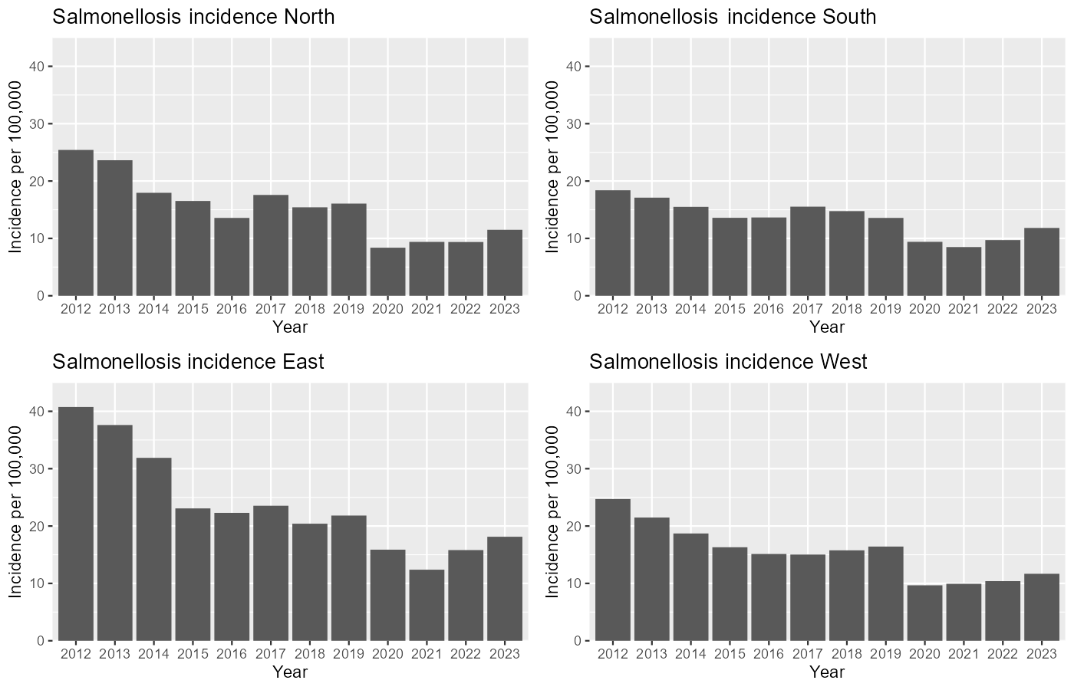

Figure S1. Salmonellosis incidence per 100,000 population from 2012–2023 per region

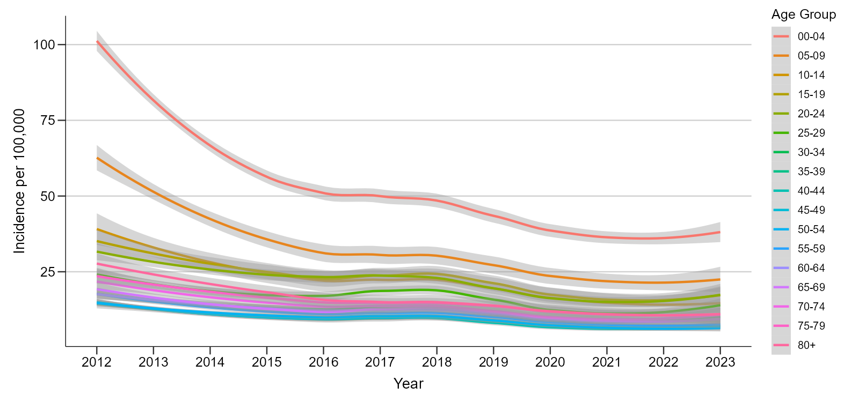
Figure S2. Salmonellosis incidence per 100,000 population by age group from 2012–2023 in Germany

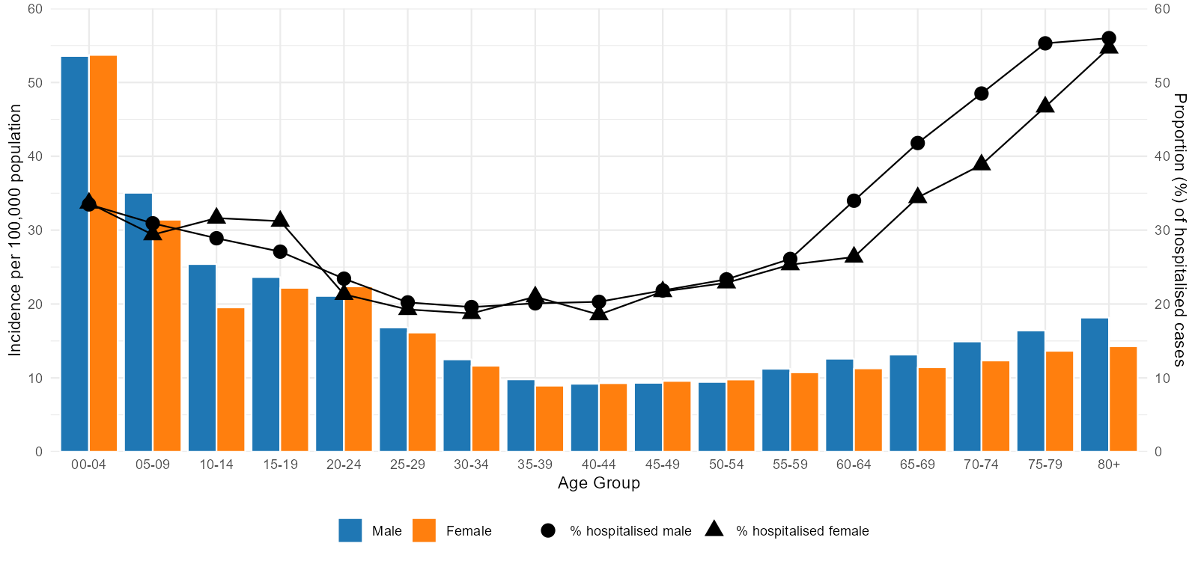
Figure S3. Salmonellosis incidence per 100,000 population by age and gender with proportion of hospitalised cases in Germany from 2012–2023

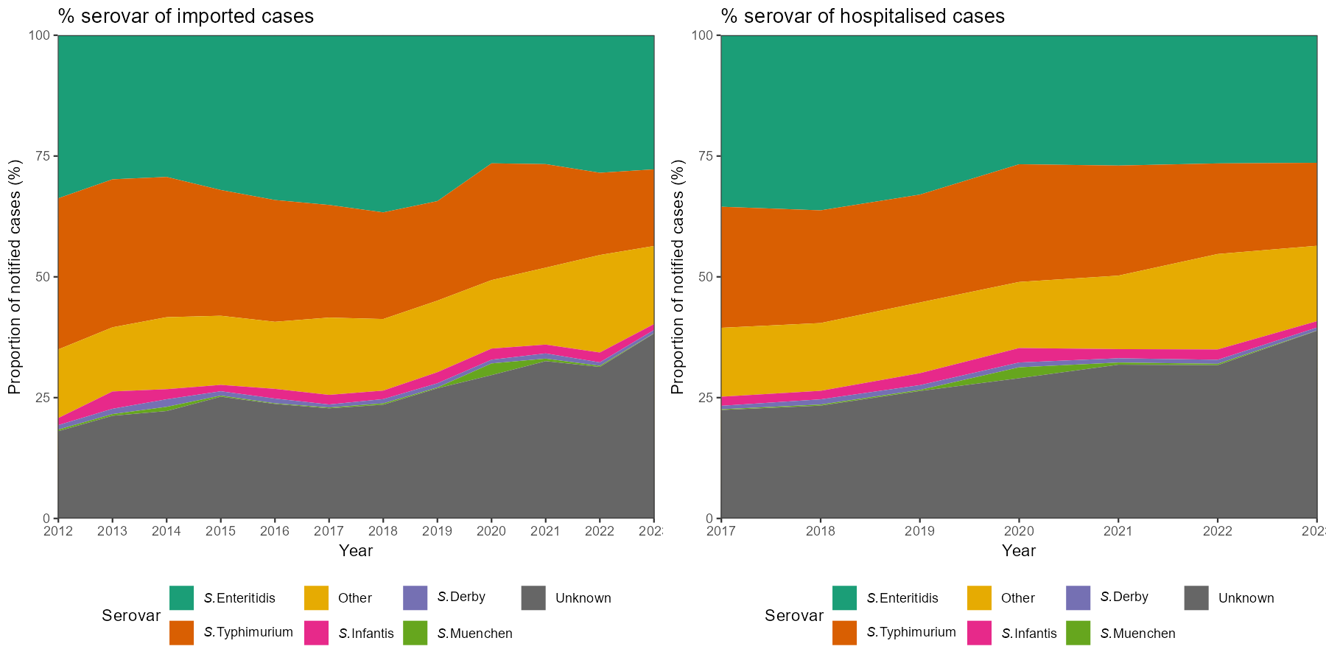

Figure S4 Serovar distribution and trend of imported salmonellosis cases (2012-2023 in Germany) and hospitalised salmonellosis cases (2017–2023 in Germany).

