Supplementary Table 1. Cut-off values for all laboratory parameters extracted from the MIMIC-IV study and included in the final analysis
Laboratory parameter | Sample | Units | Upper cut-off value | Lower cut-off value
Absolute Basophil Count | Blood | K/uL | 0.01 | 0.08
Absolute Eosinophil Count | Blood | K/uL | 0.04 | 0.54
Absolute Lymphocyte Count | Blood | K/uL | 1.2 | 3.7
Absolute Monocyte Count | Blood | K/uL | 0.2 | 0.8
Absolute Neutrophil Count | Blood | K/uL | 1.6 | 6.1
Alanine Aminotransferase | Blood | IU/L | 0 | 40
Albumin | Blood | g/dL | 3.4, 3.5 | 4.8, 5.2
Alkaline Phosphatase | Blood | IU/L | 35, 39, 40 | 105, 117, 130
Anion Gap | Blood | mEq/L | 8, 10 | 16, 18, 20
Aspartate Aminotransferase | Blood | IU/L | 0 | 40
Atypical Lymphocytes | Ascites | % | 0 | 0
Bands | Ascites | % | 0 | 5
Base Excess | Blood | mEq/L | no reported cut-off values
Basophils | Ascites | % | 0 | 1, 2
Bicarbonate | Blood | mEq/L | 22 | 32
Bilirubin, Direct | Blood | mg/dL | 0 | 0.3
Bilirubin, Indirect | Blood | mg/dL | no reported cut-off values
Bilirubin, Total | Blood | mg/dL | 0 | 1.5
Calcium, Total | Blood | mg/dL | 8.4 | 10.2, 10.3
Calculated Total CO₂ | Blood | mEq/L | 21 | 30
Chloride | Blood | mEq/L | 96 | 108
Cortisol | Blood | ug/dL | 2 | 20
C-Reactive Protein | Blood | mg/L | 0 | 5
Creatine Kinase | Blood | IU/L | 26, 29, 38, 47 | 140, 174, 201, 322
Creatine Kinase, MB Isoenzyme | Blood | ng/mL | 0 | 10
Creatinine | Blood | mg/dL | 0.4, 0.5 | 1.1, 1.2
Eosinophils | Ascites | % | 0, 1 | 4, 7
Ferritin | Blood | ng/mL | 13, 30 | 150, 400
Fibrinogen, Functional | Blood | mg/dL | 150, 180 | 400
Free Calcium | Blood | mmol/L | 1.12 | 1.32
Glucose, blood gas | Blood | mg/dL | 70 | 105
Glucose | Blood | mg/dL | 70 | 100, 105
Haptoglobin | Blood | mg/dL | 30 | 200
Hematocrit | Blood | % | 34, 36, 40 | 45, 48, 51, 52
Hemoglobin | Blood | g/dL | 11.2, 12, 13.7, 14 | 15.7, 16, 17.5, 18
Immature Granulocytes | Blood | % | 0 | 0.6
International Normalized Ratio / Prothrombin Time (INR/PT) | Blood | / | 0.9 | 1.1
Iron | Blood | ug/dL | 30, 45 | 160, 160
Iron Binding Capacity, Total | Blood | ug/dL | 260 | 470
Lactate | Blood | mmol/L | 0.5 | 2
Lactate Dehydrogenase (LDH) | Blood | IU/L | 94 | 250
Lipase | Blood | IU/L | 0 | 60
Lymphocytes | Ascites | % | 18, 19 | 42, 53
Magnesium | Blood | mg/dL | 1.5, 1.6 | 2.2, 2.6
Mean Cellular Haemoglobin (MCH) | Blood | pg | 26, 27 | 32
Mean Cellular Haemoglobin Concentration (MCHC) | Blood | g/dL | 31, 32 | 35, 37
Mean Corpuscular Volume (MCV) | Blood | fL | 82 | 98
Metamyelocytes | Ascites | % | 0 | 0
Monocytes | Ascites | % | 2, 5 | 11, 13
Myelocytes | Ascites | % | 0 | 0
Neutrophils | Blood | % | 34, 50 | 70, 71
N-terminal proBrain Natriuretic Peptide (NT-proBNP) | Blood | pg/mL | 0 | 93, 138, 177, 178, 192,  226, 229, 353, 624, 852
Oxygen | Blood | % | no reported cut-off values
Oxygen Saturation | Blood | % | no reported cut-off values
pCO₂ | Blood | mmHg | 35 | 45
pH | Blood | units | 7.35 | 7.45
Phosphate | Blood | mg/dL | 2.7 | 4.5
Platelet Count | Blood | K/uL | 150 | 400, 440
pO₂ | Blood | mmHg | 85 | 105
Potassium | Other | mEq/L | 3.3, 3.5 | 5.1, 5.4
Potassium, Whole Blood | Blood | mEq/L | 3.3, 3.5, 3.5 | 5.1, 5.3, 5.4
Prothrombin Time (PT) | Blood | sec | 9.4, 10.4 | 12.5, 13.4
Partial Thromboplastin Time (PTT) | Blood | sec | 22, 25 | 35, 36.5
Red Cell Distribution Width (RDW) | Blood | % | 10.5 | 15.5
Red Cell Distribution Width - Standard Deviation (RDW-SD) | Blood | fL | 35.1 | 46.3
Red Blood Cells | Blood | m/uL | 3.9, 4.2, 4.6 | 5.2, 5.4, 6.1, 6.2
Reticulocyte Count, Automated | Blood | % | 0.4, 1.2 | 2, 3.2
Sodium | Blood | mEq/L | 133, 135 | 145, 147
Sodium, Whole Blood | Blood | mEq/L | 133, 135, 135 | 145, 147, 148
Thyroid Stimulating Hormone | Blood | uIU/mL | 0.27 | 4.2
Transferrin | Blood | mg/dL | 200 | 360
Troponin T | Blood | ng/mL | 0 | 0.01
Urea Nitrogen | Blood | mg/dL | 6 | 20
Vitamin B12 | Blood | pg/mL | 240 | 900
White Blood Cells | Blood | K/uL | 4 | 10, 11

Supplementary Table 2. Differences in laboratory findings between patients who survived and died

Laboratory parameters | All |  | Hospitalization outcome
Laboratory parameters |  |  | Alive |  | Dead |  | P-value
Laboratory parameters | N | MEDIAN (IQR) | N | MEDIAN (IQR) | N | MEDIAN (IQR) | P-value
Absolute Basophil Count | 2644 | 0.02 (0 - 0.04) | 2259 | 0.02 (0 - 0.04) | 385 | 0 (0 - 0.03) | <0.001*
Absolute Eosinophil Count | 2645 | 0.01 (0 - 0.11) | 2260 | 0.01 (0 - 0.11) | 385 | 0.01 (0 - 0.1) | 0.011*
Absolute Lymphocyte Count | 2644 | 0.885 (0.49 - 1.42) | 2259 | 0.89 (0.5 - 1.43) | 385 | 0.83 (0.39 - 1.38) | 0.03*
Absolute Monocyte Count | 2644 | 0.75 (0.41 - 1.13) | 2259 | 0.75 (0.41 - 1.12) | 385 | 0.71 (0.38 - 1.25) | 0.938
Absolute Neutrophil Count | 2644 | 10.205 (5.92 - 15.45) | 2259 | 9.88 (5.75 - 14.995) | 385 | 12.11 (7.22 - 18.36) | <0.001*
Alanine Aminotransferase | 5769 | 29 (16 - 64) | 4703 | 28 (16 - 60) | 1066 | 35 (18 - 91) | <0.001*
Albumin | 4555 | 2.9 (2.5 - 3.3) | 3693 | 3 (2.6 - 3.4) | 862 | 2.6 (2.2 - 3) | <0.001*
Alkaline Phosphatase | 5783 | 97 (69 - 154) | 4711 | 94 (68 - 148) | 1072 | 108 (75 - 184) | <0.001*
Anion Gap | 7513 | 15 (13 - 18) | 6284 | 15 (13 - 17) | 1229 | 17 (14 - 21) | <0.001*
Aspartate Aminotransferase | 5812 | 39 (23 - 84) | 4735 | 36 (22 - 72) | 1077 | 58 (30 - 169) | <0.001*
Atypical Lymphocytes | 2448 | 0 (0 - 0) | 1828 | 0 (0 - 0) | 620 | 0 (0 - 0) | 0.27
Bands | 2619 | 2 (0 - 7) | 1957 | 2 (0 - 7) | 662 | 3 (0 - 8) | <0.001*
Base Excess | 4154 | -2 (-6 - 0) | 3010 | -1 (-5 - 0) | 1144 | -5 (-10 - 0) | <0.001*
Basophils | 5336 | 0.1 (0 - 0.3) | 4375 | 0.2 (0 - 0.3) | 961 | 0 (0 - 0.2) | <0.001*
Bicarbonate | 7510 | 22 (19 - 25) | 6281 | 22 (20 - 25) | 1229 | 20 (16 - 24) | <0.001*
Bilirubin, Direct | 952 | 1.9 (0.7 - 4) | 699 | 1.5 (0.55 - 3.45) | 253 | 2.9 (1.3 - 5.8) | <0.001*
Bilirubin, Indirect | 949 | 0.8 (0.4 - 1.6) | 706 | 0.7 (0.4 - 1.375) | 243 | 1.2 (0.6 - 3.55) | <0.001*
Bilirubin, Total | 5793 | 0.7 (0.4 - 1.5) | 4721 | 0.6 (0.4 - 1.3) | 1072 | 1 (0.4 - 2.9) | <0.001*
Calcium, Total | 7393 | 8.2 (7.6 - 8.7) | 6168 | 8.2 (7.7 - 8.7) | 1225 | 7.9 (7.3 - 8.6) | <0.001*
Calculated Total CO₂ | 4154 | 23 (19 - 27) | 3010 | 24 (20 - 28) | 1144 | 21 (17 - 26) | <0.001*
Chloride | 7509 | 103 (99 - 107) | 6279 | 103 (99 - 107) | 1230 | 103 (97 - 108) | 0.121
Cortisol | 849 | 22 (14.1 - 35.3) | 583 | 20.2 (12.85 - 29.75) | 266 | 27.6 (17.425 - 46) | <0.001*
C-Reactive Protein | 705 | 110.3 (52.8 - 182.5) | 627 | 106.3 (51.8 - 180.3) | 78 | 136.95 (68.55 - 186.875) | 0.112
Creatine Kinase | 2641 | 101 (43 - 327) | 1969 | 98 (42 - 283) | 672 | 115 (47 - 424.25) | 0.008*
Creatine Kinase, MB Isoenzyme | 2395 | 4 (2 - 9) | 1738 | 4 (2 - 7) | 657 | 6 (3 - 13) | <0.001*
Creatinine | 7514 | 1.1 (0.8 - 1.9) | 6284 | 1.1 (0.8 - 1.7) | 1230 | 1.7 (1 - 2.8) | <0.001*
Eosinophils | 5336 | 0.2 (0 - 1) | 4375 | 0.2 (0 - 1.1) | 961 | 0.1 (0 - 1) | <0.001*
Ferritin | 1562 | 451 (202 - 956.75) | 1349 | 406 (190 - 852) | 213 | 844 (379 - 1755) | <0.001*
Fibrinogen, Functional | 1818 | 421 (253.25 - 588) | 1187 | 463 (320 - 625) | 631 | 302 (165.5 - 497.5) | <0.001*
Free Calcium | 2472 | 1.08 (1.02 - 1.143) | 1592 | 1.09 (1.03 - 1.15) | 880 | 1.06 (0.98 - 1.14) | <0.001*
Glucose | 1102 | 134 (104 - 187) | 669 | 139 (108 - 194) | 433 | 130 (96 - 176) | <0.001*
Glucose | 7508 | 121 (98 - 161) | 6279 | 120 (98 - 159) | 1229 | 124 (94 - 169) | 0.983
Haptoglobin | 1474 | 217 (126 - 304) | 1155 | 225 (137 - 313.5) | 319 | 176 (85 - 264.5) | <0.001*
Hematocrit | 7481 | 32.2 (28 - 36.4) | 6258 | 32.3 (28.2 - 36.4) | 1223 | 31.4 (26.8 - 36.2) | <0.001*
Hemoglobin | 7490 | 10.5 (9 - 11.9) | 6268 | 10.5 (9.1 - 11.9) | 1222 | 10 (8.6 - 11.5) | <0.001*
Immature Granulocytes | 1952 | 0.7 (0.5 - 1.2) | 1738 | 0.7 (0.5 - 1.1) | 214 | 0.95 (0.6 - 1.6) | <0.001*
International Normalized Ratio / Prothrombin Time (INR / PT) | 6315 | 1.4 (1.2 - 1.8) | 5165 | 1.3 (1.2 - 1.7) | 1150 | 1.6 (1.3 - 2.3) | <0.001*
Iron | 1522 | 30 (17 - 53) | 1303 | 28 (16.5 - 49) | 219 | 39 (22 - 80) | <0.001*
Iron Binding Capacity, Total | 1478 | 183 (146 - 228) | 1270 | 190 (152 - 233) | 208 | 149.5 (108 - 191.25) | <0.001*
Lactate | 5548 | 1.9 (1.3 - 2.9) | 4359 | 1.8 (1.3 - 2.6) | 1189 | 2.6 (1.6 - 4.6) | <0.001*
Lactate Dehydrogenase (LDH) | 4484 | 251 (191 - 356.25) | 3579 | 235 (183 - 318) | 905 | 349 (250 - 644) | <0.001*
Lipase | 1812 | 27 (15 - 59) | 1445 | 27 (15 - 56) | 367 | 28 (13 - 73) | 0.934
Lymphocytes | 5336 | 8 (4.175 - 13.7) | 4375 | 8.1 (4.45 - 14) | 961 | 7 (3.4 - 12) | <0.001*
Magnesium | 7420 | 1.9 (1.6 - 2.1) | 6196 | 1.8 (1.6 - 2.1) | 1224 | 2 (1.7 - 2.3) | <0.001*
Mean Cellular Haemoglobin (MCH) | 7489 | 29.9 (28.2 - 31.5) | 6267 | 29.9 (28.2 - 31.4) | 1222 | 30.15 (28.425 - 32.1) | <0.001*
Mean Cellular Haemoglobin Concentration (MCHC) | 7489 | 32.5 (31.4 - 33.5) | 6267 | 32.6 (31.5 - 33.6) | 1222 | 31.9 (30.7 - 33.1) | <0.001*
Mean Corpuscular Volume (MCV) | 7490 | 92 (87 - 96) | 6267 | 91 (87 - 96) | 1223 | 94 (89 - 100) | <0.001*
Metamyelocytes | 2502 | 0 (0 - 1) | 1862 | 0 (0 - 1) | 640 | 1 (0 - 2) | <0.001*
Monocytes | 5336 | 5 (3 - 7.8) | 4375 | 5.2 (3 - 8) | 961 | 4 (2.5 - 7) | <0.001*
Myelocytes | 2476 | 0 (0 - 0) | 1848 | 0 (0 - 0) | 628 | 0 (0 - 1) | <0.001*
Neutrophils | 5336 | 82.15 (73 - 88.3) | 4375 | 82.1 (73.5 - 88) | 961 | 82.6 (72 - 89.1) | 0.537
N-terminal proBrain Natriuretic Peptide (NT-proBNP) | 864 | 4178.5 (1166.5 - 11449) | 686 | 3542 (1038.25 - 10064) | 178 | 6923.5 (2034.5 - 18200) | <0.001*
Oxygen | 1596 | 50 (40 - 98) | 916 | 50 (40 - 90) | 680 | 60 (50 - 100) | <0.001*
Oxygen Saturation | 2248 | 82 (68 - 95) | 1406 | 81 (68 - 95) | 842 | 84 (68 - 95) | 0.253
pCO₂ | 4154 | 40 (33 - 48) | 3010 | 39 (34 - 47) | 1144 | 41 (33 - 50) | 0.005*
pH | 4356 | 7.36 (7.28 - 7.41) | 3196 | 7.37 (7.31 - 7.42) | 1160 | 7.3 (7.21 - 7.38) | <0.001*
Phosphate | 7389 | 3.2 (2.6 - 4.1) | 6166 | 3.1 (2.5 - 3.8) | 1223 | 4.1 (3.1 - 5.7) | <0.001*
Platelet Count | 7477 | 188 (127 - 263) | 6257 | 191 (134 - 263) | 1220 | 170 (96.75 - 261.25) | <0.001*
pO₂ | 4157 | 65 (43 - 102) | 3012 | 64 (42 - 102) | 1145 | 67 (44 - 103) | 0.097
Potassium | 7508 | 4 (3.6 - 4.5) | 6277 | 4 (3.6 - 4.4) | 1231 | 4.3 (3.7 - 4.9) | <0.001*
Potassium, Whole Blood | 1576 | 4.1 (3.6 - 4.9) | 1015 | 4.1 (3.55 - 4.8) | 561 | 4.2 (3.6 - 5) | 0.005*
Prothrombin Time (PT) | 6319 | 15 (13.1 - 19.1) | 5167 | 14.7 (13 - 18) | 1152 | 17.45 (14.3 - 25.2) | <0.001*
Partial Thromboplastin Time (PTT) | 6178 | 32.2 (28.4 - 38.7) | 5034 | 31.6 (28.1 - 37) | 1144 | 36.65 (30.5 - 47.25) | <0.001*
Red Cell Distribution Width (RDW) | 7488 | 14.9 (13.7 - 16.7) | 6264 | 14.7 (13.6 - 16.3) | 1224 | 16.4 (14.8 - 18.3) | <0.001*
Red Cell Distribution Width - Standard Deviation (RDW-SD) | 3817 | 49.6 (45.2 - 55.8) | 3315 | 49 (44.9 - 54.5) | 502 | 55.8 (50.425 - 64.075) | <0.001*
Red Blood Cells | 7491 | 3.53 (3.03 - 4.03) | 6267 | 3.56 (3.07 - 4.05) | 1224 | 3.35 (2.85 - 3.9) | <0.001*
Reticulocyte Count, Automated | 1213 | 1.8 (1.2 - 2.7) | 992 | 1.8 (1.1 - 2.6) | 221 | 2.2 (1.3 - 3.2) | 0.002*
Sodium | 7513 | 138 (135 - 141) | 6282 | 138 (135 - 141) | 1231 | 137 (133 - 142) | 0.11
Sodium, Whole Blood | 877 | 136 (131 - 141) | 551 | 137 (132 - 142) | 326 | 135 (131 - 140) | 0.001*
Thyroid Stimulating Hormone | 1344 | 2.1 (1.1 - 4.1) | 1084 | 2 (1 - 4) | 260 | 2.25 (1.1 - 4.5) | 0.263
Transferrin | 1478 | 141 (112 - 175) | 1270 | 146 (117 - 179) | 208 | 115 (83 - 147.25) | <0.001*
Troponin T | 2135 | 0.08 (0.04 - 0.22) | 1483 | 0.07 (0.03 - 0.19) | 652 | 0.11 (0.05 - 0.302) | <0.001*
Urea Nitrogen | 7511 | 24 (15 - 40) | 6280 | 22 (14 - 36) | 1231 | 37 (24 - 58) | <0.001*
Vitamin B12 | 740 | 862 (584.5 - 1330.5) | 649 | 837 (565 - 1269) | 91 | 1171 (700 - 1573) | 0.001*
White Blood Cells | 7478 | 12.4 (8.2 - 17.8) | 6255 | 12.3 (8.2 - 17.3) | 1223 | 14 (7.9 - 20.5) | <0.001*
* - significant P-values.

Supplementary Table 3. Results of the univariate logistic regression of all laboratory parameters

Laboratory parameter | P-value | aOR (95% CI)
decreased Red Cell Distribution Width - Standard Deviation (RDW-SD) | 0.007* | 10.31 (1.92 – 55.42)
increased Hemoglobin | <0.001* | 6.95 (2.61 – 18.5)
increased Phosphate | <0.001* | 4.97 (4.29 – 5.77)
increased Red Blood Cells | <0.001* | 4.95 (2.42 – 10.1)
increased Red Cell Distribution Width - Standard Deviation (RDW-SD) | <0.001* | 4.66 (3.38 – 6.44)
increased Hematocrit | <0.001* | 4.65 (2.67 – 8.1)
increased Calcium, Total | <0.001* | 4.19 (2.5 – 7.01)
increased Lactate Dehydrogenase (LDH) | <0.001* | 3.73 (3.16 – 4.4)
increased Anion Gap | <0.001* | 3.67 (3.17 – 4.24)
increased Urea Nitrogen | <0.001* | 3.59 (3.06 – 4.22)
decreased Fibrinogen, Functional | <0.001* | 3.25 (2.38 – 4.45)
increased Red Cell Distribution Width (RDW) | <0.001* | 3.09 (2.72 – 3.51)
increased Magnesium | <0.001* | 3.07 (2.38 – 3.97)
increased Bilirubin, Direct | <0.001* | 3.04 (1.74 – 5.32)
decreased Iron Binding Capacity, Total | 0.001* | 3.03 (1.62 – 5.67)
decreased Transferrin | 0.001* | 3.03 (1.62 – 5.67)
decreased Glucose | <0.001* | 2.98 (2.24 – 3.97)
increased Partial Thromboplastin Time (PTT) | <0.001* | 2.92 (2.55 – 3.34)
increased Potassium | <0.001* | 2.76 (2.31 – 3.29)
decreased pH | <0.001* | 2.69 (2.32 – 3.12)
increased N-terminal proBrain Natriuretic Peptide (NT-proBNP) | 0.016* | 2.67 (1.2 – 5.93)
decreased Glucose | 0.002* | 2.55 (1.42 – 4.61)
increased Creatinine | <0.001* | 2.53 (2.21 – 2.88)
increased Lactate | <0.001* | 2.5 (2.19 – 2.85)
decreased White Blood Cells | <0.001* | 2.49 (1.98 – 3.13)
decreased Neutrophils | <0.001* | 2.48 (1.79 – 3.42)
increased Ferritin | <0.001* | 2.44 (1.67 – 3.56)
increased Bilirubin, Total | <0.001* | 2.39 (2.06 – 2.76)
decreased Bicarbonate | <0.001* | 2.39 (2.1 – 2.71)
decreased Absolute Basophil Count | <0.001* | 2.37 (1.89 – 2.97)
increased International Normalized Ratio / Prothrombin Time (INR/PT) | <0.001* | 2.31 (1.88 – 2.84)
increased Prothrombin Time (PT) | <0.001* | 2.27 (1.86 – 2.78)
increased Vitamin B12 | 0.001* | 2.24 (1.41 – 3.57)
increased Mean Corpuscular Volume (MCV) | <0.001* | 2.23 (1.94 – 2.58)
increased Free Calcium | 0.002* | 2.21 (1.33 – 3.69)
decreased Albumin | <0.001* | 2.17 (1.72 – 2.74)
decreased Calculated Total CO₂ | <0.001* | 2.16 (1.86 – 2.5)
increased Sodium | <0.001* | 2.12 (1.71 – 2.64)
increased Creatine Kinase, MB Isoenzyme | <0.001* | 2.11 (1.72 – 2.61)
decreased Chloride | <0.001* | 2.1 (1.77 – 2.5)
increased Bicarbonate | 0.002* | 2.08 (1.32 – 3.27)
decreased Absolute Neutrophil Count | 0.004* | 2.08 (1.27 – 3.43)
increased Aspartate Aminotransferase | <0.001* | 2.06 (1.79 – 2.36)
decreased Thyroid Stimulating Hormone | 0.01* | 2.06 (1.19 – 3.58)
increased Absolute Eosinophil Count | 0.023* | 2.01 (1.1 – 3.69)
decreased Sodium | <0.001* | 1.97 (1.68 – 2.3)
increased Cortisol | <0.001* | 1.96 (1.44 – 2.67)
increased Lymphocytes | 0.011* | 1.83 (1.15 – 2.9)
increased Metamyelocytes | <0.001* | 1.73 (1.45 – 2.08)
decreased Mean Cellular Haemoglobin Concentration (MCHC) | <0.001* | 1.72 (1.51 – 1.97)
increased Absolute Neutrophil Count | 0.001* | 1.7 (1.24 – 2.32)
increased Mean Cellular Haemoglobin (MCH) | <0.001* | 1.69 (1.46 – 1.96)
decreased Platelet Count | <0.001* | 1.68 (1.48 – 1.91)
increased Troponin T | 0.028* | 1.63 (1.05 – 2.52)
increased Reticulocyte Count, Automated | 0.005* | 1.57 (1.15 – 2.15)
decreased Calcium, Total | <0.001* | 1.57 (1.37 – 1.79)
increased Myelocytes | <0.001* | 1.55 (1.26 – 1.91)
increased pCO₂ | <0.001* | 1.53 (1.3 – 1.8)
increased Chloride | <0.001* | 1.53 (1.32 – 1.78)
decreased Free Calcium | <0.001* | 1.53 (1.28 – 1.84)
decreased Absolute Monocyte Count | 0.027* | 1.44 (1.04 – 2)
increased Creatine Kinase | <0.001* | 1.43 (1.18 – 1.75)
decreased Sodium, Whole Blood | 0.018* | 1.43 (1.06 – 1.93)
decreased Absolute Eosinophil Count | 0.003* | 1.43 (1.13 – 1.81)
increased Alkaline Phosphatase | <0.001* | 1.41 (1.23 – 1.62)
increased Potassium, Whole Blood | 0.014* | 1.4 (1.07 – 1.84)
increased Lipase | 0.009* | 1.4 (1.09 – 1.81)
increased Alanine Aminotransferase | <0.001* | 1.39 (1.22 – 1.6)
increased Bands | 0.001* | 1.39 (1.15 – 1.67)
increased White Blood Cells | <0.001* | 1.39 (1.2 – 1.6)
decreased pCO₂ | 0.006* | 1.27 (1.07 – 1.51)
decreased Red Blood Cells | 0.019* | 1.26 (1.04 – 1.53)
decreased Monocytes | 0.009* | 1.24 (1.05 – 1.46)
decreased MCH | 0.038* | 1.23 (1.01 – 1.5)
decreased Hemoglobin | 0.042* | 1.21 (1.01 – 1.45)
decreased pO₂ | 0.033* | 0.79 (0.64 – 0.98)
decreased Phosphate | 0.005* | 0.78 (0.65 – 0.93)
increased Glucose | 0.04* | 0.73 (0.55 – 0.99)
decreased Eosinophils | <0.001* | 0.72 (0.61 – 0.84)
increased Haptoglobin | <0.001* | 0.59 (0.46 – 0.77)
decreased Iron | <0.001* | 0.53 (0.39 – 0.71)
increased Fibrinogen, Functional | <0.001* | 0.48 (0.39 – 0.61)
* - significant P-values.

Supplement Table 4. e-SEPSS scoring model for predicting mortality.
Variable | Cut-off values | e-SEPSS points
Chlorides | <96 mEq/L | 1
MCH | >32 pg | 1
RDW | >15.5% | 1
Phosphates | >4.5 mg/dL | 1
PTT | >35 or >36.5 sec | 1
LDH | >250 IU/L | 1
pH | <7.35 units | 1
SUM: |  | /7

Supplementary Table 5. In-hospital mortality stratified according to the number of points calculated with e-SEPSS

Number of e-SEPSS points | Validation group (N=6542)  % (N) | Development group (N=1004)  % (N) | P-value
0 | 2.7 (1735) | 4.1 (74) | 0.489
1 | 6.6 (1936) | 12.8 (187) | 0.001*
2 | 15.3 (1336) | 17.1 (269) | 0.463
3 | 30.8 (878) | 30.4 (227) | 0.963
4 | 44.9 (428) | 38.8 (152) | 0.216
5 | 60.1 (168) | 53.7 (67) | 0.383
6 | 78.4 (51) | 76.2 (21) | 1.000
7 | 90 (10) | 100 (7) | 1.000
* - significant P-values.
Supplement Table 6. General differences between model development (MD) and model validation (MV) group.
 |  | Validation group (N=6542) | Development group (N=1004)
Age |  | 70 (57 - 82) | 69 (58 - 80)
Gender | Male | 3324 (50.8%) | 552 (55.0%)
Gender | Female | 3218 (49.2%) | 452 (45.0%)
Ethnicity | White | 4496 (68.7%) | 671 (66.8%)
Ethnicity | Black / African American | 812 (12.4%) | 139 (13.8%)
Ethnicity | Asian | 248 (3.8%) | 53 (5.3%)
Ethnicity | Hispanic / Latino | 271 (4.1%) | 32 (3.2%)
Ethnicity | Other / Unable to obtain | 715 (10.9%) | 109 (10.9%)
Hospitalization  outcome | Alive | 5551 (84.9%) | 744 (74.1%)
Hospitalization  outcome | Dead | 991 (15.1%) | 260 (25.9%)
Hospitalization duration |  | 6 (4 - 9) | 11 (7 - 18)
Comorbidities
Hypertension |  | 4066 (62.2%) | 632 (62.9%)
Cerebrovascular disorders |  | 394 (6.0%) | 75 (7.5%)
Diabetes mellitus |  | 2181 (33.3%) | 361 (36.0%)
Neoplasms |  | 1551 (23.7%) | 282 (28.1%)
Ischemic heart disease |  | 1518 (23.2%) | 241 (24.0%)
Diseases of pulmonary circulation |  | 373 (5.7%) | 95 (9.5%)
Heart failure |  | 1793 (27.4%) | 352 (35.1%)
Chronic rheumatic heart disease |  | 155 (2.4%) | 55 (5.5%)
Liver disease |  | 805 (12.3%) | 224 (22.3%)
Asthma |  | 586 (9.0%) | 80 (8.0%)
Chronic Obstructive Pulmonary Disease |  | 981 (15.0%) | 172 (17.1%)
Renal failure |  | 1637 (25.0%) | 291 (29.0%)
Hereditary and degenerative diseases of the CNS |  | 337 (5.2%) | 27 (2.7%)
Laboratory parameters
Base Excess |  | -2 (-6 - 0) | -2 (-6 - 0)
Calculated Total CO₂ |  | 23 (19 - 27) | 23 (20 - 27)
Free Calcium |  | 1 (1 - 1) | 1 (1 - 1)
Glucose |  | 132 (103 - 183) | 145 (109 - 193)
Lactate |  | 1.9 (1.3 - 2.8) | 2.1 (1.5 - 3.2)
Oxygen |  | 50 (40 - 100) | 50 (40 - 80)
Oxygen Saturation |  | 84 (69 - 95) | 77 (66 - 93)
pCO₂ |  | 40 (33 - 48) | 40 (34 - 47)
pH |  | 7.36 (7.28 - 7.41) | 7.36 (7.29 - 7.41)
pO₂ |  | 69 (44 - 106) | 53 (39 - 87.5)
Potassium, Whole Blood |  | 4.1 (3.6 - 4.9) | 4.1 (3.5 - 4.9)
Sodium, Whole Blood |  | 136 (132 - 141) | 137 (131 - 142)
Alanine Aminotransferase (ALT) |  | 29 (16 - 63) | 29 (16 - 73)
Albumin |  | 2.9 (2.5 - 3.3) | 2.8 (2.4 - 3.2)
Alkaline Phosphatase |  | 96 (69 - 153) | 102.5 (70 - 160.5)
Anion Gap |  | 15 (13 - 18) | 17 (14 - 20)
Asparate Aminotransferase (AST) |  | 37 (22 - 81) | 45 (25 - 105)
Bicarbonate |  | 22 (19 - 25) | 21 (18 - 24)
Bilirubin, Direct |  | 2 (1 - 4) | 2 (1 - 4)
Bilirubin, Indirect |  | 1 (0 - 2) | 1 (0 - 2)
Bilirubin, Total |  | 0.6 (0.4 - 1.4) | 0.8 (0.4 - 2)
C-Reactive Protein |  | 110 (53 - 183) | 109 (52 - 174)
Calcium, Total |  | 8.2 (7.6 - 8.7) | 8.1 (7.6 - 8.7)
Chloride |  | 103 (99 - 107) | 101 (97 - 106)
Cortisol |  | 23 (15 - 37) | 17 (12 - 26)
Creatine Kinase (CK) |  | 99 (42 - 289) | 126 (44 - 457)
Creatine Kinase, MB Isoenzyme |  | 4 (2 - 8) | 4 (2 - 10)
Creatinine |  | 1.1 (0.8 - 1.8) | 1.4 (0.9 - 2.4)
Ferritin |  | 402 (186 - 854) | 612 (276 - 1247)
Glucose |  | 119 (97 - 158) | 130 (101 - 180.5)
Haptoglobin |  | 218 (130 - 306) | 211 (117 - 299)
Iron |  | 29 (16 - 50) | 33 (20 - 59)
Iron Binding Capacity, Total |  | 190 (151 - 231) | 169 (135 - 214)
Lactate Dehydrogenase (LD) |  | 243 (185 - 342) | 284 (213 - 420)
Lipase |  | 26 (15 - 56) | 31.5 (15 - 75)
Magnesium |  | 1.9 (1.6 - 2.1) | 1.9 (1.6 - 2.2)
NTproBNP |  | 4108 (1229 - 10933) | 4420 (1092 - 13154)
Phosphate |  | 3.2 (2.5 - 4) | 3.6 (2.8 - 4.7)
Potassium |  | 4 (3.6 - 4.5) | 4.2 (3.7 - 4.7)
Sodium |  | 138 (135 - 141) | 137 (134 - 141)
Thyroid Stimulating Hormone |  | 2 (1 - 4) | 2 (1 - 4)
Transferrin |  | 146 (116 - 178) | 130 (104 - 165)
Troponin T |  | 0 (0 - 0) | 0 (0 - 0)
Urea Nitrogen |  | 23 (14 - 39) | 29 (18 - 49)
Vitamin B12 |  | 841 (565 - 1352) | 927 (633 - 1253)
Absolute Lymphocyte Count |  | 1 (1 - 1) | 1 (0 - 1)
Atypical Lymphocytes |  | 0 (0 - 0) | 0 (0 - 0)
Bands |  | 2 (0 - 8) | 2 (0 - 6)
Basophils |  | 0.2 (0 - 0.3) | 0.1 (0 - 0.3)
Eosinophils |  | 0.3 (0 - 1.1) | 0 (0 - 1)
Fibrinogen, Functional |  | 428 (262 - 587) | 397 (214 - 594)
Hematocrit |  | 32.3 (28.2 - 36.4) | 31.4 (26.6 - 36.2)
Hemoglobin |  | 10.5 (9.1 - 11.9) | 10.1 (8.5 - 11.7)
INR(PT) |  | 1 (1 - 2) | 1 (1 - 2)
Lymphocytes |  | 8.05 (4.5 - 13.9) | 6.8 (3.4 - 12.7)
MCH |  | 29.9 (28.2 - 31.5) | 29.7 (28 - 31.5)
MCHC |  | 32.5 (31.4 - 33.6) | 32.2 (30.9 - 33.3)
MCV |  | 92 (87 - 96) | 92.5 (87 - 98)
Metamyelocytes |  | 0 (0 - 1) | 0 (0 - 1)
Monocytes |  | 5 (3 - 7.5) | 5.95 (3 - 8.6)
Myelocytes |  | 0 (0 - 0) | 0 (0 - 1)
Neutrophils |  | 82.15 (73 - 88.3) | 82.15 (73 - 88)
Platelet Count |  | 190 (131 - 265) | 171 (103 - 249)
PT |  | 15 (13 - 19) | 16 (13 - 20)
PTT |  | 32 (29 - 39) | 32 (28 - 39)
RDW |  | 14.8 (13.7 - 16.6) | 15.5 (14.2 - 17.65)
Red Blood Cells |  | 3.54 (3.06 - 4.03) | 3.43 (2.87 - 4)
Reticulocyte Count, Automated |  | 2 (1 - 3) | 2 (1 - 3)
White Blood Cells |  | 12.3 (8.1 - 17.5) | 13.5 (8.7 - 20.4)
Absolute Basophil Count |  | 0 (0 - 0) | 0 (0 - 0)
Absolute Eosinophil Count |  | 0 (0 - 0) | 0 (0 - 0)
Absolute Monocyte Count |  | 1 (0 - 1) | 1 (0 - 1)
Absolute Neutrophil Count |  | 10 (6 - 15) | 11 (6 - 17)
Immature Granulocytes |  | 1 (1 - 1) | 1 (1 - 1)
RDW-SD |  | 49 (45 - 55) | 52 (47 - 59)

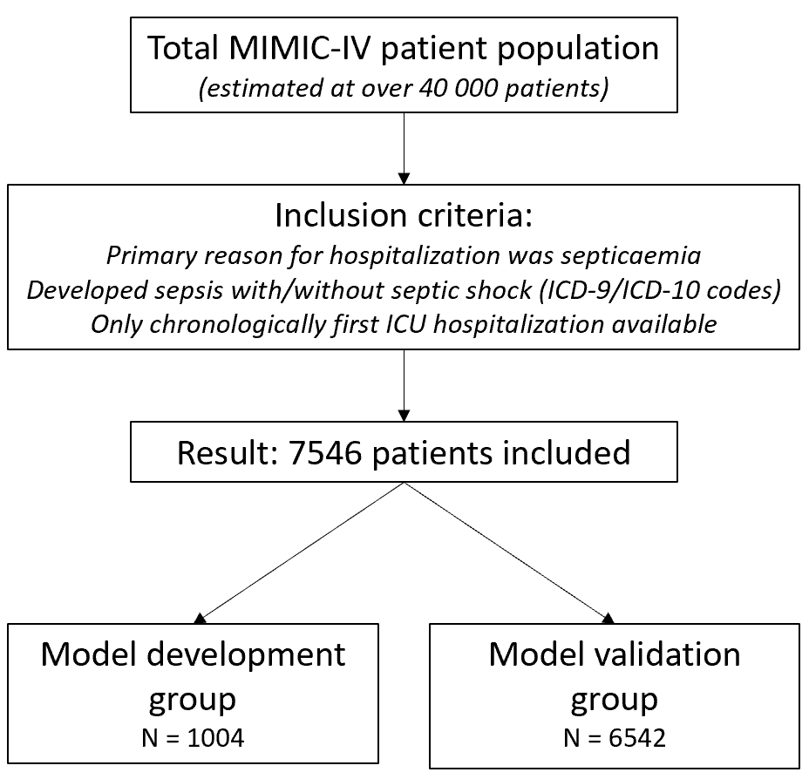
Supplementary Figure 1. Flowchart describing the patient selection process and inclusion criteria for the study. Details about the model validation and model development group can be found in the Methods section.

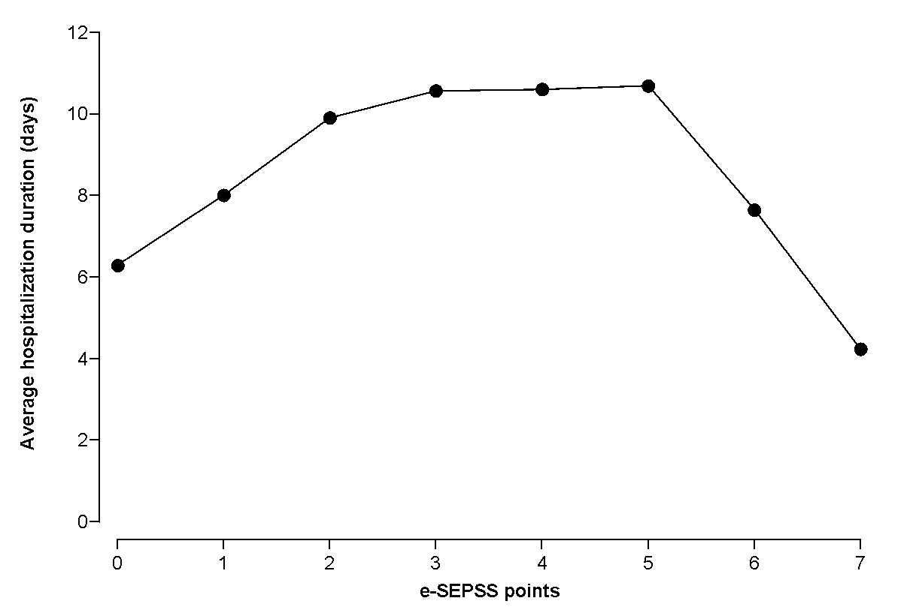Supplementary Figure 2. Kaplan-Meier survival curves for groups with different number of e-SEPSS points in the first 50 days of hospitalization.

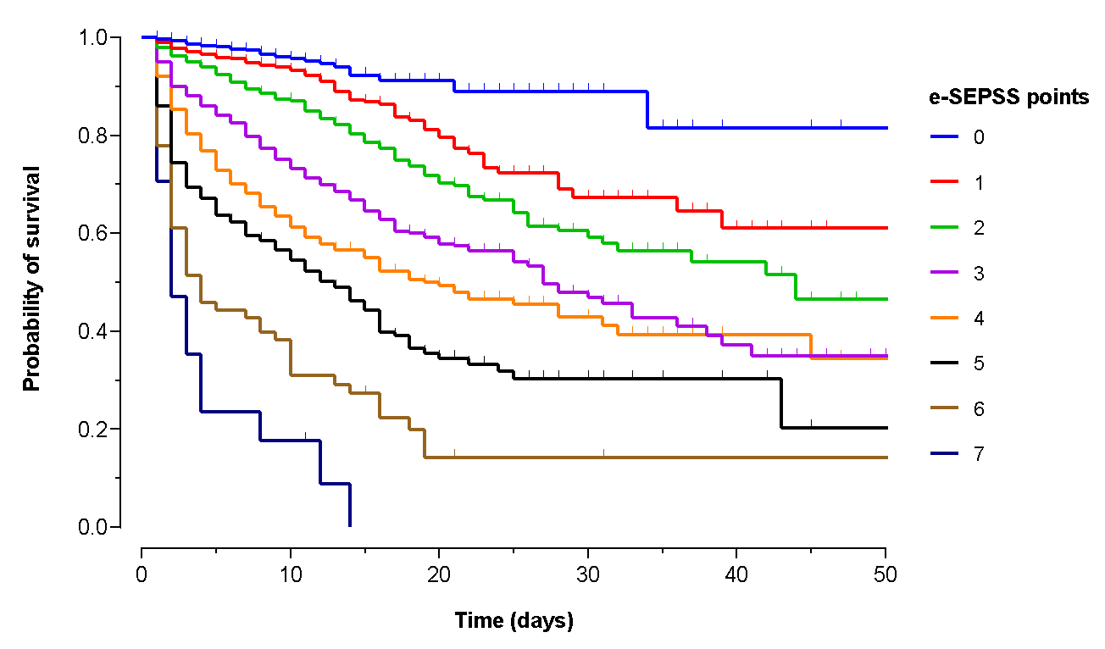
Supplementary Figure 3. Average hospital duration according to the number of e-SEPSS points.

