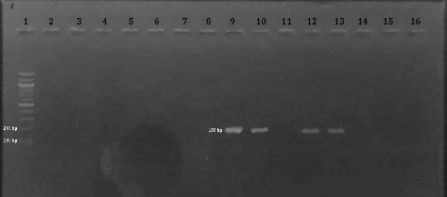
Figure 1a Gel Electrophoresis of PCR amplification of icaA gene
Lane 1: DNA Ladder (1 Kbp), Lane 2: Blank (Negative Control), Lane 9,10,12,13 clinical isolate positive with icaA gene (188 bp), Lane 3,4,5,6,7,8,11,14,15,16 clinical isolate negative with icaA gene

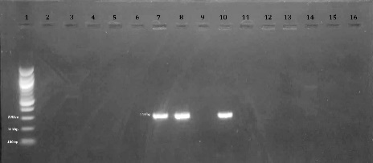
Figure 1b Gel Electrophoresis of PCR amplification of mecA gene
Lane 1: DNA Ladder (1 Kbp), Lane 2: Blank (Negative Control), Lane 7,8,10 clinical isolate positive with mecA gene (310 bp), Lane 3,4,5,6,9,11,12,13,14,15,16 clinical isolate negative with mecA gene

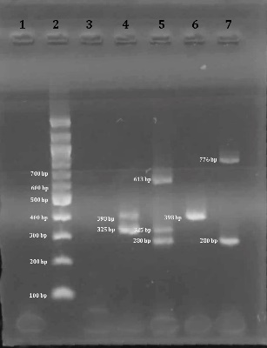
Figure 1c Agarose gel electrophoresis of amplicons for SCCmec typing
Lane 1: Blank, Lane 2: DNA Ladder (1 Kbp), Lane 3: Blank (Negative Control), Lane 4: clinical isolate positive with SCCmecV (325 bp) & II (398 bp) gene, Lane 5: clinical isolate positive with SCCmec III (280 bp), IV (776 bp) & I (613 bp) gene, Lane 6: clinical isolate positive with SCCmec II (398 bp), Lane 7: clinical isolate positive with SCCmec III (280 bp) & IV (776 bp)

