Supplementary Table 1 Variance inflation factor (VIF) of each variable
variable | VIF
Sex | 1.444
Age | 2.050
CRRT | 1.235
Potassium | 1.324
Sodium | 4.083
BUN | 2.716
glucose | 1.308
Creatinine | 2.470
Monocytes | 2.193
Neutrophils | 2.991
Lymphocytes | 1.648
WBC | 1.771
PLT | 1.388
Lactate | 1.768
PO2 | 1.940
APTT | 1.107
Calcium | 1.330
BMI | 1.000
Heart rate | 1.432
SBP | 2.510
DBP | 4.716
Resp rate | 1.419
Temperature | 1.289
SpO2 | 1.228
Congestive heart failure | 1.265
Peripheral vascular disease | 1.046
Chronic pulmonary disease | 1.141
Diabetes | 1.310
Hypertension | 1.287
Acute kidney failure | 1.512
APSIII | 2.640
SAPSII | 3.732
SOFA | 3.062
Vasopressor | 1.532
Ventilation | 1.068
BMI: body mass index, SBP: systolic blood pressure, DBP: diastolic blood pressure, SpO2: oxygen saturation, WBC: white blood cell, PLT: platelet, PO2: oxygen partial pressure, BUN: blood urea nitrogen, APTT: activated partial thromboplastin time, SOFA: sequential organ failure assessment, APSIII: acute physiology score III, SAPSII: Simplified Acute Physiological Score II, CRRT: continuous renal replacement therapy.

Supplementary Table 2 Relationship between NPR and 28-day mortality in patients with septic shock
Variables | HR (95%CI) | P
NPR
Q1 (n=104) | 1.00 (Reference)
Q2 (n=104) | 1.05 (0.65-1.69) | 0.839
Q3 (n=104) | 0.72 (0.43-1.21) | 0.214
Q4 (n=104) | 1.08 (0.67-1.73) | 0.749
NPR: neutrophil-platelet ratio, HR: hazard ratio, CI: confidence interval.

Supplementary Table 3 The value of NPR in predicting 28-day mortality in the risk score
Risk Score | AUC | AUC after NPR addition | IDI | NRI
SOFA | 0.5878 | 0.5813 | -0.00156 | 0.00325
APSIII | 0.8185 | 0.8189 | 0.0000355 | -0.0002555
SAPSII | 0.7479 | 0.7484 | 0.0000322 | 0.0000644
SOFA: sequential organ failure assessment, APSIII: Acute physiology Score III, SAPSII: Simplified Acute Physiological Score II, AUC: area under the curve, NPR: neutrophil-platelet ratio, IDI: incremental discrimination improvement, NRI: net reclassification improvement.

Supplementary Table 4 The value of NPR versus neutrophils and platelets in predicting 28-day mortality in a risk score
Risk Score | Variable | AUC | IDI | NRI
SOFA | NPR | 0.5952 | 0.0021 | 0.0889
 | neutrophils | 0.6132 | 0.0084 | 0.3912
 | platelet | 0.6143 | 0.0085 | 0.3019
APSIII | NPR | 0.8192 | -0.0001 | 0.0121
 | neutrophils | 0.8195 | 0.0002 | 0.0301
 | platelet | 0.8206 | 0.0006 | 0.0234
SAPSII | NPR | 0.7721 | 0.0006 | 0.0440
 | neutrophils | 0.7748 | 0.0028 | 0.1004
 | platelet | 0.7762 | 0.0035 | 0.0874
SOFA: sequential organ failure assessment, APSIII: Acute physiology Score III, SAPSII: Simplified Acute Physiological Score II, AUC: area under the curve, NPR: neutrophil-platelet ratio, IDI: incremental discrimination improvement, NRI: net reclassification improvement.

Supplementary Table 5 Baseline characteristics comparison among the three NPR trajectories
Variables | Total (n=434) | Trajectory 1 (n=361) | Trajectory 2 (n=27) | Trajectory 3 (n=46) | P value
Demographic
Age | 64.29 (51.11-73.51) | 64.32 (51.10-73.84) | 61.29 (47.88-67.65) | 62.35 (51.29-78.61) | 0.466
Male (%) | 233 (53.7) | 194 (53.7) | 16 (59.3) | 23 (50.0) | 0.745
Vital signs
Heart rate | 99.00 (86.00-115.00) | 99.00 (84.50-114.00) | 102.00 (88.00-120.00) | 102.00 (87.00-112.50) | 0.418
Resp rate | 22.00 (18.00-28.00) | 22.00 (18.00-27.50) | 22.00 (16.50-28.00) | 23.00 (18.00-28.25) | 0.850
Temperature | 36.94 (36.50-37.52) | 36.94 (36.50-37.53) | 37.06 (36.17-37.72) | 36.89 (36.38-37.44) | 0.525
SBP | 119.00 (103.00-135.00) | 121.00 (104.00-136.00) | 107.00 (95.00-126.00) | 108.50 (95.75-122.50) | 0.003
DBP | 66.00 (55.00-78.25) | 67.00 (55.50-79.00) | 61.00 (50.00-77.00) | 61.00 (51.75-71.50) | 0.120
SpO2 | 97.00 (93.00-99.00) | 97.00 (93.00-99.00) | 97.00 (95.00-99.00) | 95.50 (93.00-98.00) | 0.284
Laboratory tests
WBC | 12.05 (7.28-19.10) | 11.80 (7.20-17.50) | 11.80 (6.60-23.70) | 17.40 (8.35-30.33) | 0.011
Monocytes | 24.00 (1.00-75.00) | 18.00 (1.00-56.50) | 78.00 (20.00-114.00) | 66.00 (26.75-154.25) | <0.001
Lymphocytes | 52.00 (1.00-141.25) | 46.00 (1.00-127.50) | 64.00 (31.00-397.00) | 97.00 (34.75-333.75) | <0.001
Lactate | 2.00 (1.00-3.00) | 2.00 (1.00-3.00) | 2.00 (2.00-4.00) | 2.00 (2.00-4.00) | 0.013
BUN | 27.00 (16.00-44.25) | 24.00 (15.00-40.05) | 45.00 (27.00-69.00) | 38.00 (28.50-55.00) | <0.001
Potassium | 4.10 (3.70-4.70) | 4.10 (3.65-4.60) | 4.20 (3.50-5.20) | 4.25 (3.78-5.00) | 0.344
Sodium | 138.00 (134.00-141.00) | 138.00 (135.00-141.00) | 138.00 (133.00-145.00) | 135.00 (132.00-141.00) | 0.073
Creatinine | 1.20 (0.80-2.20) | 1.10 (0.80-1.90) | 1.70 (1.40-3.10) | 1.75 (1.00-2.73) | <0.001
Calcium | 7.80 (7.30-8.40) | 7.90 (7.40-8.40) | 7.40 (6.80-8.00) | 7.65 (7.00-8.20) | 0.014
APTT | 33.00 (28.00-41.00) | 32.00 (27.00-39.00) | 39.00 (35.00-54.00) | 40.00 (31.00-54.25) | <0.001
Score system
SOFA | 4.00 (3.00-6.00) | 4.00 (3.00-6.00) | 4.00 (3.00-7.00) | 4.00 (4.00-6.25) | 0.020
APSIII | 83.50 (64.00-101.00) | 80.00 (62.00-97.00) | 108.00 (85.00-120.00) | 95.00 (80.50-112.25) | <0.001
SAPSII | 47.00 (35.00-59.00) | 45.00 (33.50-57.50) | 54.00 (43.00-62.00) | 50.00 (45.75-70.25) | <0.001
Interventions
Ventilation (%) | 426 (98.2) | 354 (98.1) | 27 (100) | 45 (97.8) | 0.914
CRRT (%) | 99 (22.8) | 76 (21.1) | 8 (29.6) | 15 (32.6) | 0.146
SBP: systolic blood pressure, DBP: diastolic blood pressure, SpO2: oxygen saturation, WBC: white blood cell, BUN: blood urea nitrogen, APTT: activated partial thromboplastin time, SOFA: sequential organ failure assessment, APSIII: Acute physiology Score III, SAPSII: Simplified Acute Physiological Score II, CRRT: continuous renal replacement therapy.

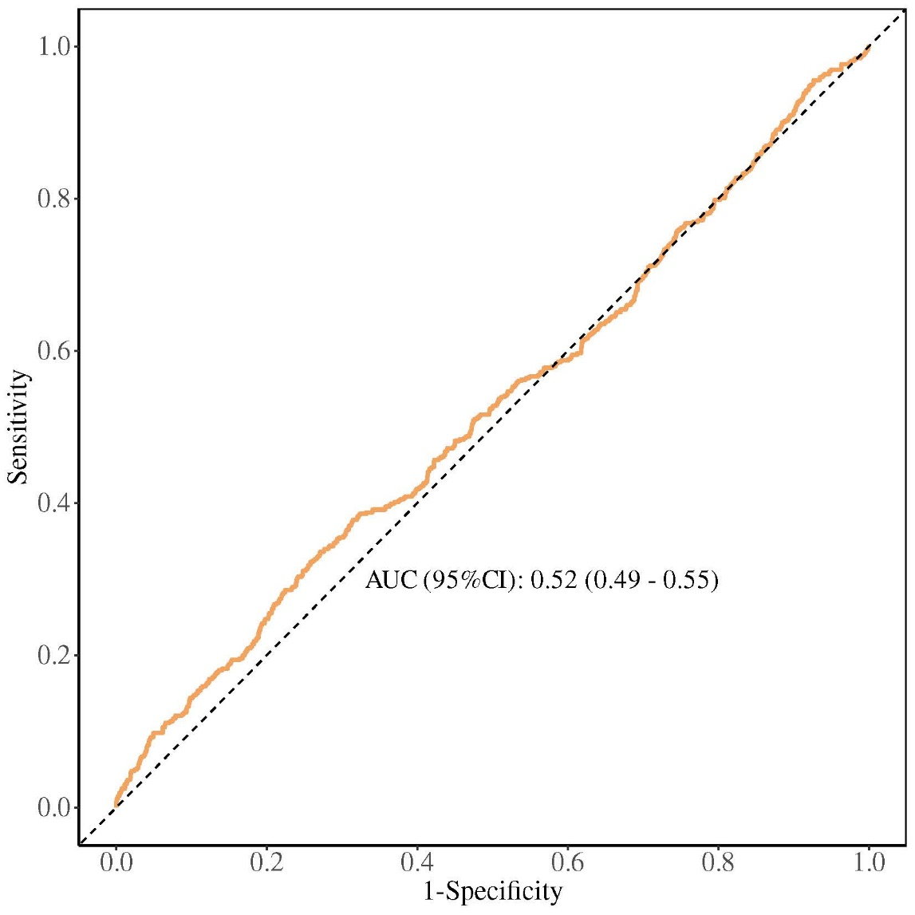
Supplementary Figure 1 ROC curve of NPR versus 28-day mortality. CI: confidence interval, AUC: area under the curve.

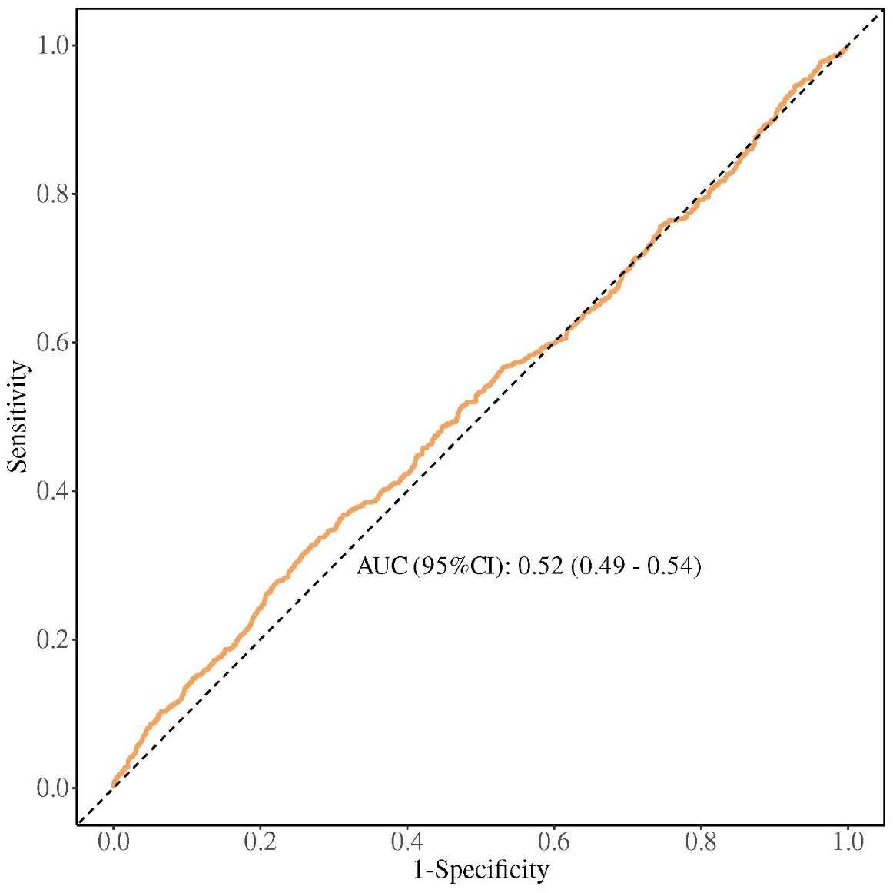
Supplementary Figure 2 ROC curve of NPR versus 90-day mortality. CI: confidence interval, AUC: area under the curve.

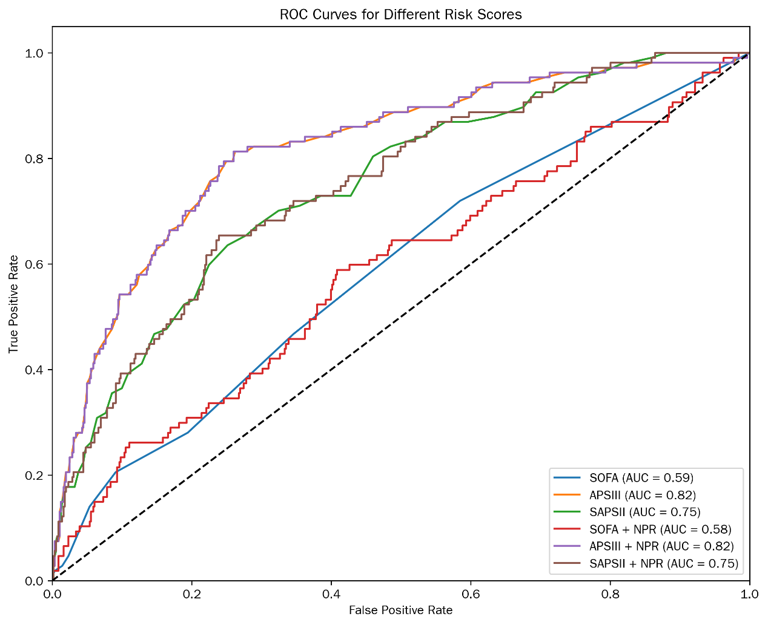
Supplementary Figure 3 NPR predicts the ROC curve of 28-day mortality in the risk score. SOFA: sequential organ failure assessment, APSIII: Acute physiology Score III, SAPSII: Simplified Acute Physiological Score II, AUC: area under the curve, NPR: neutrophil-platelet ratio.

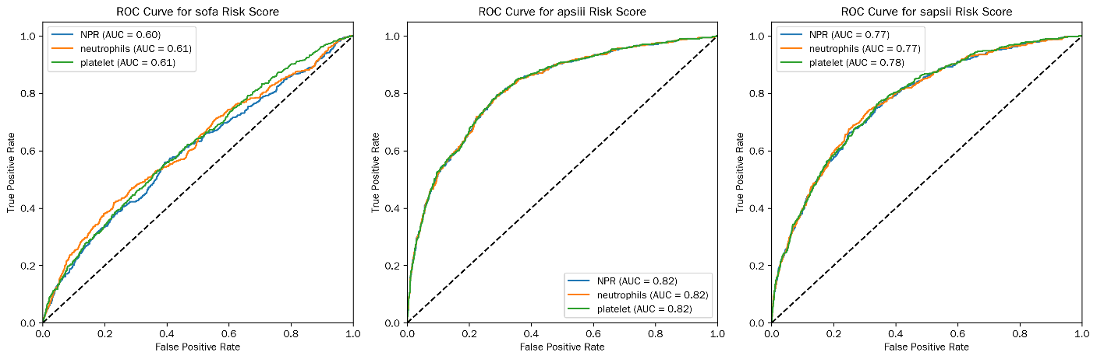
Supplementary Figure 4 ROC curve of NPR versus neutrophils and platelets in risk score for predicting 28-day mortality. SOFA: sequential organ failure assessment, APSIII: Acute physiology Score III, SAPSII: Simplified Acute Physiological Score II, AUC: area under the curve, NPR: neutrophil-platelet ratio.

