Diagnostic accuracy of non-invasive SARS-CoV-2 screening tests: a national prospective analysis

Supplementary file

Supplementary figure 1. Procedure for collecting saliva intended to the staff of the community centre in Monaco

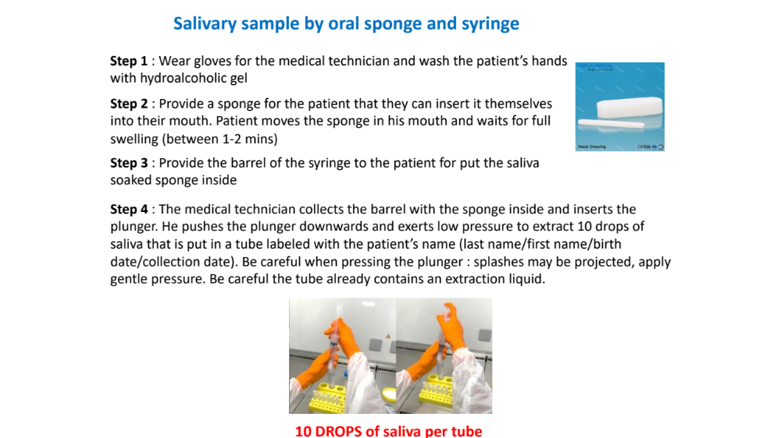
Supplementary figure 2. SARS-CoV-2 variants and subvariants in Monaco between March 2021 and February 2023

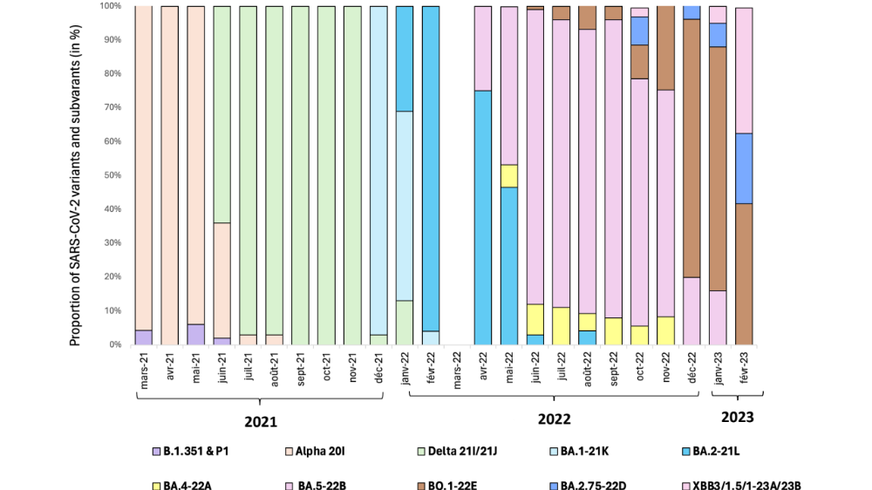

Supplementary table 1. Characteristics of the participants according to the SARS-CoV-2 test evaluated in Monaco between February 2021-February 2023
 | BS RAT  (n=1,562) | BS RT-PCR  (n=1,605) | OS RAT  (n=2,087) | OS RT-PCR  (n=1,940)
Female, n (%) | 726 (46.5) | 757 (47.2) | 1,099 (52.7) | 1,024 (52.8)
Age, median (IQR) | 44 (34-54) | 45 (34-54) | 51 (38-61) | 51 (39-62)
BMI, median (IQR) | 23.8 (21.5-26.9) | 23.8 (21.3-27.0) | 23.9 (21.3-26.9) | 23.8 (21.3-26.9)
Comorbidity, n (%) | 315 (20.2) | 325 (20.3) | 465 (22.3) | 433 (22.3)
Allergy, n (%) | 64 (4.1) | 66 (4.1) | 76 (3.6) | 72 (3.7)
Activity, n (%)
- None | 97 (6.2) | 112 (7.0) | 220 (10.5) | 207 (10.7)
- Retired | 87 (5.6) | 97 (6.0) | 212 (10.2) | 203 (10.5)
- Health worker | 40 (2.6) | 40 (2.5) | 44 (2.1) | 40 (2.1)
- Independent | 99 (6.3) | 106 (6.6) | 131 (6.3) | 118 (6.1)
- Manual | 266 (17.0) | 253 (15.8) | 246 (11.8) | 234 (12.1)
- Educational | 88 (5.6) | 91 (5.7) | 142 (6.8) | 129 (6.7)
- Office | 730 (46.7) | 747 (46.5) | 827 (39.6) | 752 (38.8)
- Other | 155 (9.9) | 159 (9.9) | 265 (12.7) | 257 (13.3)
Smoker, n (%) | 513 (32.8) | 519 (32.3) | 581 (27.8) | 539 (27.8)
Presence of symptoms, n (%) | 620 (39.7) | 633 (39.4) | 895 (42.9) | 830 (42.8)
Previously infected, n (%) | 69 (4.4) | 86 (5.4) | 585 (28.0) | 652 (29.0)
Fully vaccinated, n (%) | 172 (11.0) | 267 (16.6) | 1,404 (67.3) | 1,332 (68.7)
BS – Buccal swab
OS – Oral sponge
RAT – Rapid antigen test
RT-PCR – Reverse transcriptase polymerase chain reaction
IQR – Interquartile range
Comorbidity includes cardiovascular disease, chronic pulmonary disease, cancers, auto-immune disease, and diabetes.
Other activity includes artists, athletes, and priests.
Supplementary table 2. Number of participants according to SARS-CoV-2 detection in saliva from a buccal swab (BS) and an oral sponge (OS) compared to nasopharyngeal swab using RT-PCR tests overall, and according to previous SARS-CoV-2 infection, vaccination, and presence of symptoms in Monaco between February 2021-February 2023

 | Nasopharyngeal
 | Overall |  |  | Previously infected |  |  | Not previously infected |  |  | Vaccinated |  |  | Not vaccinated |  |  | Symptomatic |  |  | Asymptomatic
BS | Negative | Positive | Total | Negative | Positive | Total | Negative | Positive | Total | Negative | Positive | Total | Negative | Positive | Total | Negative | Positive | Total | Negative | Positive | Total
Negative | 1,457 | 21 | 1,478 | 73 | 9 | 82 | 1,384 | 12 | 1,396 | 251 | 0 | 251 | 1,206 | 21 | 1,227 | 554 | 11 | 565 | 903 | 10 | 913
Positive | 5 | 122 | 127 | 0 | 4 | 4 | 5 | 118 | 123 | 1 | 15 | 16 | 4 | 107 | 111 | 2 | 66 | 68 | 3 | 56 | 59
Total | 1,462 | 143 | 1,605 | 73 | 13 | 86 | 1,389 | 130 | 1,519 | 252 | 15 | 267 | 1,210 | 128 | 1,338 | 556 | 77 | 633 | 906 | 66 | 972
OS | Negative | Positive | Total | Negative | Positive | Total | Negative | Positive | Total | Negative | Positive | Total | Negative | Positive | Total | Negative | Positive | Total | Negative | Positive | Total
Negative | 1,057 | 41 | 1,098 | 395 | 15 | 410 | 662 | 26 | 688 | 735 | 25 | 760 | 322 | 16 | 338 | 397 | 20 | 417 | 660 | 21 | 681
Positive | 58 | 784 | 842 | 20 | 132 | 152 | 38 | 652 | 690 | 38 | 534 | 572 | 20 | 250 | 270 | 18 | 395 | 413 | 40 | 389 | 429
Total | 1,115 | 825 | 1,940 | 415 | 147 | 562 | 700 | 678 | 1,378 | 773 | 559 | 1,332 | 342 | 266 | 608 | 415 | 415 | 830 | 700 | 410 | 1,110

Supplementary table 3. Distribution of SARS-CoV-2 detection comparing the buccal swab (BS) rapid antigen diagnostic test (RAT) compared with nasopharyngeal RT-PCR test in Monaco between February 2021-February 2023
 | Nasopharyngeal RT-PCR test
BS RAT | Negative | Positive | Total
Negative | 1,086 | 125 | 1,211
Positive | 306 | 45 | 351
Total | 1,392 | 170 | 1,562
BS – Buccal swab
RAT – Rapid antigen test
RT-PCR – Reverse-transcriptase polymerase chain reaction

Supplementary table 4. Diagnostic accuracy of SARS-CoV-2 detection of the buccal swab rapid antigen diagnostic test compared with nasopharyngeal RT-PCR test in Monaco between February 2021-February 2023

Sensitivity  (95% CI) | Specificity  (95% CI) | Positive predictive value  (95% CI) | Negative predictive value  (95% CI)
26.5% (24.3-28.7) | 78.0 (76.0-80.1) | 12.8 (11.2-14.5) | 89.7 (88.2-91.2)
95% CI – 95% confidence interval
Supplementary table 5. Threshold evaluation of the oral sponge (OS) rapid antigen test (RAT) against nasopharyngeal (NP) and OS RT-PCR tests in Monaco between February 2021-February 2023. The exact cut-off index with the highest combination of sensitivity and specificity were added for each of the reference test, respectively 0.67 for OS RAT versus NP RT-PCT test, and 0.71 for OS RAT versus OS RT-PCR test.

 | OS RAT versus NP RT-PCR test |  |  |  | OS RAT versus OS RT-PCR test
Cut-off index | Sensitivity | 95% CI | Specificity | 95% CI | Sensitivity | 95% CI | Specificity | 95% CI
0.4 | 0.948 | 0.933-0.963 | 0.212 | 0.19-0.235 | 0.974 | 0.962-0.984 | 0.166 | 0.145-0.188
0.5 | 0.857 | 0.834-0.88 | 0.317 | 0.29-0.343 | 0.895 | 0.872-0.917 | 0.265 | 0.24-0.291
0.6 | 0.762 | 0.736-0.789 | 0.663 | 0.637-0.69 | 0.814 | 0.786-0.841 | 0.637 | 0.607-0.664
0.67 | 0.669 | 0.63-0.703 | 0.937 | 0.915-0.967 | - | - | - | -
0.7 | 0.642 | 0.61-0.671 | 0.958 | 0.947-0.969 | 0.697 | 0.663-0.729 | 0.964 | 0.953-0.975
0.71 | - | - | - | - | 0.691 | 0.663-0.753 | 0.975 | 0.928-0.987
0.8 | 0.565 | 0.533-0.598 | 0.980 | 0.972-0.987 | 0.625 | 0.592-0.659 | 0.993 | 0.987-0.997
0.9 | 0.518 | 0.486-0.55 | 0.985 | 0.979-0.992 | 0.572 | 0.535-0.603 | 0.996 | 0.993-0.999
1.0 | 0.484 | 0.452-0.516 | 0.987 | 0.98-0.993 | 0.534 | 0.497-0.569 | 0.997 | 0.994-1
1.1 | 0.456 | 0.424-0.49 | 0.987 | 0.98-0.993 | 0.503 | 0.465-0.538 | 0.997 | 0.994-1
95% CI – 95% confidence interval
RT-PCR – Reverse transcriptase polymerase chain reaction

