Supplementary Figure S1-S9 for
Multi-omics Driven Biomarker Discovery and Pathological Insights into Pseudomonas aeruginosa Pneumonia

Zhiwei Lin, Mingshan Xue, Mingqing Lu, Shuang Liu, Yueting Jiang, Qianyue Yang, Honghui Cui, Xia Huang, Zeguang Zheng, Baoqing Sun

- Figure S1. Proteomic Stratification and Co-expression Module Analysis.
- Figure S2. Functional and Pathway Enrichment Analysis of 16 Differentially Expressed Proteins.
- Figure S3. GO terms and KEGG pathways of P. aeruginosa-associated differentially expressed proteins and Spearman correlation analysis between P. aeruginosa-associated differentially expressed proteins and immune cells.
- Figure S4. Random Forest Analysis Identifies Key Biomarkers in P. aeruginosa Infection.
- Figure S5. ROC Curve Analysis of Protein Biomarkers in the Discovery Cohort (BALF) as a Training Set.
- Figure S6. Evaluation of Model Robustness and Discriminative Capacity in the Discovery Cohort (BALF) and ROC Curve Analysis of Metabolite Biomarkers in the Discovery Cohort (BALF) as a Training Set.
- Figure S7. Evaluation of Model Robustness and Discriminative Capacity in the Validation Cohort (BALF).
- Figure S8. Evaluation of Model Robustness and Discriminative Capacity in the Discovery Cohort (Serum) and ROC Curve Analysis of Metabolite Biomarkers in the Discovery Cohort (Serum) as a Training Set.
- Figure S9. Evaluation of Model Robustness and Discriminative Capacity in the Validation Cohort (Serum).

1. Figure S1. Proteomic Stratification and Co-expression Module Analysis.
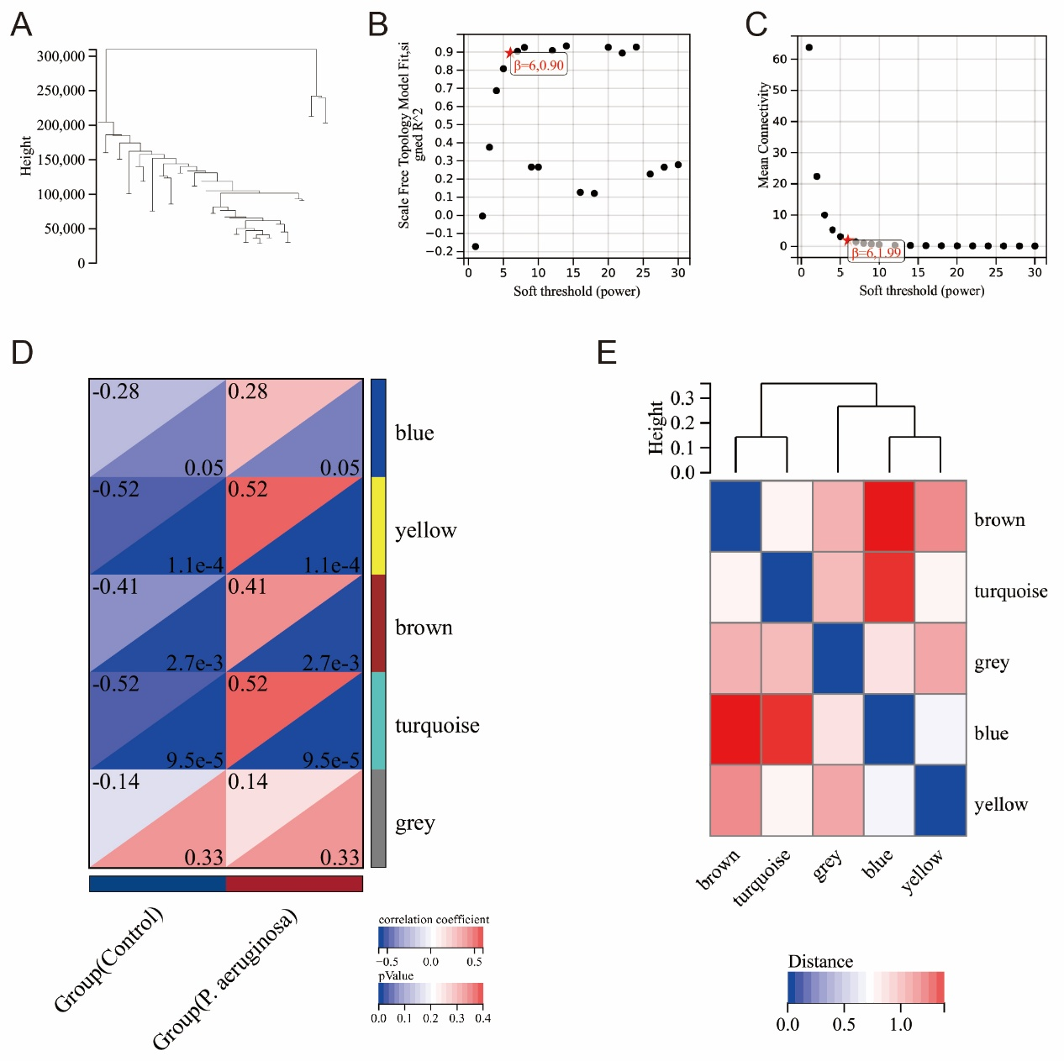
(A) A clustering dendrogram of 50 samples elucidates the stratification based on proteomic profiles. (B, C) Evaluation of scale independence and mean connectivity reinforces the robustness of network construction in our analysis. (D) Weighted Gene Co-expression Network Analysis (WGCNA) identifies 5 distinct modules of co-expressed proteins. (E) Correlation analyses among the identified modules reveal significant relationships and potential functional synergies.

2. Figure S2. Functional and Pathway Enrichment Analysis of 16 Differentially Expressed Proteins.

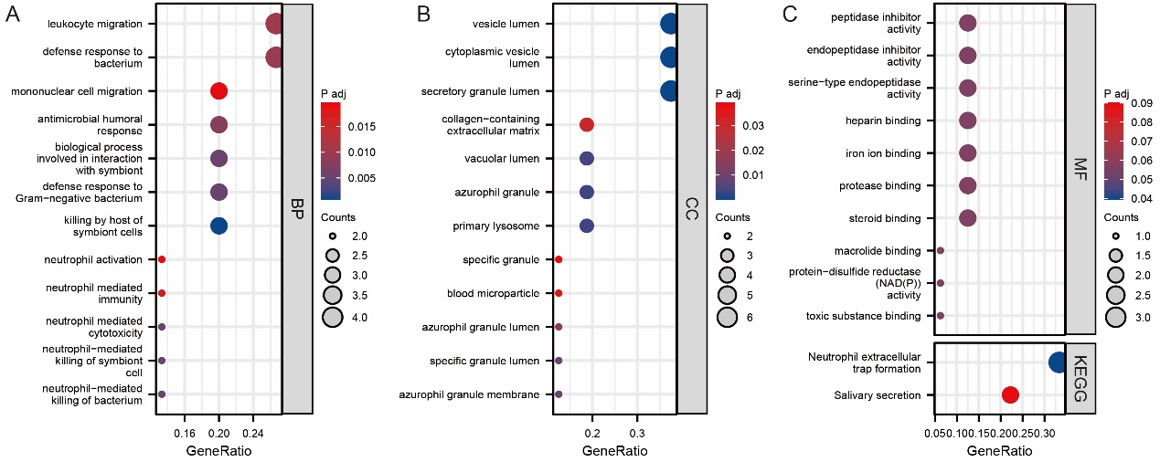
(A-C) Gene Ontology (GO) and Kyoto Encyclopedia of Genes and Genomes (KEGG) analyses facilitate the functional categorization and pathway enrichment of the 16 PDEPs. GO analysis illuminates pathways related to leukocyte migration, defense response to bacterium, Gram-negative bacterial response, neutrophil activation, vesicle lumen, peptidase inhibitor activity, and iron ion binding. KEGG analysis focuses on pathways integral to neutrophil extracellular trap formation, underscoring the biochemical pathways activated in response to the infection.

3. Figure S3. GO terms and KEGG pathways of P. aeruginosa-associated differentially expressed proteins and Spearman correlation analysis between P. aeruginosa-associated differentially expressed proteins and immune cells.
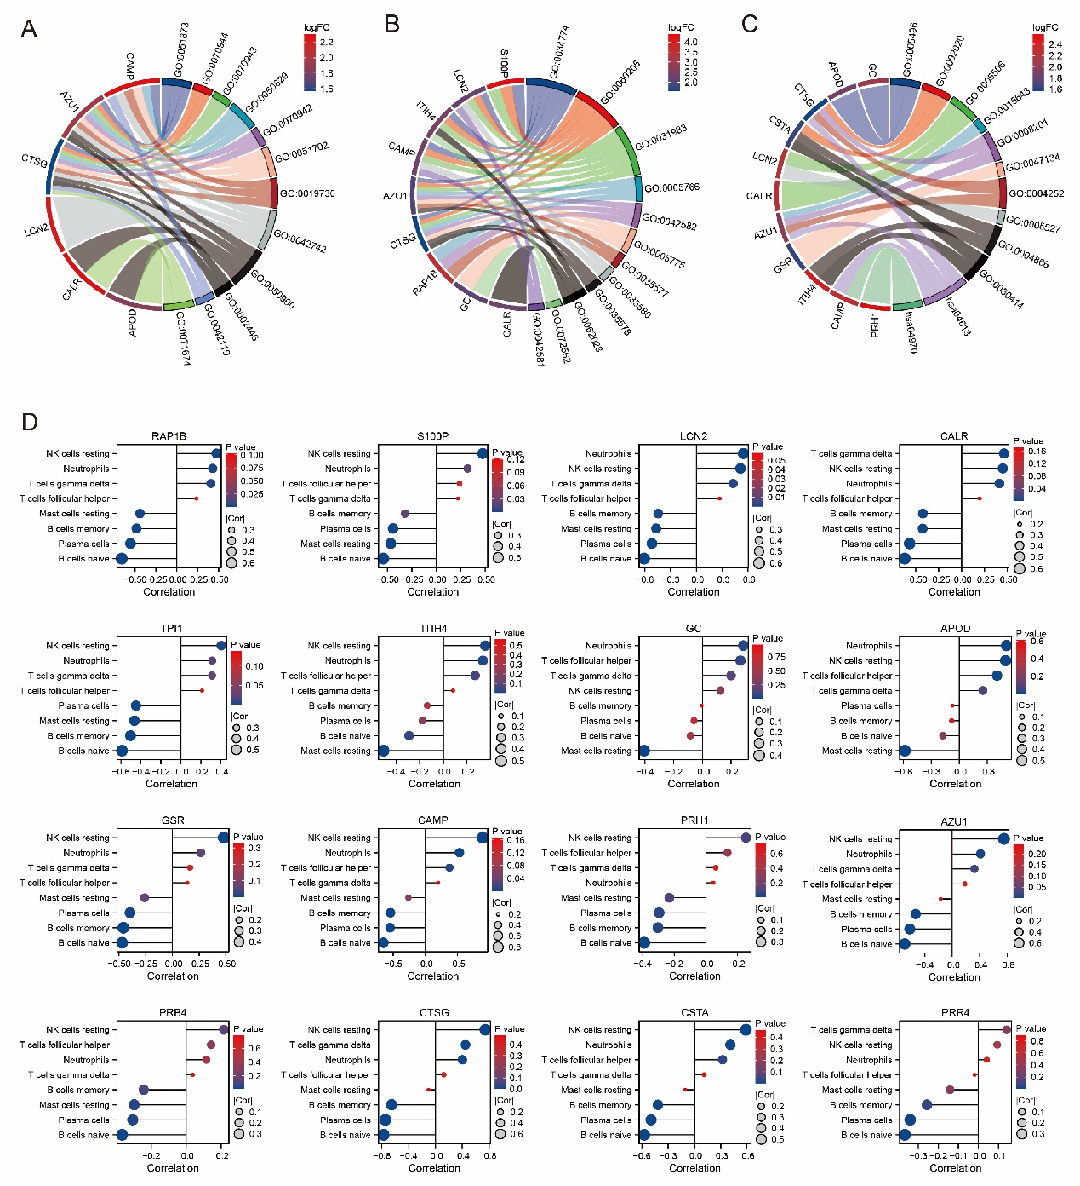

(A-C) Chord diagrams illustrate the intricate relationships among identified GO terms and KEGG pathways, elucidating the comprehensive roles P. aeruginosa-associated differentially expressed proteins (PDEPs) play in the host's response to P. aeruginosa infection. (D) Correlation analysis investigates the relationships between P. aeruginosa-associated differentially expressed proteins (PDEPs) and different immune cells, aiming to identify specific immune responses elicited by the infection and potential mechanisms of host defense or pathogen evasion.

4. Figure S4. Random Forest Analysis Identifies Key Biomarkers in P. aeruginosa Infection.
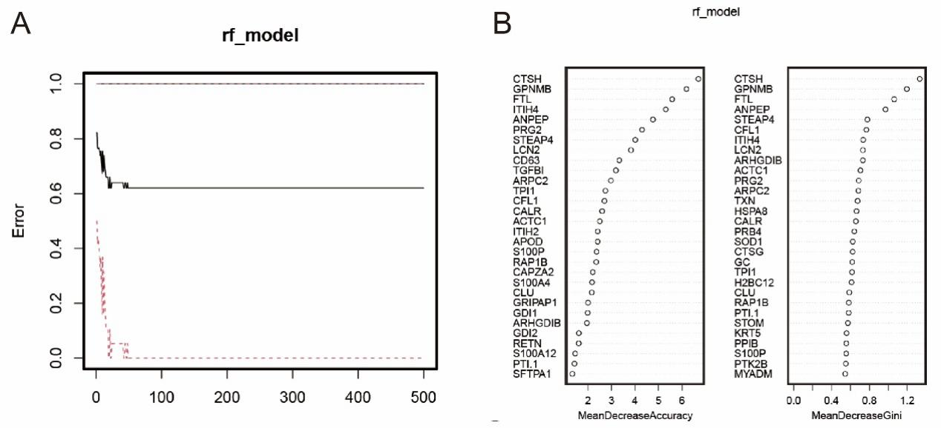
(A, B) Random Forest analysis evaluates the differential expression of proteins in P. aeruginosa infection versus healthy control. Notable proteins linked to P. aeruginosa infection were pinpointed based on mean decrease in accuracy and mean decrease in Gini, identifying them as potential biomarkers.

5. Figure S5. ROC Curve Analysis of Protein Biomarkers in the Discovery Cohort (BALF) as a Training Set.
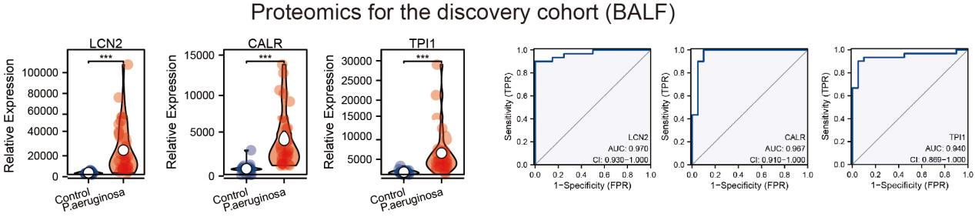
Receiver Operating Characteristic (ROC) curves illustrate the diagnostic performance of protein biomarkers identified in the discovery cohort (BALF) used as the training set. Each curve corresponds to a specific biomarker, with the area under the curve (AUC) values exceeding 0.8, demonstrating high sensitivity and specificity for distinguishing infected from non-infected samples.

6. Figure S6. Evaluation of Model Robustness and Discriminative Capacity in the Discovery Cohort (BALF) and ROC Curve Analysis of Metabolite Biomarkers in the Discovery Cohort (BALF) as a Training Set.

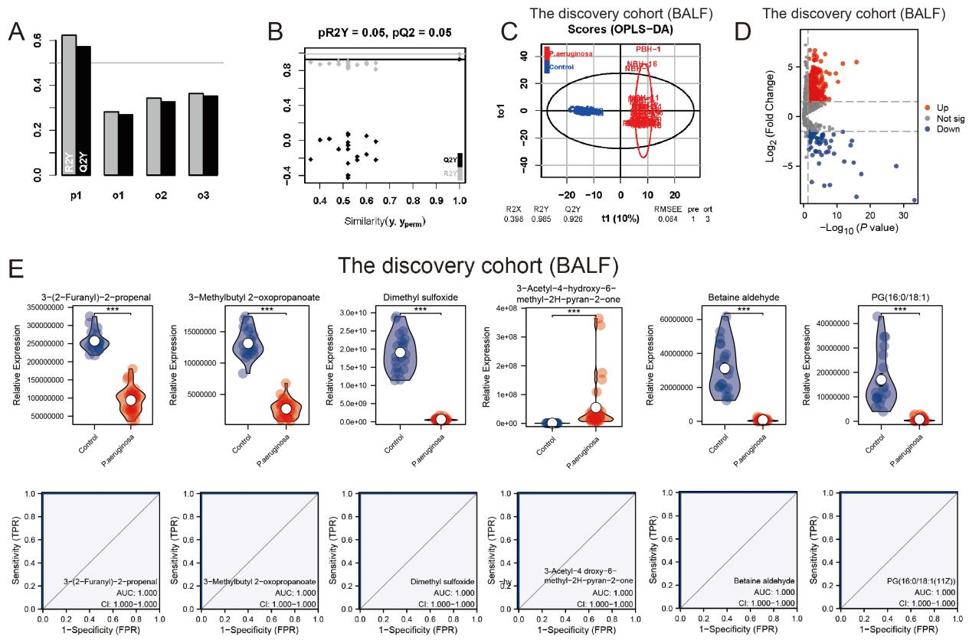
(A, B) Scatter plots evaluate the models' robustness by comparing R2Y and Q2Y values of actual versus simulated models, with models demonstrating R2Y and Q2Y values exceeding the threshold (horizontal line) indicative of overfitting. (C) An OPLS-DA plot delineates the distribution of samples along the discriminant axis, effectively differentiating between the groups. (D) Volcano plots facilitate the identification of bronchoalveolar lavage fluid (BALF) differentially expressed metabolites (DEMs) within the discovery cohort, pinpointing metabolites with significant fold changes and statistical relevance. (E) Receiver Operating Characteristic (ROC) curves depict the diagnostic accuracy of metabolite biomarkers identified in the discovery cohort (BALF) as the training set. Each curve represents a metabolite biomarker, with area under the curve (AUC) values exceeding 0.8, indicating strong sensitivity and specificity in differentiating infected from non-infected samples.

7. Figure S7. Evaluation of Model Robustness and Discriminative Capacity in the Validation Cohort (BALF).
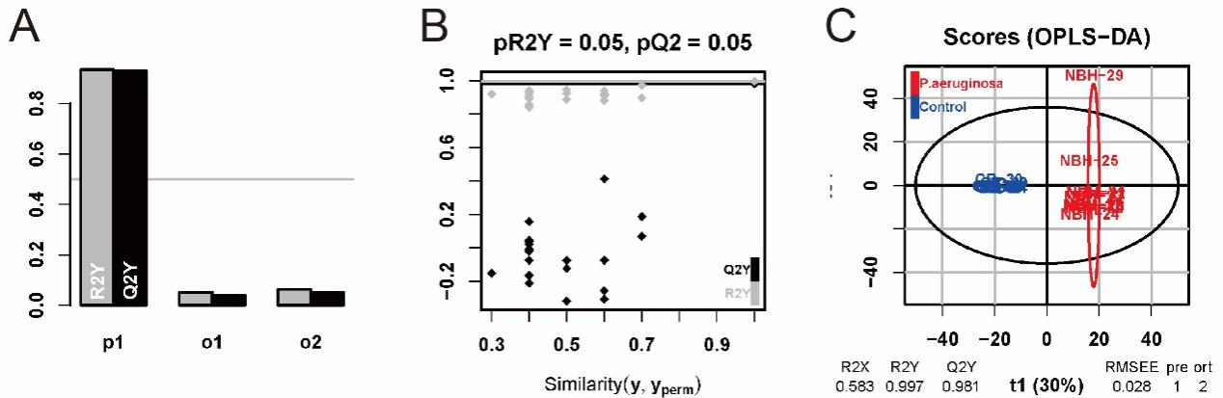
(A, B) Scatter plots evaluate the models' robustness by comparing R2Y and Q2Y values of actual versus simulated models, with models demonstrating R2Y and Q2Y values exceeding the threshold (horizontal line) indicative of overfitting. (C) An OPLS-DA score plot effectively segregates infected from non-infected samples, demonstrating distinct clustering and affirming the model's discriminative capacity.

8. Figure S8. Evaluation of Model Robustness and Discriminative Capacity in the Discovery Cohort (Serum) and ROC Curve Analysis of Metabolite Biomarkers in the Discovery Cohort (Serum) as a Training Set.

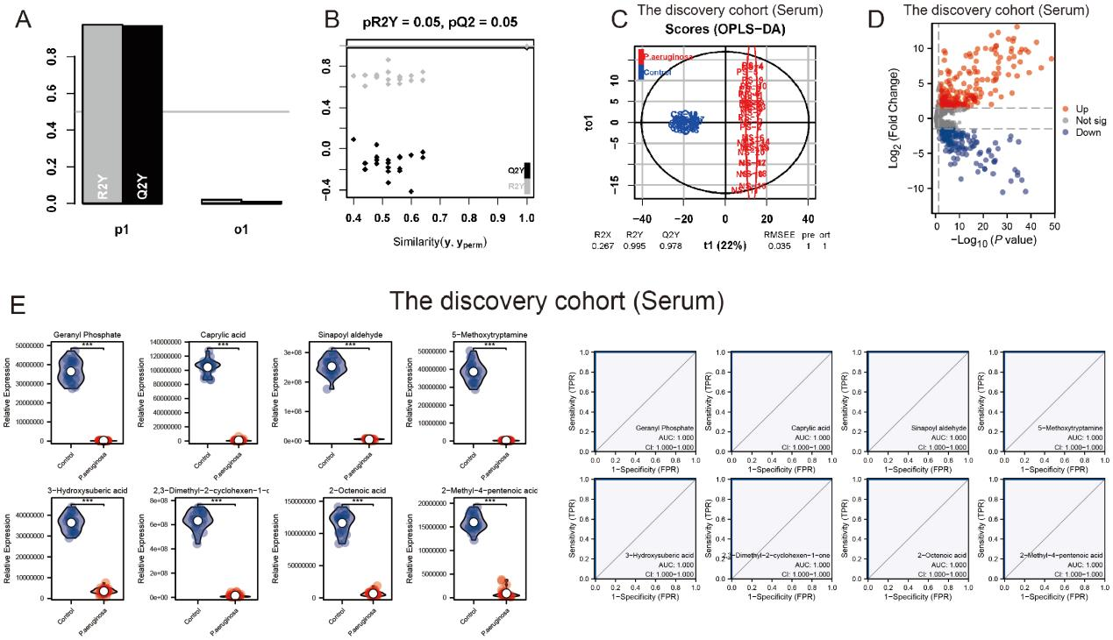
(A, B) Scatter plots evaluate the models' robustness by comparing R2Y and Q2Y values of actual versus simulated models, with models demonstrating R2Y and Q2Y values exceeding the threshold (horizontal line) indicative of overfitting. (C) An OPLS-DA score plot effectively segregates infected from non-infected samples, demonstrating distinct clustering and affirming the model's discriminative capacity. (D) A volcano plot delineates serum differentially expressed metabolites (SDEMs), showcasing marked up- and down-regulations as indicators of a substantial response to P. aeruginosa infection. (E) Receiver Operating Characteristic (ROC) curves depict the diagnostic accuracy of metabolite biomarkers identified in the discovery cohort (Serum) as the training set. Each curve represents a metabolite biomarker, with area under the curve (AUC) values exceeding 0.8, indicating strong sensitivity and specificity in differentiating infected from non-infected samples.

9. Figure S9. Evaluation of Model Robustness and Discriminative Capacity in the Validation Cohort (Serum).
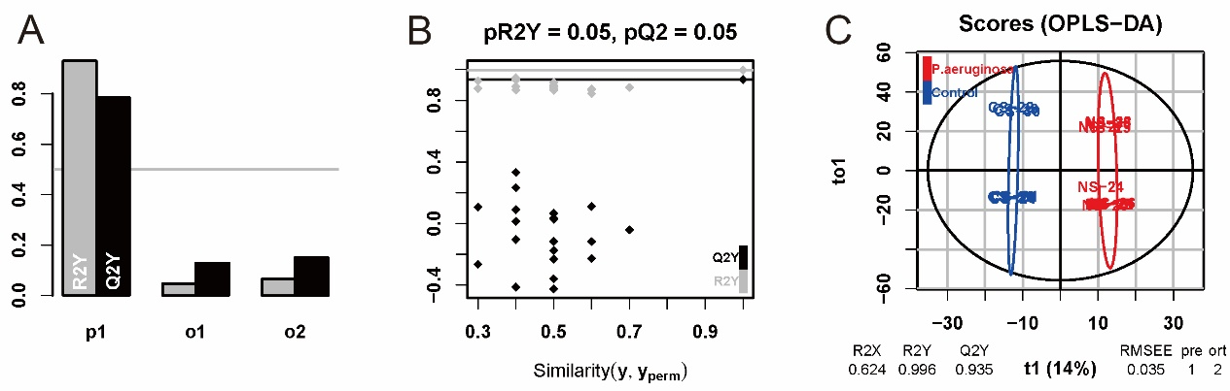
(A, B) Scatter plots evaluate the models' robustness by comparing R2Y and Q2Y values of actual versus simulated models, with models demonstrating R2Y and Q2Y values exceeding the threshold (horizontal line) indicative of overfitting. (C) An OPLS-DA score plot effectively segregates infected from non-infected samples, demonstrating distinct clustering and affirming the model's discriminative capacity.

