Supplementary Figure1. A comprehensive study designed to investigate the antimicrobial resistance pattern focusing on seasonality and hospital setting among isolates from cardiac patients. Key: Multiple antibiotic resistance (MAR), Antimicrobial resistance (AMR).

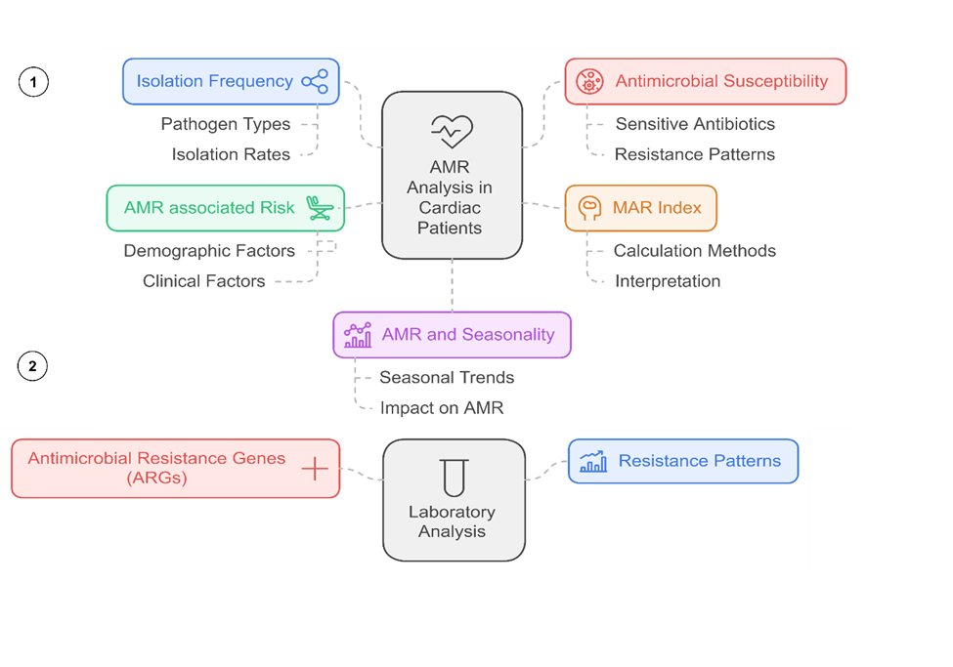

Supplementary Figure 2.
Antimicrobial Resistance Patterns Among Other Isolates. This figure presents radar graphs depicting the antimicrobial resistance (AMR) percentages of predominant bacterial isolates analyzed across seasonal and annual trends to assess temporal variations. Susceptibility testing was conducted following the Clinical and Laboratory Standards Institute (CLSI) guidelines using Oxoid discs (Basingstoke Hampshire, UK). The antibiotics tested are grouped as follows: beta-lactams, including Amoxiclav (AMC, 40 µg), Ceftriaxone (CRO, 30 µg), Cefoxitin (FOX, 30 µg), Oxacillin (OX, 30 µg), Ceftazidime (CAZ, 30 µg), Cefepime (FEP, 30 µg), Ampicillin/Sulbactam (SAM, 40 µg), Piperacillin/Tazobactam (TZP, 100 µg), Cefotaxime (CTX, 30 µg), Aztreonam (ATM, 30 µg), Imipenem (IMP, 10 µg), Doripenem (DOR, 10 µg), Meropenem (MEM, 10 µg), and Ticarcillin/Clavulanic acid (PRL, 85 µg); macrolides, including Azithromycin (AZM, 30 µg) and Erythromycin (ETM, 15 µg); quinolones, including Ciprofloxacin (CIP, 5 µg) and Levofloxacin (LEV, 5 µg); aminoglycosides, including Gentamicin (CN, 10 µg), Tobramycin (TOB, 10 µg), and Amikacin (AK, 30 µg); glycopeptides, including Vancomycin (VA, 30 µg) and Teicoplanin (TGC, 30 µg); oxazolidinones, including Linezolid (LZD, 30 µg); and others, including Trimethoprim/Sulfamethoxazole (SXT, 25 µg), Polymyxin B (PB, 300 µg), and Doxycycline (DOX, 30 µg). This comprehensive analysis provides insights into the seasonal and temporal dynamics of resistance patterns and offers valuable information for understanding AMR trends. Key: In-patients (IPs), Out-patients (OPs), AMR percentage was calculated as (number of resistant isolates / total isolates) × 100.

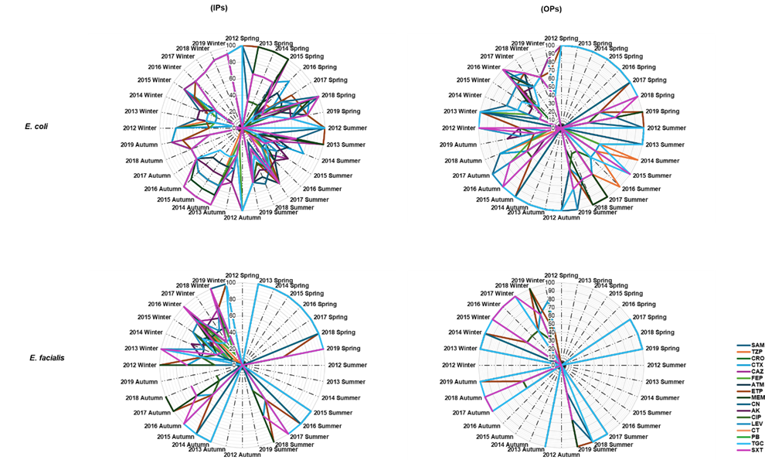

Supplementary Table 1. Specific primers were used for the amplification of antibiotic resistance genes (ARGs) through singleplex PCR. Key: Antibiotic resistance genes (ARGs), multiple antibiotic resistance (MAR), tetracyclines: tetA, tetM, sulfonamides, and trimethoprim: sul1, sul2, dfrA1, oxazolidinones: cfr, macrolides: ermB, ermC, quinolones: gyrA, gyrB, parC, beta-lactams: mecA, mecB, glycopeptides: vanA, vanB, and aminoglycosides: aac (6'), aph (3').
Primers | Sequences | Annealing temperature  (Tm ⁰ C) |  | Product Size (bp) | Positive Control | Reference
tetM | F5’GGTGAACATCATAGACACGC3’  R5’CTTGTTCGAGTTCCAATGC3’ |  | 55 | 401 |  | [1]
tetA | F5’GCTGTCGGATCGTTTCGG3’  R5’CATTCCGAGCATGAGTGCC3’ |  | 55 | 658 |  | [2]
sul1 | F5’CGGACGCGAGGCCTGTATC3’  R5’GGGTGCGGACGTAGTCAGC3’ |  | 57 | 591 |  | [2]
sul2 | F5’GCGCAGGCGCGTAAGCTGAT3’  R5’CGAAGCGCAGCCGCAATTC3’ |  | 57 | 514 |  | [3]
dfrA1 | F5’CAATGGCTGTTGGTTGGAC3’  R5’CCGGCTCGATGTCTATTGT3’ |  | 55 | 254 |  | [4]
cfr | F5’GCAGGTTGGGAGTCATTTTGT3’  R5’GACCACAAGCAGCGTCAATA3’ |  | 53 | 724 |  | This Study
ermB | F5’GAAAAGGTACTCAACCAAATA3’  R5’AGTAACGGTACTTAAATTGTTTAC3’ |  | 52 | 638 |  | [5]
ermC | F5’TCAAAACATAATATAGATAAA3’  R5’GCTAATATTGTTTAAATCGTCAAT3’ |  | 52 | 643 |  | [5]
gyrA | F5TCGTCGGTGAAGTTATCGGT3’  R5’CAGGGCCGTTTGTTTGTACA3’ |  | 55 | 760 |  | This Study
gyrB | F5CAAGCCTGGAAACCTTCACC3’  R5’ACCAGGTACAGTTCGGACAG3’ |  | 57 | 757 |  | This Study
parC | F5GCCATGAGCGAACTGGGG3’  R5’ATAGCGATAGGAGAACGGCT3’ |  | 55 | 150 |  | This Study
mecA | F5’TCCAGATTACAACTTCACCAGG3’  R5’CCACTTCATATCTTGTAACG3’ |  | 53 | 162 |  | [6]
mecB | F5’TTAACATATACACCCGCTTG3’ R5’TAAAGTTCATTAGGCACCTCC3’ |  | 50 | 279 |  | [7]
vanA | F5’CATGAATAGAATAAAAGTTGCAATA3’  R5’CCCCTTTAACGCTAATACGACGATCAA3’ |  | 50 | 732 |  | [8]
vanB | F5’GTGACAAACCGGAGGCGAGGA3’ R5’CCGCCATCCTCCTGCAAAAAA3’ |  | 63 | 1032 |  | [8]
aac (6') | F5’TAGTAGGATTTATTGGTGCAATCCC3’  R5’TTGACTTAACGTTGTTCCATGGTC3’ |  | 60 | 200 |  | This Study
aph (3') | F5’CGGAAACAGCGTTTTAGA3’  R5’TTCCTTTTGTCAGGTC3’ |  | 54 | 716 |  | This Study

Type of Isolates/ Pathogens |  | E. coli |  | S. aureus |  | K. pneumoniae |  | A. baumanii |  | P. aeruginosa |  | E. facialis
Hospital Settings |  | IPs | OPs | IPs | OPs | IPs | OPs | IPs | OPs | IPs | OPs | IPs | OPs
Demographic Factors |  | (N= numbers)
Age Groups
 | 0-22 | 17 | 10 | 30 | 17 | 10 | 6 | 17 | 9 | 13 | 4 | 10 | 1
 | 23-50 | 42 | 22 | 142 | 26 | 22 | 18 | 32 | 14 | 17 | 9 | 12 | 8
 | 51-73 | 216 | 79 | 261 | 46 | 305 | 59 | 140 | 82 | 60 | 33 | 65 | 21
Gender
 | Female | 202 | 88 | 330 | 57 | 201 | 61 | 113 | 93 | 72 | 42 | 79 | 21
 | Male | 73 | 23 | 103 | 32 | 136 | 22 | 76 | 12 | 18 | 4 | 8 | 9
Year of Isolation
 | 2012 | 13 | 4 | 33 | 6 | 22 | 2 | 9 | 3 | 3 | 1 | 2 | 1
 | 2013 | 17 | 8 | 36 | 8 | 28 | 3 | 11 | 8 | 4 | 3 | 4 | 1
 | 2014 | 29 | 9 | 41 | 9 | 31 | 4 | 19 | 9 | 8 | 3 | 7 | 2
 | 2015 | 33 | 11 | 48 | 10 | 37 | 6 | 21 | 12 | 9 | 5 | 8 | 4
 | 2016 | 38 | 12 | 52 | 11 | 39 | 11 | 27 | 13 | 11 | 7 | 10 | 4
 | 2017 | 41 | 15 | 68 | 12 | 41 | 16 | 29 | 17 | 13 | 8 | 13 | 5
 | 2018 | 49 | 20 | 75 | 14 | 43 | 19 | 31 | 19 | 16 | 9 | 16 | 6
 | 2019 | 55 | 32 | 80 | 19 | 96 | 22 | 42 | 24 | 26 | 10 | 27 | 7
Season
 | Spring | 40 | 11 | 73 | 8 | 61 | 11 | 18 | 6 | 12 | 5 | 8 | 3
 | Summer | 57 | 18 | 93 | 18 | 69 | 18 | 26 | 9 | 19 | 6 | 17 | 5
 | Autumn | 70 | 21 | 109 | 23 | 70 | 20 | 38 | 17 | 21 | 9 | 21 | 6
 | Winter | 108 | 61 | 158 | 40 | 137 | 34 | 107 | 73 | 38 | 26 | 41 | 16
Specimen Type
 | Sputum | 8 | 3 | 8 | 4 | 2 | 1 | 0 | 0 | 8 | 2 | 0 | 0
 | Fluids and effusions | 6 | 3 | 10 | 7 | 1 | 0 | 2 | 1 | 11 | 3 | 0 | 0
 | Wound and pus | 12 | 6 | 18 | 8 | 11 | 8 | 23 | 19 | 44 | 25 | 23 | 8
 | Catheter tips | 69 | 21 | 75 | 17 | 44 | 6 | 4 | 3 | 2 | 1 | 0 | 0
 | Urine | 125 | 60 | 213 | 29 | 196 | 43 | 36 | 29 | 13 | 10 | 41 | 17
 | Blood | 55 | 18 | 109 | 24 | 83 | 25 | 124 | 53 | 12 | 5 | 23 | 5
Total Each group, (n= numbers) |  | 275 | 111 | 433 | 89 | 337 | 83 | 189 | 105 | 90 | 46 | 87 | 30
Supplementary Table 2. Prevalence of bacterial isolates stratified by demographic variables from 2012 to 2019. Key: Inpatients (IPs), outpatients (OPs)
Refrences
1. Werner, G., et al., Influence of transferable genetic determinants on the outcome of typing methods commonly used for Enterococcus faecium. Journal of Clinical Microbiology, 2003. 41(4): p. 1499-1506.
2. Chuanchuen, R., S. Khemtong, and P. Padungtod, Occurrence of qacE/qacED1 genes and their correlation with class 1 integrons in Salmonella enterica isolates from poultry and swine. Southeast Asian J Trop Med Public Health, 2007. 38(5): p. 855-862.
3. Chuanchuen, R. and P. Padungtod, Antimicrobial resistance genes in Salmonella enterica isolates from poultry and swine in Thailand. Journal of Veterinary Medical Science, 2009. 71(10): p. 1349-1355.
4. Chuanchuen, R., C. Koowatananukul, and S. Khemtong, CHARACTERIZATION OF CLASS 1 INTEGRONS WITH UNUSUAL 3 CONSERVED REGION FROM SALMONELLA ENTERICA ISOLATES. 2008.
5. Sutcliffe, J., et al., Detection of erythromycin-resistant determinants by PCR. Antimicrobial agents and chemotherapy, 1996. 40(11): p. 2562-2566.
6. Belmekki, M., et al., Comparison of Xpert MRSA/SA Nasal and MRSA/SA ELITe MGB assays for detection of the mecA gene with susceptibility testing methods for determination of methicillin resistance in Staphylococcus aureus isolates. Journal of Clinical Microbiology, 2013. 51(10): p. 3183-3191.
7. Ngassam Tchamba, C., et al., Comparison of the staphylococcal chromosome cassette (SCC) mec in methicillin-resistant Staphylococcus aureus (MRSA) and non-aureus staphylococci (MRNAS) from animals and humans. Antibiotics, 2021. 10(3): p. 256.
8. Asghar, M.U., et al., Molecular distribution of biocide resistance genes and susceptibility to biocides among vancomycin resistant Staphylococcus aureus (VRSA) isolates from intensive care unit (ICU) of cardiac hospital-A first report from Pakistan. Heliyon, 2023. 9(12).

