Pictures from microscopic examination of Cryptosporidium

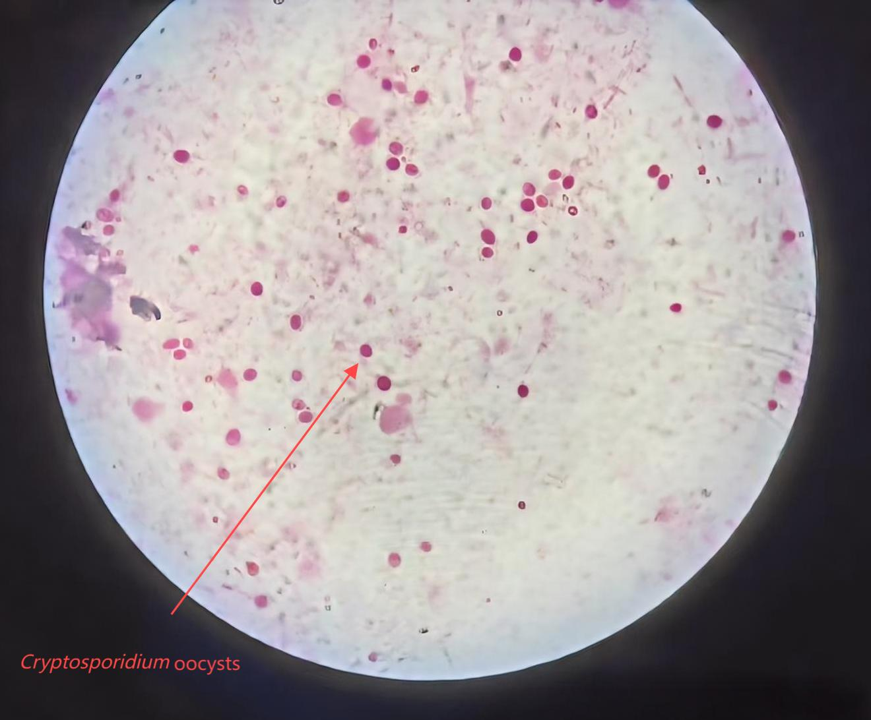

A dried and fixed fecal direct smear was stained with safranin (from the Gram stain kit), and Cryptosporidium oocysts were detected under 1000× oil immersion microscopy. The oocysts were stained in rose red.

