Supplementary Materials

Title: A Cluster Randomized Trial of an Interventions Bundle to Reduce Inappropriate Antibiotic Use for Common Upper Respiratory Tract Infections in the Outpatient Setting

Authors: Adeel Butt et al.

Items included:
Appendix 1. Total number of patient care encounters at the Primary Healthcare Center sites included in the study.

Appendix 2. Categorization of appropriate and inappropriate indications for indications for our study.

Supplementary figure 1. A simplified schema of the study design.

Supplementary figure 2. A more detailed study flow sheet including all episodes of care with a diagnosis of upper respiratory infection during the entire study period (including pre- and post-intervention implementation periods), and by treatment allocation.

Supplementary table 1. Mixed Effects Logistic Regression Model for Predictors of Inappropriate Antibiotic Prescriptions in the Control and Treatment Groups, at Baseline and Post-Intervention

Supplementary table 2. Multi-level mixed effects logistic regression model demonstrating the predictors of inappropriate prescriptions, adjusting for covariates and clustering effect within and between the PHCC facilities. In this model, antibiotic prescriptions were categorized as appropriate or inappropriate based only on associated diagnosis without regard to the comorbidities present.

Appendix 1. Total number of patient care encounters at the Primary Healthcare Center sites included in the study.
Group | 2023 |  |  |  |  | 2024
 | August | September | October | November | December | January | February | March | April | May | June | July | August | September | October
Site 1 (Control) | 11,978 | 12,872 | 13,768 | 13,325 | 11,508 | 13,847 | 12,902 | 12,110 | 10,644 | 14,382 | 10,926 | 12,311 | 11,516 | 13,763 | 13,601
Site 2 (Control) | 15,122 | 14,963 | 15,479 | 15,432 | 13,062 | 16,658 | 14,656 | 13,597 | 12,851 | 17,207 | 12,578 | 13,527 | 13,863 | 16,929 | 17,179
Site 3 (Intervention) | 13,606 | 14,876 | 16,004 | 15,808 | 13,097 | 15,965 | 14,493 | 13,947 | 12,340 | 16,830 | 11,434 | 13,514 | 12,883 | 16,687 | 16,674
Site 4 (Intervention) | 20,240 | 22,291 | 23,675 | 24,587 | 18,209 | 24,174 | 21,366 | 19,841 | 17,748 | 26,595 | 18,052 | 21,822 | 21,359 | 27,278 | 27,076
Grand Total | 60,946 | 65,002 | 68,926 | 69,152 | 55,876 | 70,644 | 63,417 | 59,495 | 53,583 | 75,014 | 52,990 | 61,174 | 59,621 | 74,657 | 74,530

ª Numbers are for the 15-month duration of study (August 2023 – July 2024), including the 3-months pre-intervention baseline (August – October 2023), 1-month training period (November 2023) and 11-months post-intervention implementation period (December 2023 – October 2024).

Appendix 2. Categorization of appropriate and inappropriate indications for indications for our study.

Inappropriate |  | Appropriate
Viral URTI | J06.x | Acute tonsillitis | J03.xx
Acute rhinitis/nasopharyngitis (common cold) | J00 | Otitis media | H65.xx, H66.xx, H67.x, H73.0x, H73.1x
Acute bronchitis | J20.x | Acute pharyngitis | J02.x
Laryngitis / Laryngotracheitis | J04.xx, J05.xx | Acute sinusitis | J01.xx
Influenza | J09.xx, J10.xx, J11.xx

Supplementary figure 1. A simplified schema of the study design.

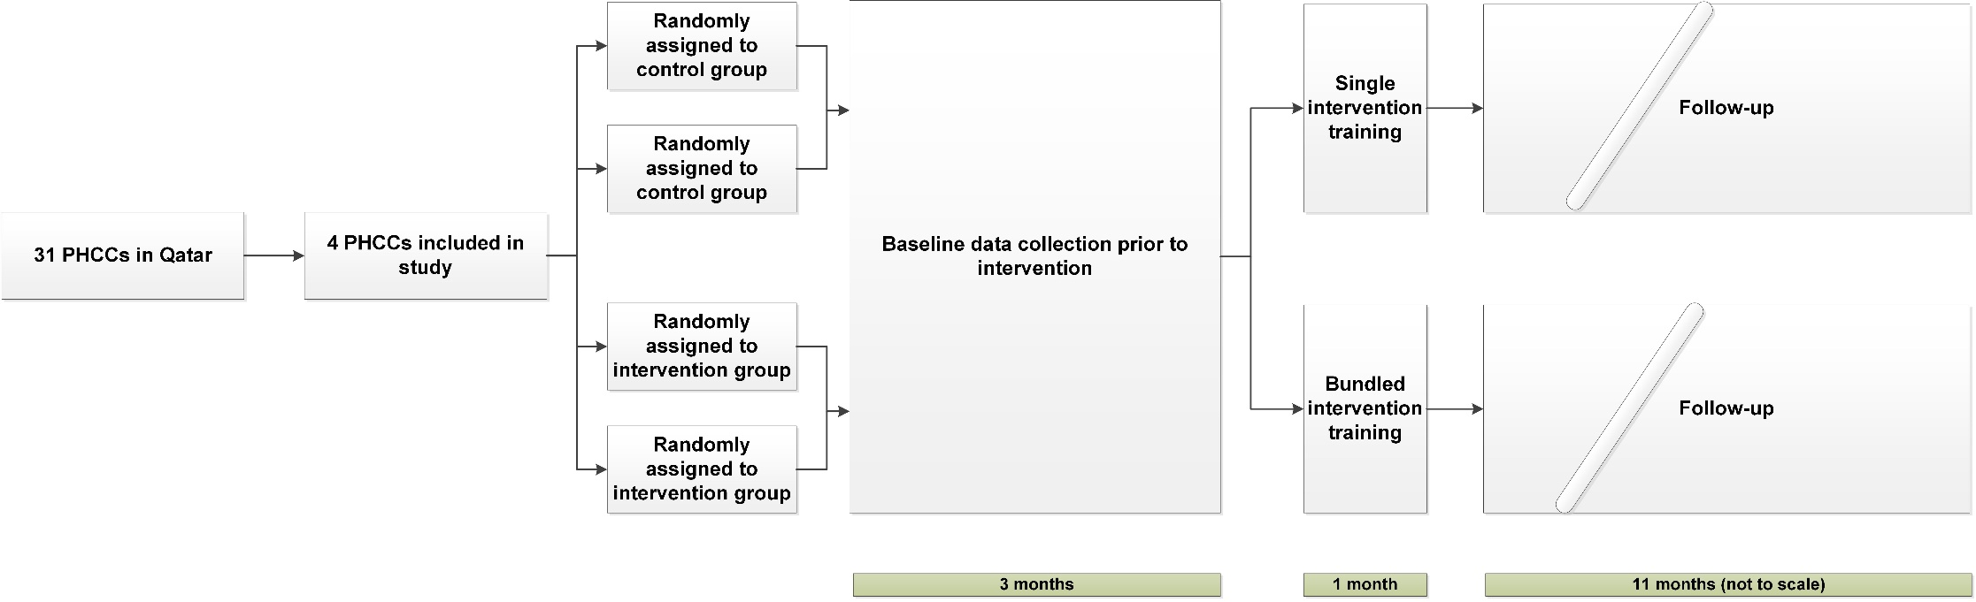

Supplementary figure 2. A more detailed study flow sheet including all episodes of care with a diagnosis of upper respiratory infection during the entire study period (including pre- and post-intervention implementation periods), and by treatment allocation.

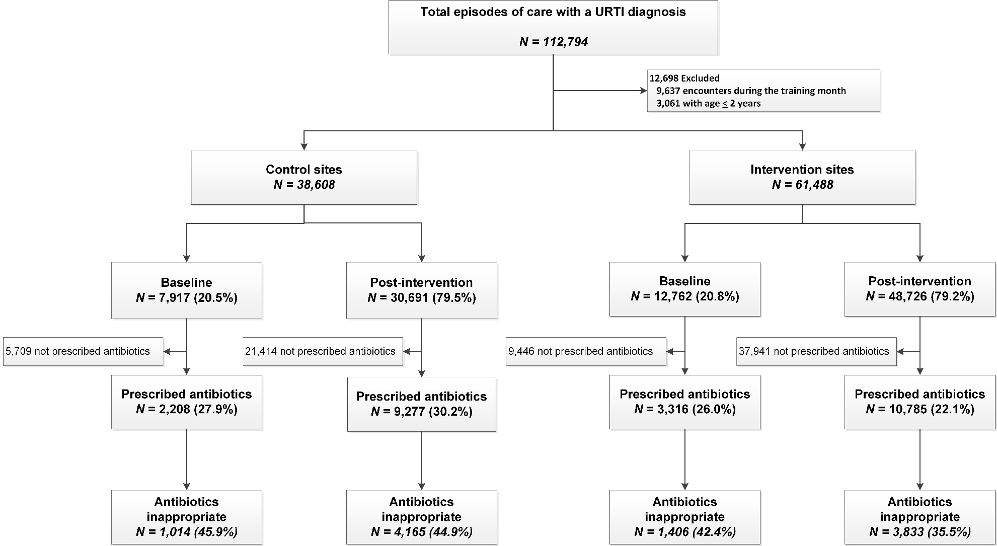

Supplementary table 1. Mixed effects logistic regression model for predictors of inappropriate antibiotic prescriptions in the control and intervention groups, at baseline and post-intervention.

Group | Control Group (N=11,482/11,485) |  |  |  |  |  | Intervention Group (N=14,093/14,101)
N | Baseline  (N=2208/2208) |  |  | Post Intervention  (N=9274/9277) |  |  | Baseline  (N=3314/3316) |  |  | Post Intervention  (N=10,779/10,785)
 | aOR | p-value | 95% CI | aOR | p-value | 95% CI | aOR | p-value | 95% CI | aOR | p-value | 95% CI
Age categories
>2-18 years | Comparator |  |  | Comparator |  |  | Comparator |  |  | Comparator
19-40 years | 1.10 | 0.48 | 0.84-1.44 | 1.35 | <0.001 | 1.18-1.53 | 1.82 | <0.001 | 1.54-2.16 | 1.84 | <0.001 | 1.67-2.03
41-65 years | 0.50 | <0.001 | 0.38-0.65 | 0.64 | <0.001 | 0.56-0.73 | 0.99 | 0.91 | 0.82-1.20 | 1.13 | 0.03 | 1.01-1.26
65+ years | 0.19 | <0.001 | 0.11-0.32 | 0.17 | <0.001 | 0.13-0.23 | 0.31 | <0.001 | 0.19-0.52 | 0.32 | <0.001 | 0.24-0.42
Sex
Female | Comparator |  |  | Comparator |  |  | Comparator |  |  | Comparator
Male | 1.32 | 0.003 | 1.10-1.58 | 1.49 | <0.001 | 1.36-1.62 | 1.28 | 0.001 | 1.11-1.49 | 1.15 | 0.001 | 1.06-1.25
Nationality*
EMR | Comparator |  |  | Comparator |  |  | Comparator |  |  | Comparator
SEAR | 1.46 | 0.001 | 1.17-1.83 | 1.10 | 0.08 | 0.99-1.23 | 1.21 | 0.12 | 0.95-1.54 | 1.34 | <0.001 | 1.16-1.54
AFR | 0.96 | 0.90 | 0.56-1.66 | 1.40 | 0.02 | 1.06-1.87 | 0.93 | 0.84 | 0.49-1.78 | 1.26 | 0.18 | 0.90-1.77
WPR | 1.57 | 0.03 | 1.06-2.33 | 1.57 | <0.001 | 1.26-1.96 | 2.03 | <0.001 | 1.42-2.90 | 1.61 | <0.001 | 1.32-1.98
EUR | 1.24 | 0.60 | 0.55-2.83 | 1.68 | 0.009 | 1.14-2.47 | 2.54 | 0.006 | 1.30-4.97 | 1.33 | 0.11 | 0.94-1.87
AMR | 1.87 | 0.26 | 0.63-5.53 | 1.69 | 0.12 | 0.87-3.30 | 0.77 | 0.62 | 0.28-2.13 | 1.29 | 0.28 | 0.81-2.06
Level of Provider
Trainee | Comparator |  |  | Comparator |  |  | Comparator |  |  | Comparator
Specialist | 2.63 | 0.17 | 0.67-10.39 | 3.24 | 0.003 | 1.49-7.03 | 1.46 | 0.04 | 1.02-2.09 | 0.90 | 0.39 | 0.71-1.15
Consultant | 2.00 | 0.33 | 0.50-7.89 | 2.19 | 0.05 | 1.01-4.77 | 1.08 | 0.65 | 0.76-1.54 | 0.89 | 0.37 | 0.70-1.14
Senior Consultant | 2.46 | 0.22 | 0.58-10.48 | 2.44 | 0.03 | 1.09-5.50 | 1.44 | 0.09 | 0.94-2.19 | 1.40 | 0.02 | 1.06-1.85
Others/Unknown | 2.92 | 0.13 | 0.73-11.64 | 2.91 | 0.007 | 1.34-6.35 | 1.71 | 0.008 | 1.15-2.55 | 1.28 | 0.06 | 0.99-1.65

aOR, adjusted odds ratio; N, Total numbers; n, number; WHO, World Health Organization; EMR, Eastern Mediterranean Region; SEAR, South-East Asian Region; AFR, African Region; WPR, Western Pacific Region; EUR, European Region; AMR, Region of the Americas.

*9 unknown nationalities were removed from the model

Supplementary table 2. Multi-level mixed effects logistic regression model demonstrating the predictors of inappropriate prescriptions, adjusting for covariates and clustering effect within and between the PHCC facilities. In this model, antibiotic prescriptions were categorized as appropriate or inappropriate based only on associated diagnosis without regard to the comorbidities present.

Variables | Odds Ratio (95% CI) | p-value
Intervention
Control group | Comparator
Treatment | 0.60 (0.55-0.66) | <0.001
Age categories
>2-18 years | Comparator
19-40 years | 1.42 (1.32-1.54) | <0.001
41-65 years | 1.93 (1.78-2.10) | <0.001
65+ years | 2.92 (2.47-3.45) | <0.001
Sex
Female | Comparator
Male | 1.56 (1.46-1.66) | <0.001
Nationality
EMRO | Comparator
SEARO | 0.91 (0.83-1.00) | 0.05
AFRO | 0.82 (0.66-1.02) | 0.08
WPRO | 0.93 (0.80-1.09) | 0.39
EURO | 0.85 (0.65-1.10) | 0.22
AMRO | 0.75 (0.51-1.10) | 0.14
Level of Provider
Trainee | Comparator
Specialist | 1.30 (1.04-1.63) | 0.02
Consultant | 0.93 (0.74-1.16) | 0.51
Senior Consultant | 1.56 (1.21-2.02) | 0.001
Others/Unknown | 1.33 (1.05-1.68) | 0.02

EMR, Eastern Mediterranean Region; SEAR, South-East Asian Region; AFR, African Region; WPR, Western Pacific Region; EUR, European Region; AMR, Region of the Americas.

