Risk Factors, Recovery, and Quality of Life in Long COVID-19: A Four-Year Prospective Cohort Study
Kamal et. al

Supplementary Tables

Supplementary Table 1. Univariate Logistic Regression of Demographics and Comorbidities Associated with Long COVID-19
Variable | Odds Ratio (OR) | 95% CI | P value
Age ≥60 years | 2.15 | 1.48 – 3.11 | <0.001
Female sex | 1.74 | 1.31 – 2.31 | <0.001
BMI ≥30 | 1.68 | 1.23 – 2.29 | 0.001
Smoker | 1.53 | 1.12 – 2.09 | 0.008
Hospitalization | 2.94 | 2.12 – 4.06 | <0.001
Reinfection | 2.42 | 1.66 – 3.53 | <0.001
Diabetes mellitus | 9.41 | 6.01 – 14.72 | <0.001
Chronic pulmonary disease | 2.86 | 1.72 – 4.77 | <0.001
Chronic renal disease | 9.08 | 3.91 – 21.10 | <0.001
Hypertension | 2.14 | 1.59 – 2.88 | <0.001

Odds ratios (OR), 95% confidence intervals (CI), and p-values are reported. Statistically significant variables (p < 0.05) include age ≥60 years, female sex, smoking, obesity, hospitalization, reinfection, and multiple comorbidities (including chronic pulmonary, renal, liver, cardiac, autoimmune, and metabolic diseases).. P values <0.05 were considered statistically significant.

Supplementary Table 2. Multivariable logistic regression of predictors of Long COVID-19

Predictor | Adjusted Odds Ratio (aOR) | 95% Confidence Interval | P value
Age ≥60 years | 1.23 | 0.72 – 2.10 | 0.41
Female sex | 11.11 | 4.48 – 26.24 | <0.001*
BMI ≥30 | 1.36 | 0.81 – 2.28 | 0.24
Smoker | 1.28 | 0.73 – 2.25 | 0.39
Hospitalization | 1.72 | 0.91 – 3.27 | 0.095
Reinfection | 2.01 | 1.17 – 3.47 | 0.011
Diabetes mellitus | 14.3 | 7.0 – 29.4 | <0.001*
Chronic pulmonary disease | 1.86 | 1.05 – 3.29 | 0.033
Vaccination completion | 1.86 | 1.05 – 3.29 | 0.053

All variables listed were included in the multivariable logistic regression model prior to stepwise backward elimination. Adjusted odds ratios (aORs), 95% confidence intervals (CIs), and P-values are presented from this full model for transparency. After backward elimination, only female sex and diabetes mellitus remained statistically significant independent predictors of long COVID-19. Although initially significant, reinfection and chronic pulmonary disease were removed in the final model due to collinearity and reduced contribution after adjustment for stronger predictors. Vaccination completion showed a protective trend but did not reach statistical significance. The final model demonstrated good discrimination (C-statistic = 0.81) and acceptable calibration (Hosmer–Lemeshow P = 0.74).

Supplementary Table 3. Cox Proportional Hazards Model for Predictors of Time to Recovery from Long COVID-19

Covariate | Adjusted Hazard Ratio (aHR) | 95% Confidence Interval | P value
Age ≥60 years | 1.54 | 0.94 – 2.53 | 0.089
Female sex | 3.36 | 1.85 – 6.10 | <0.001
Diabetes mellitus | 1.57 | 1.00 – 2.46 | 0.048
Reinfection | 1.86 | 1.05 – 3.29 | 0.033
Hospitalization | 1.08 | 1.01 – 1.16 | 0.026
Chronic pulmonary disease | 1.48 | 0.91 – 2.41 | 0.118

Note: Adjusted hazard ratios (aHR), 95% confidence intervals (CIs), and p-values are derived from the Cox proportional hazards model. An aHR >1 indicates delayed recovery. Female sex, diabetes mellitus, reinfection, and hospitalization were independently associated with slower recovery, while age ≥60 years and pulmonary disease did not reach statistical significance.

Supplementary Table 4: Longitudinal Comparison of Quality of Life Scores and Work Resumption Between Long COVID-19 and Resolved Groups
Parameter | Long COVID, (n=238) Mean ± SD | Resolved, n=578)  Mean ± SD | Mean Difference (95% CI) | P-value
SF-36 PCS (Enrollment) | 43.20 ± 12.30 | 72.70 ± 17.60 | -29.50 (-31.62 to -27.38) | <0.001
SF-36 MCS (Enrollment) | 42.50 ± 13.00 | 68.10 ± 13.40 | -25.60 (-27.58 to -23.62) | <0.001
EQ-5D (Enrollment) | 0.43 ± 0.29 | 0.78 ± 0.18 | -0.35 (-0.39 to -0.31) | <0.001
SF-36 PCS (6 mo) | 56.10 ± 15.00 | 72.80 ± 13.40 | -16.70 (-18.90 to -14.50) | <0.001
SF-36 MCS (6 mo) | 50.50 ± 16.80 | 84.90 ± 13.40 | -34.40 (-36.80 to -32.00) | <0.001
EQ-5D (6 mo) | 0.49 ± 0.31 | 0.84 ± 0.17 | -0.35 (-0.39 to -0.31) | <0.001
SF-36 PCS (12 mo) | 59.80 ± 19.40 | 72.80 ± 13.40 | -13.00 (-15.70 to -10.30) | <0.001
SF-36 MCS (12 mo) | 50.50 ± 16.80 | 87.60 ± 12.70 | -37.10 (-39.47 to -34.73) | <0.001
EQ-5D (12 mo) | 0.48 ± 0.24 | 0.86 ± 0.16 | -0.38 (-0.41 to -0.35) | <0.001
SF-36 PCS (End) | 74.80 ± 18.70 | 89.60 ± 14.20 | -14.80 (-17.44 to -12.16) | <0.001
SF-36 MCS (End) | 71.70 ± 17.40 | 87.91 ± 11.94 | -16.21 (-18.63 to -13.79) | <0.001
EQ-5D (End) | 0.72 ± 0.24 | 0.90 ± 0.10 | -0.18 (-0.21 to -0.15) | <0.001
Work resumption (weeks ) | 16.43±4.99 | 2.00±0.82 |  | <0.001

Values represent mean ± standard deviation. P values and 95% confidence intervals were calculated using independent samples t-tests comparing the long COVID-19 and resolved groups at each time point. SF-36 scores are presented as physical component summary (PCS) and mental component summary (MCS). EQ-5D Index ranges from 0 to 1, with higher scores indicating better health-related quality of life. The SF-36 two summary scores include the physical component summary (PCS), which combines the first four domains (PF, RP, BP, and GH), and the mental component summary (MCS), which combines the latter four domains (VT, SF, RE, and MH). The patients who resolved the acute infection within three months (control group) resumed their work significantly earlier than patients with long COVID-19.

Supplementary Figure 1a

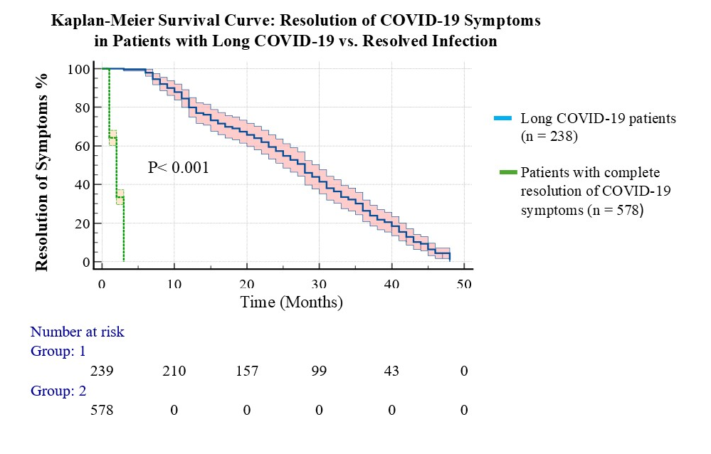
Kaplan–Meier survival curve comparing time to complete symptom resolution between patients with long COVID-19 (n = 238) and those with resolved COVID-19 infection (n = 578). Patients with long COVID-19 had significantly delayed recovery compared to those with resolved infection (log-rank p <0.001). The y-axis represents the cumulative proportion of patients with persistent symptoms over time, and the x-axis indicates time to recovery in months. Numbers at risk are shown below the x-axis.

Supplementary Figure 1b

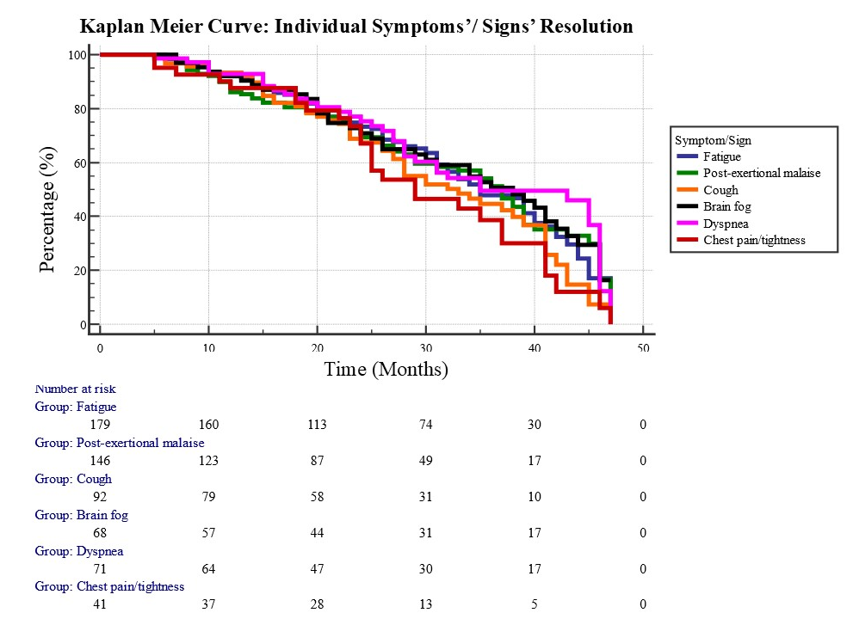

Kaplan–Meier survival curves showing the time to resolution of six common long COVID-19 symptoms: fatigue, post-exertional malaise, cough, brain fog, dyspnea, and chest pain/tightness. Fatigue and post-exertional malaise exhibited the longest persistence, with many patients remaining symptomatic beyond 30–40 months, whereas cough and chest pain resolved more rapidly. The y-axis represents the proportion of patients with persistent symptoms over time, and the x-axis shows time to recovery in months. Numbers at risk for each symptom are shown below the x-axis.

Supplementary Figure 2
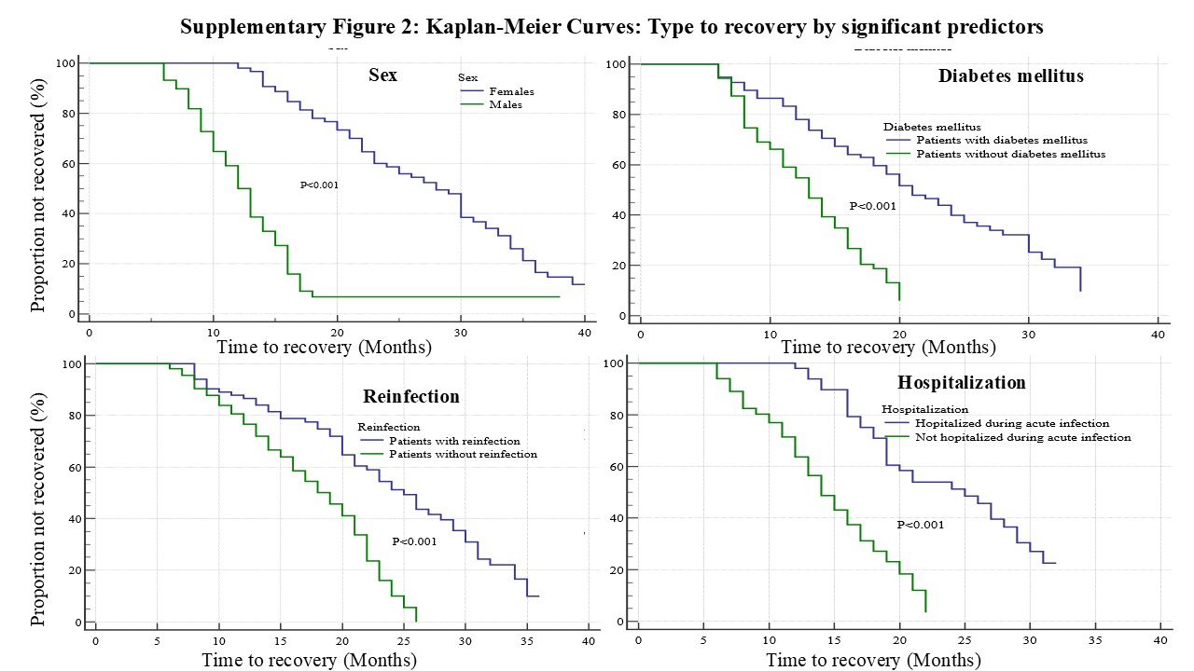
D
C
B
A

Kaplan–Meier survival curves showing the probability of remaining symptomatic over time among patients with long COVID-19, stratified by significant predictors.
(A) Sex: Female patients had significantly delayed recovery compared to males (log-rank p <0.001).
(B) Diabetes mellitus: Patients with diabetes experienced slower recovery compared to those without diabetes (log-rank p <0.001).
(C) Reinfection: Reinfection was associated with delayed symptom resolution (log-rank p <0.001).
(D) Hospitalization: Patients hospitalized during acute COVID-19 had significantly delayed recovery compared to non-hospitalized patients (log-rank p <0.001).
The y-axis represents the proportion of patients who had not recovered at each time point, and the x-axis shows time to recovery in months.

Supplementary Figure 3: Temporal distribution of participant enrollment and follow-up durations.

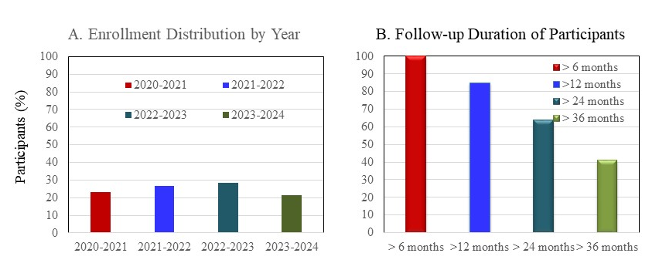

(Panel A) Enrollment distribution by year: March 2020–March 2021 (23.3%), March 2021–March 2022 (26.5%), March 2022–March 2023 (28.6%), and March 2023–March 2024 (21.6%).
(Panel B) Follow-up duration of participants: 100% had ≥6 months, 84.9% had ≥12 months, 64.2% had ≥2 years, 41.5% had ≥3 years, and 19.8% had ≥4 years of follow-up.

