Supplementary file
Detection of AcrAB efflux pump mediated ciprofloxacin resistance in Escherichia coli and Klebsiella pneumoniae in Nepal
Supplementary Table 1. List of primers used for target gene amplification by PCR
Target Genes | Primers | Primer sequences (5' – 3') | Amplicon  size (bp)
AcrA | Primer F  Primer R | TTGAAATTACGCTTCAGGAT  CTTAGCCCTAACAGGATGTG | 189
AcrB | Primer F  Primer R | CGTACACAGAAAGTGCTCAA  CGCTTCAACTTTGTTTTCTT | 183
TolC | Primer F  Primer R | AAGCCGAAAAACGCAACCT  CAGAGTCGGTAAGTGACCATC | 100
F= Forward, R= Reverse

Supplementary figures

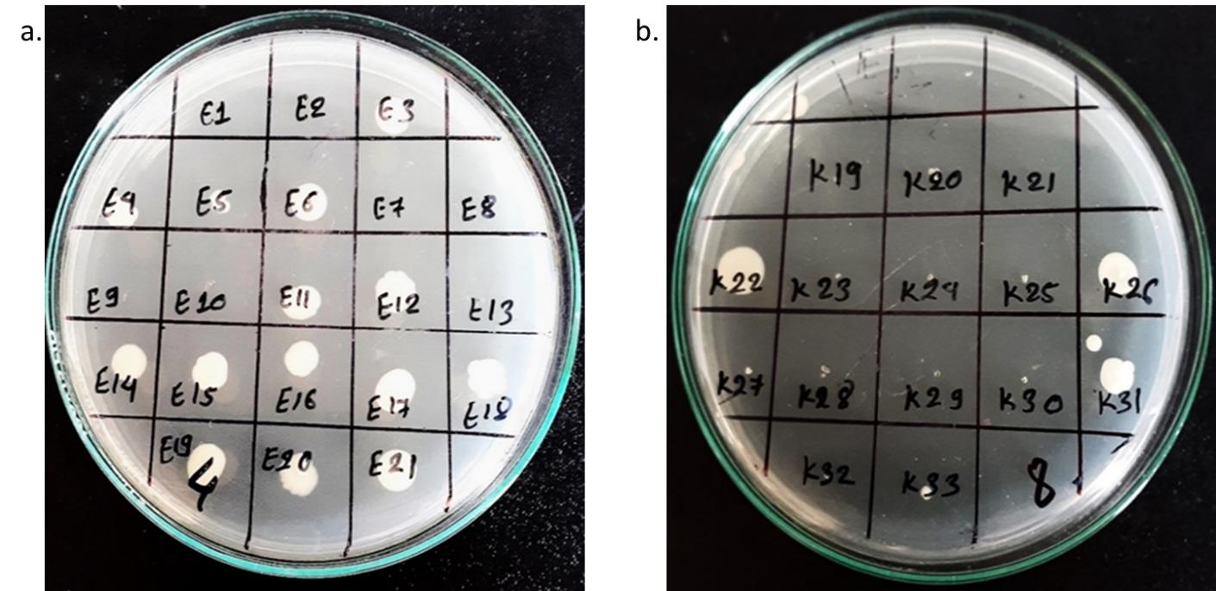
Supplementary Figure 1. MIC of ciprofloxacin against; a. E. coli; b. K. pneumoniae

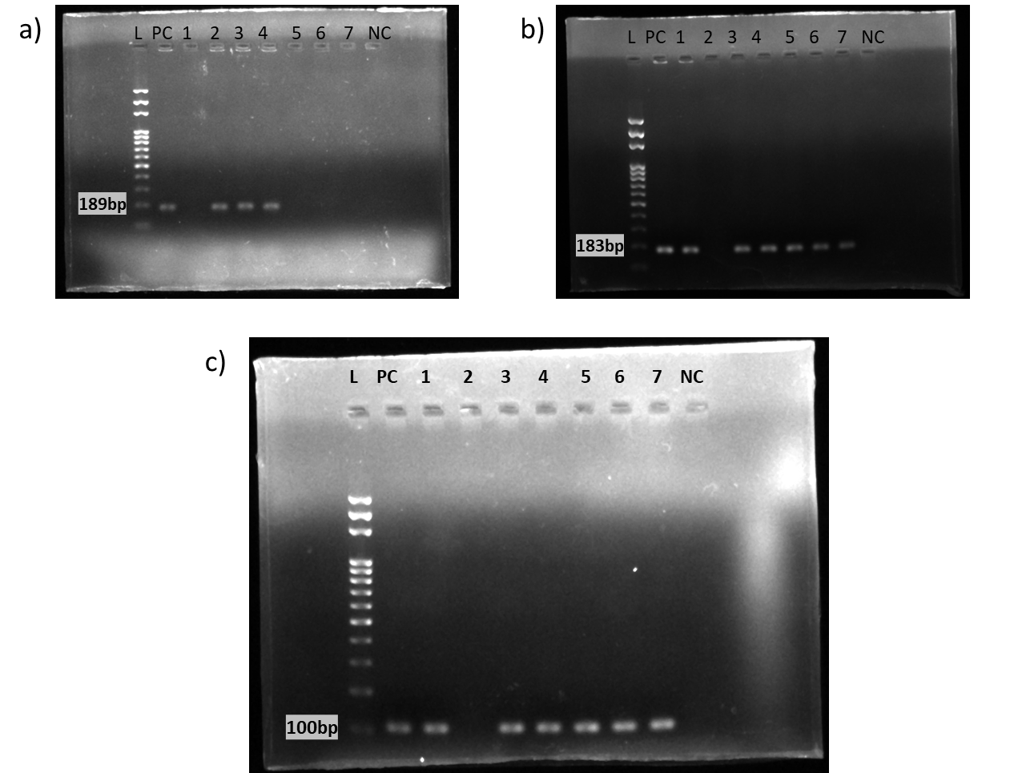

Supplementary Figure 2. Agarose gel showing PCR amplified bands: a) AcrA gene (189 bp) b) AcrB gene (183 bp) and c) TolC gene (100 bp); L: DNA ladder (100-1500 bp), PC: Positive control, NC: Negative control, 1-7: Positive and negative samples

Questionnaire
Demographic profile
Patient ID: ………………… Date: ………………….
Sex: ………………………... Age: ……………………
Microbiological profile
Specimen type: ……………... Culture result: …………... Bacteria detected: ……………...
Antibiotic susceptibility test result:
Antibiotic class | Antibiotics used | Sensitive | Intermediate | Resistant
Aminopenicillins | Amoxicillin
Cephalosporins | Ceftriaxone
Cephalosporins | Ceftazidime
Cephalosporins | Cefixime
Sulphonamides | Cotrimoxazole
Fluoroquinolones | Nalidixic acid
Fluoroquinolones | Ciprofloxacin
Nitrofurans | Nitrofurantoin
Aminoglycosides | Gentamicin
Aminoglycosides | Amikacin
Carbapenems | Imipenem
Carbapenems | Meropenem
Tetracyclines | Doxycycline
β-lactam with inhibitors | Piperacillin/  tazobactam
Lipopeptides | Colistin

