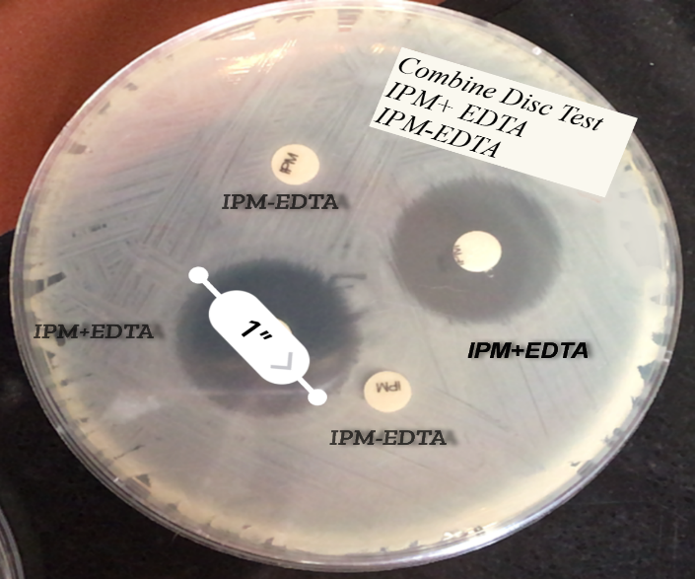

Figure 1. A combined disk of imipenem-EDTA with an inhibition zone ≥7 mm in compare with the imipenem disk

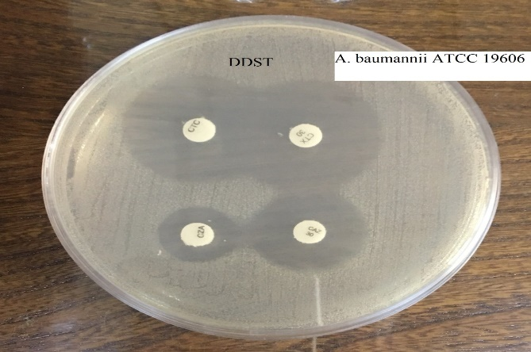

Figure 2. Figure 4: DDST on ATCC19606 standard sample

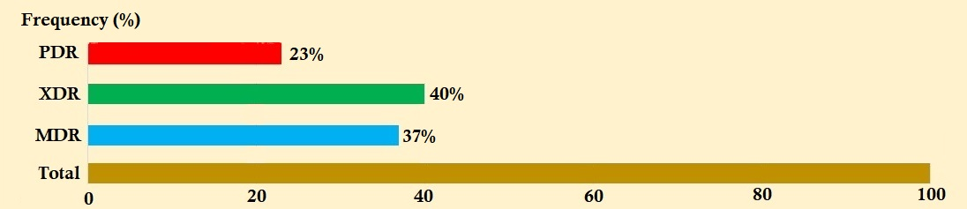
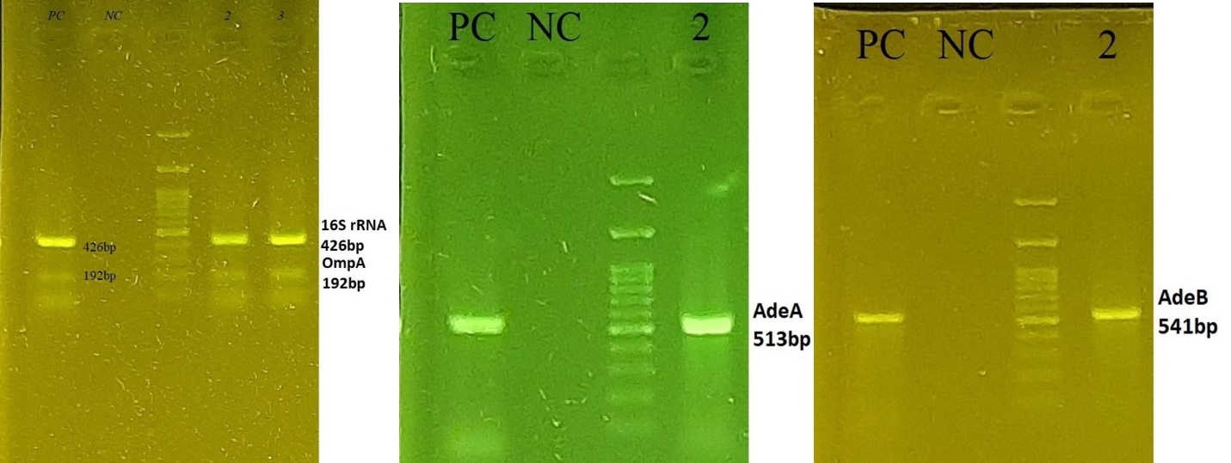
Figure 3. The Positive Control, Negative Control, Ladder, and Samples
Figure 4. The frequencies of PDR, XDR and MDR strains of clinical isolated of A. baumannii in present study.
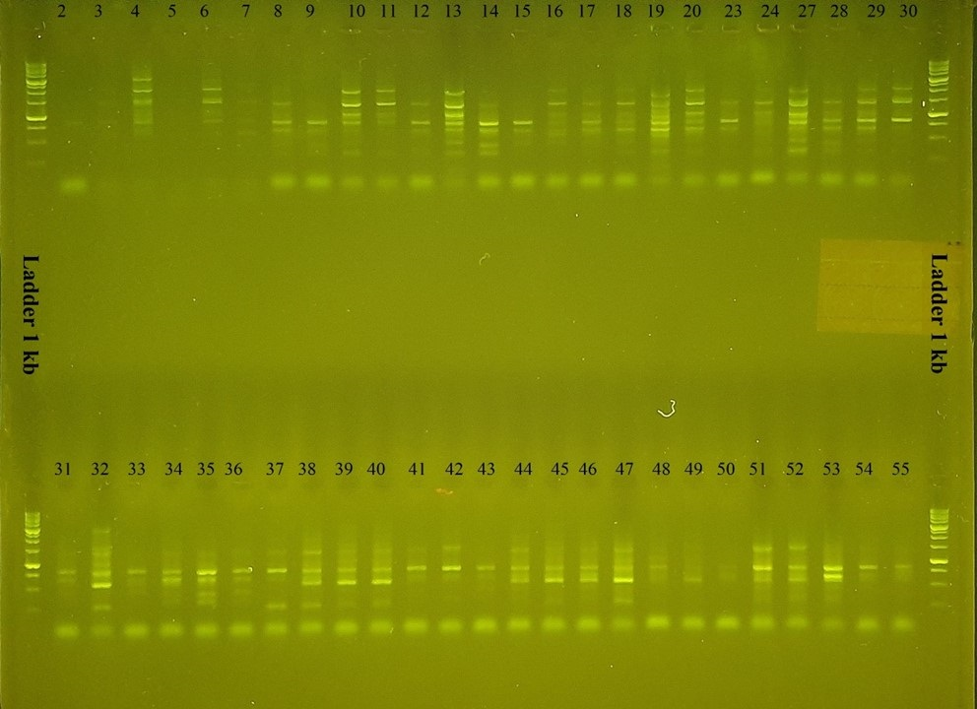
Figure 5. ERIC-PCR phylogenetic analysis

