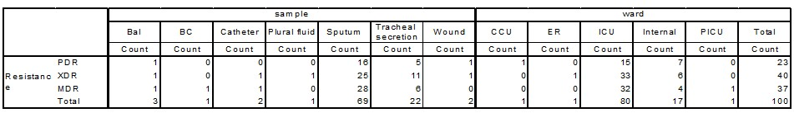
Supplementary Table 3: MDR, XDR, PDR strains; clinical samples and ward sections

