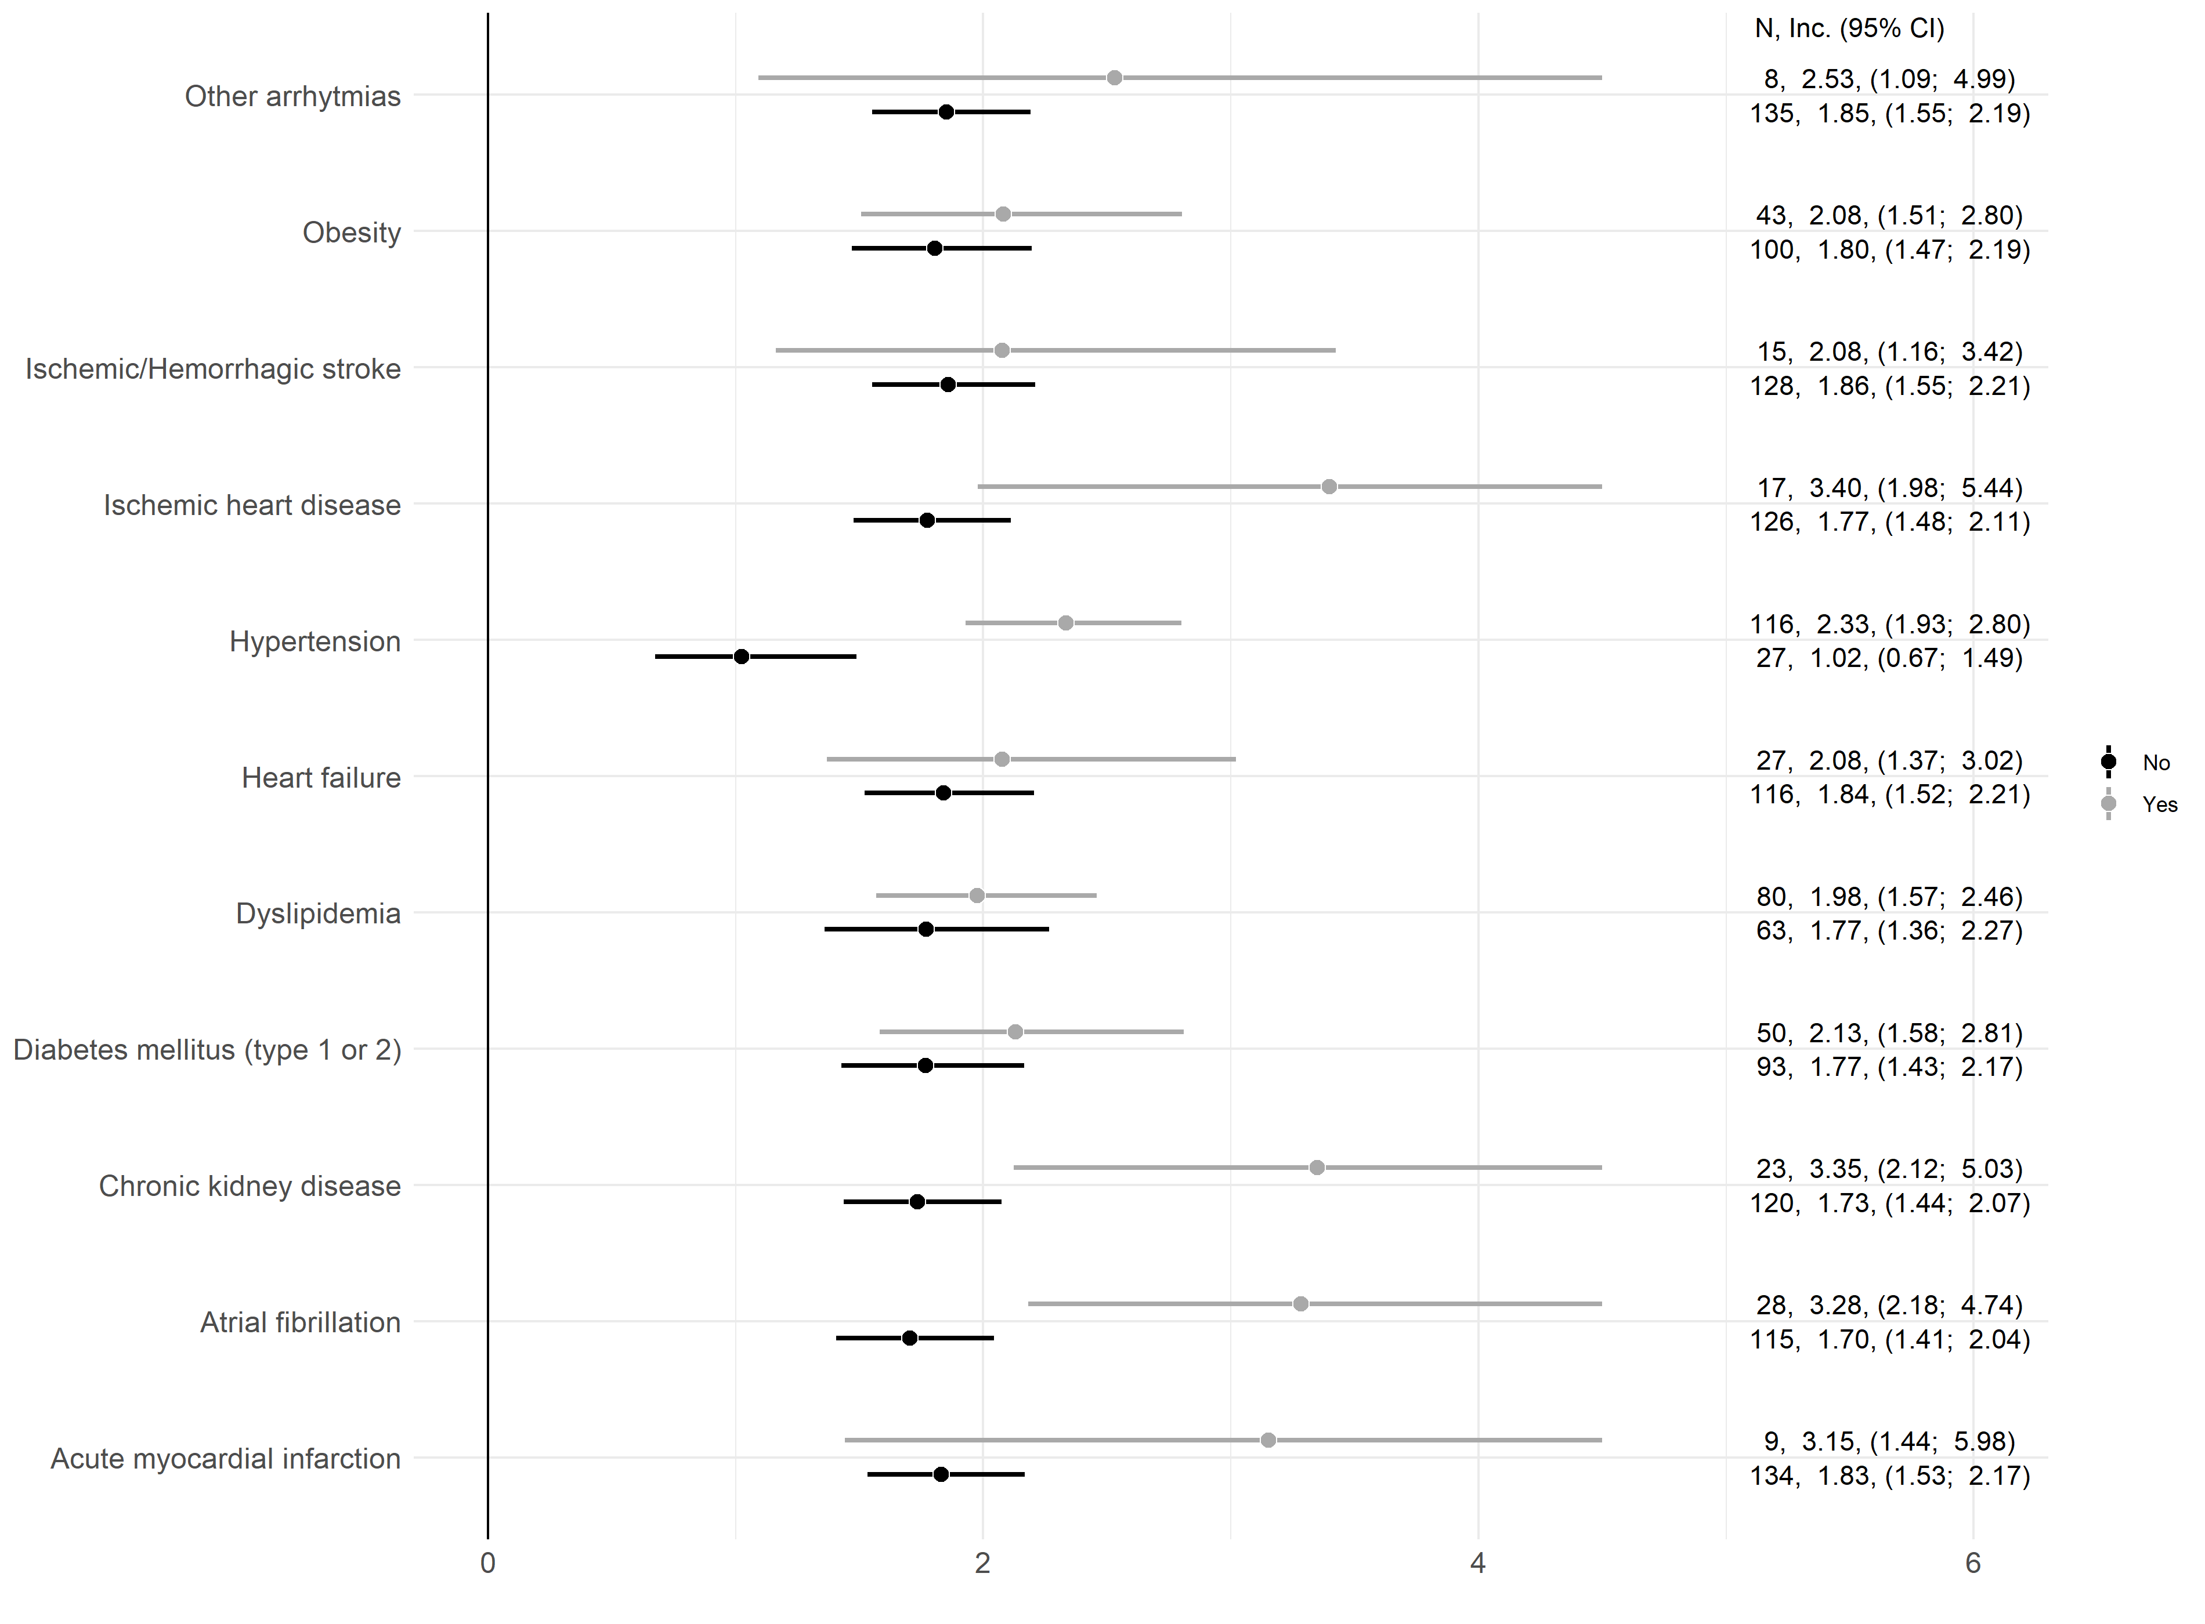

Supplementary Figure 1. Incidence rate, per 1,000 person-years, of at least one cardiovascular event with the respective 95% confidence interval according to individual factors conferring increased risk of a cardiovascular event. The column N represents the number of events. Estimates and confidence intervals are truncated at 4.5 to facilitate visualisation.

