SUPPLEMENTARY FIGURES

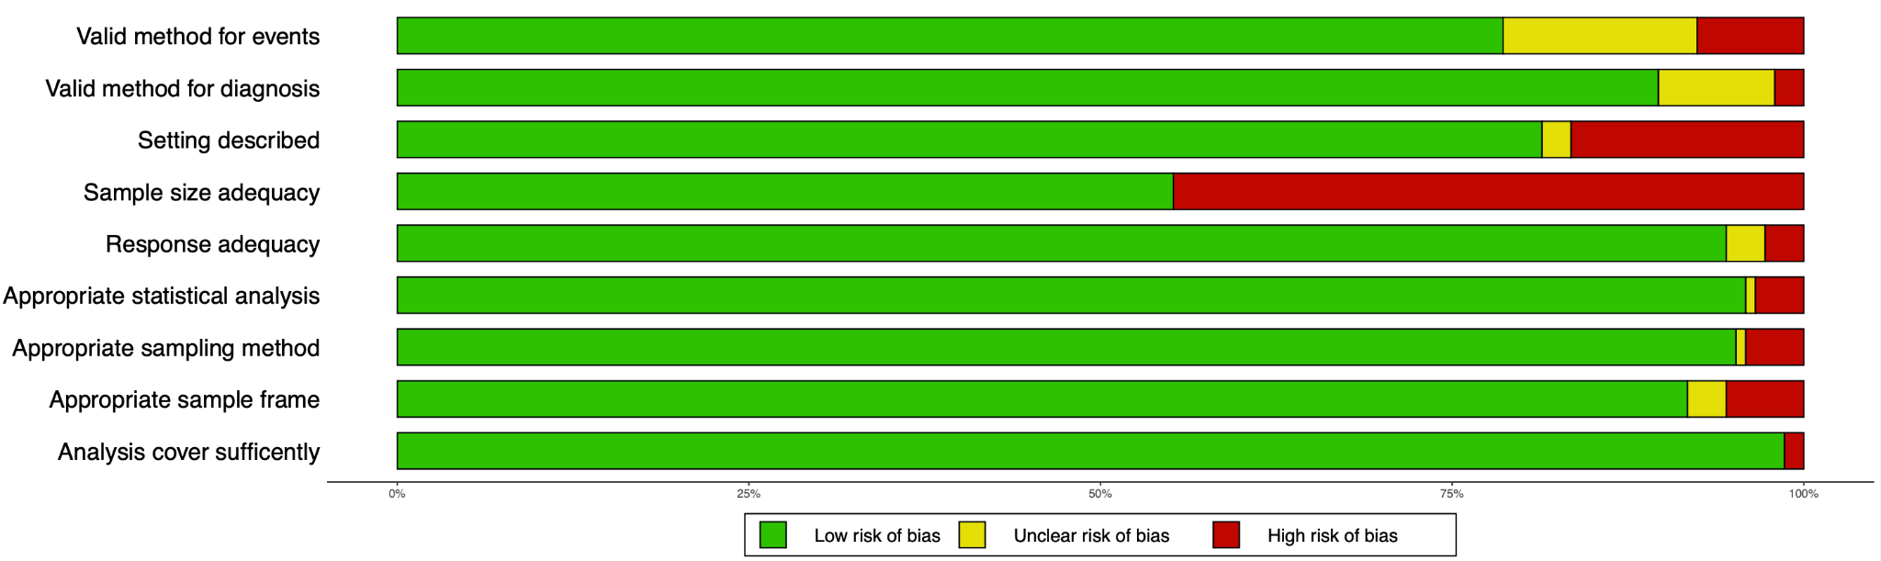

Figure S1. Risk of Bias Analysis

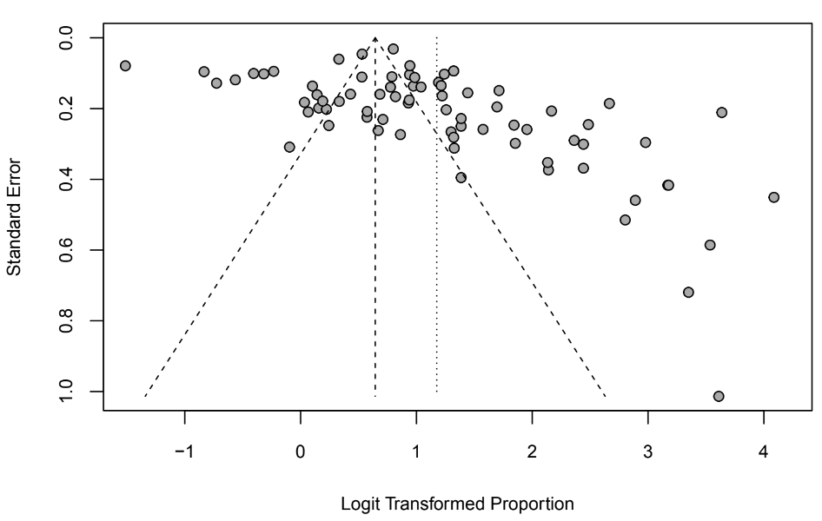

Figure S2. Funnel plot of included studies

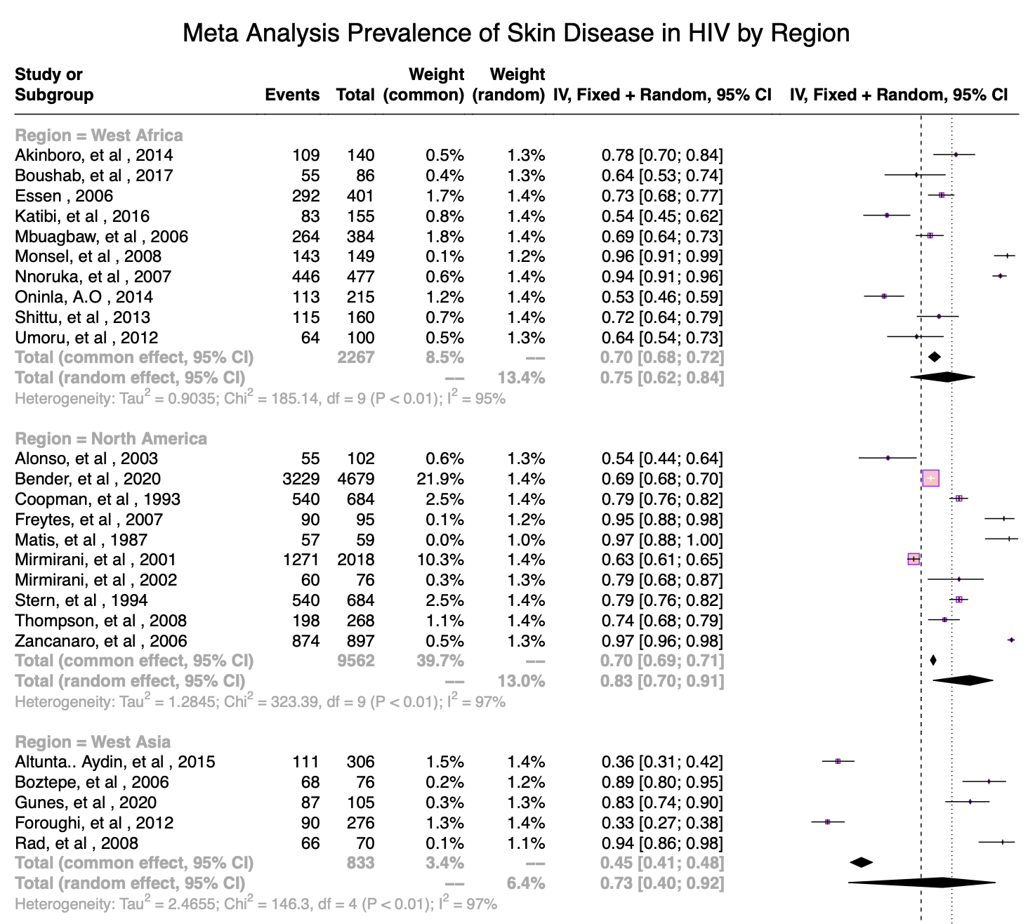

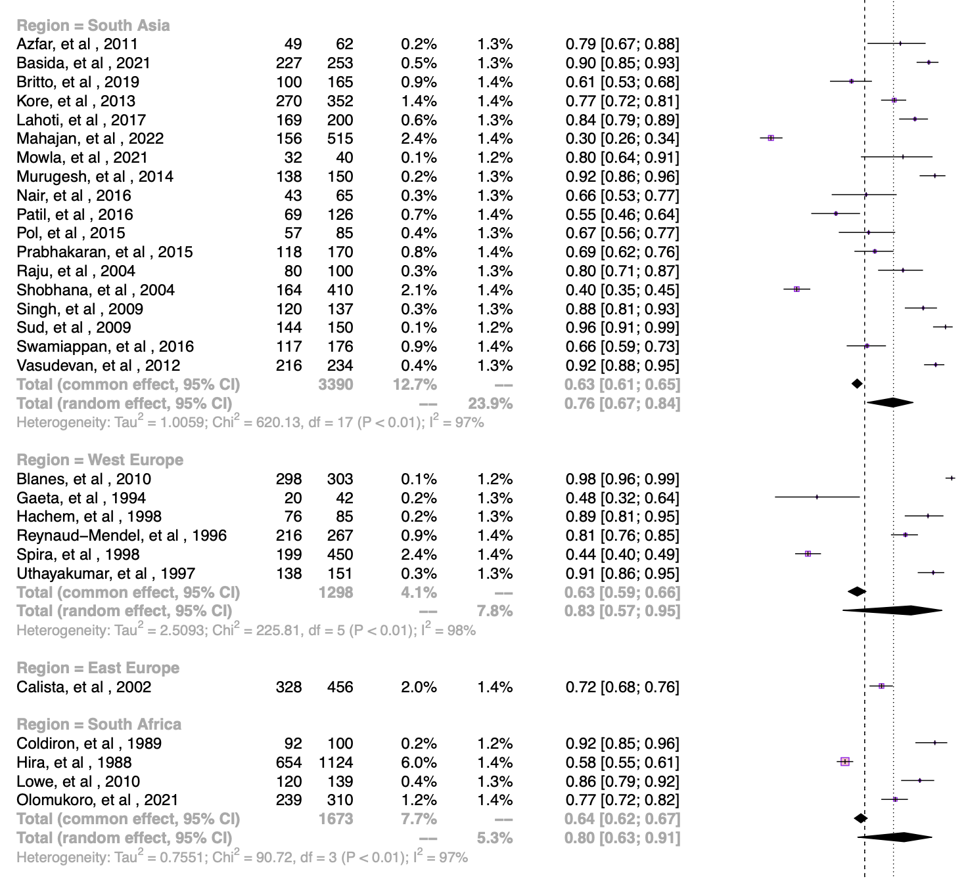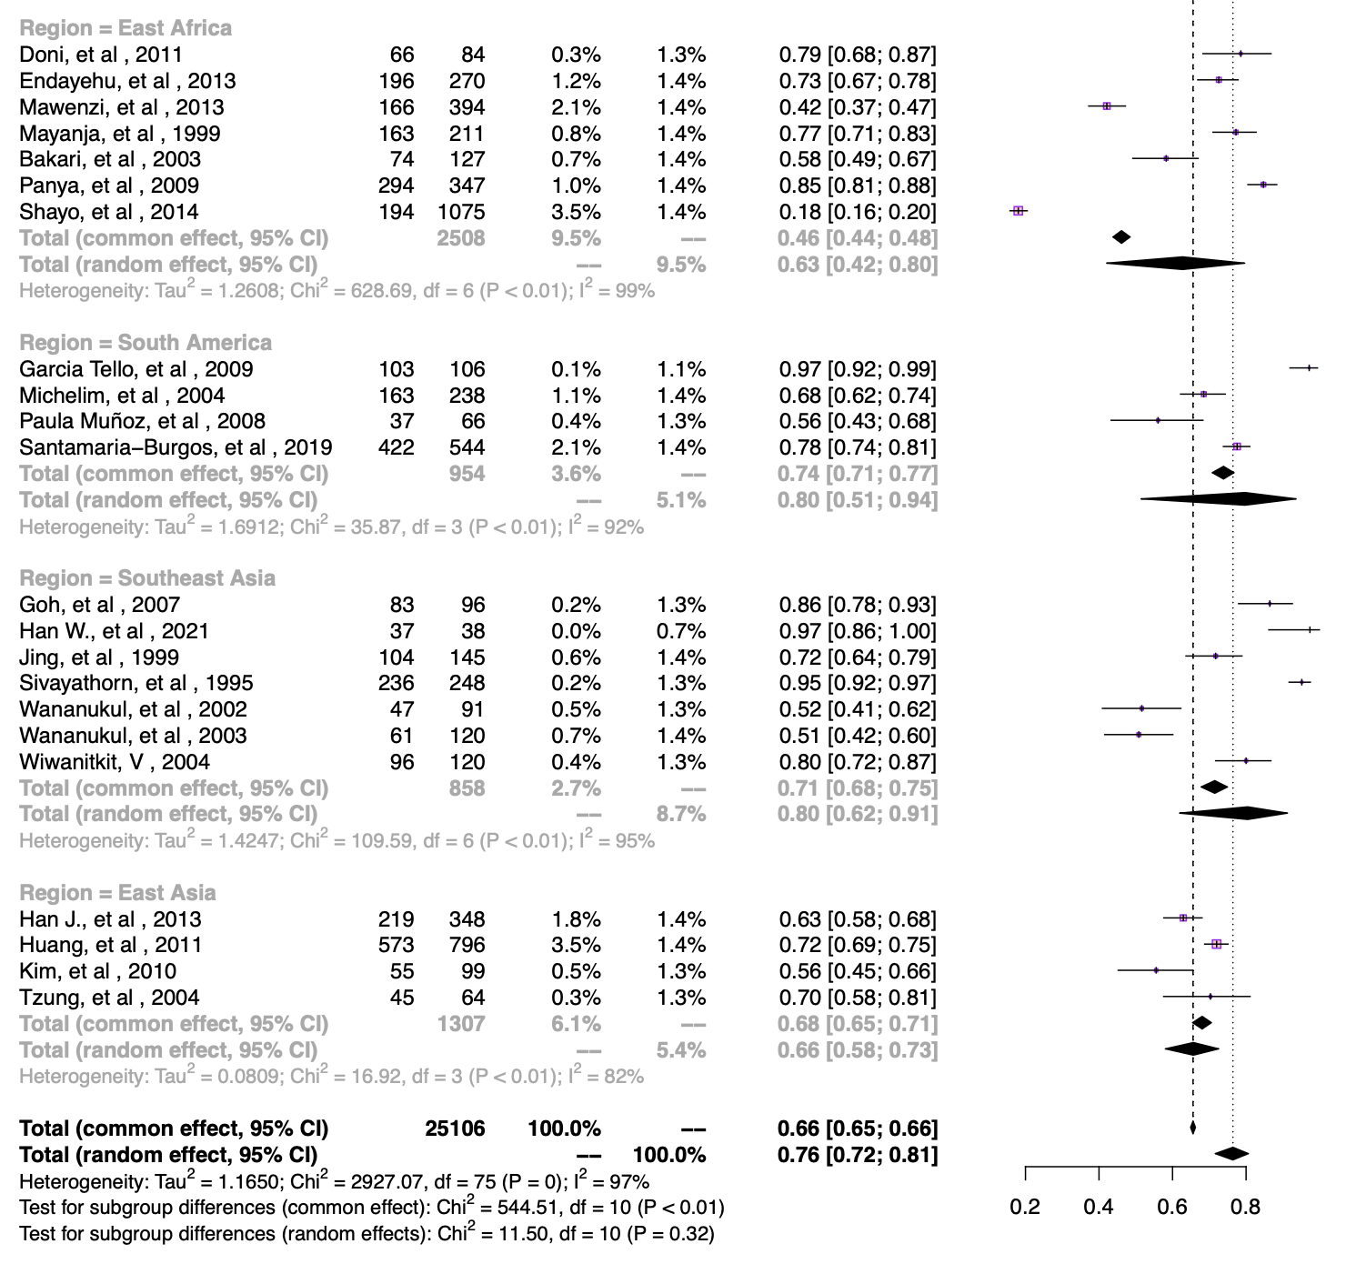
Figure S3. Forest plot of meta-analysis of dermatological disease prevalence in HIV patients by region

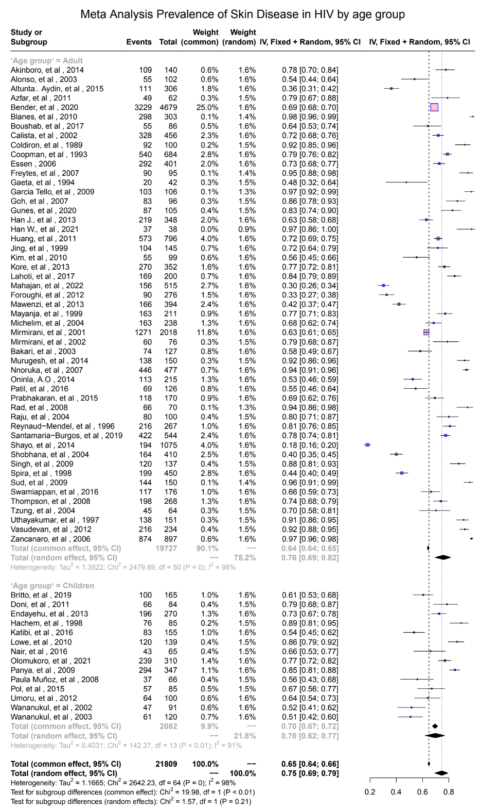
Figure S4. Meta-analysis of prevalence of dermatological disease based on age group

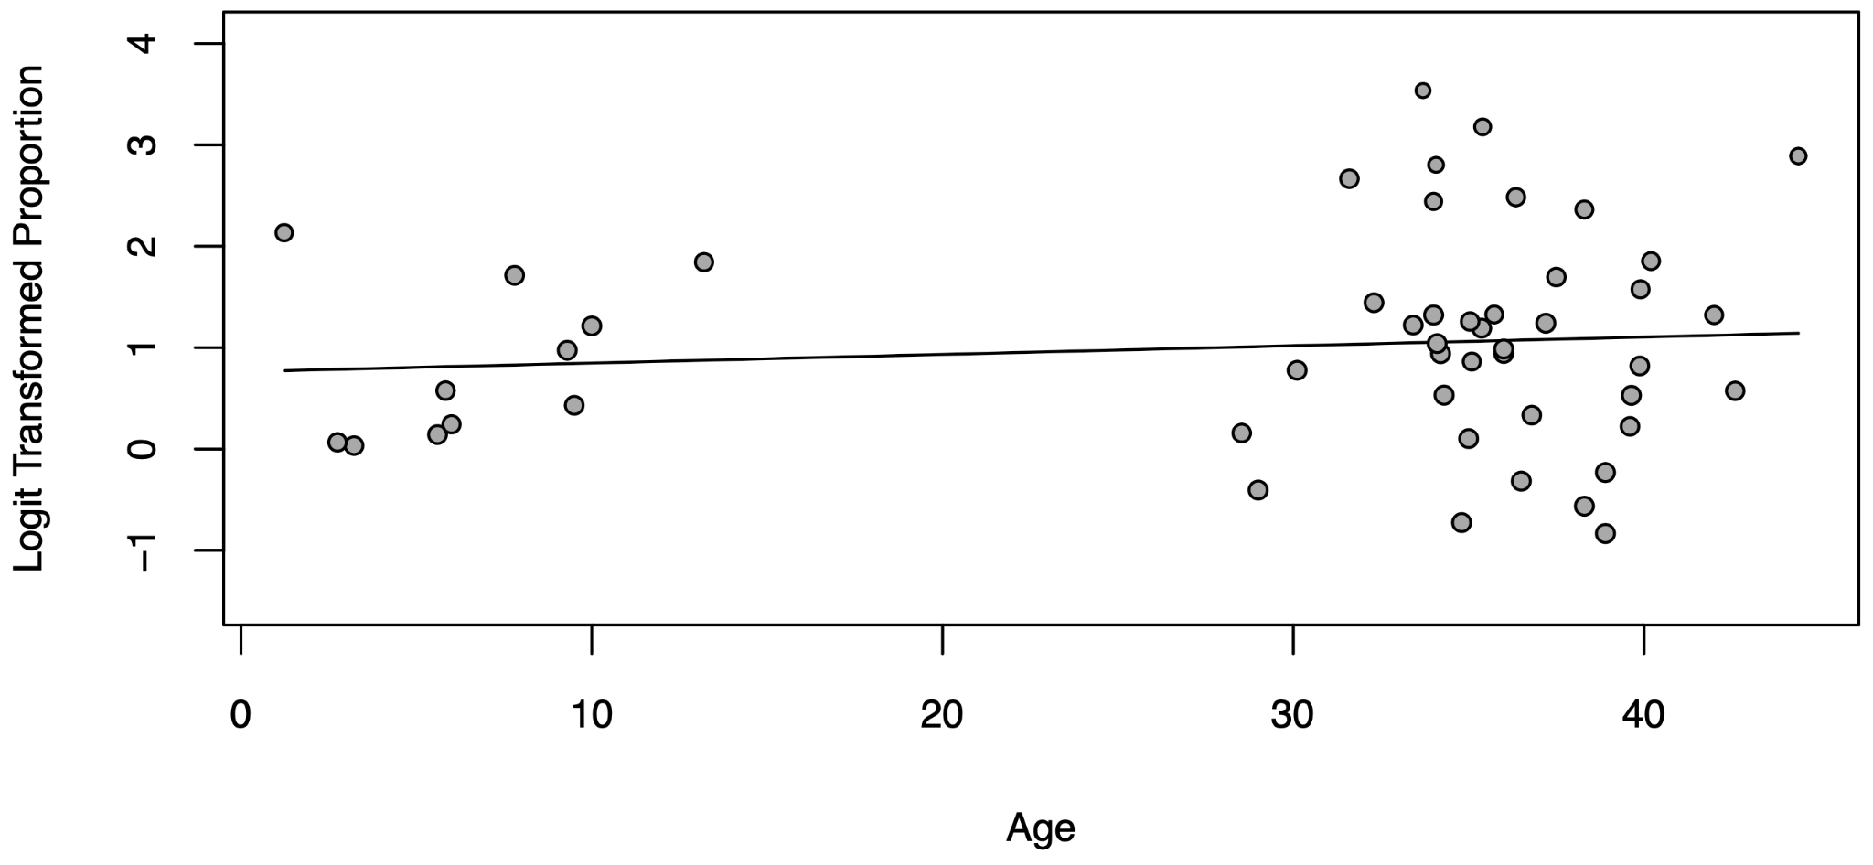
Figure S5. Meta-regression of prevalence of dermatological disease with age (means)

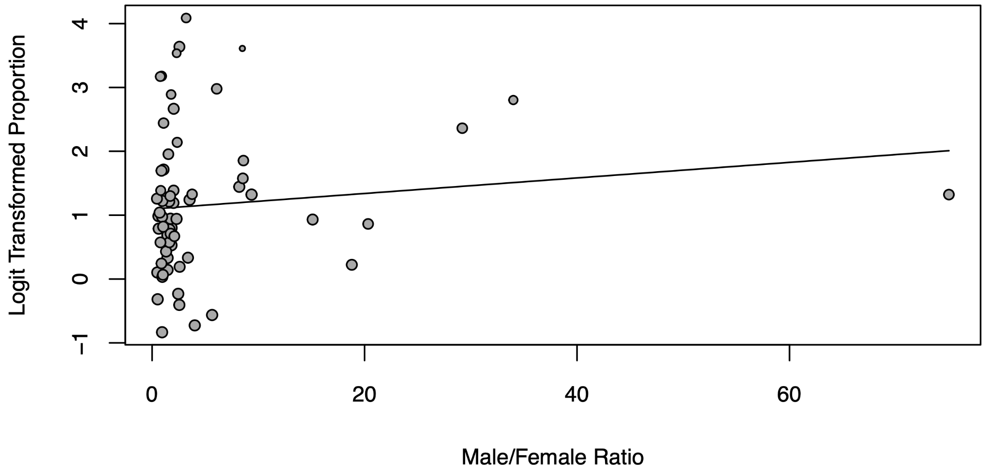
Figure S6. Meta-regression of prevalence of dermatological disease based on male to female ratio

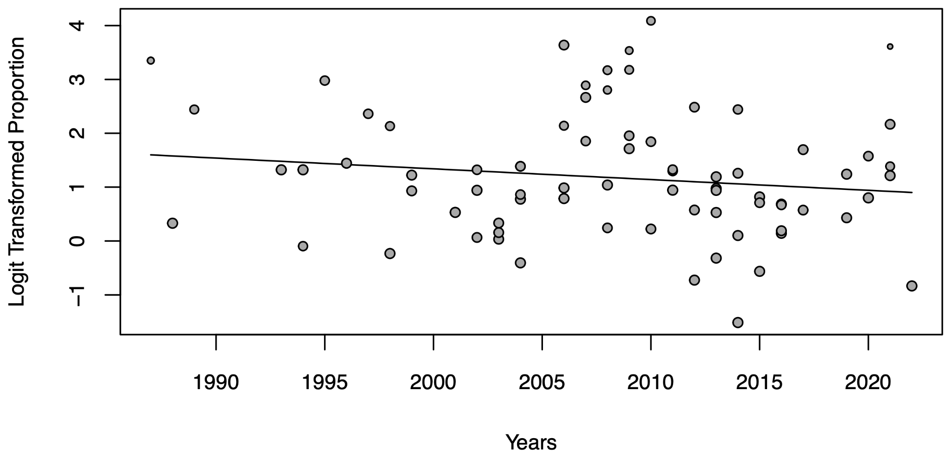
Figure S7. Figure 10. Meta-regression analysis of dermatological disease prevalence in HIV patients based on years

