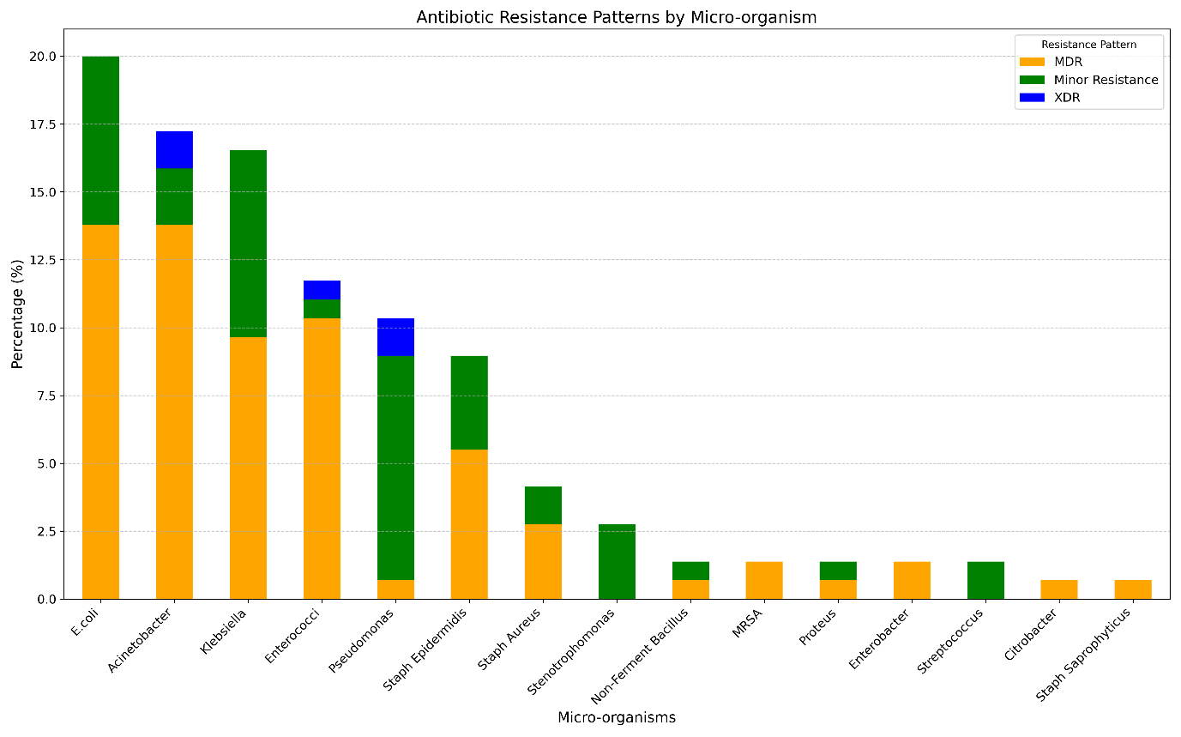
Additional file 6. Proportional Distribution of Antibiotic Resistance Patterns by Micro-organism

