Supplementary Table 1 Baseline Characteristics of eICU-CRD patients with Sepsis and CKD

 | Overall | Survival during hospitalization | Death during hospitalization | p
n | 3718 | 3009 | 709
age (median [IQR]) | 71.00 [61.00, 80.00] | 71.00 [60.00, 80.00] | 74.00 [64.00, 84.00] | <0.001
gender = 2 (%) | 1687 (45.4) | 1381 (45.9) | 306 (43.2) | 0.202
stage (%) |  |  |  | 0.337
1 | 43 (1.2) | 36 (1.2) | 7 (1.0)
2 | 263 (7.1) | 216 (7.2) | 47 (6.6)
3 | 1086 (29.2) | 899 (29.9) | 187 (26.4)
4 | 869 (23.4) | 695 (23.1) | 174 (24.5)
5 | 1457 (39.2) | 1163 (38.7) | 294 (41.5)
race (%) |  |  |  | 0.322
ASION | 58 (1.6) | 49 (1.6) | 9 (1.3)
BLACK | 571 (15.4) | 478 (15.9) | 93 (13.1)
ISPANIC/LATINO | 214 (5.8) | 169 (5.6) | 45 (6.3)
OTHER | 153 (4.1) | 126 (4.2) | 27 (3.8)
WHITE | 2722 (73.2) | 2187 (72.7) | 535 (75.5)
CPD (%) | 960 (25.8) | 795 (26.4) | 165 (23.3) | 0.094
CAD (%) | 361 (9.7) | 283 (9.4) | 78 (11.0) | 0.222
Atrial Fibrillation (%) | 769 (20.7) | 605 (20.1) | 164 (23.1) | 0.082
Heart Failure (%) | 1313 (35.3) | 1059 (35.2) | 254 (35.8) | 0.785
Diabetes (%) | 1797 (48.3) | 1501 (49.9) | 296 (41.7) | <0.001
Hypertension (%) | 2576 (69.3) | 2106 (70.0) | 470 (66.3) | 0.061
CVD (%) | 611 (16.4) | 495 (16.5) | 116 (16.4) | 0.999
RRT (%) | 136 (3.7) | 71 (2.4) | 65 (9.2) | <0.001
Vasoactive agents (%) | 1218 (32.8) | 840 (27.9) | 378 (53.3) | <0.001
Ventilation (%) | 1041 (28.0) | 572 (19.01) | 469 (66.1) | <0.001
los_hospital (days) | 9.87 (11.34) | 10.23 (11.19) | 8.35 (11.85) | <0.001
los_icu (days) | 4.36 (5.76) | 4.09 (5.17) | 5.50 (7.71) | <0.001
wbc_max | 15.86 [11.40, 22.20] | 15.20 [11.10, 20.80] | 19.69 [13.90, 27.40] | <0.001
wbc_min | 7.40 [5.30, 10.29] | 7.20 [5.30, 9.74] | 8.91 [5.90, 13.60] | <0.001
wbc_mean | 11.17 [8.32, 14.94] | 10.73 [8.09, 14.12] | 13.73 [9.69, 19.54] | <0.001
hemoglobin_max | 11.36±1.92 | 11.37±1.91 | 11.34±1.96 | 0.667
hemoglobin_min | 8.77±1.89 | 8.81±1.87 | 8.61±1.99 | 0.013
hemoglobin_mean | 9.95±1.66 | 9.96±1.65 | 9.90±1.71 | 0.374
platelet_max | 240.00 [172.00, 322.00] | 242.00 [175.00, 323.00] | 229.00 [158.00, 310.00] | 0.001
platelet_min | 142.00 [96.00, 197.00] | 146.00 [101.00, 199.00] | 126.00 [77.00, 182.00] | <0.001
platelet_mean | 186.00 [134.61, 246.32] | 189.11 [139.08, 248.75] | 170.33 [111.40, 233.20] | <0.001
alt_max | 28.00 [17.00, 53.00] | 27.00 [17.00, 47.00] | 38.00 [20.00, 116.00] | <0.001
alt_min | 19.00 [12.00, 31.00] | 18.00 [12.00, 30.00] | 22.00 [13.00, 40.00] | <0.001
alt_mean | 24.00 [15.00, 41.56] | 23.00 [15.00, 37.33] | 31.62 [18.00, 76.67] | <0.001
ast_max | 35.00 [22.00, 75.00] | 33.00 [21.00, 62.00] | 63.00 [31.00, 203.00] | <0.001
ast_min | 22.00 [15.00, 35.00] | 21.00 [15.00, 32.00] | 30.00 [19.00, 59.00] | <0.001
ast_mean | 29.00 [19.46, 53.00] | 27.00 [18.50, 46.00] | 47.00 [26.00, 135.50] | <0.001
creatinine_max | 3.30 [2.01, 5.84] | 3.20 [1.94, 6.00] | 3.77 [2.50, 5.47] | <0.001
creatinine_min | 1.66 [1.07, 2.94] | 1.60 [1.05, 2.97] | 1.90 [1.20, 2.85] | 0.004
creatinine_mean | 2.40 [1.53, 4.25] | 2.30 [1.47, 4.33] | 2.69 [1.87, 3.96] | <0.001
bun_max | 56.00 [39.00, 80.00] | 55.00 [37.00, 78.00] | 64.00 [47.00, 92.00] | <0.001
bun_min | 25.00 [16.00, 38.00] | 24.00 [16.00, 36.00] | 31.00 [19.00, 45.00] | <0.001
bun_mean | 40.50 [28.00, 56.25] | 38.92 [27.00, 54.22] | 46.92 [33.67, 63.31] | <0.001
potassium_max | 5.07±0.87 | 5.02±0.87 | 5.25±0.87 | <0.001
potassium_min | 3.57±0.58 | 3.55±0.55 | 3.66±0.70 | <0.001
potassium_mean | 4.23±0.54 | 4.20±0.52 | 4.36±0.61 | <0.001
sodium_max | 142.21±5.79 | 142.00±5.43 | 143.11±7.06 | <0.001
sodium_min | 133.77±5.10 | 133.81±5.00 | 133.60±5.52 | 0.316
sodium_mean | 138.10±4.56 | 138.03±4.34 | 138.37±5.40 | 0.075
total_calcium_max | 9.00 [8.60, 9.50] | 9.00 [8.60, 9.50] | 8.90 [8.40, 9.50] | 0.001
total_calcium_min | 7.80 [7.20, 8.30] | 7.90 [7.30, 8.30] | 7.60 [7.00, 8.20] | <0.001
total_calcium_mean | 8.39±0.72 | 8.42±0.69 | 8.25±0.81 | <0.001
magnesium_max | 2.20 [2.00, 2.40] | 2.20 [2.00, 2.40] | 2.30 [2.10, 2.60] | <0.001
magnesium_min | 1.71 [1.50, 2.00] | 1.70 [1.50, 2.00] | 1.80 [1.50, 2.00] | 0.005
magnesium_mean | 1.97 [1.80, 2.15] | 1.95 [1.80, 2.13] | 2.03 [1.85, 2.24] | <0.001
phosphate_max | 4.60 [3.70, 6.10] | 4.50 [3.60, 5.90] | 5.30 [4.10, 7.00] | <0.001
phosphate_min | 3.00 [2.20, 4.10] | 3.00 [2.20, 4.00] | 3.20 [2.20, 4.50] | <0.001
phosphate_mean | 3.75 [3.03, 4.85] | 3.68 [3.00, 4.71] | 4.12 [3.22, 5.36] | <0.001
lactate_max | 2.20 [1.40, 3.64] | 2.00 [1.30, 3.20] | 3.30 [1.90, 7.10] | <0.001
lactate_min | 1.30 [0.90, 1.90] | 1.20 [0.80, 1.80] | 1.60 [1.00, 2.70] | <0.001
lactate_mean | 1.75 [1.20, 2.65] | 1.65 [1.12, 2.40] | 2.43 [1.50, 4.80] | <0.001
sbp_max | 159.00 [139.00, 181.00] | 161.00 [141.00, 182.00] | 152.00 [131.00, 177.00] | <0.001
sbp_min | 83.03±21.77 | 86.07±21.09 | 70.15±19.82 | <0.001
sbp_mean | 119.78±18.86 | 122.12±18.57 | 109.89±16.80 | <0.001
dbp_max | 96.00 [82.00, 112.00] | 96.00 [82.00, 112.00] | 96.00 [80.00, 113.00] | 0.677
dbp_min | 39.45±13.46 | 41.04±13.11 | 32.69±12.81 | <0.001
dbp_mean | 62.37±10.96 | 63.31±10.96 | 58.36±9.98 | <0.001
mbp_max | 109.00 [95.00, 125.00] | 109.00 [96.00, 125.00] | 106.00 [91.00, 125.00] | 0.003
mbp_min | 52.00 [43.25, 62.00] | 54.00 [46.00, 63.00] | 44.00 [35.00, 52.00] | <0.001
mbp_mean | 75.51 [68.29, 84.56] | 76.91 [69.41, 85.90] | 69.92 [64.57, 77.99] | <0.001
hr_max | 114.00 [98.00, 132.00] | 112.00 [97.00, 130.00] | 125.00 [107.00, 143.00] | <0.001
hr_min | 65.36±15.11 | 65.79±14.22 | 63.55±18.32 | <0.001
hr_mean | 86.69±14.23 | 85.62±13.64 | 91.24±15.74 | <0.001
spo2_max | 100.00 [100.00, 100.00] | 100.00 [100.00, 100.00] | 100.00 [100.00, 100.00] | >0.99
spo2_min | 88.00 [80.00, 92.00] | 89.00 [82.00, 93.00] | 82.00 [66.00, 90.00] | <0.001
spo2_mean | 96.82 [95.46, 98.00] | 96.85 [95.58, 98.02] | 96.62 [94.74, 97.97] | <0.001
eICU-CRD, Telehealth Intensive Care Unit Collaborative Research Database; CKD, chronic kidney disease; CPD, chronic pulmonary disease; CAD, coronary artery disease; CVD, cerebrovascular disease; RRT, renal replacement therapy; los_hospital, length of hospital stay; los_icu, length of stay in the intensive care unit; max, maximal value; min, minimal value; mean, average value; wbc, white blood cell; alt, alanine transaminase; ast, aspartate aminotransferase; bun, blood urea nitrogen; sbp, systolic blood pressure; dbp, diastolic blood pressure; mbp, mean arterial pressure; hr, heart rate; spo₂, pulse oximeter readings of oxygen saturation.

Supplementary Figure 1 SHARP summary plot for the top 20 features of the XGBoost model in the dialysis subgroup. A: Bar charts that rank the top 20 significant variables most correlated to in-hospital mortality; B: Impact of each feature on the in-hospital mortality. XGBoost, Extreme Gradient Boosting; SHAP, Shapley Additive Explanations; min, minimum value; max, maximum value; mean, average value; wbc, white blood cell; spo₂, oxyhemoglobin saturation; bun, blood urea nitrogen; inr, international normalized ratio; los_icu, length of stay in intensive care unit; ast, aspartate aminotransferase; ptt, partial thromboplastin time; sbp, systolic blood pressure; los_hospital.

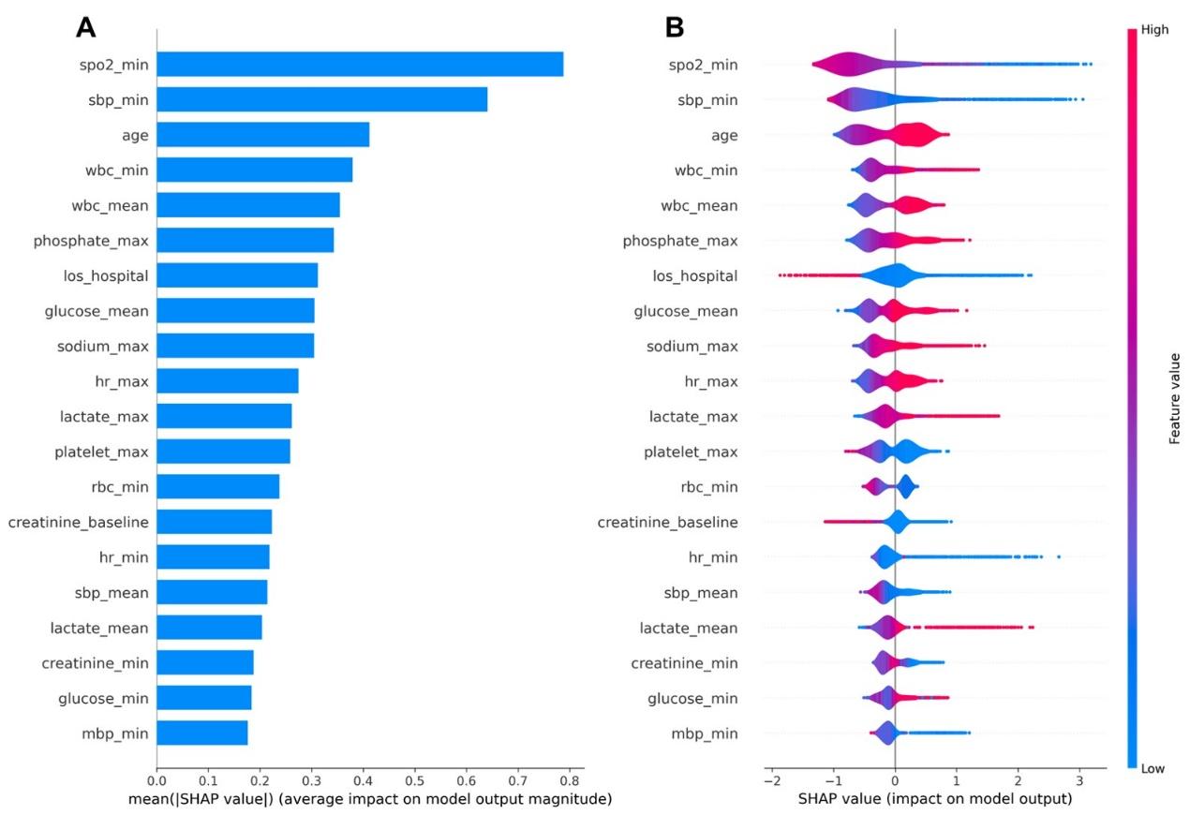

Supplementary Figure 2 SHARP summary plot for the top 20 features of the XGBoost model in the non-dialysis subgroup. A: Bar charts that rank the top 20 significant variables most correlated to in-hospital mortality; B: Impact of each feature on the in-hospital mortality. XGBoost, Extreme Gradient Boosting; SHAP, Shapley Additive Explanations; min, minimum value; max, maximum value; mean, average value; spo₂, oxyhemoglobin saturation; sbp, systolic blood pressure; wbc, white blood cell; los_hospital, length of hospital stay; hr, heart rate; rbc, red blood cell; mbp, mean blood pressure.

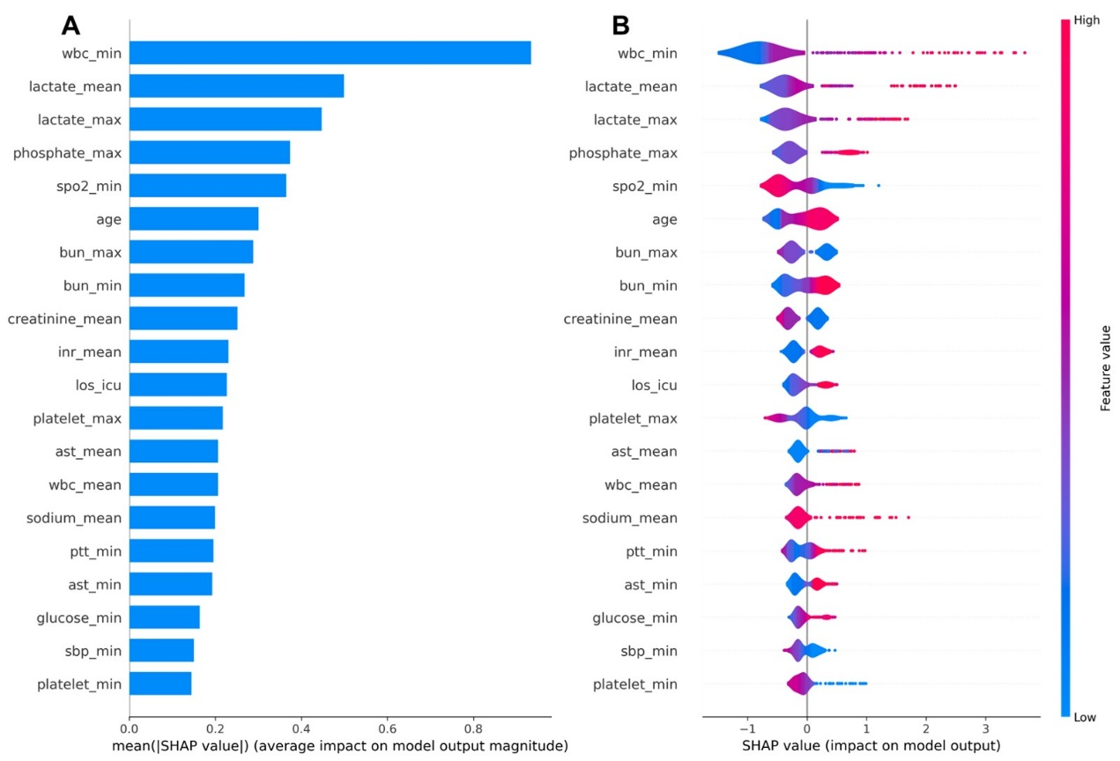

Supplementary Figure 3 Restricted cubic spline (RCS) analyses of key predictors in relation to in-hospital mortality among ICU patients with sepsis and CKD.
(A) minimum systolic blood pressure (SBP), (B) minimum SpO₂, (C) minimum phosphate, and (D) maximal level of sodium. Overall and nonlinear P values were annotated in each panel. The analyses confirmed significant associations for all predictors, and suggested potential non-linear relationships between the indicators and hospital mortality.

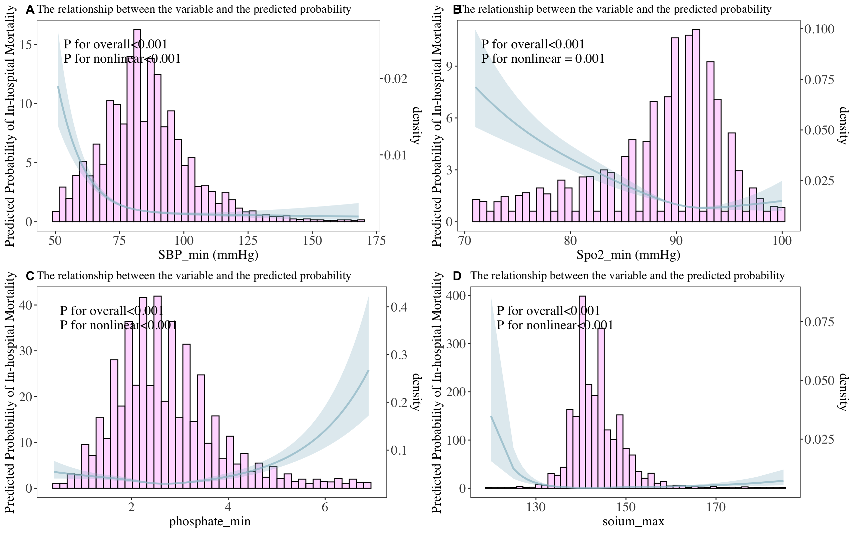

Supplementary Table 2 Missing data of variables included in the machine-learning methods

Variable | Missing Percentage (%)
CKD_stage | 0
age | 0
gender | 0
los_icu | 0
race | 0
SOFA_score | 0
CPD | 0
CAD | 0
ACS | 0
AF | 0
HF | 0
HT | 0
DM | 0
CVD | 0
wbc_max | 0.064
wbc_min | 0.064
wbc_mean | 0.064
rbc_max | 0.064
rbc_min | 0.064
rbc_mean | 0.064
hemoglobin_max | 0.064
hemoglobin_min | 0.064
hemoglobin_mean | 0.064
hematocrit_max | 0.043
hematocrit_min | 0.043
hematocrit_mean | 0.043
platelet_max | 0.064
platelet_min | 0.064
platelet_mean | 0.064
alt_max | 21.69
alt_min | 21.69
alt_mean | 21.69
ast_max | 21.42
ast_min | 21.42
ast_mean | 21.42
bilirubin_total_max | 21.51
bilirubin_total_min | 21.51
bilirubin_total_mean | 21.51
creatinine_baseline | 0
creatinine_max | 0
creatinine_min | 0
creatinine_mean | 0
bun_max | 0.064
bun_min | 0.064
bun_mean | 0.064
potassium_max | 0
potassium_min | 0
potassium_mean | 0
sodium_max | 0
sodium_min | 0
sodium_mean | 0
total_calcium_max | 0.87
total_calcium_min | 0.87
total_calcium_mean | 0.87
magnesium_max | 0.021
magnesium_min | 0.021
magnesium_mean | 0.021
phosphate_max | 0.83
phosphate_min | 0.83
phosphate_mean | 0.83
inr_max | 3.62
inr_min | 3.62
inr_mean | 3.62
pt_max | 3.62
pt_min | 3.62
pt_mean | 3.62
ptt_max | 3.82
ptt_min | 3.82
ptt_mean | 3.82
glucose_max | 0.021
glucose_min | 0.021
glucose_mean | 0.021
lactate_max | 15.19
lactate_min | 15.19
lactate_mean | 15.19
RRT_inhospital | 0
vasoactive_agents | 0
ventilation | 0
sbp_max | 0
sbp_min | 0
sbp_mean | 0
dbp_max | 0
dbp_min | 0
dbp_mean | 0
mbp_max | 0
mbp_min | 0
mbp_mean | 0
hr_max | 0
hr_min | 0
hr_mean | 0
spo2_max | 0.021
spo2_min | 0.021

Supplementary Table 3 Performance of prediction models XGBoost in the main analysis and sensitivity analyses

Analysis method | AUC | AP
Main analysis (MICE, rf, m=5) | 0.910 | 0.766
Complete-case analysis | 0.912 | 0.763
Alternative imputation (pmm) | 0.895 | 0.769
Increased imputations (m=10) | 0.910 | 0.765

Supplementary Table 4 Model performance under two threshold strategies (Youden index and sensitivity ≥95%) showing threshold, AUC, AP, sensitivity, and specificity.

Model | Strategy | Threshold | AUC | AP | Specificity | Sensitivity
XGBoost | Youden | 0.170 | 0.911 | 0.769 | 0.960 | 0.621
XGBoost | Sens>=0.95 | 0.017 | 0.920 | 0.796 | 0.628 | 0.950
Logistic Regression | Youden | 0.410 | 0.885 | 0.762 | 0.961 | 0.550
Logistic Regression | Sens>=0.95 | 0.139 | 0.893 | 0.729 | 0.458 | 0.954
SVM | Youden | 0.207 | 0.907 | 0.744 | 0.960 | 0.511
SVM | Sens>=0.95 | 0.068 | 0.916 | 0.756 | 0.611 | 0.950
KNN | Youden | 0.133 | 0.488 | 0.259 | 0.965 | 0.053
KNN | Sens>=0.95 | 0.000 | 0.836 | 0.602 | 0.000 | 1.000
NN | Youden | 0.004 | 0.756 | 0.617 | 0.920 | 0.565
NN | Sens>=0.95 | 0.000 | 0.875 | 0.717 | 0.441 | 0.950
Random Forest | Youden | 0.202 | 0.847 | 0.724 | 0.949 | 0.580
Random Forest | Sens>=0.95 | 0.105 | 0.896 | 0.724 | 0.569 | 0.954
GBDT | Youden | 0.025 | 0.904 | 0.722 | 0.949 | 0.576
GBDT | Sens>=0.95 | 0.002 | 0.917 | 0.791 | 0.616 | 0.950

XGBoost, Extreme Gradient Boosting; SVM, Support Vector Machine; GBDT, Gradient Boosting Decision Tree Machine; NN, Neural Network; KNN, K-nearest neighbors.

