Supplementary Material
The Impact of Fluoroquinolone-Resistant Enterobacterales Colonization on Fluoroquinolone Prophylaxis Efficacy in Hematopoietic Cell Transplant Recipients
Rima Moghnieh ^{12*}, Ahmad Khalil ³, Antoine Khoury ³, Hilal W. Abdessamad ², Monica Abi Abdallah ⁴, Pamela Sfeir ⁴, Mariana Mezher ⁴, Bilal Hamade ⁴, Kamal Zahran ⁴, Edmond Abboud ⁴, Aysar Fakih ², Rana Attieh ², Farah Hneini ², Marilyne Sily ², Wael Zorkot ⁵, Shadi Eid ², Dania Abdallah ⁶, Ahmad Ibrahim ^{3,4,5,6}
Affiliations
¹Lebanese American University Medical Center-Rizk Hospital, Beirut, Lebanon.
²Lebanese American University, Byblos, Lebanon.
³University of Balamand, Alkoura, Lebanon.
⁴Middle East Institute of Health, Bsalim, Lebanon.
⁵Lebanese University, Beirut, Lebanon.
⁶Makassed General Hospital, Beirut, Lebanon.

*Correspondence
Rima Moghnieh, MD, FRCP
Professor of Clinical Medicine, Lebanese American University, Beirut, Lebanon
Head, Division of Infectious Diseases, Department of Internal Medicine, Lebanese American University Medical Center, Beirut, Lebanon
E-mail: moghniehrima@gmail.com; rima.moghnieh@laumcrh.com

Figure S1. Kaplan-Meier curves depicting cumulative probability of post-transplant fever among autologous HCT recipients, stratified by receipt of FQ prophylaxis and baseline FQRE carriage status: (a) FQP vs. NoFQP, (b) FQP+FQRE vs. FQP-FQRE, (c) NoFQP+FQRE vs. NoFQP-FQRE, (d) FQP+FQRE vs. NoFQP+FQRE, (e) FQP-FQRE vs. NoFQP-FQRE
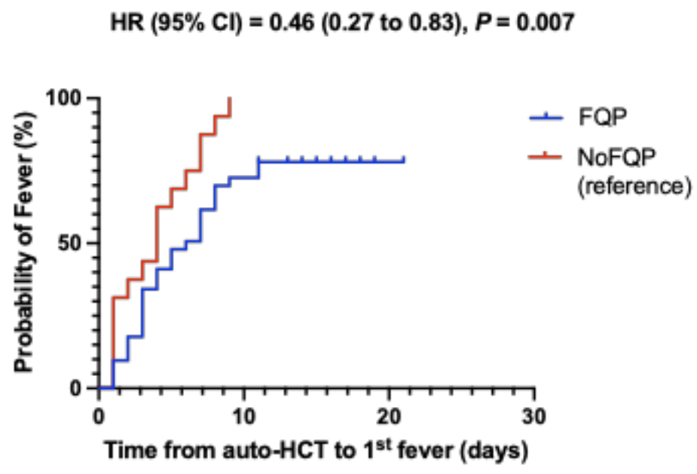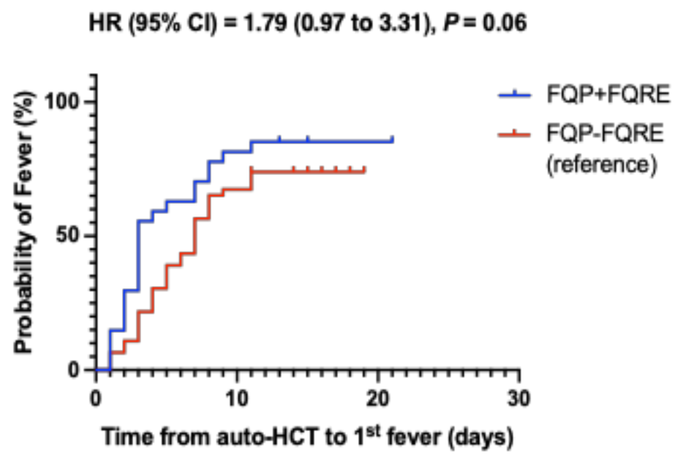
(a)
(b)

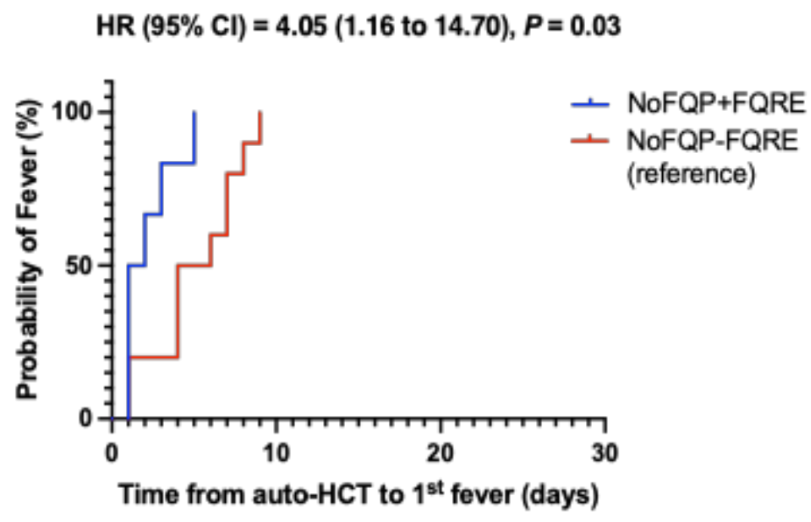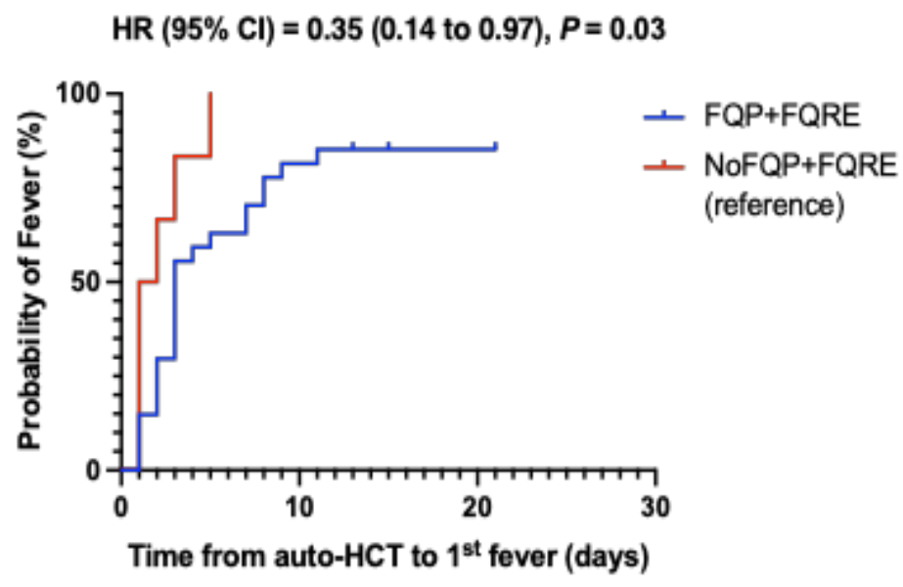
(c)
(d)
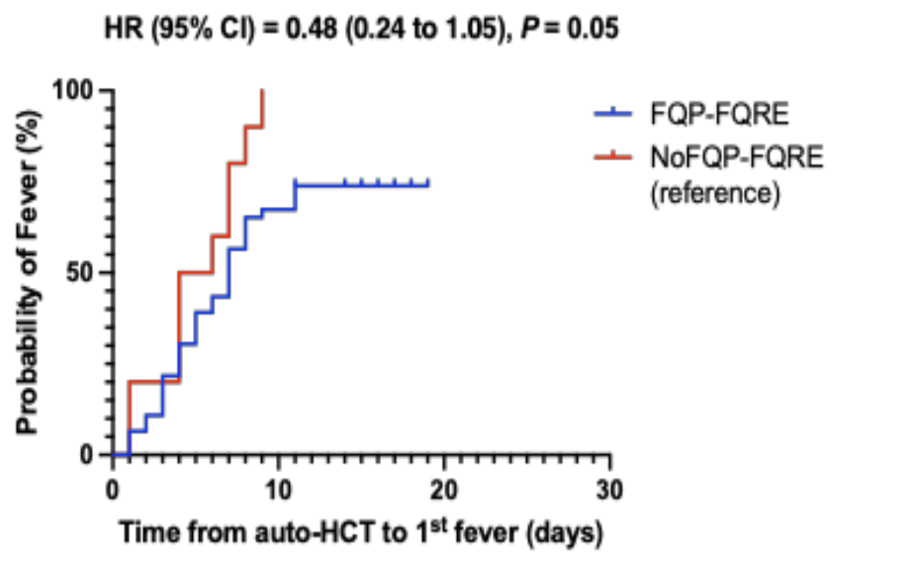
(e)
Abbreviations: CI= Confidence Interval, FQ = Fluoroquinolone, FQP = FQ Prophylaxis, FQRE = Fluoroquinolone-Resistant Enterobacterales, FQP+FQRE = FQ Prophylaxis & Positive FQRE Screen, FQP-FQRE = FQ Prophylaxis & Negative FQRE Screen, HCT = Hematopoietic Cell Transplantation, HR = Hazard Ratio, IQR = Interquartile Range, NoFQP = No FQ Prophylaxis, NoFQP+FQRE = No FQ Prophylaxis & Positive FQRE Screen, NoFQP-FQRE = No FQ Prophylaxis & Negative FQRE Screen.
Figure S2. Kaplan-Meier curves depicting cumulative probability of post-transplant fever among allogeneic HCT recipients, stratified by receipt of FQ prophylaxis and baseline FQRE carriage status: (a) FQP vs. NoFQP, (b) FQP+FQRE vs. FQP-FQRE, (c) NoFQP+FQRE vs. NoFQP-FQRE, (d) FQP+FQRE vs. NoFQP+FQRE, (e) FQP-FQRE vs. NoFQP-FQRE
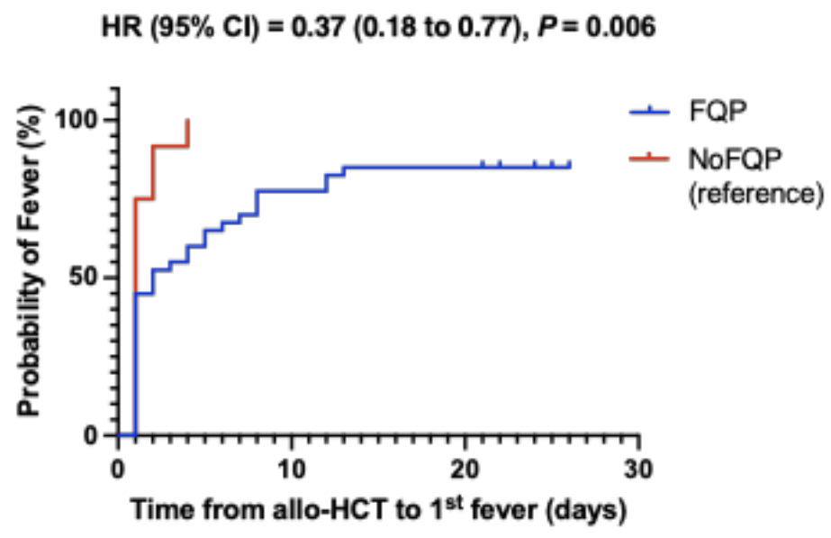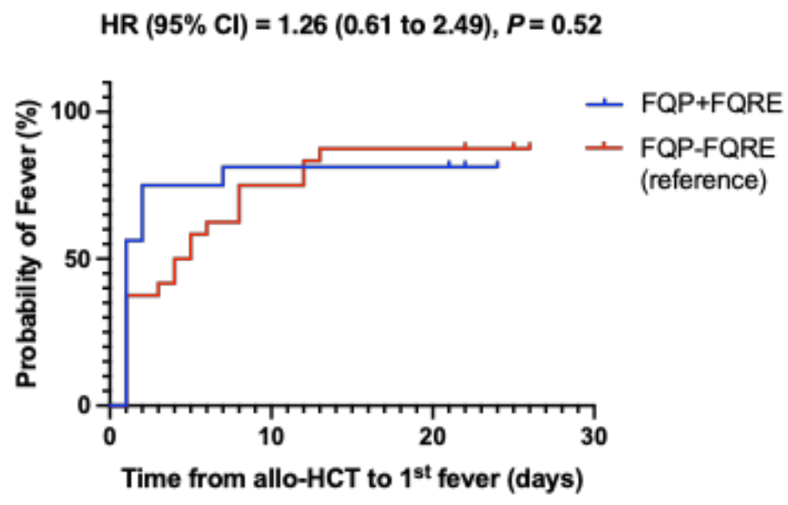
(a)
(b)

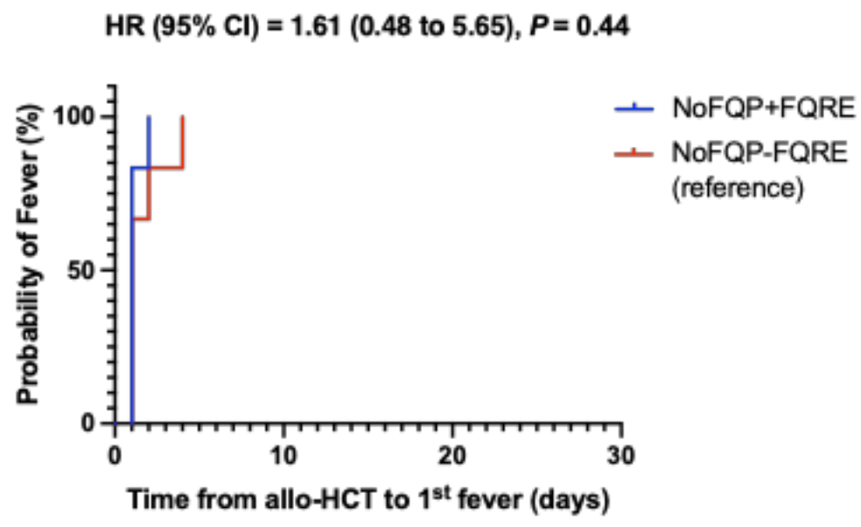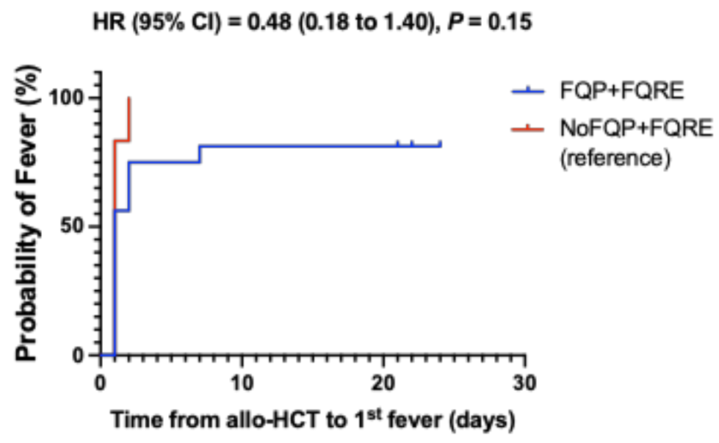
(c)
(d)
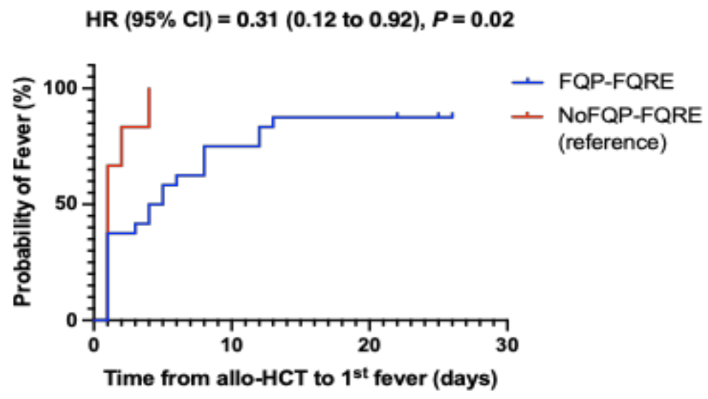
(e)
Abbreviations: CI= Confidence Interval, FQ = Fluoroquinolone, FQP = FQ Prophylaxis, FQRE = Fluoroquinolone-Resistant Enterobacterales, FQP+FQRE = FQ Prophylaxis & Positive FQRE Screen, FQP-FQRE = FQ Prophylaxis & Negative FQRE Screen, HCT = Hematopoietic Cell Transplantation, HR = Hazard Ratio, IQR = Interquartile Range, NoFQP = No FQ Prophylaxis, NoFQP+FQRE = No FQ Prophylaxis & Positive FQRE Screen, NoFQP-FQRE = No FQ Prophylaxis & Negative FQRE Screen.

Figure S3. Kaplan-Meier curves depicting cumulative probability of pre-engraftment bacteremia among autologous HCT recipients, stratified by receipt of FQ prophylaxis and baseline FQRE carriage status: (a) FQP vs. NoFQP, (b) FQP+FQRE vs. FQP-FQRE.
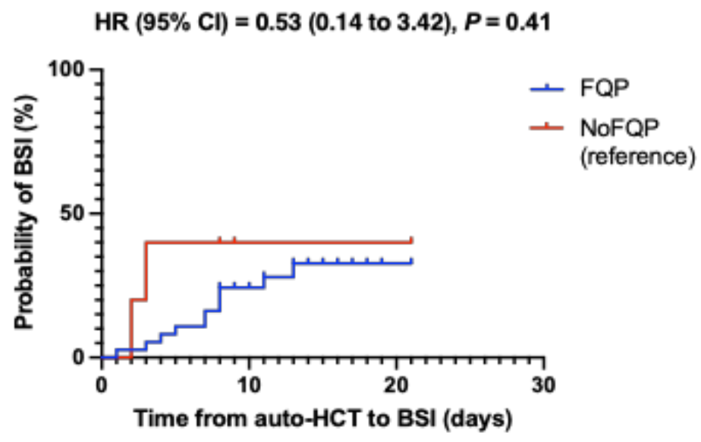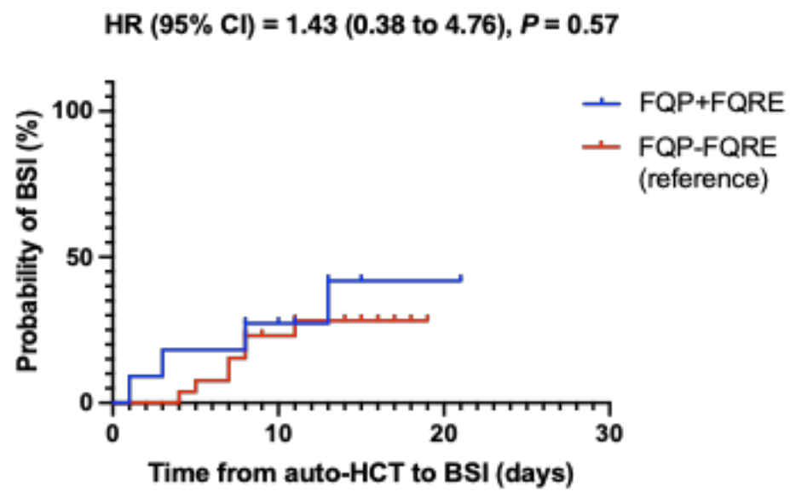
(a)
(b)
Abbreviations: BSI= Bloodstream Infections, CI= Confidence Interval, FQ = Fluoroquinolone, FQP = FQ Prophylaxis, FQRE = Fluoroquinolone-Resistant Enterobacterales, FQP+FQRE = FQ Prophylaxis & Positive FQRE Screen, FQP-FQRE = FQ Prophylaxis & Negative FQRE Screen, HCT = Hematopoietic Cell Transplantation, HR = Hazard Ratio, IQR = Interquartile Range, NoFQP = No FQ Prophylaxis.

N.B. Other Kaplan-Meier curves were not generated due to the small sample size.

Figure S4. Kaplan-Meier curves depicting cumulative probability of pre-engraftment bacteremia among allogeneic HCT recipients, stratified by receipt of FQ prophylaxis
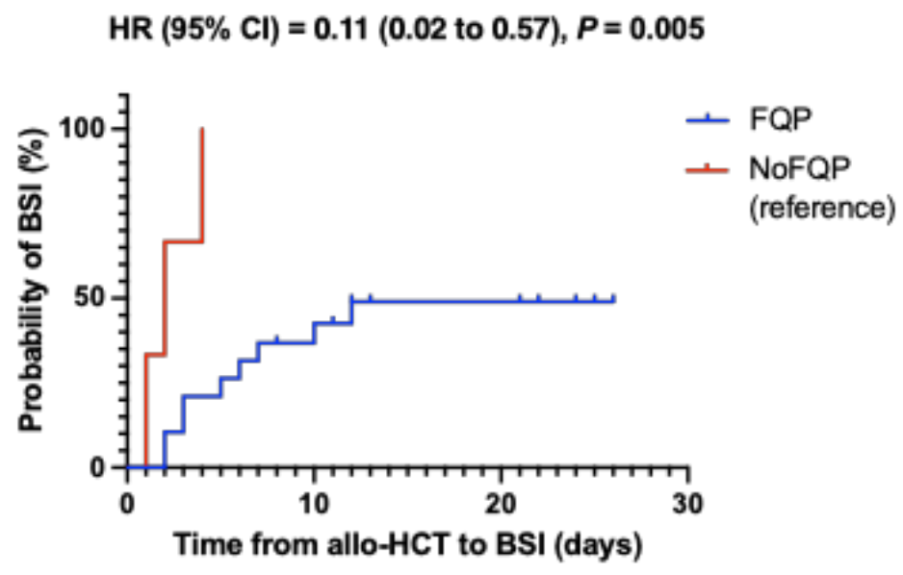
Abbreviations: BSI= Bloodstream Infections, CI= Confidence Interval, FQ = Fluoroquinolone, FQP = FQ Prophylaxis, HCT = Hematopoietic Cell Transplantation, HR = Hazard Ratio, IQR = Interquartile Range, NoFQP = No FQ Prophylaxis.

N.B. Other Kaplan-Meier curves were not generated due to the small sample size.

Figure S5. Kaplan-Meier curves depicting cumulative probability of pre-engraftment Gram-negative bacteremia among all HCT recipients, stratified by receipt of FQ prophylaxis and baseline FQRE carriage status: (a) FQP vs. NoFQP, (b) FQP+FQRE vs. FQP-FQRE, (c) NoFQP+FQRE vs. NoFQP-FQRE, (d) FQP+FQRE vs. NoFQP+FQRE, (e) FQP-FQRE vs. NoFQP-FQRE

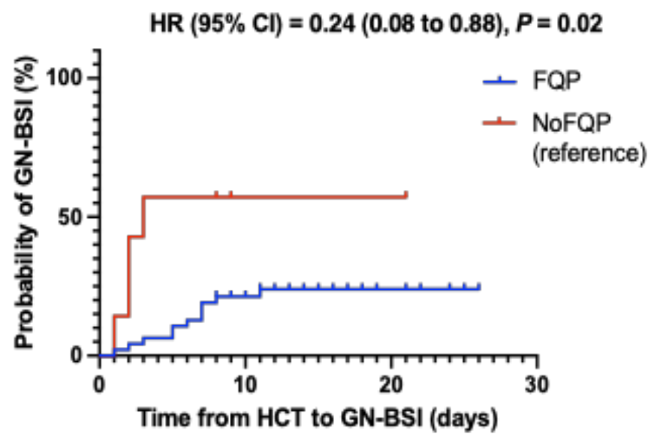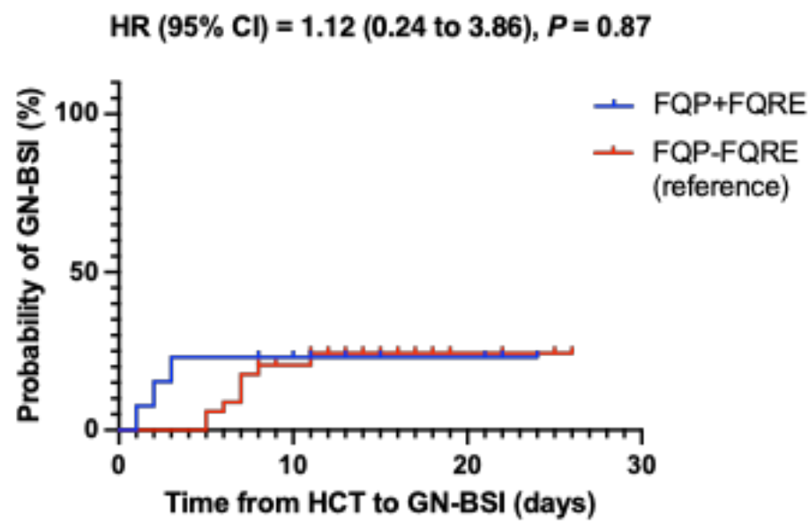
(a)
(b)

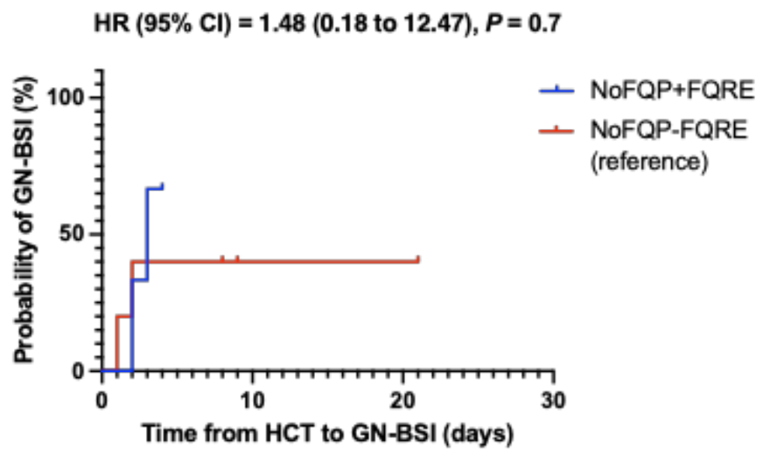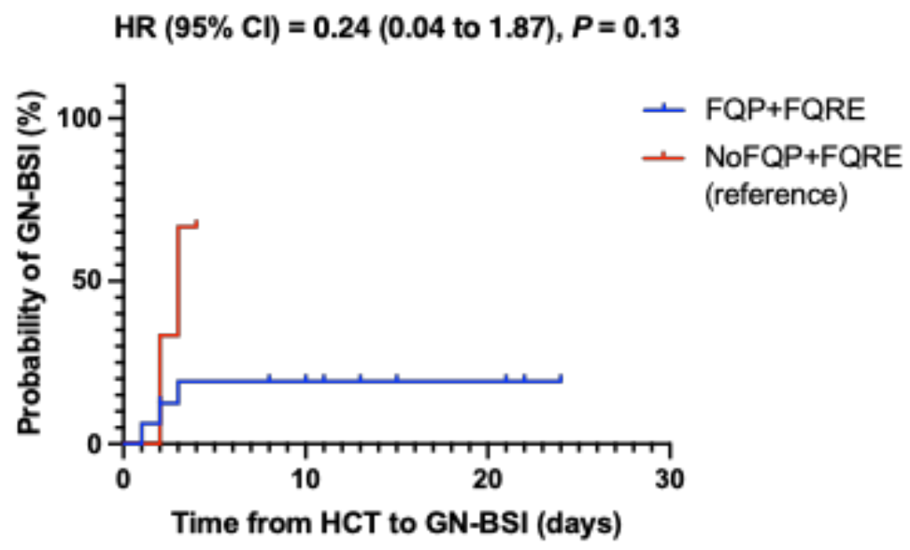
(c)
(d)
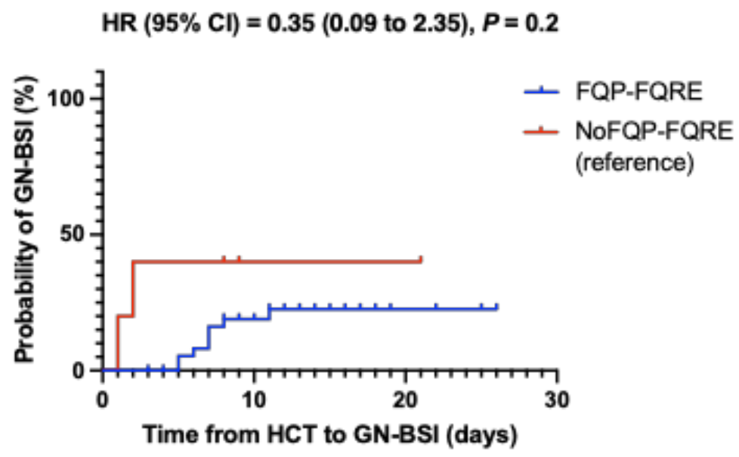
(e)
Abbreviations: BSI= Bloodstream Infections, CI= Confidence Interval, FQ = Fluoroquinolone, FQP = FQ Prophylaxis, FQRE = Fluoroquinolone-Resistant Enterobacterales, FQP+FQRE = FQ Prophylaxis & Positive FQRE Screen, FQP-FQRE = FQ Prophylaxis & Negative FQRE Screen, HCT = Hematopoietic Cell Transplantation, HR = Hazard Ratio, IQR = Interquartile Range, NoFQP = No FQ Prophylaxis, NoFQP+FQRE = No FQ Prophylaxis & Positive FQRE Screen, NoFQP-FQRE = No FQ Prophylaxis & Negative FQRE Screen.
Figure S6. Kaplan-Meier curves depicting cumulative probability of pre-engraftment Gram-negative bacteremia among autologous HCT recipients, stratified by receipt of FQ prophylaxis and baseline FQRE carriage status: (a) FQP vs. NoFQP, (b) FQP+FQRE vs. FQP-FQRE.

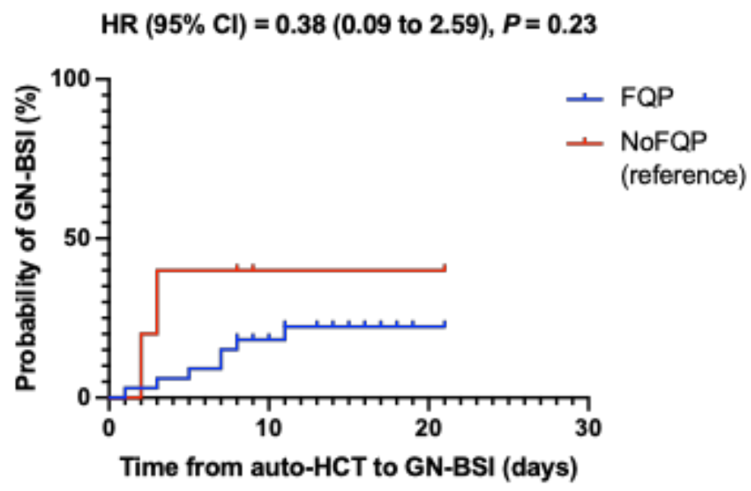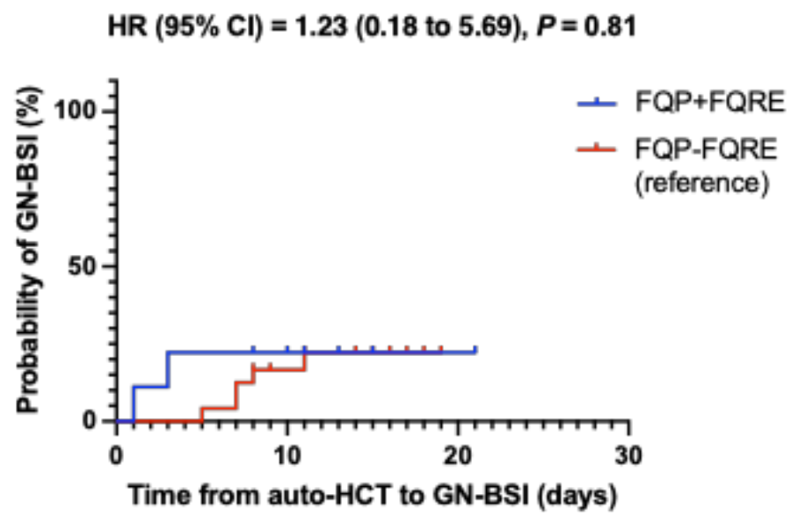
(a)
(b)
Abbreviations: BSI= Bloodstream Infections, CI= Confidence Interval, FQ = Fluoroquinolone, FQP = FQ Prophylaxis, FQRE = Fluoroquinolone-Resistant Enterobacterales, FQP+FQRE = FQ Prophylaxis & Positive FQRE Screen, FQP-FQRE = FQ Prophylaxis & Negative FQRE Screen, HCT = Hematopoietic Cell Transplantation, HR = Hazard Ratio, IQR = Interquartile Range, NoFQP = No FQ Prophylaxis.

N.B. Other Kaplan-Meier curves were not generated due to the small sample size.

Figure S7. Kaplan-Meier curves depicting cumulative probability of pre-engraftment Gram-negative bacteremia among allogeneic HCT recipients, stratified by receipt of FQ prophylaxis

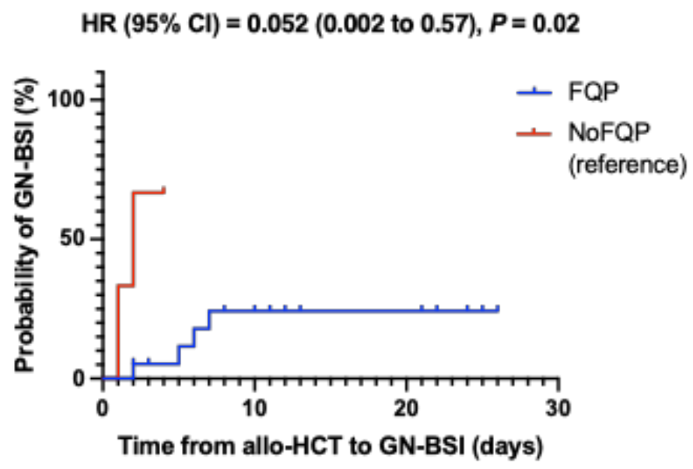
Abbreviations: BSI= Bloodstream Infections, CI= Confidence Interval, FQ = Fluoroquinolone, FQP = FQ Prophylaxis, HCT = Hematopoietic Cell Transplantation, HR = Hazard Ratio, IQR = Interquartile Range, NoFQP = No FQ Prophylaxis.

N.B. Other Kaplan-Meier curves were not generated due to the small sample size.

