Title: The Predictive Performance of NEWS, MEWS, SOFA and SAPS II in Outcomes of Bacteremic and Non-Bacteremic Sepsis

Supplementary Table 1: Diagnostic Accuracy of Sepsis Scores and inflammatory biomarkers in prediction of 30 Days Mortality in Bacteremic Sepsis (N=95)

Sepsis Scores | AUC | 95% CI | P value | Sensitivity | Specificity | PPV | NPV | LR (+) | LR (-) | Diagnostic  Accuracy
SOFA ≥ 6 | 0.618 | 0.48- 0.76 | 0.097 | 82.6 | 33.3 | 28.4 | 85.7 | 1.24 | 0.52 | 45.3
NEWS ≥12 | 0.940 | 0.89-0.99 | <0.001 | 78.3 | 80 | 66.7 | 85 | 3.7 | 0.3 | 77.9
MEWS ≥7 | 0.628 | 0.51-0.75 | 0.034 | 73.9 | 45.1 | 30.4 | 84.2 | 1.35 | 0.58 | 52.13
SAPS II ≥ 56 | 0.690 | 0.58-0.80 | 0.001 | 91.3 | 47.2 | 35.6 | 94.4 | 1.7 | 0.2 | 57.9
Pitt Bacteremia Score ≥ 3 | 0.685 | 0.56-0.81 | 0.004 | 87 | 40.3 | 31.8 | 90.6 | 1.5 | 0.3 | 51.6
Procalcitonin | 0.721 | 0.58-0.86 | 0.002 | 78.3 | 40.3 | 29.5 | 85.3 | 1.31 | 0.54 | 49.5
CRP | 0.533 | 0.12-1.12 | 0.574 | 47.8 | 52.8 | 24.4 | 76 | 1.01 | 0.99 | 51.6
NLR | 0.420 | 0.28-1.13 | 0.250 | 56.5 | 27.8 | 20.0 | 66.7 | 0.78 | 1.57 | 34.8
Ferritin | 0.804 | 0.71-0.90 | <0.001 | 82.6 | 61.1 | 40.4 | 91.6 | 2.1 | 0.28 | 66.3

Supplementary Table 2: Diagnostic Accuracy of Sepsis Scores and inflammatory markers in prediction of 30 Days Mortality in non-Bacteremic Sepsis (N=101)

Scores | AUC | 95% CI | P value | Sensitivity | Specificity | PPV | NPV | LR (+) | LR (-) | Diagnostic  Accuracy
SOFA ≥6 | 0.852 | 0.76-0.94 | <0.001 | 84.6 | 61.3 | 43.1 | 92 | 2.2 | 0.25 | 67.3
NEWS ≥12 | 0.621 | 0.29-1.12 | 0.73 | 84.6 | 30.7 | 29.7 | 85.2 | 1.2 | 0.5 | 44.6
MEWS ≥7 | 0.834 | 0.75-0.92 | <0.001 | 100 | 50.6 | 41.3 | 100 | 2.03 | 0 | 63.4
SAPS II ≥ 56 | 0.749 | 0.65-0.85 | <0.001 | 73.1 | 70.7 | 46.3 | 88.3 | 2.5 | 0.4 | 71.3
Procalcitonin ≥2.5 | 0.503 | 0.18-1.13 | 0.968 | 65.4 | 39.2 | 27.4 | 76.3 | 1.08 | 0.88 | 46
CRP ≥ 250 | 0.623 | 0.51-0.74 | 0.033 | 73.1 | 46.7 | 32.2 | 83.3 | 1.37 | 0.58 | 53.47
NLR ≥7.5 | 0.434 | 0.11-1.29 | 0.391 | 41.7 | 37.3 | 17.5 | 66.7 | 0.6 | 1.6 | 38.4
Ferritin ≥650 | 0.614 | 0.49-0.74 | 0.068 | 100 | 26.7 | 30.4 | 100 | 1.36 | 0 | 44.4

Supplementary Table 3: Logistic Regression Analysis: Association Between Sepsis screening Scores/biomarkers and 30-Day Mortality

Scores | Odds ratio | 95% CI | P value
NEWS ≥12 | 4.9 | 2.0-12.1 | <0.001
MEWS≥7 | 3.7 | 1.7-7.8 | 0.002
SOFA≥6 | 4.7 | 2.01-10.62 | 0.001
SAPS II ≥56 | 5.1 | 2.2-11.5 | <0.001
Pitt Bacteremia scores≥3 | 1.8 | 0.4-8.7 | 0.481
Procalcitonin ≥2.5 | 0.62 | 0.31-1.26 | 0.19
Ferritin≥650 | 5.4 | 2.2-13.6 | <0.001
CRP≥250 | 1.5 | 0.8-2.9 | 0.202

Supplementary Table 4: Logistic Regression Analysis: Association Between Sepsis screening Scores/biomarkers and prediction of bacteremia

Scores | Odds ratio | 95% CI | P value
NEWS ≥12 | 0.25 | 0.13-0.46 | <0.001
MEWS≥7 | 5.1 | 2.4-11.1 | <0.001
SOFA≥6 | 2.4 | 1.3-4.2 | 0.005
SAPS II≥56 | 1.3 | 0.74-2.3 | 0.344
Procalcitonin ≥2.5 | 0.95 | 0.53-1.7 | 0.861
Ferritin≥650 | 0.26 | 0.14-0.49 | 0.001
CRP≥250 | 0.63 | 0.35-1.1 | 0.104

Supplementary Table 5: Sensitivity, specificity, PPV and NPV of Inflammatory Biomarkers in Prediction of Septic Shock (Overall, N=196)

Scores | AUC | 95% CI | P value | Sensitivity | Specificity | PPV | NPV | Diagnostic Accuracy
Procalcitonin ≥2.5 | 0.709 | 0.63-0.79 | <0.001 | 75 | 58 | 75.4 | 58.3 | 69.1
CRP ≥250 | 0.733 | 0.66-0.81 | <0.001 | 68 | 71.2 | 79.8 | 57.1 | 69.2
NLR ≥6 | 0.433 | 0.14-1.11 | 0.138 | 58.3 | 30.1 | 57.9 | 30.6 | 47.7
Ferritin ≥650 | 0.698 | 0.63-0.77 | <0.001 | 73.8 | 52.1 | 72 | 54.3 | 65.6

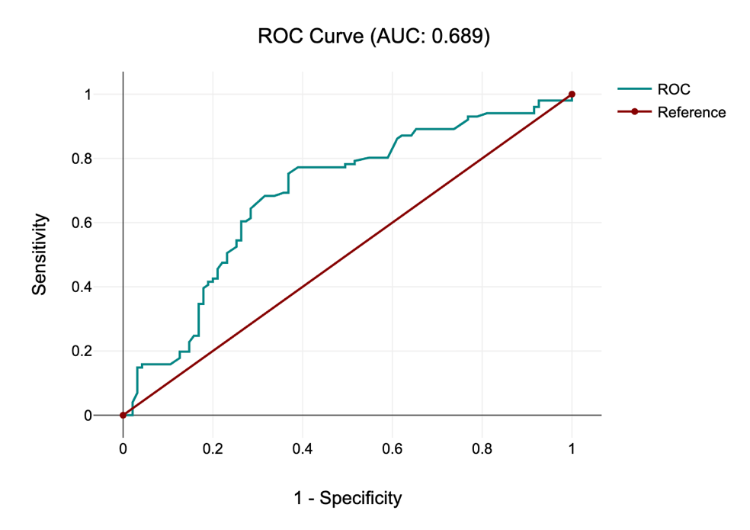

Supplementary Fig:1 Area Under the ROC curve showing the diagnostic accuracy of Ferritin for prediction of Bacteremia

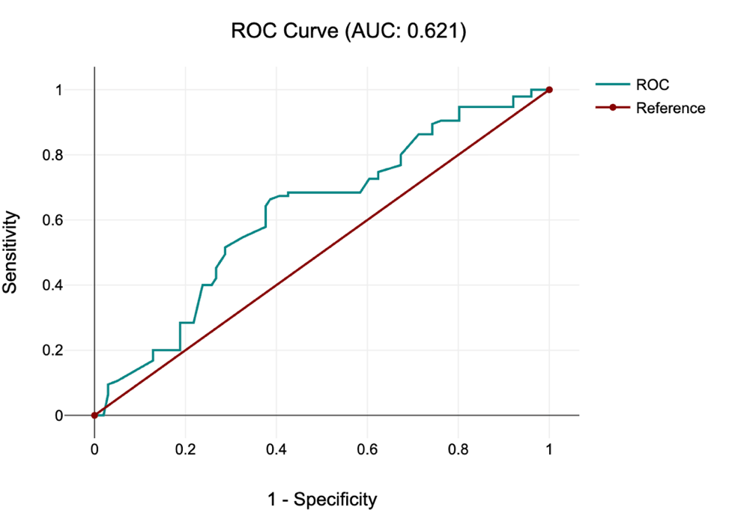

Supplementary Fig:2 Area Under the ROC curve showing the diagnostic accuracy of NLR for prediction of Bacteremia

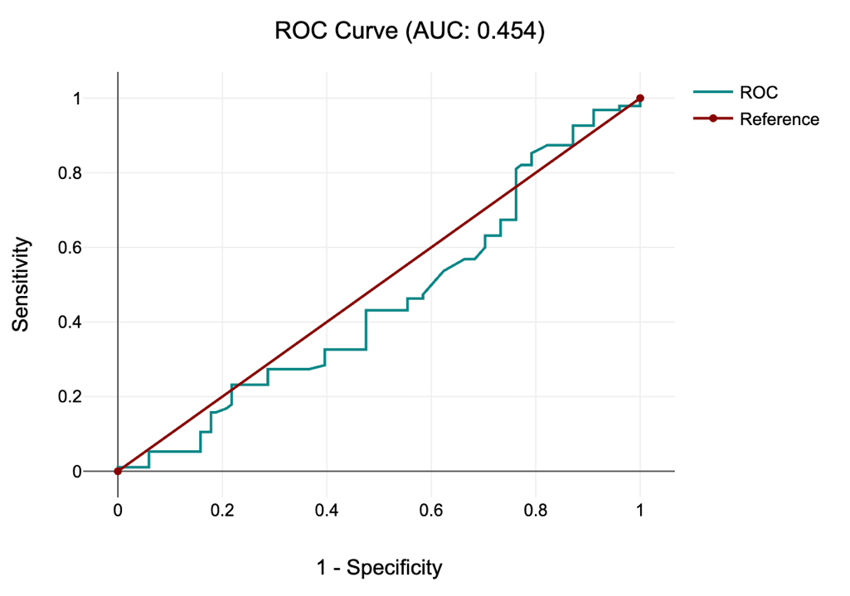

Supplementary Fig:3 Area Under the ROC curve showing the diagnostic accuracy of HsCRP for prediction of Bacteremia

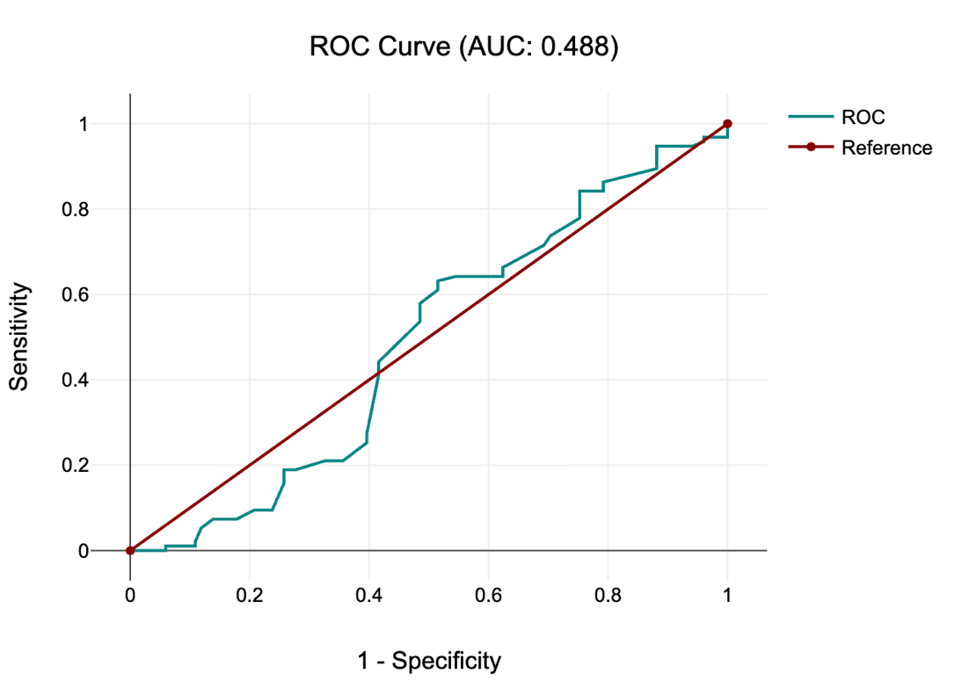

Supplementary Fig:4 Area Under the ROC curve showing the diagnostic accuracy of Procalcitonin for prediction of Bacteremia

