Supplementary file (S files)
S1. Mean value of the HB viral load of the study participants (three rounds)
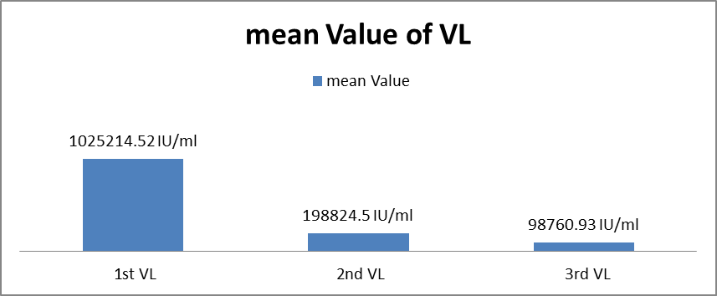
S2. Box plot of patients’ HB viral loads in three phases
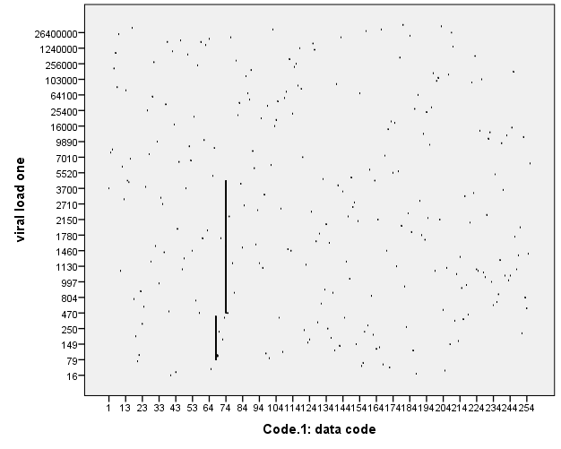
NB: viral load one = the first viral load of patients in IU/ml, Data code = patient code number

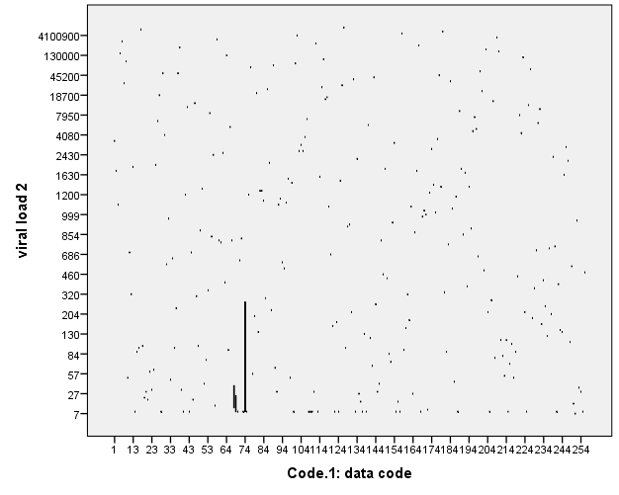
NB: viral load tow = the second viral load of patients in IU/ml, Data code = patient code number
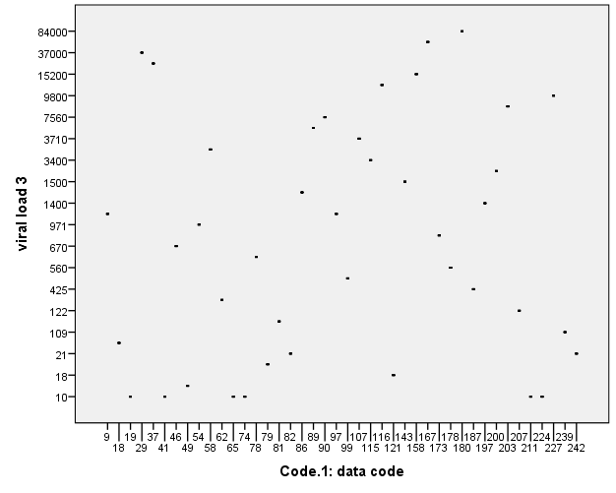

NB: viral load three = the 3rd viral load of patients in IU/ml, Data code = patient code number

S3. Check list form and questioner for the study
Code no
 | Response and value | Remark
MRN
Sex
Age
HB viral load amount | 1st  2nd 3rd
HBV therapy | Yes  No
Duration of therapy for HBV
Infection by other pathogens  Disease condign | Yes  No
If yes specify the pathogen or
the disease
Vaccination history for HBV | Yes  No
Pregnant | Yes  No
Organ transplantation | Yes  No
Smoker | Yes  No
Alcohol consumption | Yes  No

Socio-demographic data
Patient Code
number | Questions
1 | Sex | - male | - female
2 | Age
3 | Residence | - Urban | - rural
4 | occupations | - Farmer  - Housewife  - Maid servant  - Housewife  - employee/private | - student  - Daily laborer  - Unemployed  - Other (specify)
5 | Educational status | - No formal education  - Elementary school | - High school  - Diploma  - degree and above
6 | Income | - <3000/ month  - 3000--5000/month | - 5000—10000/month  - >10000  - No formal income
7 | Marital status | - single  - Madrid | - Unaired  - separated
Knowledge-related questions about HBV viral load level, early detection, transmission, and prevention.
Questions | Yes | no | Not sure
Can HBV cause liver cancer or cirrhosis?
Can HBV spread by casual hand shaking?
Can HBV spread by contact with open wound
Can HBV transmitted by contaminated blood and bodyfluids
Can HBV transmitted by unsafe sex?
Can HBV transmitted with contaminated water?
HBV is 50 to 100 times more infectious than HIV?
What is HB viral load and its purpose?
Do you think HBV has laboratory tests?
Do you know HBV has postexposure prophylaxis?
Attitude-related questions about HBV early detection, transmission, and prevention
Attitude-related questions | Strongly agree | Agree | Dis agree | Strongly disagree | Not sure
No concern of being infected with HBV
All patients should be tested for HBV
before receive health care
I do not feel comfortable to take care of
people with HBV
Post exposure prophylactic can prevent
from HBV infection
HBV viral suppression is effective
Practice-related questions about HBV early detection, transmission, and prevention
Practice questions | yes | no
Have you ever tested HB viral load?
Are there any challenges or barriers you face in accessing or
Promoting Hepatitis B viral load testing?
Have you ever hand a needle stick injury
Do you dispose of sharps properly after a procedure?
Questions to assess the affordability HB viral load level test
Questions | Response
how much is the total household income in a month
how often do you get HBV level test
Do you face any financial challenges when it comes to getting  HBV level tests? | Yes | no
Who covers the cost of the test
Have you ever had to pay out-of-pocket for HBV level  testing | yes | no
If so, how much did it cost?
Have you ever delayed or skipped HBV level testing  due to financial concerns | yes | no
Does the cost of HBV level testing influence you economically | yes | no
Do you think that the cost for hepatitis B virus level is  coasty | yes | no
IDI / interview clients guiding question
- What you think about HBV early detection, transmission prevention?
- How do you get hepatitis B virus?
- What you think about HBV viral load level?
- What are your perceptions about the importance of regularly monitoring Hepatitis B viral load in patients?
- What you think about the cost of HB viral load test?

