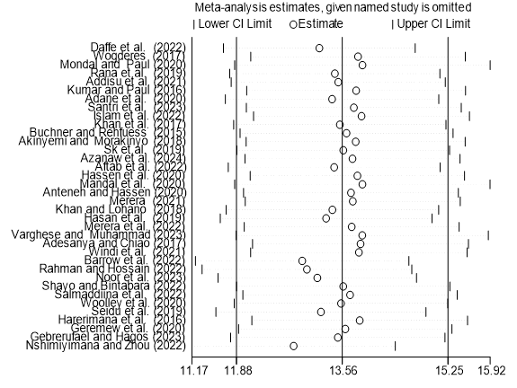
Sensitivity analysis for association of IAPs exposure and ARIs among under-five children in LMICs, 2024.

